Try, Test and Learn Information Session – Tasmania

31 January – 1 February 2018

Slide 1 – Introduction
This was an introductory slide to the presentation, with the title: Try, Test and Learn Fund tranche 2 information session.

Slide 2 – Overview of the Try, Test and Learn Fund
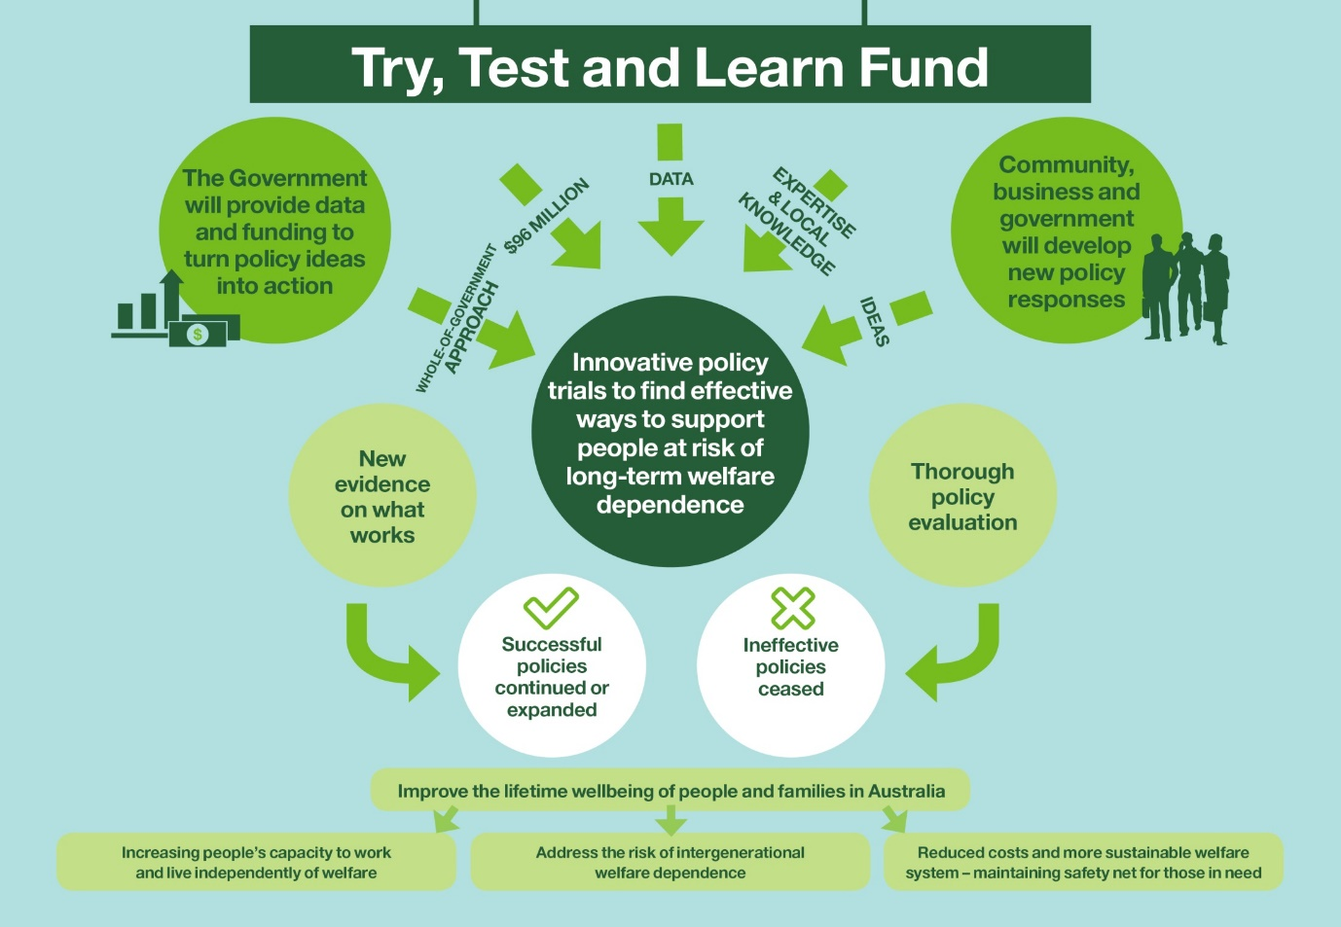
- Let’s begin with a look at the overarching aims of the Try, Test and Learn Fund.
- It is a $96 million initiative that aligns with the Government’s Innovation Agenda. It fosters a flexible policy design process and supports collaboration both across government and with external stakeholders.
- Some of the fund’s guiding principles are that it supports collaboration, data-driven approaches, is supportive of new ideas and innovation, is outcomes focused, and is flexible.
- Under the Try, Test and Learn Fund, we seek innovative proposals from across government, not-for-profit organisations, social policy experts and businesses.
- The fund provides us an opportunity to trial new or innovative policy responses to support people to live independently of welfare.
- These policy responses may include applying insights from behavioural economics, technology responses such as smart phone applications, or new approaches to service delivery.
- The Government will track the impact of these policy responses using actuarial analysis of Australia’s social security system and other evaluation methods. We can then identify what works and use those insights to inform policy decisions going forward.
- Our overarching aim is to improve lifetime wellbeing with the following three goals:
- increase people’s capacity to live independently of welfare through employment
- address the risk of intergenerational welfare dependence; and
- reduce long-term social security costs.

Slide 3 – Tranche one update
- The Minister for Social Services approved $23 million for 14 projects that were co-developed through tranche one of the fund.
- The projects take varied approaches to helping members of our priority groups transition into work. Fact sheets on the individual projects are on the DSS website.
- Most of these projects were funded through restricted non-competitive funding rounds, otherwise known as direct grant funding.
- We expect project delivery to commence on the ground over the coming weeks and months.
- We appreciate the efforts of all idea submitters and the partners who helped shape these proposals through co-development.
- It was great to see the level of collaboration between the sector and the Department during this process, and the inclusion of priority group representatives to help shape ideas.
- The way these projects were developed and funded is very different to the way the Department usually works.
- In short: we asked you to propose new ways of responding to particular policy issues, we selected some of the more promising of these to be co-developed, sought funding approval, then went to a direct grant funding process for those which were approved.
- Through the TTL Fund, we are testing new ways of working – and we (that means us and you) won’t always be getting it right - and that’s ok. We would expect that to happen as we look for different, for new, for innovative policy responses to addressing welfare dependency among specific groups of people.
- We acknowledge that we need to do things differently, if we are going to find new ways of helping people (and ultimately their children) to have a better chance of finding a stable job. And in doing things differently, we expect projects will not always go the way we expect them to.
- We will be working more closely with the service delivery organisations so we can see what works, and what doesn’t work.
- And when things aren’t quite going according to plan, we will work with you to try to find ways to tweak the project, so that it is better at assisting the people we are aiming to help.
- As mentioned earlier, a key objective of the Try, Test and Learn Fund is to generate new insights and empirical evidence into ‘what works’ to reduce long-term welfare dependence.
- Projects are being selected based, in part, on the value of the evidence that they will generate.
- This means that projects will be robustly evaluated to produce high-quality policy evidence about the effectiveness of interventions, for whom, and under what circumstances.
- In this way, the fund will allow us to identify projects that work, and use the evidence we have gathered to transform our investment in existing programs or make the case for new investments.
- We have recently finalised the process of engaging external evaluation experts, who will be leading overall evaluation of the fund. Each individual project will be monitored and evaluated as well.
- We also had an external consultant review the way in which we delivered tranche one. Among the feedback received was that:
  - The limited time available for co-development put pressures on co-development collaborators to be responsible and available at short notice. Contributions to co-development from end users provided vital insights. Processes for ideas generation, eligibility checking, assessment and shortlisting need to be streamlined.
- This, and other feedback we received, has helped inform the way in which we have designed the second funding tranche.
- Tranche 2 has been designed to be streamlined and flexible to stakeholders’ needs and emerging policy priorities.

Slide 4 – Tranche 2

- Tranche 2 was opened by the Minister for Social Services on 22 November 2017.
- It continues the focus on gathering new policy evidence on what works to help members of our priority groups move from welfare into employment; and as a result, have better lifetime wellbeing for themselves and for their children.
- This tranche will be open continuously through to 28 September 2018.
- Up to $50 million is available to support projects. There is a $5 million cap on individual projects. Grant amounts for tranche 2 projects will be guided by project design and complexity.
- Projects will run for up to two years. As the budget for the fund ends in the 2019-20 financial year, all projects need to be completed by June 2020.
- Funding for the evaluation of individual projects will be provided through a separate contract, and undertaken by an external body contracted by DSS.
- That means your grant submission doesn’t need to include evaluation costs, or extensive detail on how your project will be evaluated.
- Successful service delivery organisations will need to provide regular progress reports to DSS, and there will be a requirement to gather data to support the evaluation.
- The successful service delivery organisations will also be provided some capacity building and support for this monitoring and evaluation work. The level of support will depend on the need within the organisation.
- We expect that part of this work will include nutting out some key performance indicators, or reporting milestones for your projects. You could also include some early ideas about KPIs in your grant application, though this is not mandatory.
- We are very conscious that moving people into employment is not always a blunt transition, that there may be a pathway, or a myriad of pathways between the education and support an individual requires to be job ready. This pathway will differ between projects – some may well be straight forward, others not.
- We are very conscious of having a theory of change within each project, and a logic for getting to that change: so applications should address the objective of the project you want to deliver, as well as defining the problem you are trying to solve.

Slide 5 – New priority groups
- Tranche 2 will support groups at risk of long-term welfare dependence, including four new priority groups:
  - Newstart Allowance recipients aged 50 and over (with a focus on those who have been out of the workforce for longer than 12 months)
  - Migrants and refugees aged 16-64 and receiving income support
  - Carers aged 16-64 and receiving Carer Payment
  - At-risk young people aged 16-21 and receiving income support.
- These groups were identified using data from the Australian Priority Investment Approach to Welfare, and other evidence. The approach uses actuarial analysis to estimate Australia’s overall future lifetime welfare costs, and the cost of future payments to various groups within the population.
- This data may be helpful for forming the basis of your application. A subset of the data has been made available publicly, which we will show you a bit later on.
- Applications are also welcomed for the priority groups from tranche one, or for any other group at risk of long-term welfare dependence, if you can appropriately justify this through evidence.
- This evidence could include Priority Investment Approach data, other research, or from your experience in working at the front line with vulnerable people.
- In allowing applicants to propose their own priority groups, we are aiming to take full advantage of the knowledge and creativity of the sector in gathering evidence about ‘what works’ to help people in need.
- I’ll now briefly go through each of the new priority groups.

Slide 6 – Older Newstart Allowance recipients
- This group is made up of older Australians who receive Newstart Allowance, with a focus on those who have been receiving income support for more than a year.
- As of 30 June 2017, there were around 251,400 people aged 50 or over receiving Newstart Allowance.
- At June 2017, there were 195,000 of the group (which is close to 80 per cent) who have been on income support for 12 months or more.
- The gender and age split across this group is fairly even: 53 per cent are female, 32 per cent are aged 50-54, 32 per cent are aged 55-59, 35 per cent are aged 60-64.
- 81,600 people in this group were assessed as having a partial capacity to work.
- The data also indicates that over a third of this group live in inner and outer regional areas.

Slide 7 – Migrants and refugees
- The migrant and refugee group looks at migrants and refugees aged 16 to 64 who are receiving income support.
- There are nearly 300,000 people in this group, of which 65 per cent are female.
- While most refugees successfully gain employment within the first few years of arrival, a small group continue to struggle due to barriers such as lack of skills recognition, low levels of English literacy, discrimination and mental health issues.
- For the migrant group, many of these enter Australia through skills-based and family visas. Their families, especially migrant women, face a number of barriers to engaging in work. This includes low proficiency in English, and childcare responsibilities.
- Most migrants and refugees live in metropolitan areas, with data showing us that 85 per cent reside in major cities.

Slide 8 – Working age carers
- This priority group refers to people aged 16 to 64 who are in receipt of Carer Payment.
- As of 30 June 2017, there were around 221,700 working age carers.
- Working age carers have a relatively low labour force participation rate, compared to non-carers.
- The majority (around 7 in 10) are female, and a large proportion (60 per cent) are aged between 46 and 64.
- A third live in inner and outer regional areas.

Slide 9 – At-risk young people on income support
- This group is quite broad, including people aged 16 to 21 who receive Youth Allowance (other) or Disability Support Pension (with mental health as the primary condition).
- As at 30 June 2017, there were around 109,000 young people in this priority group.
- The needs and barriers to employment for members of this group are highly varied and may include disengagement from education, experience of severe family breakdown, history of abuse, drug and alcohol misuse, or family instability.
- Almost 4 in 10 (38 per cent) live in inner and outer regional areas.
- Sixteen per cent of the group are Indigenous.
- Seven per cent are on DSP with mental health issues.
- Not all young people on these payments are considered at-risk, but there will be sub-cohorts with various significant risk characteristics.

Slide 10 – Process
- I’ll now outline the general process for applying for funding through tranche 2.
- For those of you that participated in tranche one, the tranche 2 process will look quite different.
- Tranche 2 is more closely aligned to a traditional open competitive grant process than tranche one was. Organisations can apply for grant funding, proposing their unique approach to assist identified individuals at risk of long-term welfare dependence.
- To submit a grant application, you need to visit the Department’s Community Grants Hub or the Australian Government’s GrantConnect websites.
- Here you will also find the Grant Opportunity Guidelines, which I strongly encourage you to read. In fact, the vast majority of answers to questions about this grant process that people have come to us with can be found in the Grant Opportunity Guideline.
- On the grants hub website, you will also find:
  - questions and answers, including a transcript of any Q&A from these information sessions
  - a copy of the DSS Comprehensive Grant Agreement Terms and Conditions
  - sample application forms
  - a project plan template
  - and other information.
- Submissions will be initially assessed by the Community Grants Hub. Policy experts from across government will be consulted on promising applications, and recommendations made to an Inter-Departmental Committee.
- The Minister, in consultation with the Prime Minister, Treasurer and Minister for Finance, will approve which projects receive funding.
- Successful applicants will receive funding for both co-development and subsequent delivery of their project.
- Co-development will be tailored to the needs of each project and may involve collaboration with end users, the Commonwealth and other stakeholders.
- The Try, Test and Learn Fund takes an open and collaborative approach to policy development.
- While we expect co-development will involve collaboration, we also encourage stakeholders to collaborate prior to submitting proposals. And indeed, to submit joint proposals if partnerships are formed.
- To this end, the Department is compiling a directory of interested tranche 2 stakeholders to facilitate discussion and potential partnerships between applicants.
- This directory will be published on the Community Grants or Grant Connect websites to ensure that it is available to all prospective applicants. The register will comprise the names and email addresses of individuals, or a contact from an organisation. It is up to these individuals to contact each other regarding potential collaboration.
- Inclusion in the stakeholder directory is voluntary and your organisation will not be included without your permission.
- If you are interested in being on that register, please see Doug at the sign in desk as you leave.

Slide 11 – Timing
- We’ve designed this tranche to ensure we can take a flexible approach to receiving applications and getting the best projects funded and on the ground.
- The fund is open now through to 2pm AEST on 28 September 2018. You can put in a grant application, or indeed multiple applications, at any point in time up to then.
- Applications will be assessed in batches – that means if you submit before 31 January, your submission will be assessed by the hub in the first batch. It will then be assessed by an expert panel, and depending on the volume and scope of applications received, may carry some applications over to be considered alongside future batches.
- Our aim is to allocate funding fairly evenly at these points in time, and fairly evenly across the priority groups.
- If you submit an application in January that is not approved for funding within the first batch, it could be reassessed at each other funding batch point, alongside all other applications received.
  - Cut-off dates for batches are: 31 January, 30 March, 31 May, 31 July and 28 September 2018.
- The cut-off date for each batch is an indication of when applications received up to that time will be considered; you can submit an application at any time up to 28 September.
- The grant guidelines (found on Community Grants Hub and GrantConnect) provide more information on this process, and I encourage you to read the guidelines carefully before you submit an application.

Slide 12 – More information and how to apply
- More information on the priority groups and how to apply can be found on the Community Grants Hub website.
- I strongly encourage you to have a look at the information available.

Slide 13 – Thank you/questions
- This slide closed the presentation and opened for questions. Questions and their answers are available on the Community Grants Hub website.

