Try, Test and Learn Information Session – Adelaide
Thursday, 8 February 2018

Slide 1 – Introduction
This was an introductory slide to the presentation, with the title: Try, Test and Learn Fund tranche 2 information session.

Slide 2 – Overview of the Try, Test and Learn Fund
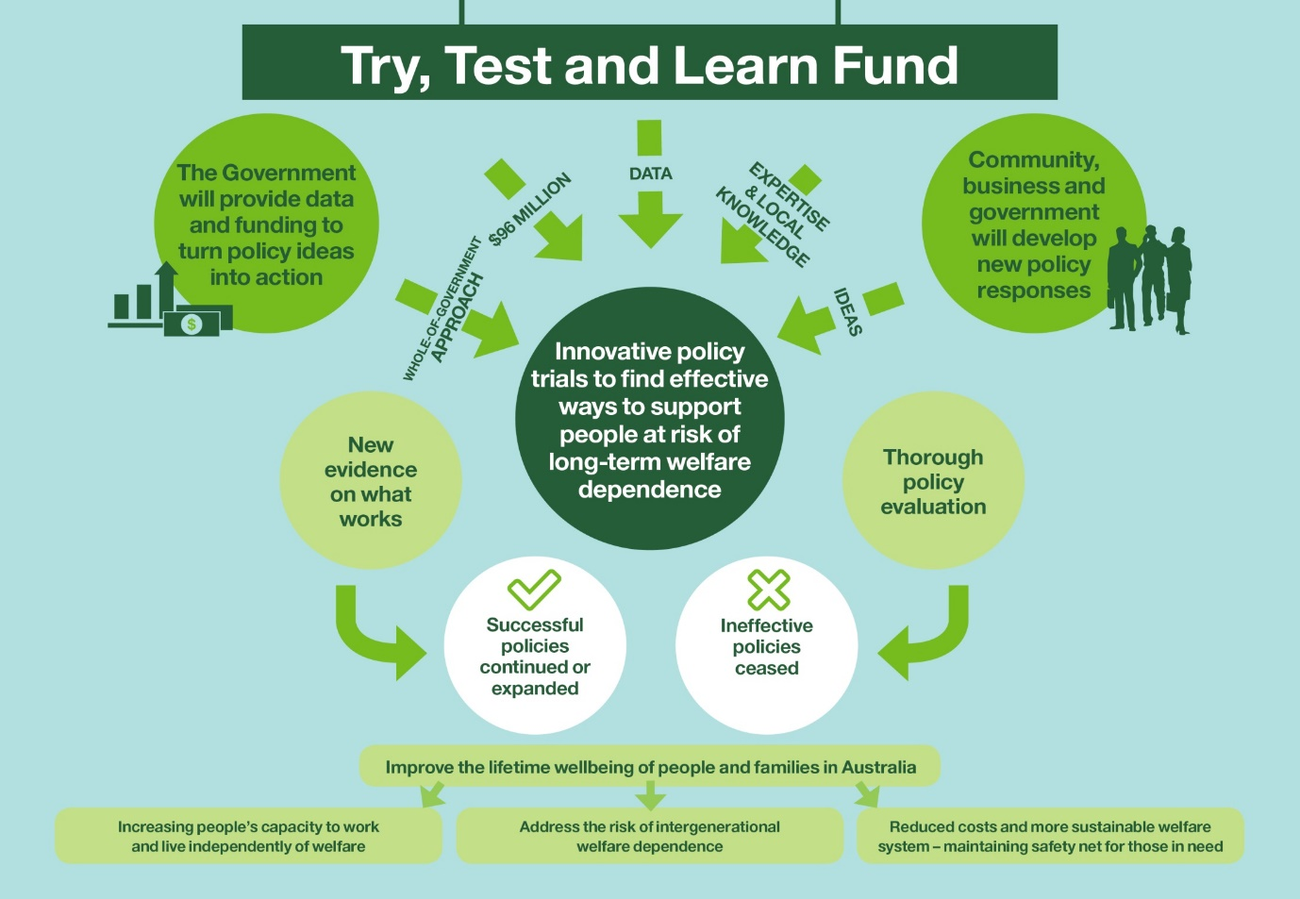
Key points
- The Try, Test and Learn Fund is a $96 million commitment that aims to trial new and innovative approaches to address long-term welfare dependence.
- The overarching aim is to improve lifetime wellbeing with the following three goals:
  - Increase people’s capacity to live independently of welfare through employment
  - Reduce the risk of intergenerational welfare dependence; and
  - Reduce long-term social security costs.
- The fund supports collaboration, uses data-driven approaches, is supportive of new ideas and innovation, is outcomes focused, and is flexible.
Additional info
- Policy responses may include applying insights from behavioural economics, technology responses such as smart phone applications, or new approaches to service delivery.
- The Government will track the impact of these policy responses using a range of evaluation methods.

Slide 3 – Tranche 1
- Tranche 1 focused on three priority groups: young carers, young parents and students at risk of moving to long-term unemployment, or unemployed former students.
- These groups are among a number that were identified from Priority Investment Approach data as groups of interest who have relatively high lifetime costs and where there is, potential to reduce these costs and improve lifetime outcomes.
- The first tranche of TTL was open for ideas from 9 December 2016 to 24 February 2017.
- We received nearly 400 submissions from individuals and organisations across Australia.
- We took some of the most promising and refined these ideas through co-development with idea proponents, members of the priority groups, and other experts.

Slide 4 – Progress of tranche 1
- The Minister for Social Services approved around $23 million for 14 projects from tranche 1. Projects are currently being rolled out across Australia.
- The projects take varied approaches to helping members of the priority groups transition into work (I’ll provide some examples shortly).
- Projects have been selected, in part, based on the kind of evidence they will produce. They will be robustly evaluated to produce high-quality policy evidence about the effectiveness of interventions, for whom, and under what circumstances.
- The fund will allow us to identify projects that work, and use the evidence we have gathered to transform our investment in existing programs or make the case for new investments.
Additional info
- Fact sheets on the individual projects are on the DSS website.

Slide 5 – Tranche 1 project overview
- Tranche 1 projects have a split of 4 young parent projects, 3 young carer projects and 7 student and unemployed former student projects.
- Parents projects:
  - Supporting expecting and parenting teens
  - Career readiness for young parents
  - In-school parenting employment services
  - Train and Care
- Carer projects:
  - Data-driven job opportunities
  - Skills for micro-enterprise
  - Carer Achievement Pathway
- Student or former student projects:
  - Rewire the Brain
  - Strengthening Students’ Resilience
  - Support for VET students
  - Mentoring 2 Work
  - Y4Y Youthforce
  - My Maintenance Crew
  - Build & Grow
- Participant numbers range from 60 – 10,000 but most have about 100-500 participants
- Fund amounts have ranged from $500,000 to $4 million but they are predominantly funded at around $1 million
- Trial periods will range from 15 months – 2.5 years but the majority of projects will go for around 2 years
Project examples
- Young parents: The Supporting Expecting and Parenting Teens project involves mentors working with young parents helping them set goals and navigate existing services and address barriers.
- Young unemployed people: One project in Geelong is establishing a social enterprise and will train unemployed young people to work in the enterprise.
- Young students: Rewire the Brain will use face-to-face and computer-based training to improve cognitive functioning and social and emotional skills of a group of students.
- Young carers: The data-driven job opportunities program will use data analytics and augmented intelligence to match guaranteed job opportunities and training with young carers.

Slide 6 – Tranche 2 – priority groups
- Four new priority groups for tranche 2:
  - Older unemployed people
  - Working age migrants and refugees
  - Working age carers
  - At-risk young people
  - Plus any other group including tranche 1 priority groups
    - Young parents
    - Young carers
    - Young students
- We would expect that many of the applications will be in relation to a sub-group of one of the groups.

Slide 7 – Older Newstart Allowance recipients
- This group is made up of older Australians who receive Newstart Allowance.
- As of 30 June 2017, there were around 251,400 people aged 50 or over receiving Newstart Allowance.
- The pie chart shows that nearly 80 per cent of this group have been on income support for 12 months or more.
- The bar charts show that the gender split is fairly even (53 per cent female, 47 male) and the split across the age range is also fairly even (32 per cent aged 50-54, 32 per cent aged 55-59 and 35 per cent aged 60-64).
- People in this group may have experienced redundancy from long term employment or may have moved from another income support payment such as Parenting Payment for example.
- People in this group may experience age discrimination and around 32 per cent have been assessed as having a partial capacity to work.

Slide 8 – Working age migrants and refugees
- The migrant and refugee group looks at migrants and refugees aged 16 to 64 who are receiving income support. Income support for this group includes Newstart Allowance, Parenting Payment Partnered, Parenting Payment Single, Partner Allowance, Sickness Allowance, Special Benefit, Widow Allowance, or Youth Allowance (Other).
- 299,400 migrants and refugees of working age or on income support.
- There are nearly 300,000 of this group, of which 65 per cent are female.
- Interestingly, most migrants and refugees (85 per cent) live in major cities.
- While a large proportion of migrants and refugees successfully gain employment within the first few years of arrival, a small group continue to struggle due to barriers such as lack of skills recognition, language barriers and discrimination.

Slide 9 – Working age carers
- This priority group is made up of people aged 16 to 64 who are in receipt of Carer Payment.
- There are 221,700 working age carers receiving Carer Payment.
- As of 30 June 2017, there were around 221,700 working age carers
- A pie chart shows that a large proportion are female (around 7 in 10 or 71 per cent).
- A bar chart shows that a large portion of this group are aged between 46 and 64 (60 per cent).
- Working age carers have a relatively low labour force participation rate, compared to non-carers with 56 percent participating in the labour force compared to 80 per cent for non-carers

Slide 10 – At-risk young people on income support
- This is a broad group and while not really defined by income support payments, to give some idea of the scope:
- At 30 June 2017 there were around 109,000 young people aged 16 to 21 receiving Youth Allowance (other) or Disability Support Pension (with mental health as the primary condition).
- Of the group 54 per cent are male, 16 per cent are Indigenous and 7 per cent are on DSP with mental health issues
Important note on this group
- Of course, not all of this group fit into the ‘at-risk’ definition – but within the group there will be young people with specific needs and barriers to employment
  - Some will have not completed their education
  - Some will have experienced severe family breakdown or family instability
  - Some may be homeless
  - Some will have been in the juvenile justice system
  - Some will have been in out-of-home care
  - Some will have drug and alcohol issues or have lived in families where these things exist.

Slide 11 – Tranche 2 process
- Tranche 2 is more closely aligned to a traditional open competitive grant process than tranche 1 was. Organisations can apply for grant funding, proposing their innovative approach to assist identified groups at risk of long-term welfare dependence.
- To submit a grant application, you need to visit the Department’s Community Grants Hub or the Australian Government’s GrantConnect websites.
- Here you will also find the Grant Opportunity Guidelines, which I strongly encourage you to read. You will also find additional material including:
  - questions and answers, including a transcript of any Q&A from these information sessions
  - a copy of the DSS Comprehensive Grant Agreement Terms and Conditions
  - sample application forms
  - a project plan template
  - In addition, other information.
- The Community Grants Hub will initially assess submissions.
- Policy experts from across government will be consulted on promising applications, and recommendations made to an Inter-Departmental Committee.
- The Minister, in consultation with the Prime Minister, Treasurer and Minister for Finance, will decide which projects receive funding.
- Successful applicants will receive funding for both co-development and subsequent delivery of their project.
- While we expect co-development will involve collaboration, we also encourage stakeholders to collaborate prior to submitting proposals. And indeed, to submit joint proposals if partnerships are formed.
- To this end, the Department is compiling a directory of interested tranche 2 stakeholders to facilitate discussion and potential partnerships between applicants.
- This directory will be published on the Community Grants or Grant Connect websites to ensure that it is available to all prospective applicants. The register will comprise the names and email addresses of individuals, or a contact from an organisation. It is up to these individuals to contact each other regarding potential collaboration.
- If you are interested in being on that register, please contact the Try, Test and Learn Fund team via email.

Slide 12 – Timing of tranche 2
- While tranche 2 is open continuously until 28 September 2018, applications will be assessed in five batches.
- Each batch will contain applications that have been submitted for the grant opportunity over the preceding two months. The batches will occur at 31 January, 30 March, 31 May, 31 July, and 28 September 2018.
- Applications for each batch may be considered at later stages.
- Applications will be assessed on the extent to which the project is likely to:
  - gather policy evidence on what works to support people at risk of long-term welfare dependence to improve their workforce participation or capacity to work
  - improve capacity to work (e.g. through training or skills development) and / or workforce participation for people involved in the trials
  - build capacity and collaboration between government and other stakeholders.
- Projects financed through this program will be evaluated against outcomes specific to each project. For example, these outcomes may include:
  - improved job readiness;
  - increased access to training and retention in training or course completion;
  - increased pursuit of employment where appropriate to circumstances; or
  - increased employment including hours worked and duration of employment.
- There will be around $50 million available for tranche 2 projects, and we expect the approximate budget range for grants to be between $500,000 and $5 million.

Slide 13 – Who can apply?
- These types of organisations or individuals can apply for tranche 2:
  - Company
  - Indigenous corporation
  - Incorporated association
  - Co-operative
  - Incorporated trustee on behalf of a trust
  - Local government
  - Partnership
  - Sole trader
  - Statutory entity
  - Person
- State and territory governments are not eligible to apply for this grant opportunity as solo or lead applicants.
- DSS is keen to have state and territory governments involved in TTL in partnership with non-government organisations.
- Non-government organisations may apply as the lead members of consortia that may include state and territory governments.

Slide 14 – More information and how to apply
- Over the next few months, we are visiting capital cities and regional areas across Australia delivering information sessions to state governments and other interested stakeholders.
- If you are aware of stakeholders who could be interested in applying for a grant, and working with you to apply for a grant, and who miss out on coming to the information sessions, we are also posting all of the transcripts, including the questions and answers, on the community grants hub website.
- More information on the priority groups and how to apply can be found on the Community Grants Hub website.
- We also have a newsletter that we send out via a mailing list – and we encourage anyone interested in keeping up to date with the TTL Fund to subscribe to that newsletter.
- Details of how to subscribe can be found on the DSS website, or by emailing us at TTLFund@dss.gov.au.
- I strongly encourage you to have a look at the information available.

Slide 15 – Thank you/questions
- This slide closed the presentation and opened for questions. Questions and their answers are available on the Community Grants Hub website.

