Carer Gateway service areas
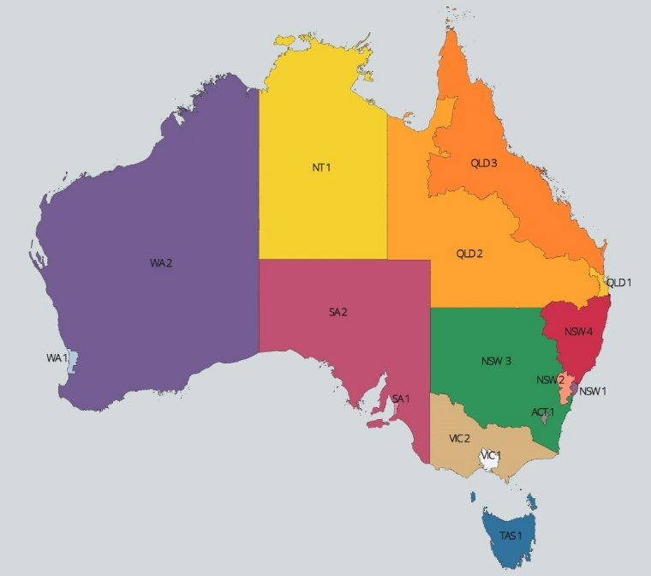
Service Area | Corresponding PHNs | Carer Population
ACT 1 | 31 - ACT | 44,700
NSW 1 | 1 – Central and Eastern Sydney  2 – Northern Sydney  3 – Western Sydney | 345,054
NSW 2 | 4 – Nepean Blue Mountains  5 – South Western Sydney | 175,074
NSW 3 | 6 – South Eastern NSW  7 – Western NSW  10 - Murrumbidgee | 167,783
NSW 4 | 8 – Hunter New England and Central Coast  9 – North Coast | 215,535
QLD 1 | 17 – Brisbane North  18 – Brisbane South  19 – Gold Coast | 253,254
QLD 2 | 20 – Darling Downs & West Moreton  21 – Western Queensland | 64,741
QLD 3 | 22 – Central Queensland, Wide Bay, Sunshine Coast  23 – Northern Queensland | 163,130
VIC 1 | 11 – North Western Melbourne  12 – Eastern Melbourne  13 – South Eastern Melbourne | 526,051
VIC 2 | 14 – Gippsland  15 - Murray  16 – Western Victoria | 216,939
SA 1 | 24 - Adelaide | 177,676
SA 2 | 25 – Country SA | 66,116
WA 1 | 26 – Perth North  27 – Perth South | 149,032
WA 2 | 28 - Country WA | 54,570
TAS 1 | 29 - TAS | 85,508
NT 1 | 30 - NT | 11,520
Total |  | 2,716,683

