Rural Financial Counselling Service Program in New South Wales
This fact sheet provides background information on the Rural Financial Counselling Service (RFCS) Program in New South Wales (NSW) for organisations interested in submitting an application for the 2021 to 2024 grant round on the Community Grants Hub.

About the RFCS Program
The RFCS Program is an Australian Government initiative that provides free and independent financial counselling to eligible farmers, fishers, foresters and small related enterprises who are experiencing, or at risk of, financial hardship.
The RFCS Program has been in operation since 1986. The vision for the 2021 to 2024 RFCS Program is to improve financial wellbeing and resilience at the farm level to build a more sustainable and profitable primary production sector.

NSW RFCS Program regions
There are 12 predefined RFCS regions across Australia. NSW has three regions—Northern, Central and Southern, as shown in the map below. A more detailed map of the NSW RFCS regions and associated Local Government Areas can be found here.
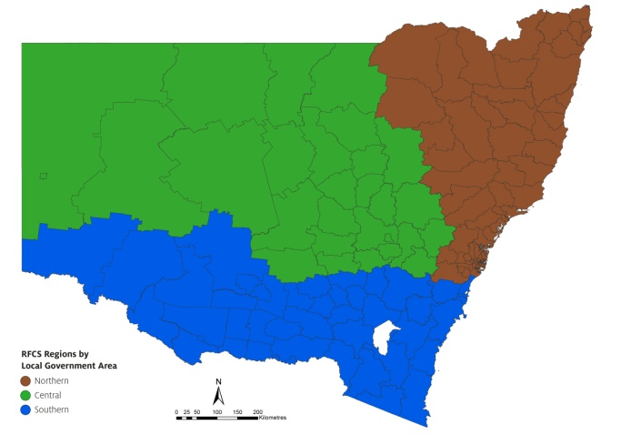

Farm businesses in NSW
The number of farm businesses and land area for each NSW RFCS service region is listed in the table below.
Service region | Kilometres of land area | Number of farm businesses*
Northern | 176,556 km² | 15,987
Central | 409,749 km² | 8,166
Southern | 214,506 km² | 11,037
* Businesses with an annual turnover of more than $50,000. Source: ABS 8165.0 (2019) and ABS.STAT (Dataset: Regional Statistics by LGA 2019, 2011-2019).
Note: NSW Northern will also service Norfolk Island and NSW Southern will service the Australian Capital Territory (ACT).
The main types of primary production businesses in NSW are:
- beef cattle farming (7,320 businesses)
- grain-sheep or grain-beef cattle farming (5,787 businesses)
- sheep-beef cattle farming (4,409 businesses)
- sheep farming (2,707 businesses)
- other grain growing (2,447 businesses)
- dairy cattle farming (1,083 businesses)
- vegetable growing (815 businesses)
- fishing (785 businesses)
- fruit and tree nut growing (739 businesses).

