Rural Financial Counselling Service Program in Queensland
This fact sheet provides background information on the Rural Financial Counselling Service (RFCS) Program in Queensland (QLD) for organisations interested in submitting an application for the 2021 to 2024 grant round on the Community Grants Hub.

About the RFCS Program
The RFCS Program is an Australian Government initiative that provides free and independent financial counselling to eligible farmers, fishers, foresters and small related enterprises who are experiencing, or at risk of, financial hardship.
The RFCS Program has been in operation since 1986. The vision for the 2021 to 2024 RFCS Program is to improve financial wellbeing and resilience at the farm level to build a more sustainable and profitable primary production sector.

QLD RFCS Program regions
There are 12 predefined RFCS regions across Australia. QLD has two RFCS regions—Northern and Southern, as shown in the map below. A more detailed map of the QLD RFCS regions and associated Local Government Areas can be found here.
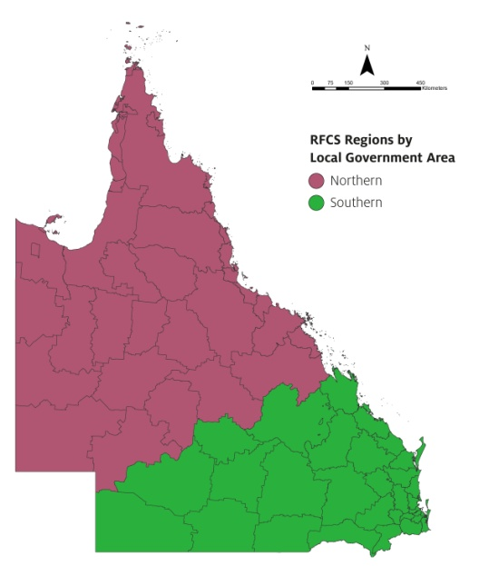

Farm businesses in QLD
The number of farm businesses and land area for each QLD RFCS service region is listed in the table below.
Service region | Kilometres of land area | Number of farm businesses*
Northern | 1,114,709 km² | 7,862
Southern | 627,221 km² | 18,840
*Businesses with an annual turnover of more than $50,000. Source: ABS 8165.0 (2019) and ABS.STAT (Dataset: Regional Statistics by LGA 2019, 2011-2019).
The main types of primary production businesses in QLD are:
- beef cattle farming (9,813 businesses)
- grain-sheep or grain-beef cattle farming (3,329 businesses)
- sheep-beef cattle farming (1,995 businesses)
- sheep farming (1,086 businesses)
- other grain growing (964 businesses)
- dairy cattle farming (949 businesses)
- vegetable growing (874 businesses)
- fishing (732 businesses)
- fruit and tree nut growing (526 businesses).

