Rural Financial Counselling Service Program in Victoria
This fact sheet provides background information on the Rural Financial Counselling Service (RFCS) Program in Victoria (VIC) for organisations interested in submitting an application for the 2021 to 2024 grant round on the Community Grants Hub.

About the RFCS Program
The RFCS Program is an Australian Government initiative that provides free and independent financial counselling to eligible farmers, fishers, foresters and small related enterprises who are experiencing, or at risk of, financial hardship.
The RFCS Program has been in operation since 1986. The vision for the 2021 to 2024 RFCS Program is to improve financial wellbeing and resilience at the farm level to build a more sustainable and profitable primary production sector.

VIC RFCS Program regions
There are 12 predefined RFCS regions across Australia. VIC has four RFCS regions—North West, Western, North East, and Eastern; as shown in the map below. A more detailed map of the VIC RFCS regions and associated Local Government Areas can be found here.
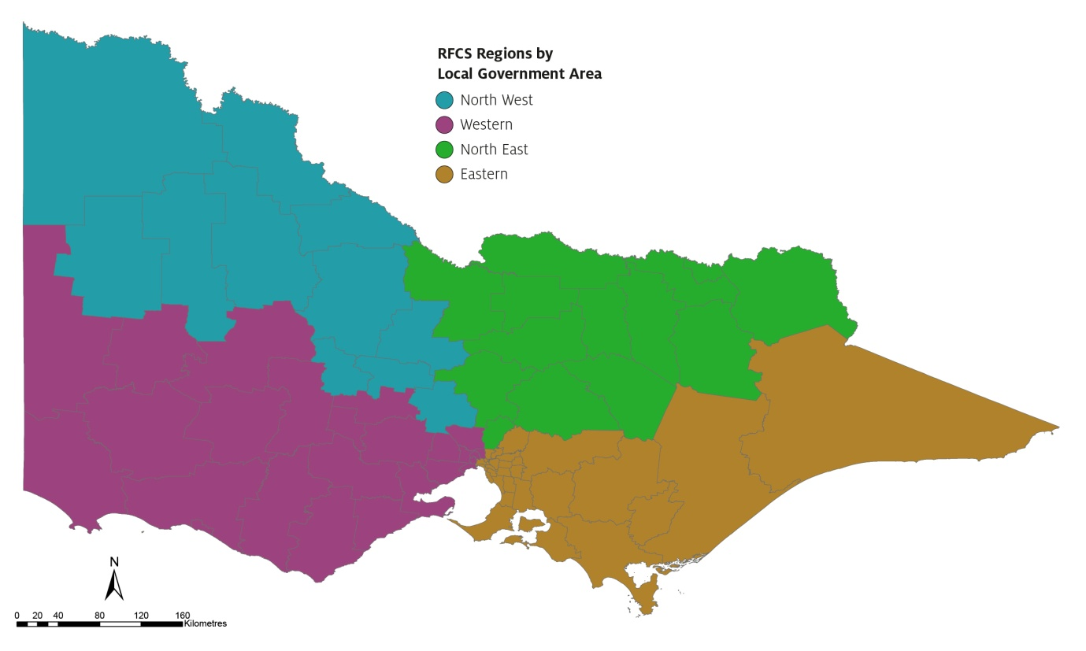

Farm businesses in VIC
The number of farm businesses and land area for each VIC RFCS service region is listed in the table below.
Service region | Kilometres of land area | Number of farm businesses*
North West | 48,113 km² | 5,478
Western | 45,299 km² | 8,572
North East | 69,291 km² | 6,264
Eastern | 64,793 km² | 7,604
*Businesses with an annual turnover of more than $50,000. Source: ABS 8165.0 (2019) and ABS.STAT (Dataset: Regional Statistics by LGA 2019, 2011-2019).
The main types of primary production businesses in VIC are:
- dairy cattle farming (4,948 businesses)
- beef cattle farming (4,311 businesses)
- grain-sheep or grain-beef cattle farming (3,396 businesses)
- sheep-beef cattle farming (2,385 businesses)
- sheep farming (2,379 businesses)
- other grain growing (2,060 businesses)
- grape growing (1,169 businesses)
- vegetable growing (735 businesses)
- fishing (461 businesses).

