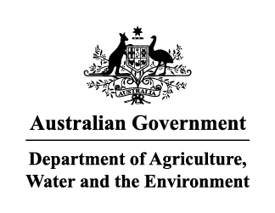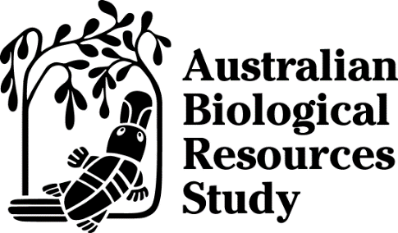

Australian Biological Resources Study
National Taxonomy Research Grant Program

Activity Work Plan
for Research Grants and Postdoctoral Fellowship Grants

The Australian Biological Resources Study (ABRS) National Taxonomy Research Grant Program (NTRGP) provides grants for taxonomic research. Grants are awarded for research projects where the primary aim is to undertake taxonomic research on the Australian biota or to develop products that aid in the dissemination of taxonomic information. The program also supports projects that build Australian taxonomic capacity.
The NTRGP is managed through the Community Grants Hub (CGH).

Important
For specific dates for submission of reports, please refer to your grant funding agreement or contact the CGH on [insert appropriate contact email address].
Activity Work Plans must be lodged with the CGH by email. All emailed reports must include a PDF of the signature page.
Do not delete any part of this form.
Please ensure you complete this form using Arial 11 point font.
Complete this form as per the funding agreement and application form. If you are unsure, you should contact the CGH.

Grant number
Please enter your grant number. If you are unsure of your grant number, please contact the CGH.

Project title
Please enter your project title as per your funding agreement.

Host institution details
Please enter the name of the host institution and the contact details of the relevant administration contact, that is, Grants Administrator, including name, title, phone number and email address.
Host institution
Full name (including salutation)
Title
Phone
Email

Principal Investigator details
Please enter the details of the Principal Investigator on the project. If these details have not changed, please enter only the name of the Principal Investigator.
Full name (including salutation)
Address
Phone
Email

Commencement date
Has this project commenced? Yes No
If no, please state reasons:

Project aims
Please enter the aims of the activity. The project aims can be found in your application form.

Work plan and outputs
Using the Work Plan section of your application form, please provide a year by year outline of the intended plan of work. Include information on how each output listed in your application will be achieved by the different aspects of the plan.

Please complete the certification on the following page.

Certification

Principal Investigator
I, the Principal Investigator, certify to the best of my knowledge that all the details in this Activity Work Plan are true and complete at the time of submitting to the host institution.
Full Name:

Signature |  | Date:

Host institution
I, as the responsible officer representing the host institution, certify to the best of my knowledge that all the details in this Activity Work Plan are true and complete at the time of submitting to the CGH.
Full Name:
Title/Designation:

Signature |  | Date:
Please note that electronic signatures may be included but that the Certification page must be provided to the CGH as a PDF, either as part of the full report or as a separate attachment.
Completed reports should be returned to the CGH at:
[insert contact details for CGH]

