Viewing Grant Information
  - Grant Recipient Portal Task Card
The Portal enables Grant Recipients to view grant details, including Grant Agreement documentation, Variation documentation and Grant Activities details. This includes details of the Funding Arrangement Manager, Bank Accounts and a Financial Overview. This task card will describe the process for reviewing Grant Agreements and Grant Activities details.

Viewing Grant Agreements
Step | Action
From the Home screen, select on the Grant Agreements tile. Alternatively, select Grants in the Navigation menu and select Grant Agreements from the drop down menu.
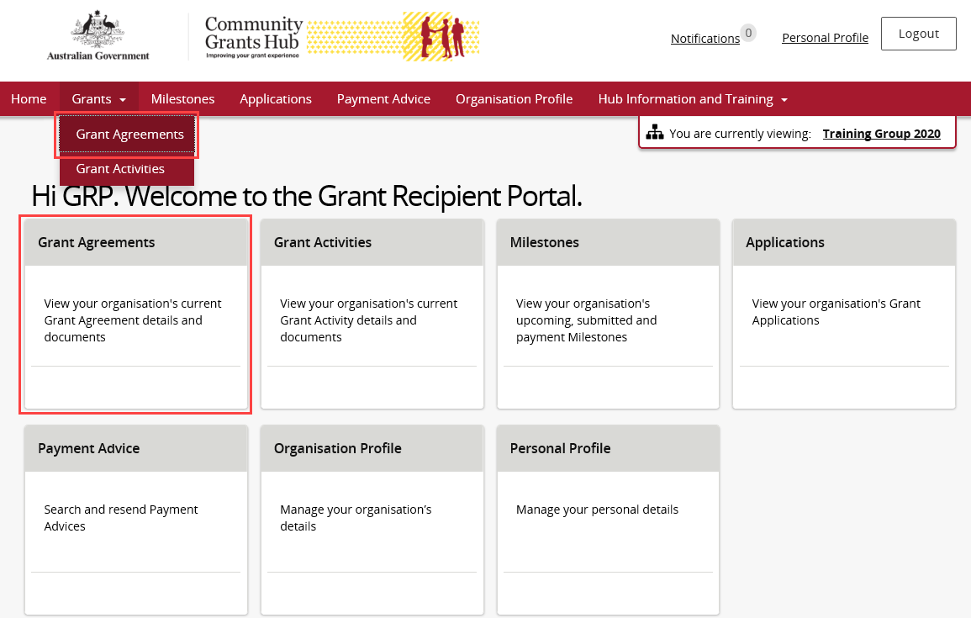
The Grant Agreements screen will display. To view a particular Grant Agreement, select on the Grant Agreement’s View button.
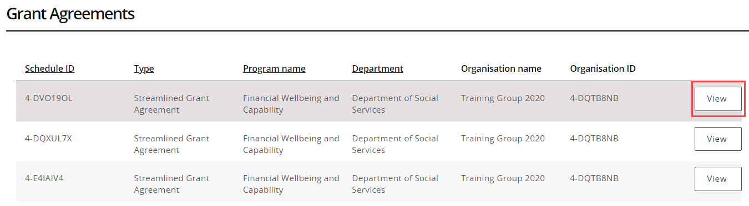

Viewing the Grant Agreement details
Step | Action
The Grant Agreement menu screen displays an Overview of the Agreement by default. The below information related to the Grant Agreement can viewed:
- Schedule ID | - Agreement Type
- Start date | - Completion date
- Program name | - Department
- Organisation name | - Organisation ID
A list of Grant Activities associated with the Grant Agreement are displayed below. To view the Activities linked to this Agreement select the View button.
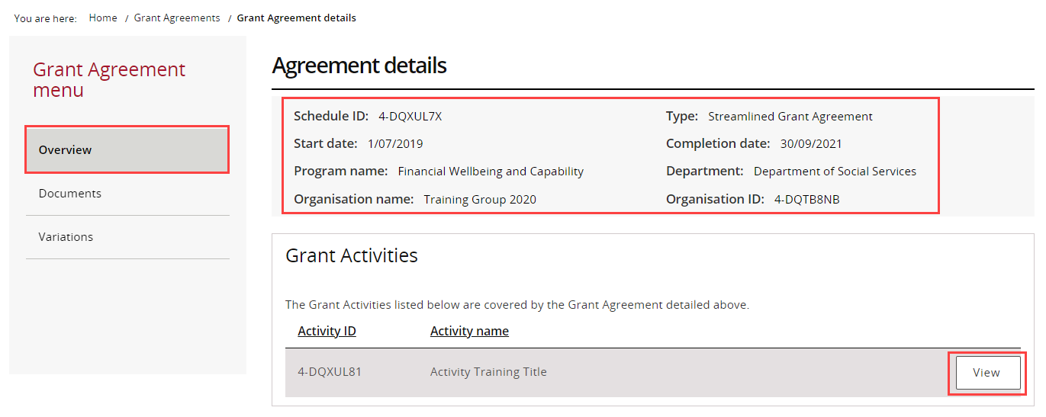
The Grant Agreement menu allows Grant Recipients to obtain a copy of their Grant Agreement Documents.
From the menu, select the Documents link. The Documents screen will display. To download the signed Executed Grant Agreement, select the View button.
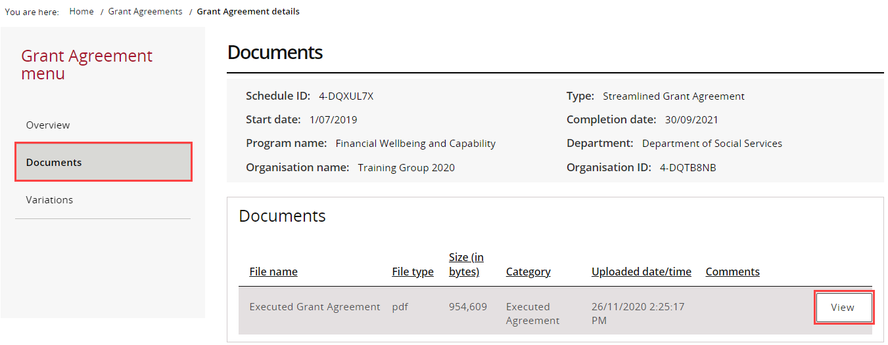
The File Download message will appear. Select Download to save a copy of the Executed Grant Agreement.
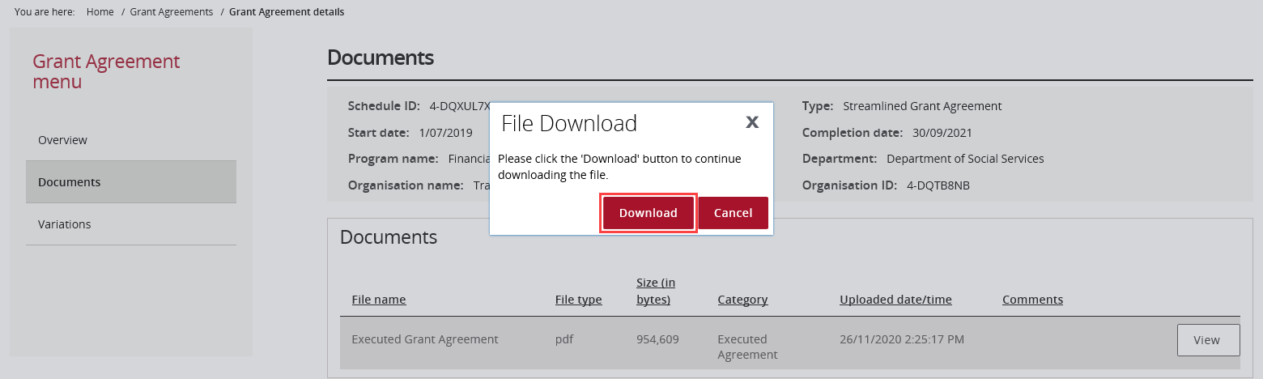
The Grant Agreement menu also allows Grant Recipients to view their Grant Agreement Variations if applicable.
From the menu, select the Variations link. The Variations screen will display. To download the signed Executed Variation, select the View button.
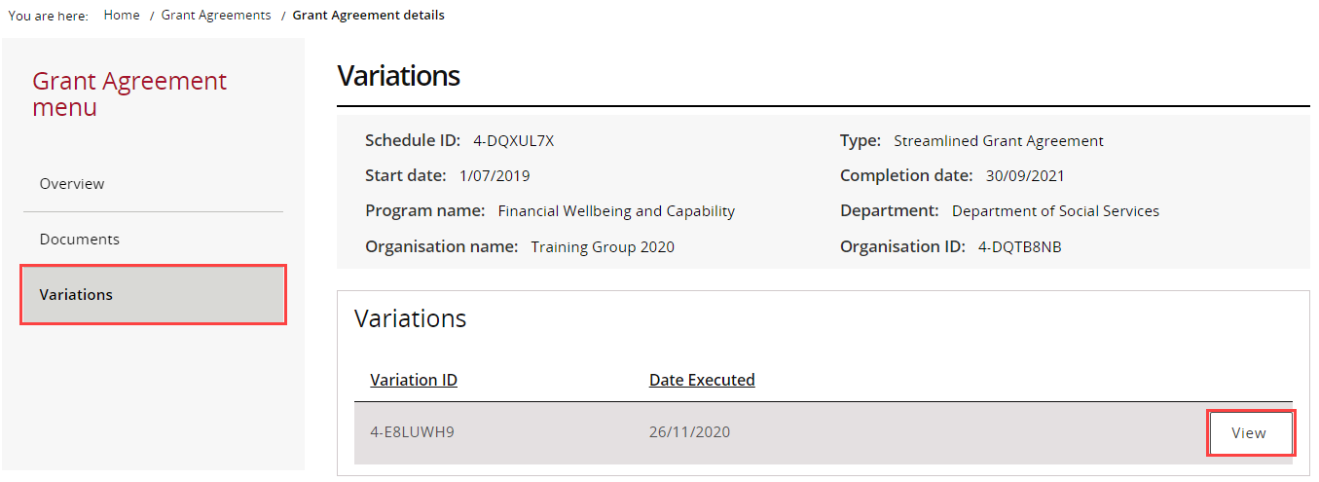
A popup window will appear showing the variation document, select View.
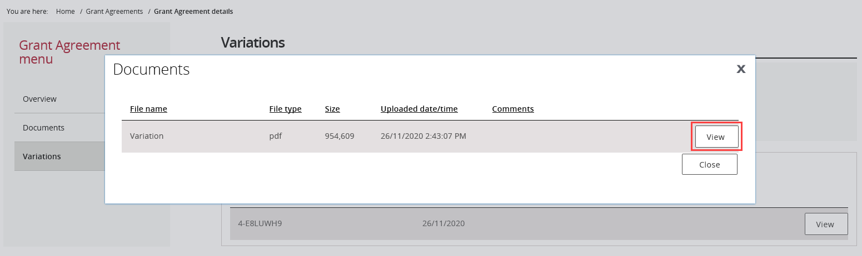
The File Download message will appear. Select Download to save a copy of the Executed Variation.
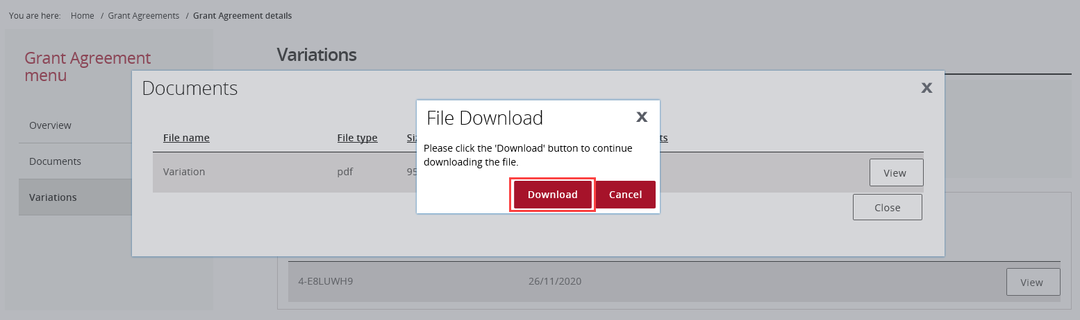

Navigating to Grant Activities
Step | Action
From the Home screen, select the Grant Activities tile. Alternatively, select Grants in the Navigation menu and select Grant Activities from the drop down menu.
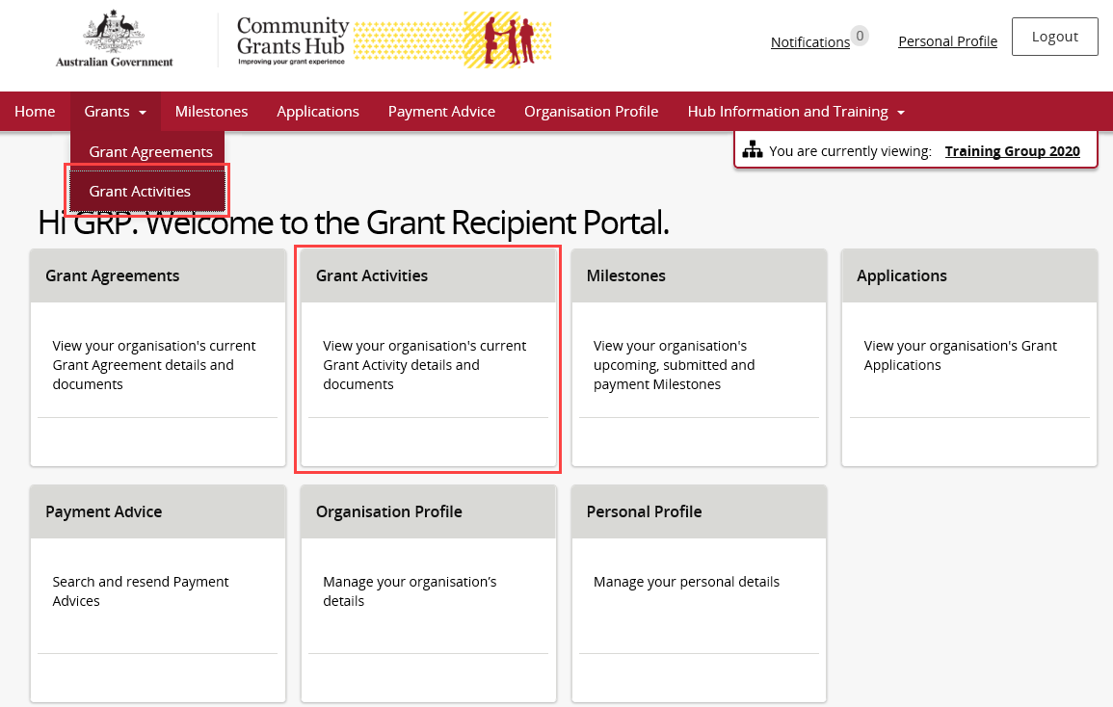
The Grant Activities screen will display. Select the expansion arrow next to an Activity ID to show additional information about the Activity.
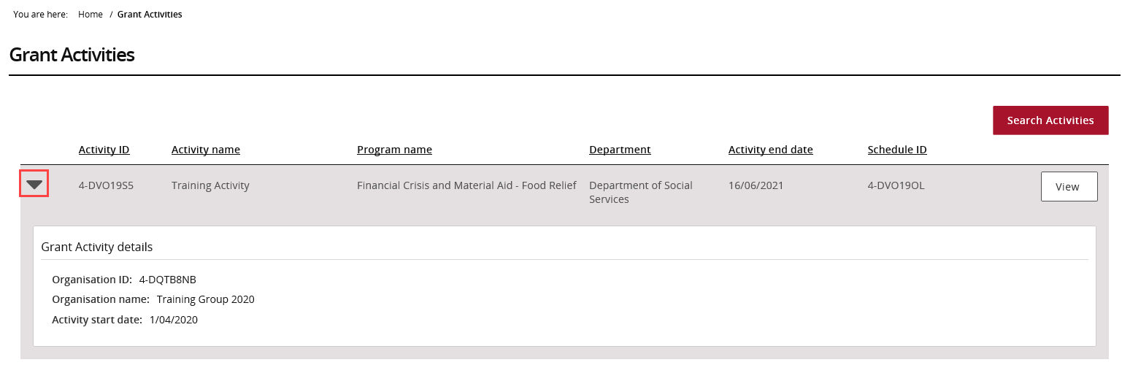
To view more details about an Activity, select View next to the Grant Activity record.
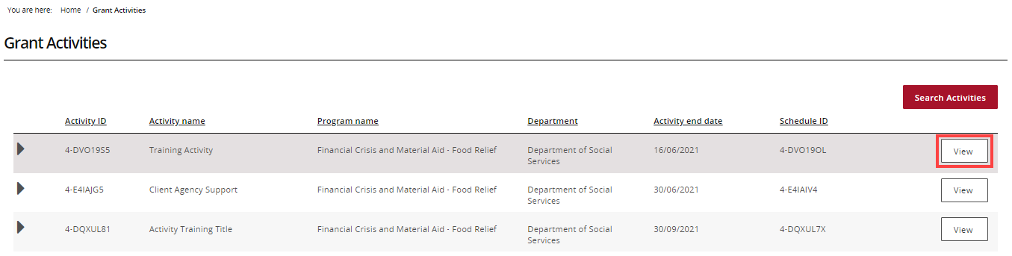
The Overview screen is the default view displaying the Activity details. To view additional information about the Activity, use the Grant Activity menu to view:
- Milestones | - Bank account details
- Finances | - Contacts
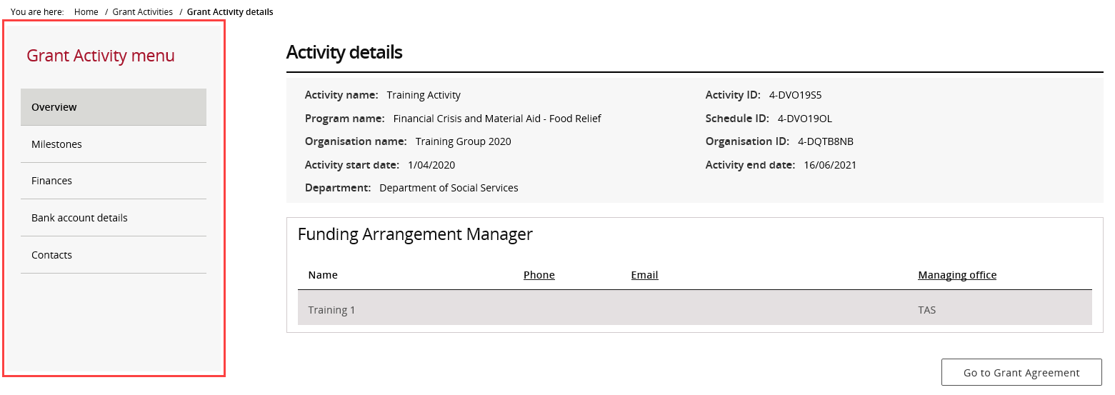
Select the View Grant Agreement button to view the Grant Agreement associated with this Activity.
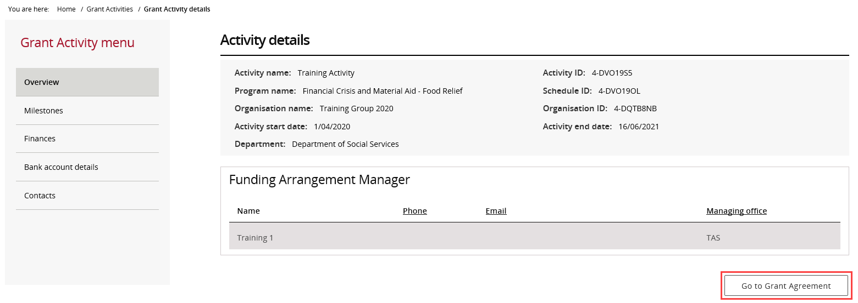
Need Help?
For further assistance, contact the Grant Recipient Portal Helpdesk:
Email: GRP.Helpdesk@communitygrants.gov.au
Phone: 1800 020 283 (Option 5)
Operating Hours: Monday to Friday 8:30am – 5:30pm (AEST/AEDT)

