View Applications
  - Grant Recipient Portal Task Card
The Portal enables Grant Recipients to view their organisation’s Grant Applications. This task card describes the process for viewing submitted Grant Applications.

Viewing Applications
Step | Action
From the Home screen select on the Applications tile or select the Applications link from the Navigation menu.
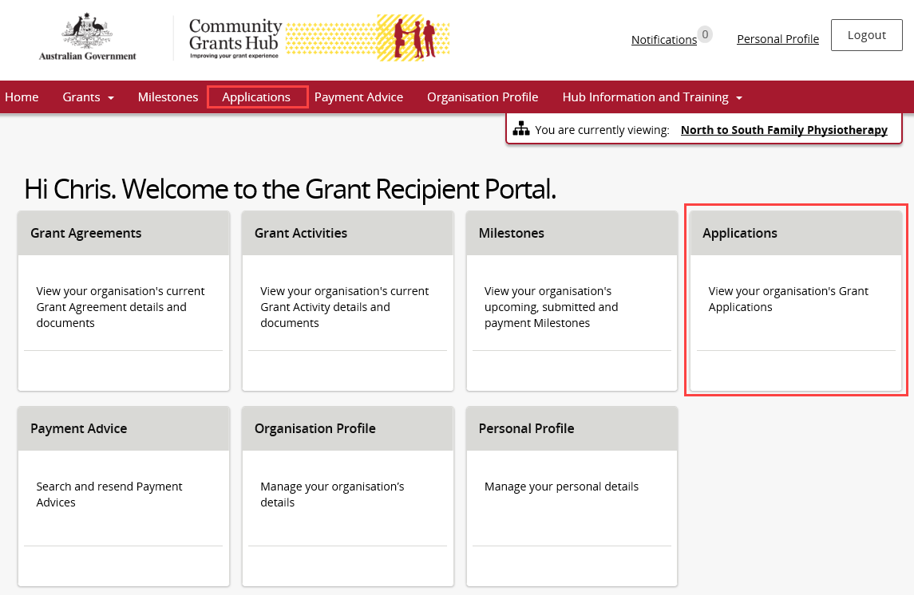
The Applications screen will display showing a list of submitted applications with the following information.
- Application ID | - Department
- Funding Round Name | - Funding Round Category

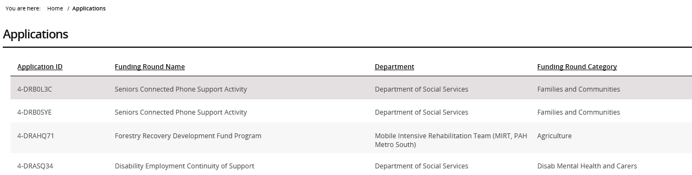
Need Help?
For further assistance, contact the Grant Recipient Portal Helpdesk:
Email: GRP.Helpdesk@communitygrants.gov.au
Phone: 1800 020 283 (Option 5)
Operating Hours: Monday to Friday 8:30am – 5:30pm (AEST/AEDT)

