Updating Your Personal Profile
  - Grant Recipient Portal Task Card
The Portal allows Grant Recipients who have access to multiple organisations with the same ABN to choose which organisation details to view. To access an organisation with a different ABN, Grant Recipients must have a separate account and access to the ABN in Relationship Authorisation Manager (RAM). This task card will describe the process for updating your Personal Profile and selecting which organisation details to view.

Updating your Personal Profile
Step | Action
From the Home screen, select on the Personal Profile tile or the Personal Profile link in the top right hand corner.
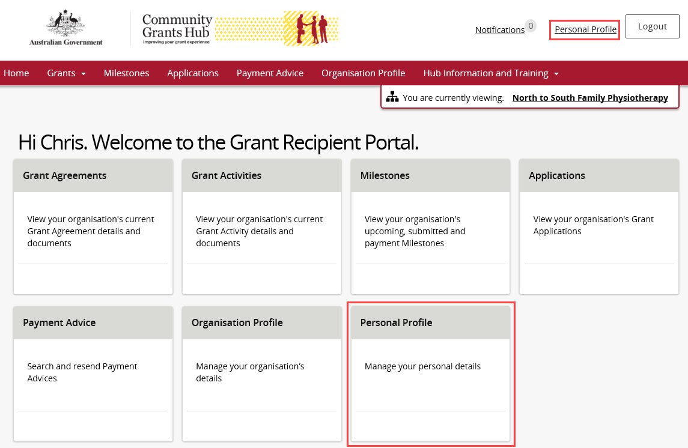
The Personal Profile screen will display. To update your personal details, select the Update Profile button.
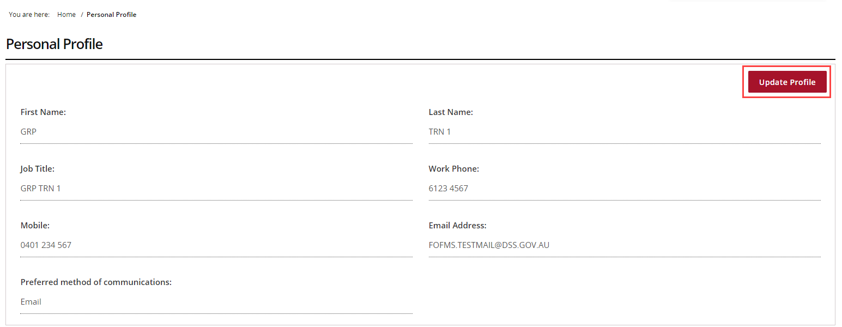
The Update Personal Profile page will display. All mandatory fields marked with an asterisk must be populated at all times.
- Job Title | - Mobile
- Work Phone | - Preferred method of communications

Once the changes have been made, select the Save button.
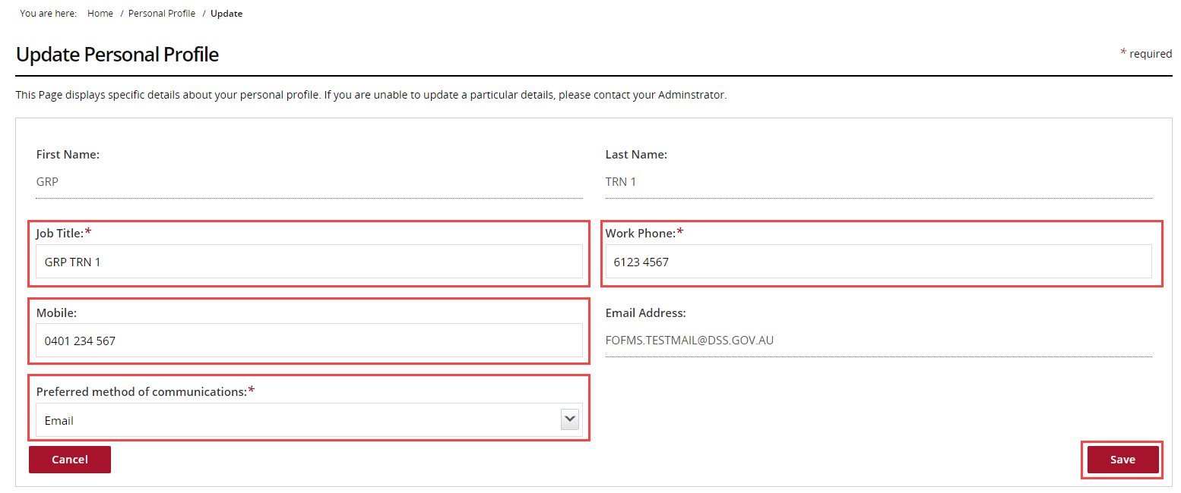

Updating your Organisation view
Step | Action
In the Personal Profile screen, if your profile have access to multiple Organisations they will be listed under Personal Profile, Organisation selection.
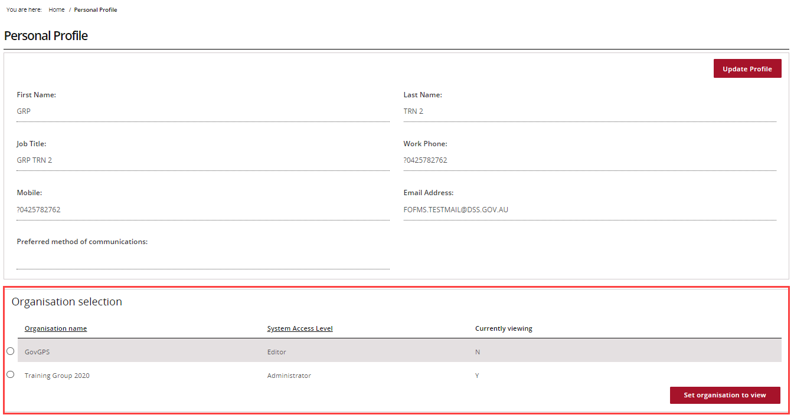
To change the Organisation, select the Organisation name and select the Set organisation to view button.
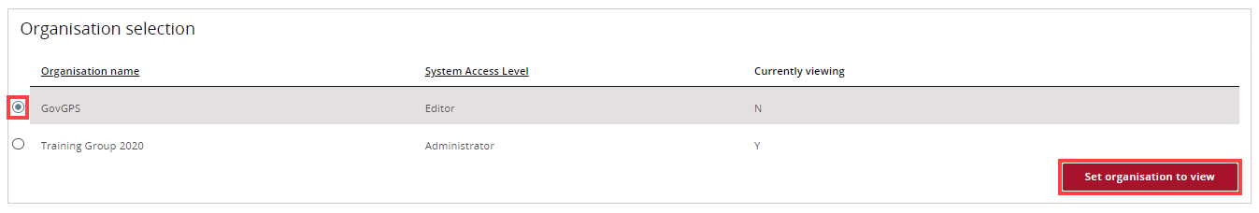
The Organisation Currently viewing in the portal will be marked as ‘Y’.
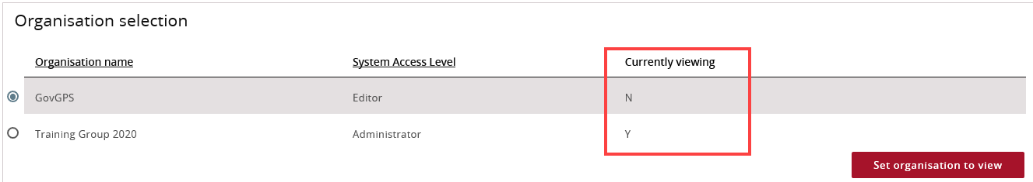
Need Help?
For further assistance, contact the Grant Recipient Portal Helpdesk:
Email: GRP.Helpdesk@communitygrants.gov.au
Phone: 1800 020 283 (Option 5)
Operating Hours: Monday to Friday 8:30am – 5:30pm (AEST/AEDT)

