Viewing Milestones
  - Grant Recipient Portal Task Card
The Portal enables Grant Recipients to view their Grant Agreement milestones. The milestones represent actions, deliverables or payments applicable to your Organisation, as detailed in the Grant Agreement. This task card will describe the process for reviewing Grant Agreement milestones.

Navigating to Milestones
Step | Action
From the Home screen, select on the Milestones tile or select the Milestones link in the navigation menu.
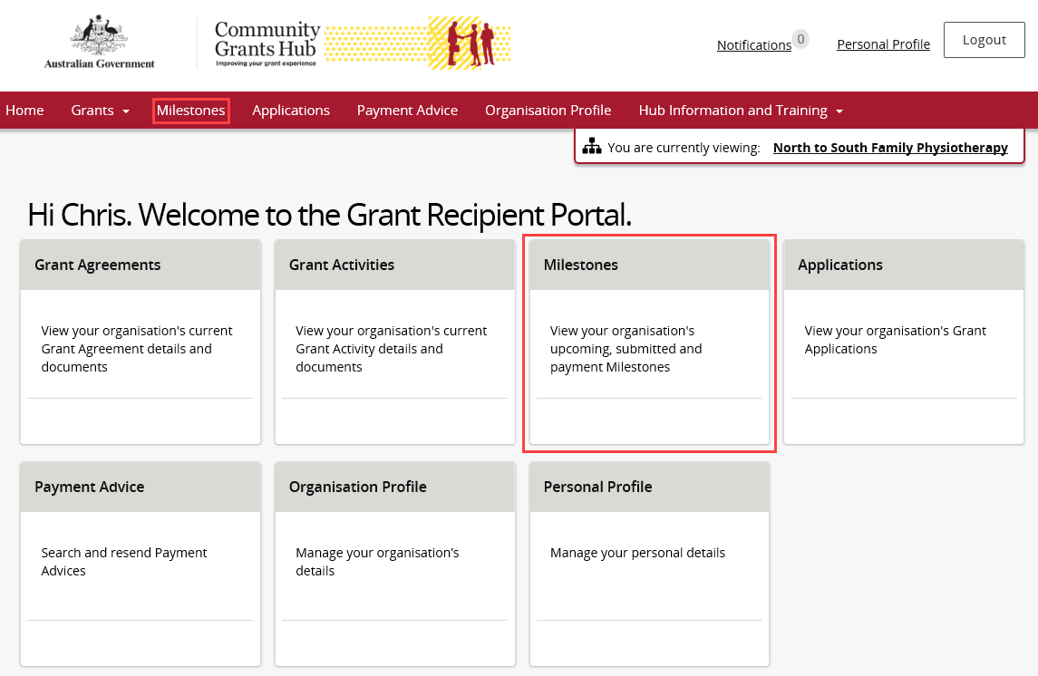
The Milestones screen will display showing upcoming milestones for the organisation by default.
The Milestones list can be filtered using the drop down choosing one of the following:
- Upcoming Milestones
- Submitted Milestones
- Payment Milestones
- All Milestones
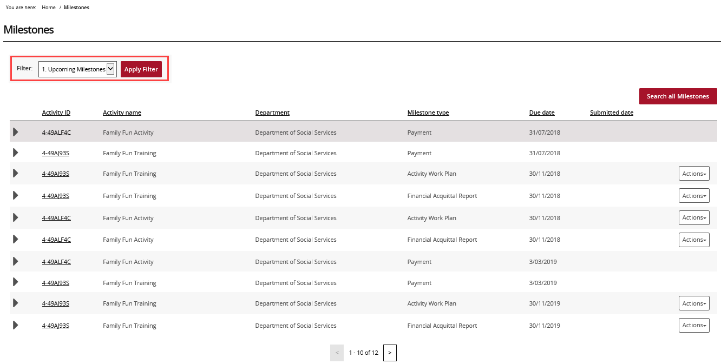
Choose the appropriate option from the drop down and select Apply Filter.
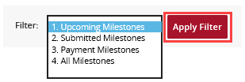
Once the filter has been applied, the applicable Milestones view will display. To view information about the Milestone, select the expand arrow next to the Activity ID.
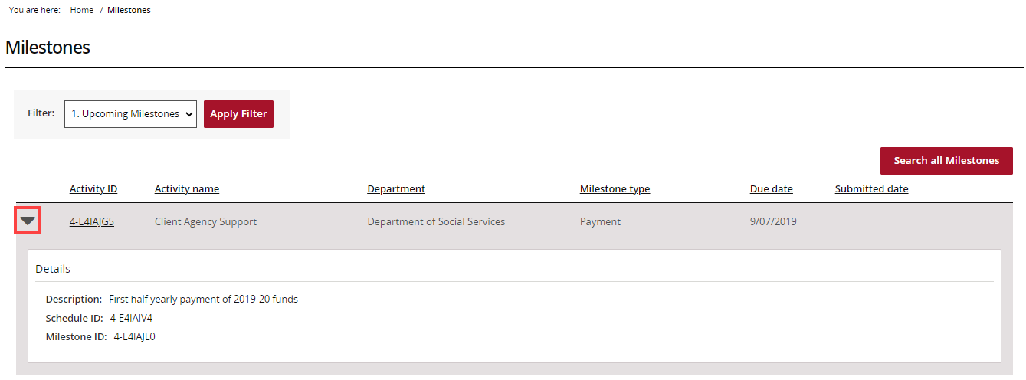
To navigate to the Activity details, select the Activity ID hyperlink.
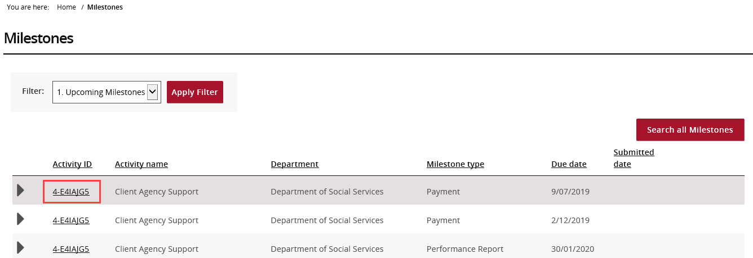

Searching for a Milestone
Step | Action
To locate a specific milestone select Search all Milestones.
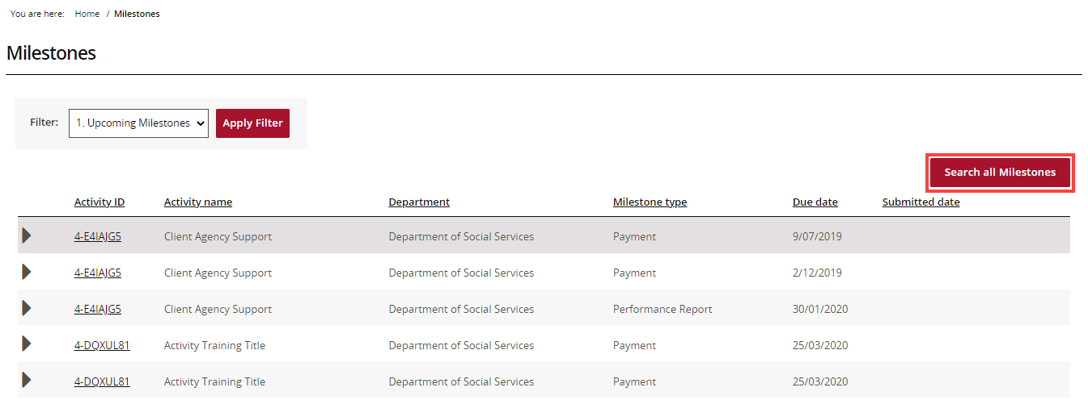
The Search all Milestones screen will display. Enter in at least one search criteria and select Run search.
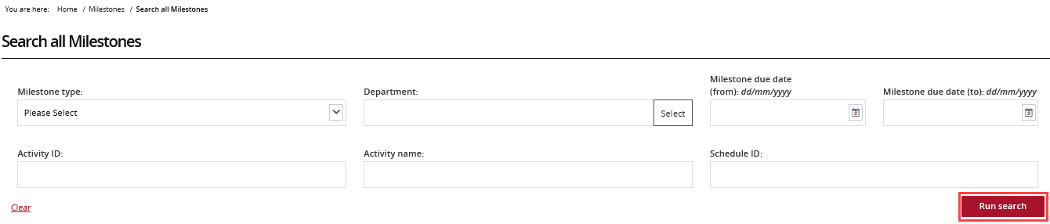
The results will display underneath the search fields. To export the results, choose the Format from the drop down followed by Export.
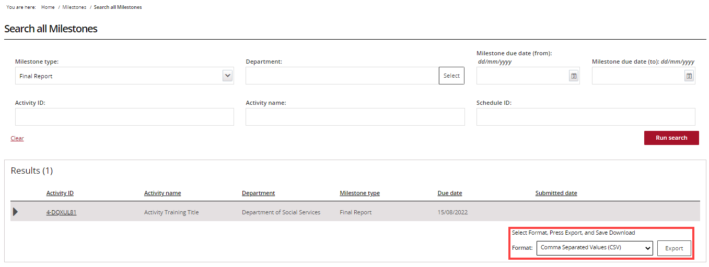
Need Help?
For further assistance, contact the Grant Recipient Portal Helpdesk:
Email: GRP.Helpdesk@communitygrants.gov.au
Phone: 1800 020 283 (Option 5)
Operating Hours: Monday to Friday 8:30am – 5:30pm (AEST/AEDT)

