  - Submitting a Financial Acquittal and Activity Work Plan
  - Grant Recipient Portal Task Card
The Portal enables Grant Recipients to submit some reporting milestones including Financial Acquittals and Activity Work plans online. Reporting milestones are displayed on both the Milestones and Grant Activities pages. This task card describes the process for submitting these reports.

Navigating to Milestones
Step | Action
From the Home screen select on the Milestones tile or select the Milestones in the top navigation menu.
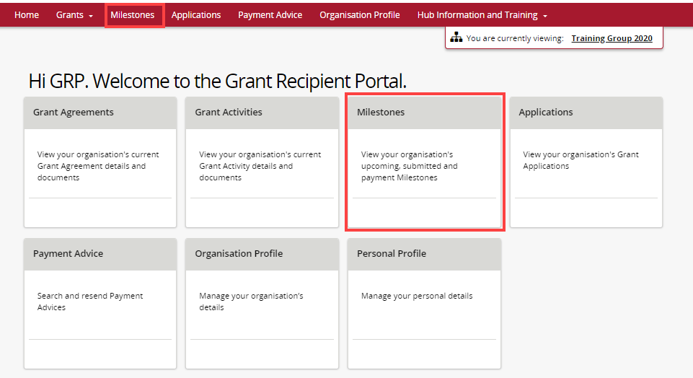
Select the dropdown and select Upcoming Milestones then select Apply Filter.
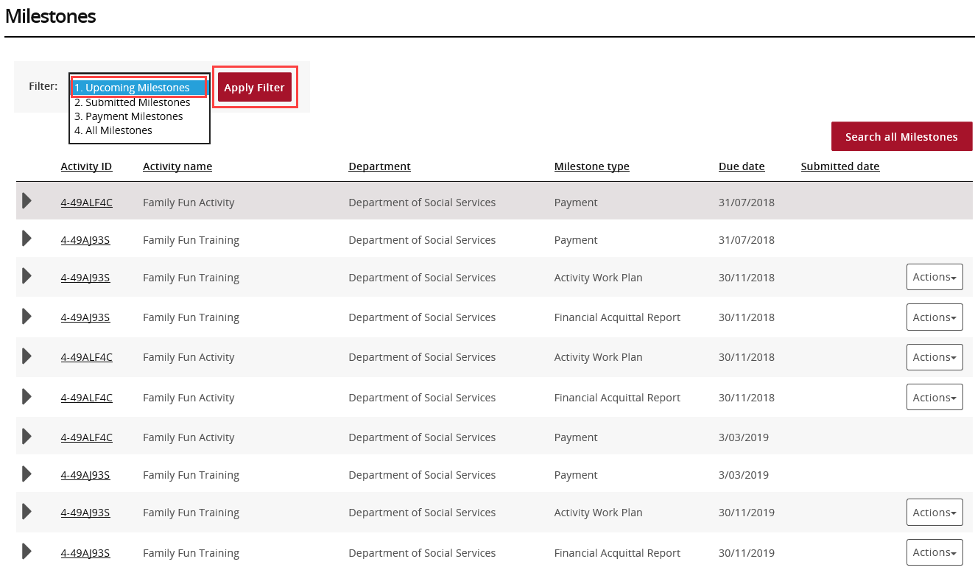
Select on the Actions button against the appropriate milestone and select Launch report to launch the form.
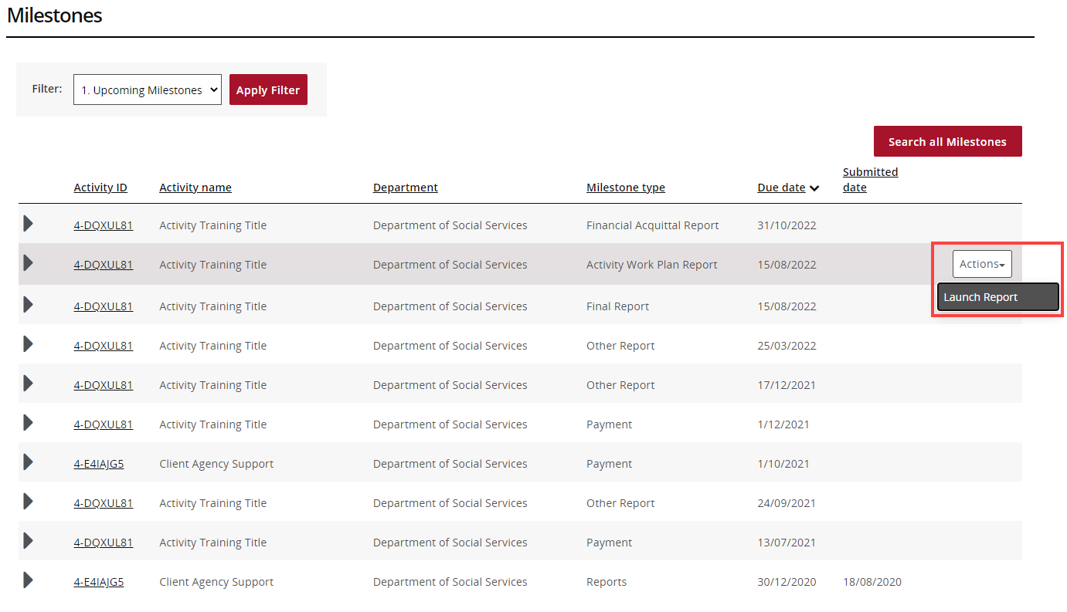

Navigate to Milestones from Grant Activities
Step | Action
From the Home screen, select the Grant Activities tile. Alternatively, select Grants in the Navigation menu and select Grant Activities from the drop down menu.
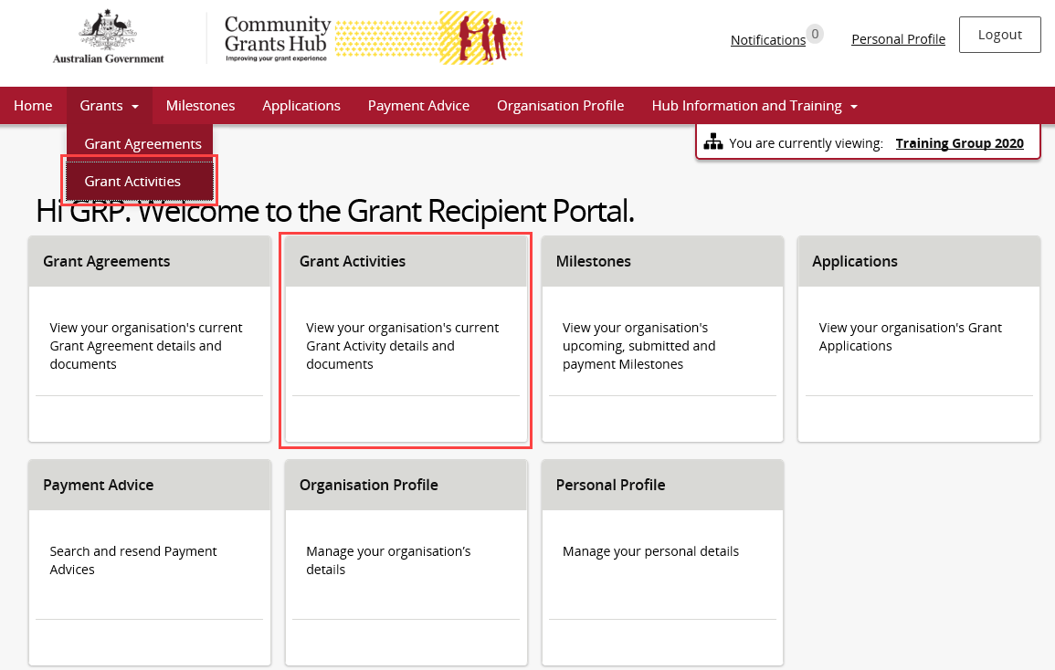
The Grant Activities screen will display. Select the View button to open the Activity details.
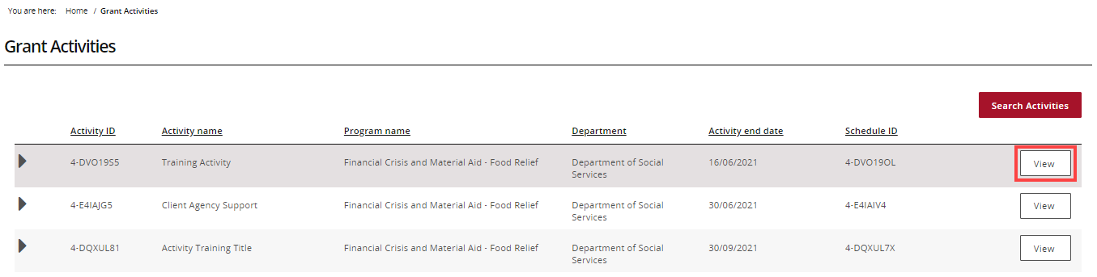
The Activity details screen will display. Select Milestones from the Grant Activity menu.
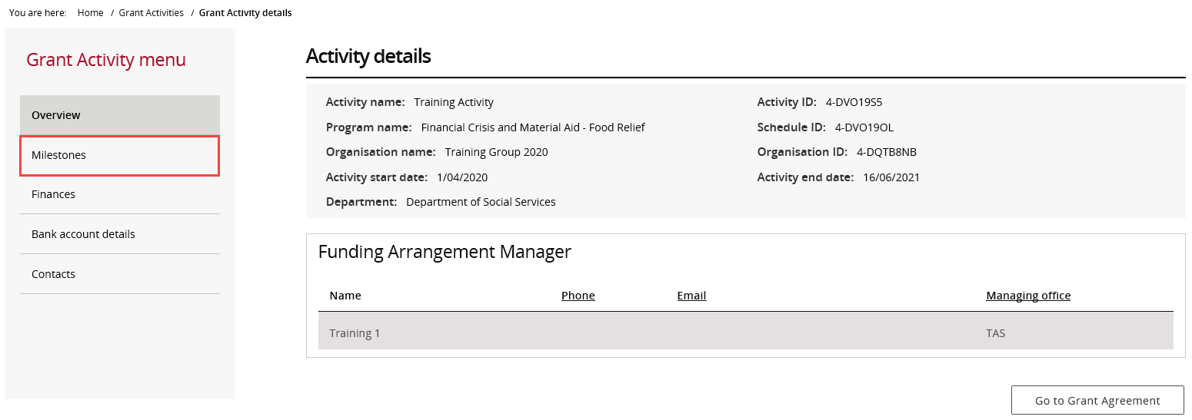
The Milestones screen will display. By default, Filter 1. Upcoming Milestones will be presented.
To change the filter, use the drop down and select Apply Filter or,
To locate a specific Milestone, perform a search by selecting Search all Milestones.
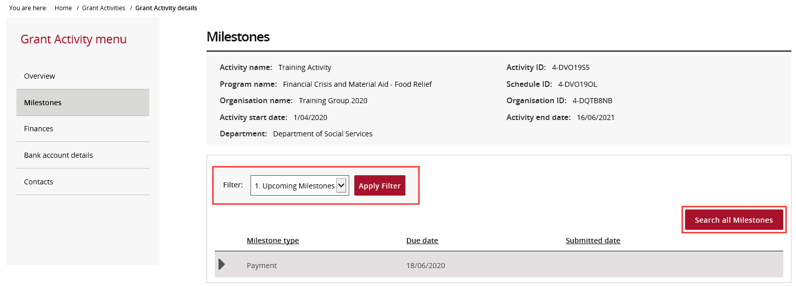
When the correct milestone has been identified, select Actions to submit the report.
To submit a Financial Acquittal, proceed to step 9. To submit an Activity Work Plan, proceed to step 21.

Submitting a Financial Acquittal
Step | Action
 | Select the Actions button to Launch Report.
The Financial Acquittal Report screen will display.
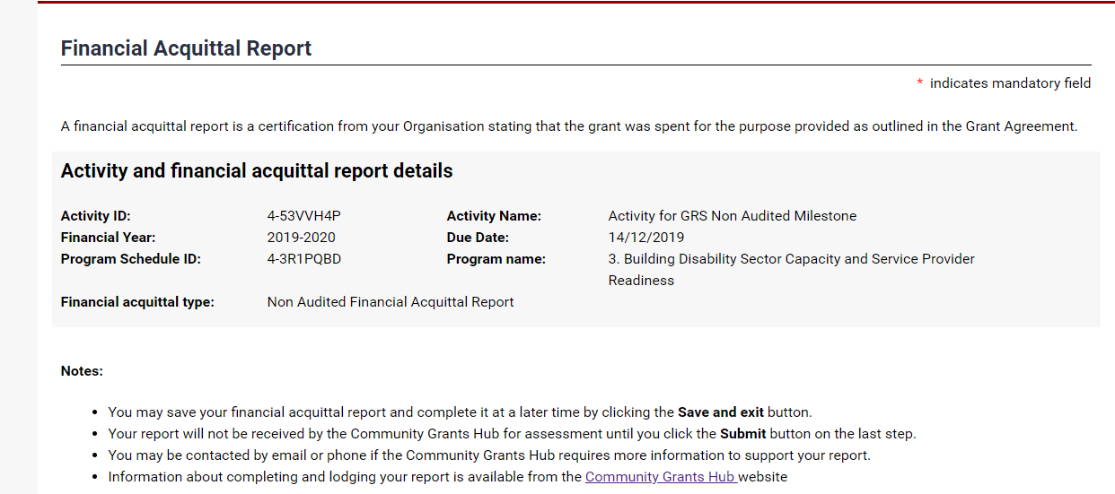
The Activity funding received from the prior financial year will need be declared. The mandatory fields marked with a red asterisk need to be completed.
Note: If SACS funding was received for the financial year it will be declared in a separate section of the acquittal.
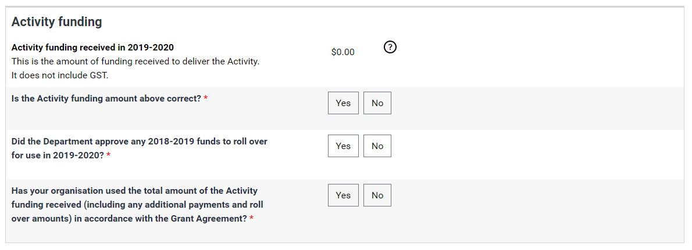
Supporting documents must be provided if the Grant Agreement requires an Audited or Non-audited Financial Acquittal.
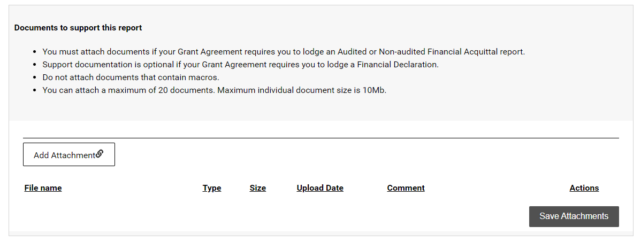
Select Add Attachment to include documents saved on a desktop.
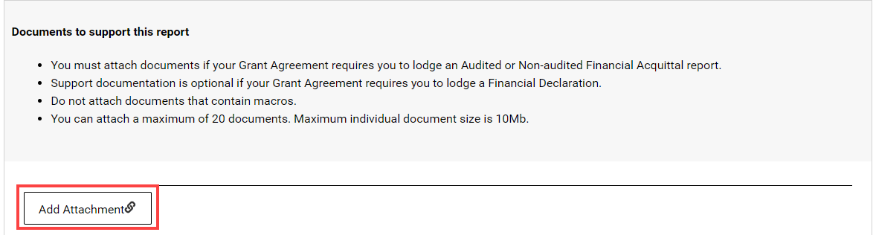
After choosing the document, select the Actions drop down to View, Remove or Edit comment for the attachment.
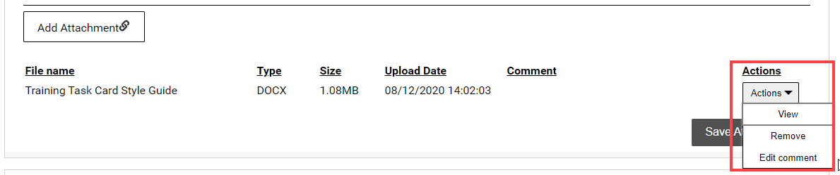
Once all attachments to support the Acquittal have been provided, select Save Attachments.
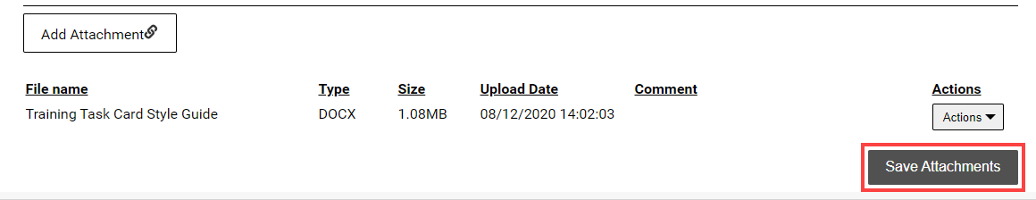
Do not leave this screen while data is being submitted. Once the message disappears, continue to complete the report.
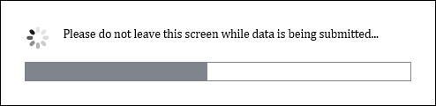
A message will display to advise if the documents were successfully saved.
Note: If more documents need to be attached, select Return to list.
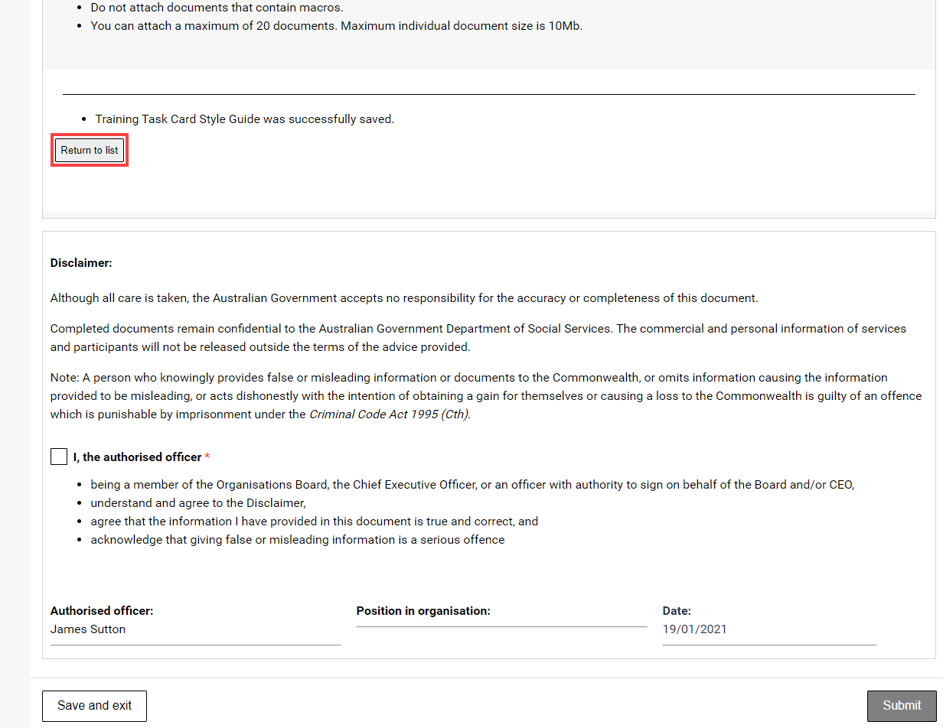
Review the Disclaimer and select the checkbox to agree to the Disclaimer. Select Submit.
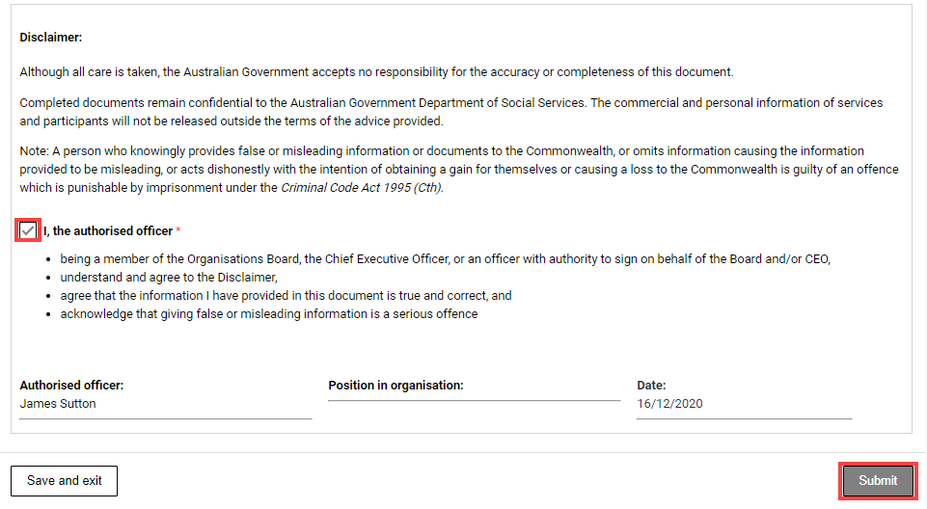
A message will appear to advising to stay on this screen until the data has been submitted.
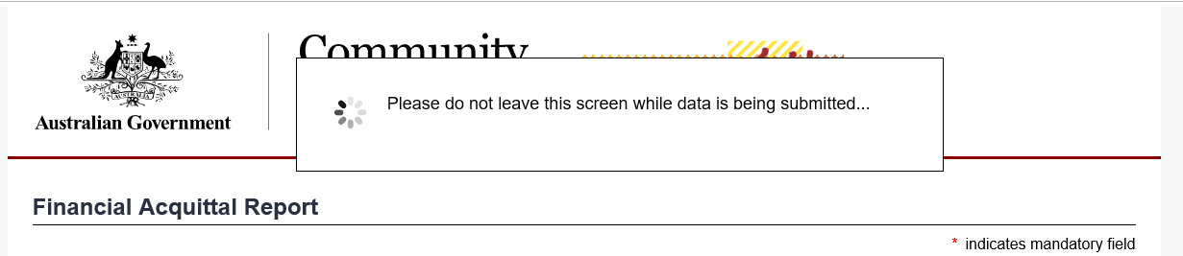
A confirmation page will display. Select Save and exit to close the form.
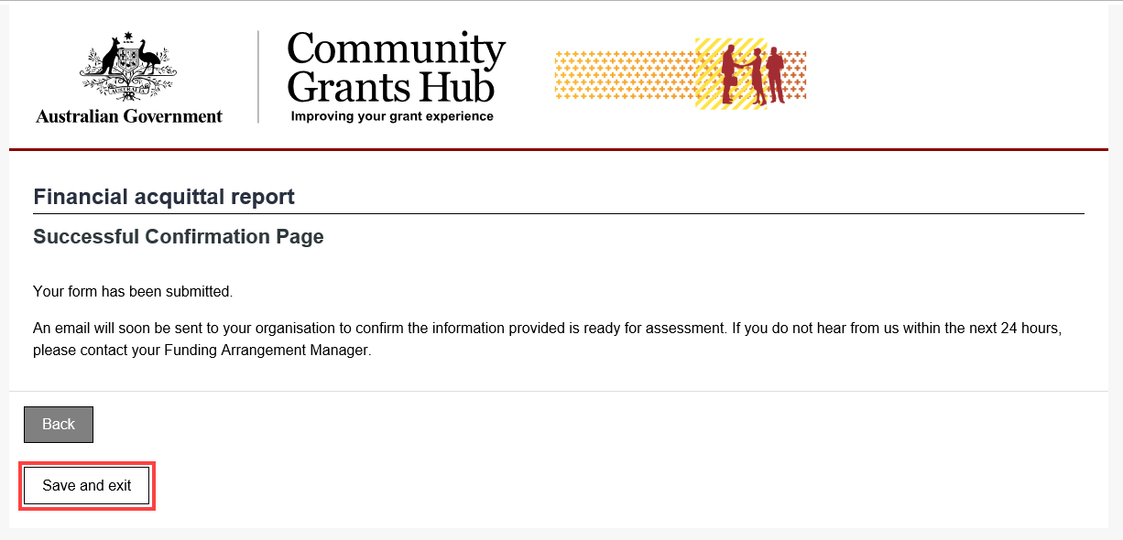

Submitting an Activity Work Plan
Step | Action
Select the Actions button to Launch Report.
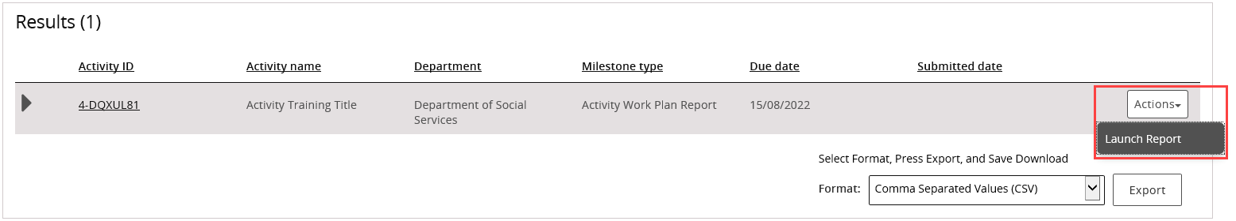
The Upload Report screen will display. The Activity Work Plan (AWP) template will need to be completed and saved before attaching it in this view.
If an Activity Work Plan template is required, select on the Activity Work Plan (AWP) report template link.
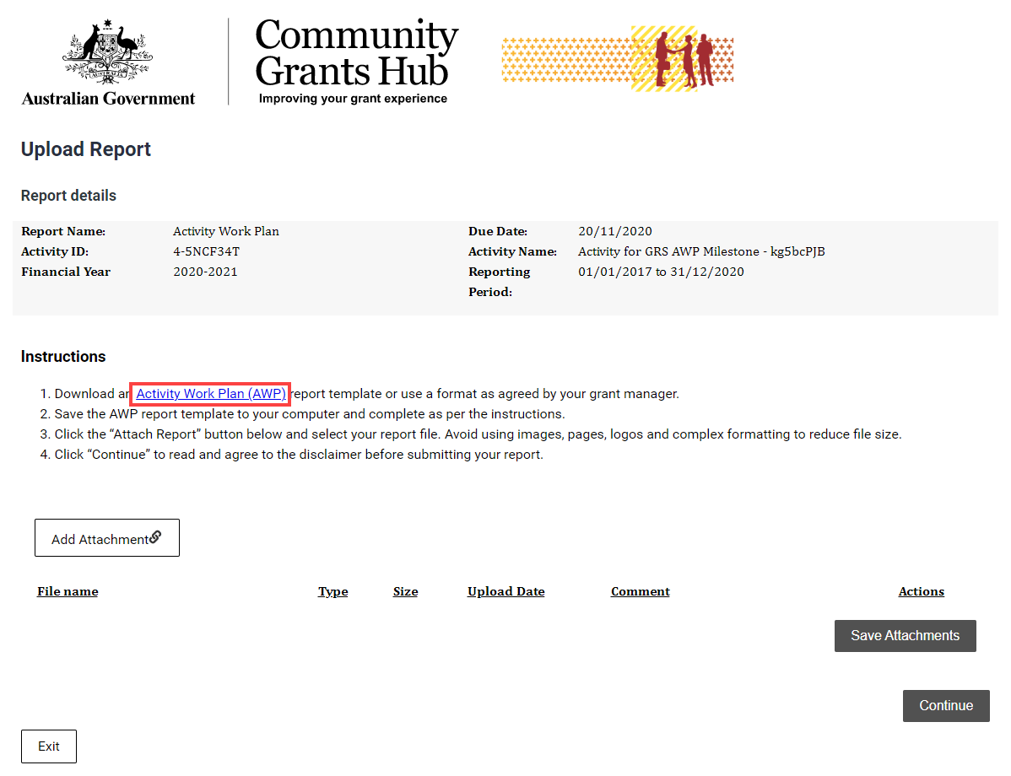
The link will display the Department of Social Services webpage. Select the Standardised AWP report template link.
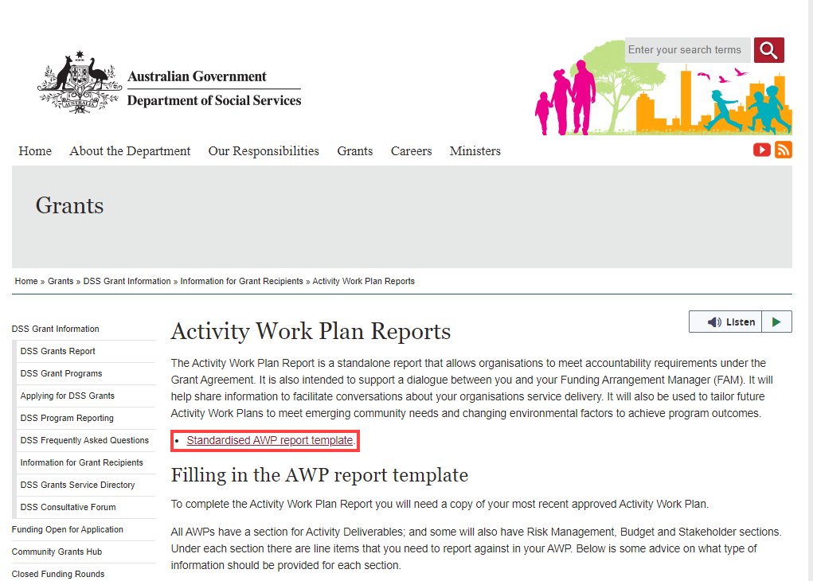
Use the word version for completing the Activity Work Plan report and save the document to upload it into the Portal.
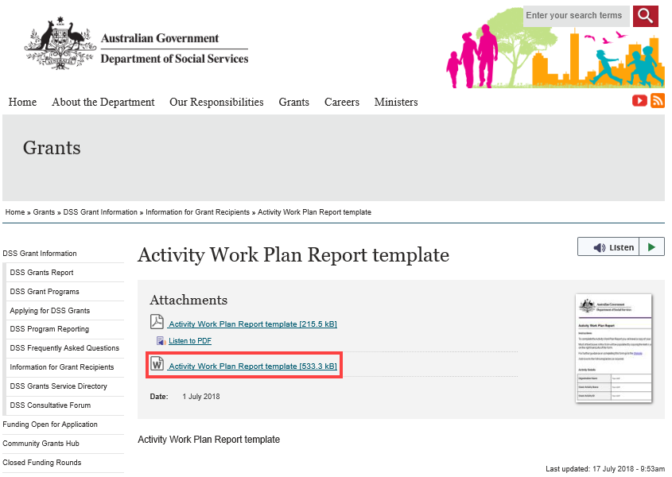
Select Add attachment and choose the appropriate file.
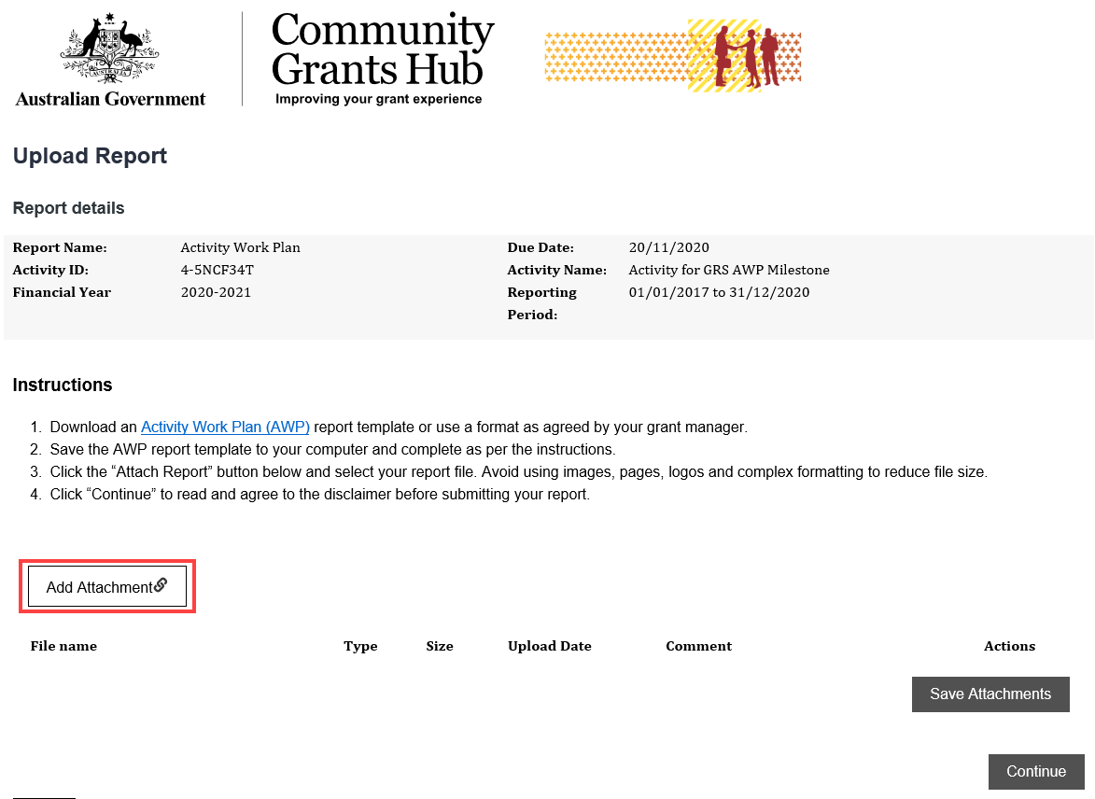
 | To review an Attachment, select the Actions button to View, Remove or Edit comment.
 | Once all attachments have been added, select Save Attachments.
 | Do not leave this screen while data is being submitted. Once the message disappears, continue to complete the report.
A message will display to advise if the documents were successfully saved.
Note: To attach more documents, select Return to list.
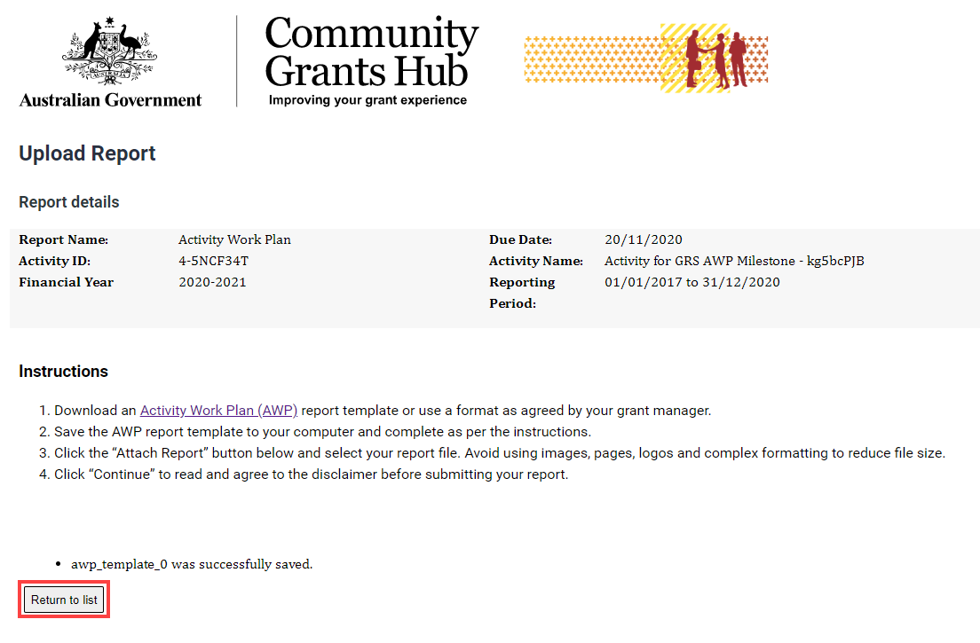
Select Continue to go to the next step.
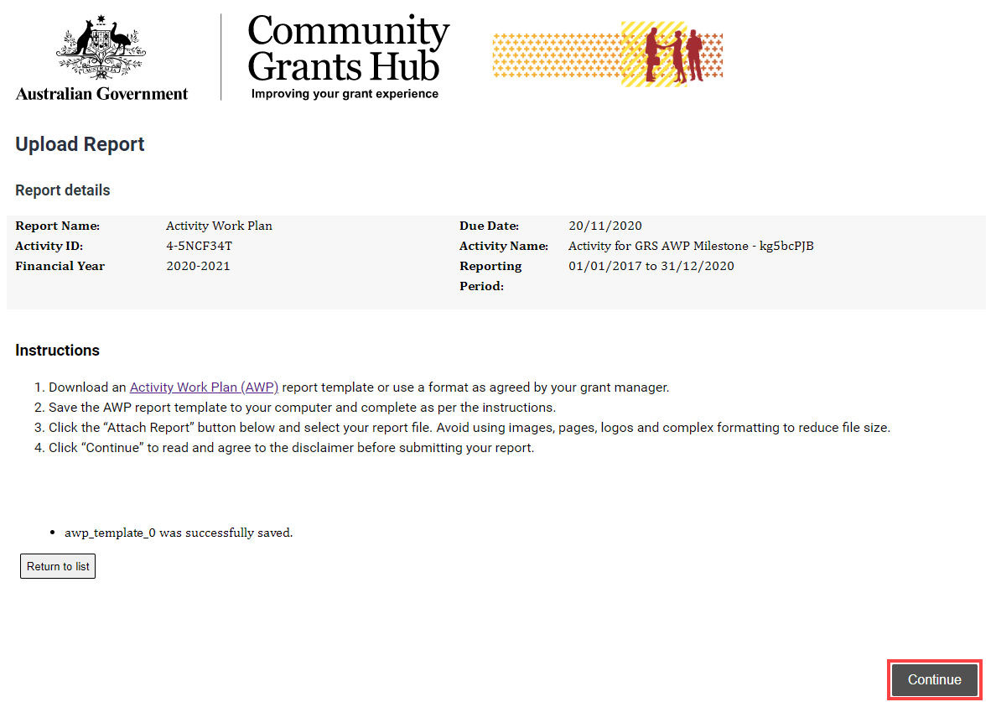
Review the Disclaimer and select the checkbox to agree to the Disclaimer. Select Submit.
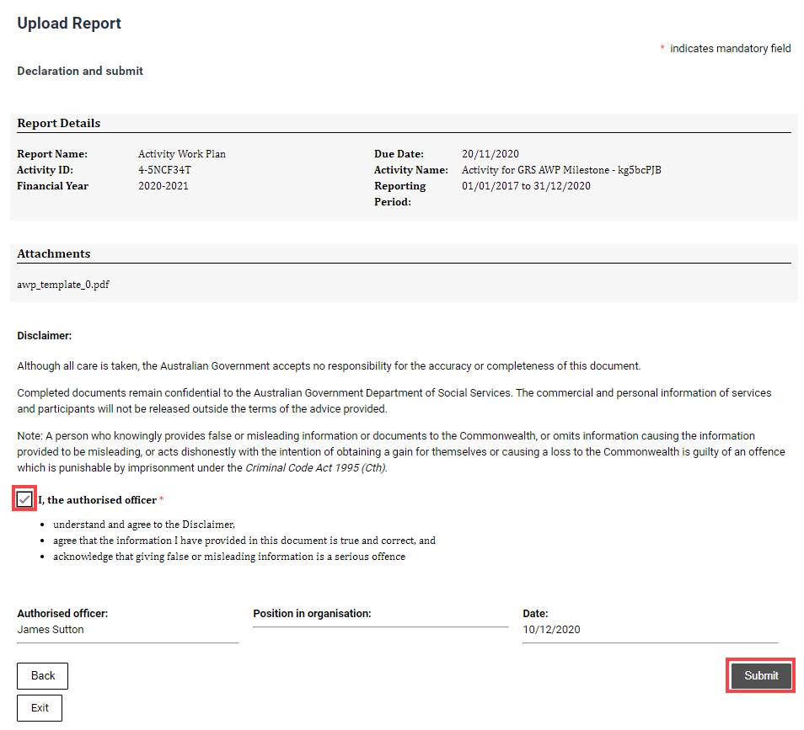
A message will appear to advising to stay on this screen until the data has been submitted.
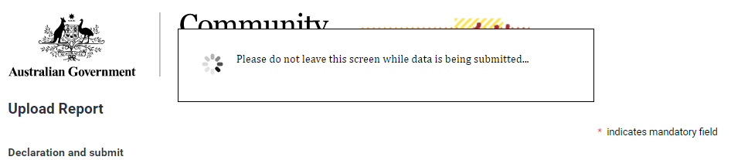
A confirmation page will display. Select Exit to close the form.
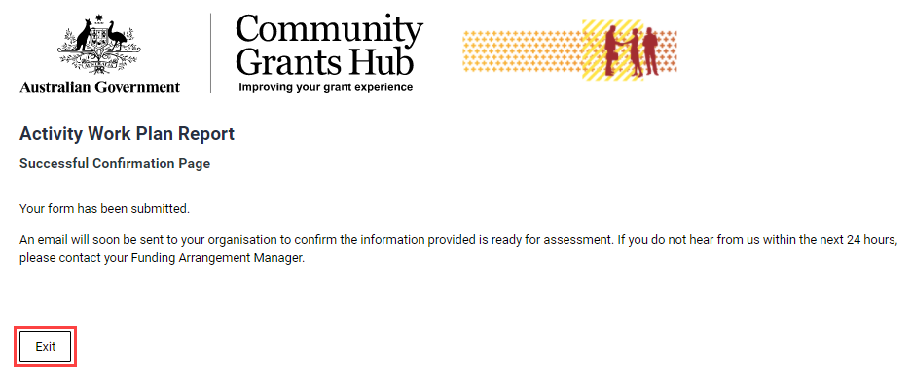

Need Help?
For further assistance, contact the Grant Recipient Portal Helpdesk:
Email: GRP.Helpdesk@communitygrants.gov.au
Phone: 1800 020 283 (Option 5)
Operating Hours: Monday to Friday 8:30am – 5:30pm (AEST/AEDT)

