# Murray–Darling Healthy Rivers Program – Mapping tool user guide

Version: July 2021

Pictures of rivers and dam


© Commonwealth of Australia 2021

**Ownership of intellectual property rights**

Unless otherwise noted, copyright (and any other intellectual property rights) in this publication is owned by the Commonwealth of Australia (referred to as the Commonwealth).

**Creative Commons licence**

All material in this publication is licensed under a [Creative Commons Attribution 4.0 International Licence](https://creativecommons.org/licenses/by/4.0/legalcode) except content supplied by third parties, logos and the Commonwealth Coat of Arms.

Inquiries about the licence and any use of this document should be emailed to [copyright@awe.gov.au](mailto:copyright@awe.gov.au).

All material in this publication is licensed under a Creative Commons Attribution 4.0 International Licence except content supplied by third parties, logos and the Commonwealth Coat of Arms.

**Cataloguing data**

This publication (and any material sourced from it) should be attributed as: DAWE 2021, *Mapping tool user guide – Murray–Darling Healthy Rivers Program*, Department of Agriculture, Water and the Environment, Canberra, July 2021. CC BY 4.0.

This publication is available at [awe.gov.au/publications](https://www.awe.gov.au/publications).

Department of Agriculture, Water and the Environment

GPO Box 858 Canberra ACT 2601

Telephone 1800 900 090

Web [awe.gov.au](https://www.awe.gov.au/)

**Disclaimer**

The Australian Government acting through the Department of Agriculture, Water and the Environment has exercised due care and skill in preparing and compiling the information and data in this publication. Notwithstanding, the Department of Agriculture, Water and the Environment, its employees and advisers disclaim all liability, including liability for negligence and for any loss, damage, injury, expense or cost incurred by any person as a result of accessing, using or relying on any of the information or data in this publication to the maximum extent permitted by law.

Contents

1 Introduction 1

1.1 Grant opportunities 1

1.2 Browser compatibility 1

1.3 Culturally sensitive sites 2

1.4 Successful projects 2

1.5 Departmental standards 2

2 An outline of what you need to do 3

3 Launching the mapping tool 4

3.1 Before launching the tool 4

3.2 Launching the mapping tool 4

4 Navigating the mapping tool screen 5

5 Mapping – uploading an existing map file 6

5.1 Loading Google Earth KML files 6

5.2 Editing a loaded Google Earth KML file polygon 7

6 Mapping – Creating a new or additional site 8

6.1 Search for project location 8

6.2 Adjust map position and zoom 8

6.3 Draw one or more project site areas 9

6.4 Label your site 13

6.5 Save your mapping 13

7 Editing an existing site 15

7.1 Re-positioning the polygon perimeter 15

7.2 Editing a project site title 16

8 Deleting a single project site 17

9 Deleting all project sites 18

10 Saving your mapping and copying and pasting the map URL (link) into your application form 19

11 Downloading your mapping 20

12 How to return to the application form 21

13 Contacts for help and information 22

**Figures**

Figure 1 Initial mapping tool screen 4

Figure 2 Orientation to mapping tool screen 5

Figure 3 Image of 'Load from file (KML)’ button 6

Figure 4 Navigating to KML file for upload 7

Figure 5 Image of 'Save mapping' button 7

Figure 6 How to change type of map view 8

Figure 7 Example of address results to select from 8

Figure 8 Hand tool icon 9

Figure 9 Zoom in andout buttons 9

Figure 10 Drawing tool icon 9

Figure 11 Cross symbol as mouse cursor 9

Figure 12 Initial step of drawing a site polygon 10

Figure 13 Second step of drawing a site polygon 10

Figure 14 Subsequent steps of drawing a site polygon 11

Figure 15 Final step of drawing a site polygon 12

Figure 16 Total area of all mapped sites 13

Figure 17 How to label a site with a name 13

Figure 18 'Save mapping' button 14

Figure 19 Identifying white and grey dots 15

Figure 20 How to undo a drawing step 16

Figure 21 How to delete a mapped project site 17

Figure 22 Upload, download, delete and help buttons 18

Figure 23 'Save mapping' button 19

Figure 24 Copying the URL (link) for your map 19

Figure 25 Buttons for downloading your mapping 20

## Introduction

As part of submitting your grant application you must include mapping of the location of the project site/s where you propose to carry out on-ground activities. This document contains guidance on how to create the required map.

### Grant opportunities

This mapping guide is for the following grant opportunities:

* 2021-5214 – Murray–Darling Healthy Rivers Program – Small Grants (Round 2)
* 2020-4634 – Murray–Darling Healthy Rivers Program – Large Grants.

You must submit your application/s to the Community Grants Hub by 09:00 pm AEDT on 6 October 2021.

We will not provide application forms or accept applications for this grant opportunity by any means other than the online system.

The application form includes help information. You are responsible for making sure your application is complete and accurate. Giving false or misleading information is a serious offence under the [*Criminal Code Act 1995*](https://www.legislation.gov.au/Details/C2021C00183) and we will investigate any false or misleading information and may exclude your application from further consideration.

If you need further help with the application process, submitting an application online, have any technical difficulties or find an error in your application after submission, but before the closing date and time, you should contact the Community Grants Hub immediately on 1800 020 283 (option 1) or email [support@communitygrants.gov.au](mailto:support@communitygrants.gov.au). The Community Grants Hub does not have to accept any additional information, or requests from you to correct your application after the closing time.

You cannot change your application after the closing date and time.

If we find an error or something missing, we may ask you for clarification or additional information.

This will not change the nature of your application. However, we can refuse to accept any additional information from you that would change your application after the closing time.

You should keep a copy of your application and any supporting documents.

### Browser compatibility

This mapping tool is known to work with the following web browser applications:

* Google Chrome version 36 and above
* Microsoft Edge version 89 and above
* Mozilla Firefox version 17 and above
* Safari (Mac users).

If you need to download one of the above browsers for your desktop computer, you can do so at the following sites:

* [Google Chrome](https://www.google.com/chrome/)
* [Mozilla Firefox](https://www.mozilla.org/en-US/firefox/new/)

If you experience any issues, please ensure that you are using the latest version of your browser.

### Culturally sensitive sites

If your project contains a culturally sensitive site, you may map an area larger than the site (but that still encompasses the site) to prevent its exact location being revealed.

### Successful projects

You will be asked to update your project site mapping using this tool as part of your delivering your project if your application is successful.

### Departmental standards

The Department of Agriculture, Water and the Environment has published a standard regarding fine scale mapping of the locations of all on-ground investments that the public are encouraged to adopt. For more information, visit the [department’s website](http://www.environment.gov.au/about-us/environmental-information-data/information-policy/on-ground-investment-location-data-capture-mgt-sharing-standards-v1). While you must provide mapping, the standard is flexible around the level of detail required for different activities.

## An outline of what you need to do

This document provides detailed instructions for mapping of your project site/s. In summary, you will need to:

1. **check** that you are using a compatible web browser and then **launch** the mapping tool (Launching the mapping tool)
2. **familiarise** yourself with the mapping screen, tools and functions (Navigating the mapping tool screen)
3. **add or create project** sites by:
   1. where relevant, uploading an existing project mapping file for your project site/s (Mapping ­– uploading an existing map file)
   2. creating a new site for each proposed area of work by drawing the perimeter of the site/s to create a site polygon (Mapping – Creating a new or additional site)
   3. name each site (Label your site)
4. **save** your mapping and **copy and paste** the URL (link) for your mapping into your application form on the Community Grants Hub Portal (Saving your mapping and copying and pasting the map URL (link) into your application form)
5. **download** a copy of your map for your records (Downloading your mapping).

These steps are outlined in more detail in the following pages. Please work through these to ensure your project is successfully mapped and saved.

## Launching the mapping tool

### Before launching the tool

Before accessing the mapping tool, make sure your application form is saved.

If you are working in a web browser that the mapping tool does not support (see Introduction), save and close your application form and re-open it in a supported web browser before attempting to access the mapping tool.

### Launching the mapping tool

The mapping tool can be launched by left clicking with your mouse on the ‘mapping tool’ link in the ‘project site address’ section of your online application form. Once launched, the tool window will open and should look similar to Figure 1 below.

Figure 1 Initial mapping tool screen

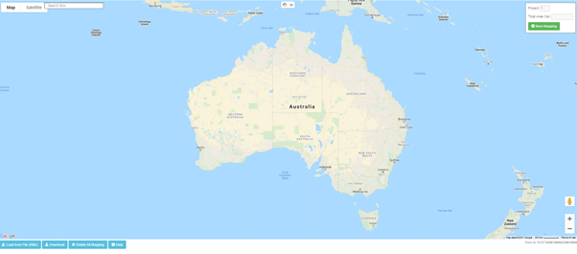

You do not need to compete all mapping in one session. If you save your work as you go by using the ‘Save Mapping’ button () and record the unique mapping link using the ‘Copy’ button (Screenshot of mapping tool showing the Copy button) that is displayed after you save, you can return to the tool at any time prior to submitting your application by using this unique link.

Note: This is not the original mapping tool link from your application form.

For instructions on how to return to the application form, refer to How to return to the application form.

## Navigating the mapping tool screen

The mapping tool screen contains several tools and features. These are summarised in Figure 2. Please familiarise yourself with these before proceeding further.

Figure 2 Orientation to mapping tool screen

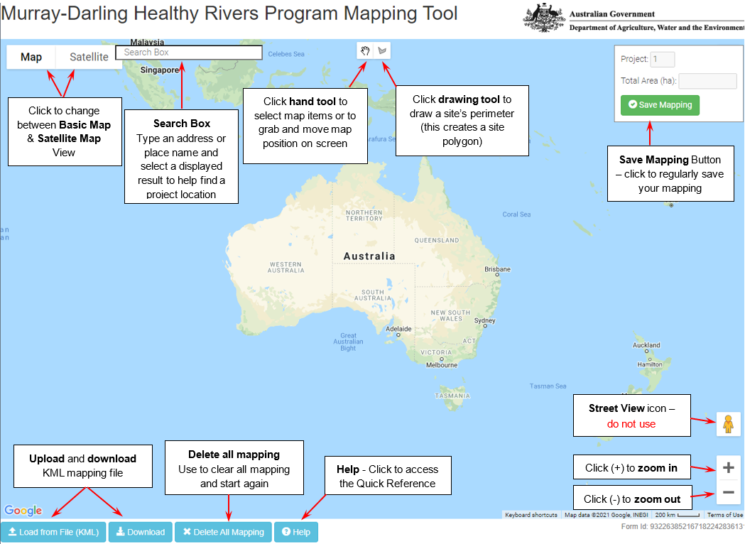

## Mapping ­– uploading an existing map file

To map your project without using existing project mapping files, please go to Mapping – Creating a new or additional site to create a new site/s).

### Loading Google Earth KML files

Google Earth Keyhole Markup Language (KML) is an open source file format used to store geographic information that can be visualised in a web browser application or Geographic Information System (GIS), such as Google Earth. More information on KML files is available on the [Google Developers blog](https://developers.google.com/kml/).

If you have an existing KML map file for your project site/s, it must be uploaded before creating any additional sites in the mapping tool.

Important: Failure to follow this order will cause the KML file to over-ride and clear all existing mapping you have done using the tool.

Once uploaded, modifications to the KML file’s polygon areas can be made in the mapping tool.

Before attempting to use the ‘Load from File (KML)’ function, please note the below.

* This function may require the latest version of your browser (see Introduction).
* The function only loads KML file format mapping files and not KMZ files.
* **You can only upload one KML file in total. Further uploads will overwrite previous KML uploads.** Experienced Google Earth Pro users with multiple existing KML files, should merge them into a single KML file before uploading. This can be done within [Google Earth Pro](https://www.google.com.au/earth/download/gep/agree.html), which can be downloaded at no cost.
* Due to web browser limitations, the mapping tool can generally only load a maximum KML file size of about 1.3 MB (12,000 vertices). If you experience problems in loading large files into the mapping tool, please contact the Community Grants Hub (see details in Contacts for help and information).
* If you intend to upload a Google Earth KML file, please make sure the KML file only contains polygons, and not other spatial information (such as points and lines).
* To upload a KML file, left click with your mouse on the blue ‘Load from File (KML)’ button in the bottom left of the map screen.

Figure 3 Image of 'Load from file (KML)’ button

Screenshot of mapping tool showing the Load form File (KML) button.

A file system navigation box will appear (Figure 4). Use it to locate your KML file and left click on it. Left click on the ‘Open’ button to upload the KML file into the mapping tool.

Figure 4 Navigating to KML file for upload

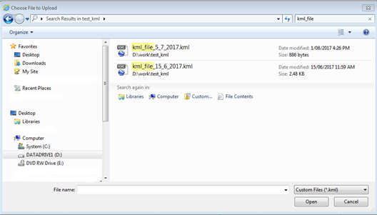

The KML file should upload and display a message stating ‘Successfully loaded kml file.’

To save the mapping, close the successful file load message and left click on the ‘Save Mapping’ button at the top right of your screen to save your map in the tool.

Figure 5 Image of 'Save mapping' button



If issues are encountered when loading non-standard KML files, they may be corrected by loading the file into Google Earth Pro and then resaving it. [Google Earth Pro](https://www.google.com.au/earth/download/gep/agree.html) is available for download at no cost.

After using Google Earth Pro to address the issue, attempt to upload your KML file again. If the issue persists, please contact the Community Grants Hub for assistance (see Contacts for help and information).

### Editing a loaded Google Earth KML file polygon

Once a KML file has been loaded into the tool you can edit the site polygon/s and site titles. Please refer to Editing an existing site.

If you wish to add additional sites to those uploaded from your KML file, refer to Mapping – Creating a new or additional site.

## Mapping – Creating a new or additional site

### Search for project location

Left click ‘Satellite’ in the top left of the screen (Figure 6) and ensure the ‘Labels’ tick box is selected.

Note: You can change your map view selection later at any time.

Figure 6 How to change type of map view

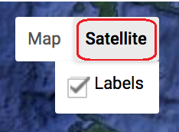

Type the address or name of a town or street location near the project area into the search box in the upper left of the screen (Figure 7).

Figure 7 Example of address results to select from

Screenshot of an example of address results to select from

The tool will suggest a list of locations based on the address, town or street location entered. Select the closest location by left clicking on the preferred listed place or location.

### Adjust map position and zoom

To zoom into the exact site location, adjust the map position by panning and zooming.

Panning means moving the map image left and right, or up and down on the screen. To pan, select the small hand tool (Screenshot of small hand tool) at the top centre of the mapping screen (Figure 8) with a left mouse click.

Figure 8 Hand tool icon

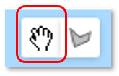

Move the hand cursor (Screenshot of small hand tool) to anywhere on the map. Click and hold the left mouse button while moving the mouse to re-position the map so the area of interest is in the centre of the screen. Once positioned, release the mouse button.

To zoom in or zoom out, you can either:

* click on the plus (+) or minus (-) symbols in the lower right of the map (Figure 9)
* scroll your mouse wheel up or down.

Figure 9 Zoom in andout buttons



By using the pan and zoom functions, zoom in to your project site area as close as you can. This will help you prepare for accurately drawing a perimeter around your project site/s.

### Draw one or more project site areas

Left click on the drawing tool icon at the centre top of the mapping tool window (Figure 10).

Figure 10 Drawing tool icon

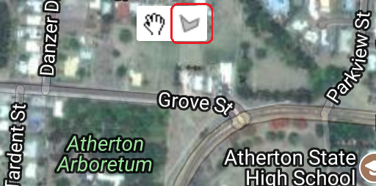

Your mouse cursor will now display as a cross symbol.

Figure 11 Cross symbol as mouse cursor

Tip: If your cursor is ever stuck as a cross, click on the small hand tool to turn it off.

Place the cursor cross at the location where you want to start drawing the perimeter or polygon of your site and left click once to make your first point (Figure 12).

Figure 12 Initial step of drawing a site polygon

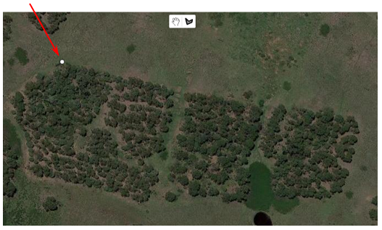

Move your cursor to the next corner of your site’s perimeter (i.e. polygon area) and left click once to create a second point (Figure 13).

Figure 13 Second step of drawing a site polygon

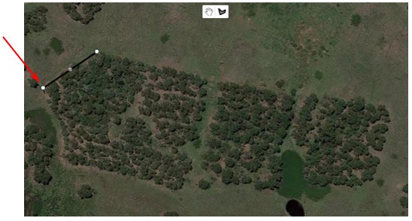

Continue this process of one left click at each point on your site’s perimeter (Figure 14) until you get back to the starting point to create your site’s polygon. If you make an error on the way, don’t worry, keep proceeding until you reach the starting point again. You will have the opportunity later (if needed) to edit the site (Editing an existing site) or to delete the site (Deleting a single project site).

Figure 14 Subsequent steps of drawing a site polygon

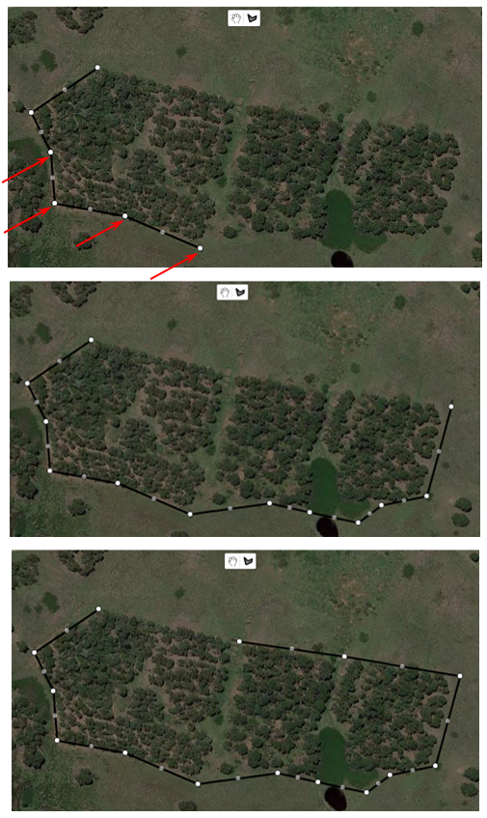

Tip: To move the map around whilst in draw mode by holding down the left mouse button and drag the mouse until the map is in the desired position. To return to drawing, release the mouse button.

To finish drawing your polygon, click on the starting point. A pop-up window will appear as shown in Figure 15.

Figure 15 Final step of drawing a site polygon

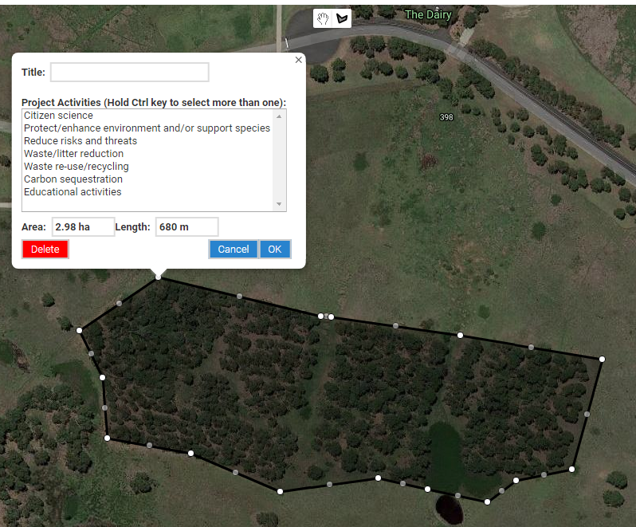

The information window will automatically display the hectare area of the polygon and the length of its perimeter (Figure 15). To view the total area mapped for all the sites you have mapped so far, refer to the ‘Total Area (ha)’ field at the top right of the map screen (Figure 16).

Figure 16 Total area of all mapped sites

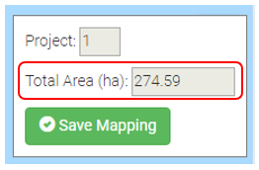

### Label your site

The information window allows you to type in a title for your site, but if you wish to draw your site location again, you can left click the red ‘Delete’ button in the information window to delete your site polygon (Figure 21).

Note: If only a minor edit is needed, an option is to edit the polygon/perimeter later (see Editing an existing site).

To add a site title, left click in the ‘Title’ field and type a name for the site (Figure 17). If you have already clicked on ‘OK’ without labelling your site, go to Editing a project site title to edit your site.

Figure 17 How to label a site with a name

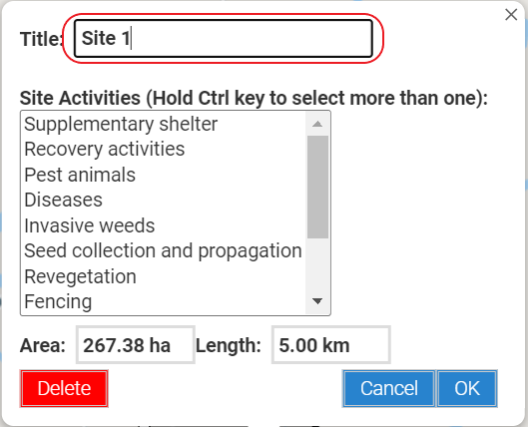

### Save your mapping

Incompletely drawn polygons cannot be saved. If a polygon’s information window is still open, left click the ‘OK’ button to close it (Figure 18). Then left click on the ‘Save Mapping’ button at the top right of the screen to save your work.

Figure 18 'Save mapping' button



Next steps are included below.

* To edit your site polygon or its information further, go to Editing an existing site.
* To add an additional project site to your mapping, go to the beginning of Mapping – Creating a new or additional site and repeat the process of creating a site polygon.
* If you have finished mapping your site/s and adding the site title/s, go to Saving your mapping and copying and pasting the map URL (link) into your application form

## Editing an existing site

Once a site polygon is created (or uploaded from a KML file), it is possible to adjust the polygon further or to adjust the site title. To do this, follow the directions below. Otherwise, progress to Saving your mapping and copying and pasting the map URL (link) into your application form.

The polygon site perimeter has 2 types of dots – white dots and grey dots (Figure 19). The white dots are the primary points and must be positioned first. The grey dots are secondary points and allow finer adjustments by adding more points to the shape’s perimeter. When you make adjustments to the position of grey dots, they may turn white and additional points may appear on the perimeter to allow even finer adjustments.

Figure 19 Identifying white and grey dots

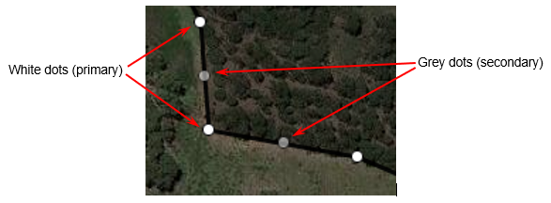

### Re-positioning the polygon perimeter

To re-position the polygon perimeter, please follow the below steps.

* Left click on the small hand tool (screenshot of the small hand tool) at the centre top of your map (Figure 20).
* Left click and hold down the left mouse button over a white dot () to take hold of it.
* While holding down the mouse button, move the pointer to the desired position and release the mouse button.
* To undo the last adjustment, click the back symbol (Screenshot of back symbol) (Figure 20) which appears when a point is adjusted.

Figure 20 How to undo a drawing step

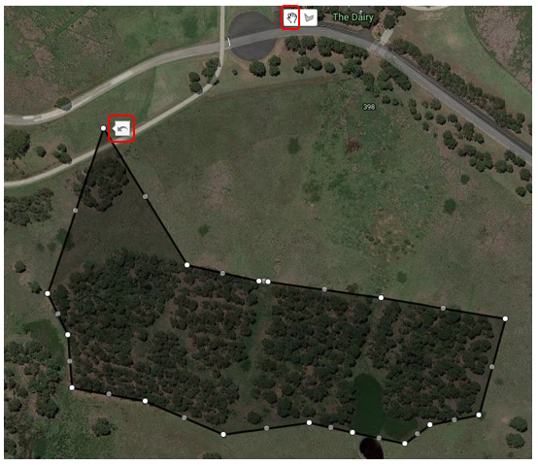

If necessary, repeat this process to re-position other white dots.

To fine tune your polygon area, follow the same process for any grey dots.

Left click the ‘Save Mapping’ button at the top right of your screen when finished.

### Editing a project site title

To edit a project site title, please follow the below steps.

* Left click on the small hand tool (Screenshot of small hand tool) at the centre top of your map (Figure 8).
* Place the cursor over the shaded area of a site polygon that you have drawn () and left click the mouse.
* The site information window will appear (Figure 17). The title can be edited as required. If needed, refer to Label your site and Save your mapping for more details on how to do this.
* When all edits have been completed, click ‘OK’ to confirm and close the information window (Figure 17). Alternatively, click ‘Cancel’ if you don’t want to keep any of the changes you have made.

## Deleting a single project site

To delete a single project site, please follow the below steps.

* Left click on the small hand tool (screenshot of the small hand tool) at the centre top of your map (Figure 8).
* Place the cursor over the shaded area of a site polygon that you have drawn () and left click the mouse.
* The site information window will appear (Figure 21). Left click the red ‘Delete’ button to delete the site and its associated information.

Warning: Clicking the ‘Delete’ button will delete the whole polygon. This action cannot be undone.

Figure 21 How to delete a mapped project site

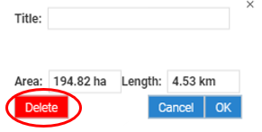

## Deleting all project sites

To delete all site polygons and re-start all mapping, left click on the blue ‘Delete All Mapping’ button in the bottom left of the mapping tool screen (Figure 22). This will delete all polygon areas and their information.

Figure 22 Upload, download, delete and help buttons

Screenshot of upload, download, delete and help buttons

## Saving your mapping and copying and pasting the map URL (link) into your application form

Once you have completed your mapping, left click ‘Save Mapping’.

Figure 23 'Save mapping' button



The pop-up screen shown in Figure 24 will be shown.

Figure 24 Copying the URL (link) for your map

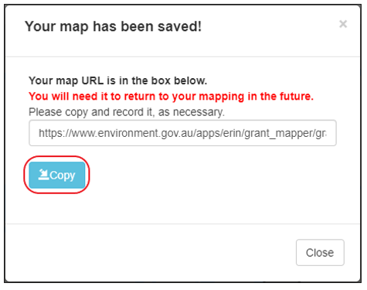

Click ‘**Copy**’ and then paste the URL (link) into your application form in the relevant section.

## Downloading your mapping

You have the option to download a file in KML format of your mapping for your records. KML files can be viewed in many mapping applications, such as [Google Earth](https://www.google.com/earth) and [National Map](http://www.nationalmap.gov.au).

To download your mapping, left click ‘Save Mapping’, then left click on the blue ‘Download’ button (bottom left of screen). You will then be asked where to save the file on your computer.

Figure 25 Buttons for downloading your mapping

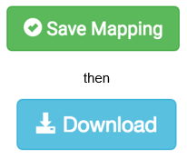

## How to return to the application form

You do not have to complete all your mapping in one session. You can return to the mapping tool at any time using the link you recorded in Saving your mapping and copying and pasting the map URL (link) into your application form and complete the remaining mapping prior to submitting your application.

Note: You can only return to the mapping using the unique link that is generated when you click ‘Save Mapping’ and ‘Copy’. Using the link from your application form will open a new, empty map.

To close the mapping tool and return to the application form:

* click on the ‘Save Mapping’ button
* click on the ‘Copy’ button
* close your browser tab.

## Contacts for help and information

Please contact the Community Grants Hub on:

* phone: 1800 020 283 (option 1)
* email: [support@communitygrants.gov.au](mailto:support@communitygrants.gov.au?subject=Murray–Darling%20Healthy%20Rivers%20Program%20–%20Mapping%20tool%20user%20guide)
* the [Community Grants Hub website](http://www.communitygrants.gov.au/contact).

When you phone or email the Community Grants Hub, please quote either:

* 2021-5214 – Murray–Darling Healthy Rivers Program – Small Grants (Round 2)
* 2020-4634 – Murray–Darling Healthy Rivers Program – Large Grants.

For further information on the program, including supporting documents, visit the [Community Grants Hub website](https://www.communitygrants.gov.au/grants).