2020-4634 Murray–Darling Healthy Rivers Program: Large Grants

Draft activity work plan template
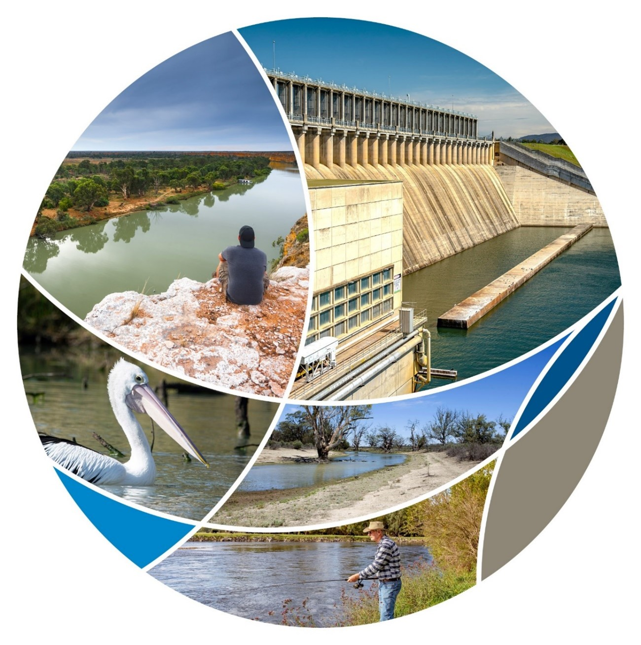

Template instructions
It is a requirement that a draft Activity Work Plan is completed as one of the attachments to your application.
If you application is successful, we will ask you to refine and update to the draft Activity Work Plan as one the first milestones for your project.
The purpose of developing an Activity Work Plan is to provide more details of what you propose to use grant funding for, the timeframe for delivery, a risk assessment, program management arrangements, and plans for after the project.
Do not simply copy and paste your responses from the the application form. Provide additional detail but please note that this is a draft to assist with assessment of your application. You will have the opportunity to further refine this plan.
When using this template, provide information as requested in each section.
Template instructions can be deleted.
Contents
Template instructions 2
Project 1
Project background 2
Project linkages 3
Project outputs, assumptions and monitoring 4
Primary investment theme 4
Project outcome/s 4
Investment themes 5
Government approvals and permits 7
Project deliverables and timeframe 8
Project resourcing and governance 9
Project risks 11
Stakeholder engagement and communication 12
Arrangements post funding 13
Evaluation and improvement 14
Appendix A: Risk matrix 15
Appendix B: Program logic 16
Appendix C: Examples of potential outputs 17
Natural resource management 17
Economic 17

Tables
Table 1 Applicant and project title 1
Table 2 Project linkages to relevant plans 3
Table 3 Invest theme – project outputs, Delivery mechanisms, assumptions and rationale, and monitoring 5
Table 4 Milestone description 7
Table 5 Milestone description 8
Table 6 Key personnel 10
Table 7 Risk management plan 11
Table 8 Stakeholder analysis matrix 12
Table 9 Evaluation questions 14
Table A1 Risk matrix 15

Figures
Figure 1 Governance structure 9

Project
Section instruction: Complete the following table with details for the proposed project consistent with those provided in your application form.
Table 1 Applicant and project title
Applicant Name/Organisation:
Project Title:

Project background
Section instruction: Your introduction can include information such as the purpose of your organisation, a description of its activities, a description of its target population, and evidence to show that it is a healthy organisation. This should provide additional information to the application form.
[Enter your response here]

Project linkages
Section instruction: List relevant plans (including those related to Matters of National Environmental Significance, such as Species Recovery Plans, Threat Abatement Plans, Conservation Advice, Wildlife Conservation Advice) that your project aligns with, and intends to deliver against.
Table 2 Project linkages to relevant plans
Name of plan | Owner of plan  (organisation that issued the plan) | Relevant actions within plan being addressed (include reference where possible) | Brief description of how target will be addressed
Add more or delete rows as required.

Project outputs, assumptions and monitoring

Primary investment theme
Select one of the following:
- the conservation and protection of biodiversity (diversity of native plant and animal species), including species and communities listed under the Environment Protection and Biodiversity Conservation Act 1999 (EPBC Act)
- the protection of rivers or wetlands
- the protection of listed migratory species and their habitats
- the sustainable management or conservation and enhancement of water resources
- combating desertification and mitigating the effects of drought on natural systems.

Project outcome/s
For example, contribute to conservation and recovery of 11 kilometers of river.

Investment themes
Table 3 Invest theme – project outputs, Delivery mechanisms, assumptions and rationale, and monitoring
Investment theme  (choose those that apply) | Total project output  Total to be delivered by end of project.  Statements should be SMART.  Examples are in Appendix C: Examples of potential outputs.  NOTE: Each output should be linked to only one Investment theme – choose the most relevant. | Delivery mechanisms, assumptions and rationale  How is the output to be delivered (i.e. briefly describe the method to be used)? What assumption/s is/are being made about how the output will be achieved, and how it will lead to the achievement of the project outcome? What evidence is there to support the assumption? | Monitoring  How will the progress, achievement and impact of the project output be monitored? Data and information collected will assist in evaluating progress toward the project outcome/s.
The conservation and protection of biodiversity (diversity of native plant and animal species), including species and communities listed under the EPBC Act |  | - Delivery mechanism
 |  | - Assumption and rationale
The protection of rivers or wetlands |  | - Delivery mechanism
 |  | - Assumption and rationale
The protection of listed migratory species and their habitats |  | - Delivery mechanism
 |  | - Assumption and rationale
The sustainable management or conservation and enhancement of water resources |  | - Delivery mechanism
 |  | - Assumption and rationale
Combating desertification and mitigating the effects of drought on natural systems |  | - Delivery mechanism
 |  | - Assumption and rationale
Improved community involvement in restoring the environmental health of the Murray–Darling Basin |  | - Delivery mechanism
 |  | - Assumption and rationale
Increased economic activity and employment in Basin communities as a result of grant funding |  | - Delivery mechanism
 |  | - Assumption and rationale

Government approvals and permits
Section instruction: Please outline any government approvals and/or permits required before your project can commence on-ground works.
Table 4 Milestone description
Approval required | Agency responsible for approval | Is approval in place? (Yes or No) | Estimated date for gaining approval (dd/mm/yyyy) | What would happen to your project if approval is delayed or denied?
Add more or delete rows as required.

Project deliverables and timeframe
Section instruction: What is to be delivered throughout the project? What are key milestones to be throughout the life of the project? Do not include more than 6 milestones. List the activities and tasks and indicative completion dates for the project if funded in the table below.
Table 5 Milestone description
Activity | Responsibility | Deliverable | Associated cost | Estimated start date  (dd/mm/yyyy) | Estimated end date  (dd/mm/yyyy)
Add more or delete rows as required.

Project resourcing and governance
Section instruction: List the types of resources needed to complete the proposed project, including personnel in the table below. Describe how the project is to be managed addressing the following items: proposed governance structure; accountability for delivery of outcomes under the governance arrangements (noting the lead organisation will be accountable to the Australian Government); key personnel and their skills and capabilities (enter in table below); financial management systems and grant payment authorisation processes; project management capability and systems; any physical requirements; continuation of collaborative structure post grant funding.
[Enter your response here]
Figure 1 Governance structure

Table 6 Key personnel
Name | Organisation | Project role and responsibilities | Previous and relevant experience, skills & attributes | Any other notes
Add more or delete rows as required.

Project risks
Section instruction: Itemise risks related to the project in the table below based on the matrix above. Consider risks from multiple sources including governance, financial, resourcing, stakeholders etc. Include all substantial matters that would affect delivery of your project. The risk level (low, medium, high, extreme) is the magnitude of the risk. It is a product of the likelihood of the risk occurring (almost certain, likely, possible, unlikely, rare) and the measure of consequence to the project should the risk occur (insignificant, minor, moderate, major, severe). Detail treatments for each risk.
A risk matrix is in Appendix A: Risk matrix.
Table 7 Risk management plan
Risk item and its effect on the objective of the proposed project | Risk level before treatment |  |  | Treatment strategies | Treated risk level
 | Likelihood  (Almost Certain/ Likely / Possible / Unlikely / Rare) | Consequence  (Insignificant / Minor / Moderate / Major / Severe) | Risk Rating  (low / medium / high / extreme) |  | Likelihood  (Almost Certain / Likely / Possible / Unlikely / Rare) | Consequence  (Insignificant / Minor / Moderate / Major / Severe) | Risk Rating  (low / medium / high / extreme)
Add more rows as required.

Stakeholder engagement and communication
Section instruction: Outline the arrangements for engaging with and communicating with stakeholders before, during and after your project to ensure the success and enduring benefits of project outcomes.
[Enter your response here]
Table 8 Stakeholder analysis matrix
Stakholder group | Role/connection | Benefits of involvement | Level of interest | Level of influence | Level of impact
Individual, sectors or known groups.  For example:  - chamber of commerce  - community organisations  - young people  - media. | The stakeholder’s role and their connection to the project or proposition.  What expectation does the stakeholder group have of the organisation in relation to participation, information and involvement in the project.  For example:  - to be kept informed on the overall progress of the project  - to be involved in providing input on relevant operational issues. | What the stakeholder group can bring to the project that is of benefit.  For example:  - to be kept informed on the overall progress of the project  - to be involved in providing input on relevant operational issues. | What level of interest does the stakeholder group have in the final outcome:  For example:  - significant interest. | What influence will the stakeholder group have on the final outcomes? | The level of impact that the project will have on the stakeholder.  For example:  - significant  - moderate.
Add more rows as required.

Arrangements post funding
Section instruction: Outline the arrangements for ensuring the longevity of the project outcomes once completed.
[Enter your response here]

Evaluation and improvement
Section instruction: As a funding recipient, you have responsibility for reporting on how your project is progressing in terms of delivery of outputs and progress towards the desired outcomes. Through reporting on these aspects, you also play a role in contributing to a natural resource management (NRM) community of continual improvement. Evaluation provides an opportunity to draw conclusions about what has been achieved, what is yet to be done, what worked well and what didn’t. At each interim and yearly reporting period, you will have the opportunity to provide a summary of your project, including progress and lessons learned. Evaluation findings may also support you to review and make changes to this Monitoring, Evaluation, Reporting and Improvement (MERI) plan. You will also be required to provide an evaluation of your project as part of the Final Report.
In the table below, describe how your project will capture the information needed, as well as the processes that are in place to evaluate and make conclusions about the progress, achievements and lessons learned. For example, this may involve undertaking internal evaluations or engaging professional evaluative services. Include a description of how information about the project, including from monitoring activities will be used to evaluate progress. Also provide detail around process and roles and responsibilities.
In developing appropriate evaluation questions, you should include useful evaluation questions that:
- cover the key evaluation criteria of: the effectiveness of the project and whether it delivered what it intended; the impact of the project; the efficiency of the delivery mechanism/s; and the appropriateness of the methodology
- consider whether the assumptions and logic of the project will hold true
- consider whether the project’s key risks will impact the project’s outcomes or whether the controls to mitigate the threat/risk will be sufficient
- are drawn from the Caring for our Country Program Plan/s and evaluation questions, where possible including in relation to Community and Indigenous engagement
- are answerable within the resources available to the project. Larger, long-term projects are expected to provide suitably high quality responses to in-depth evaluation questions
- can be answered by the monitoring data the project intends (and can afford) to collect
- outline the arrangements for ensuring the longevity of the project outcomes once completed.
Table 9 Evaluation questions
 | Key evaluation questions | Describe how this project will ensure that evaluation questions will be addressed in a timely and appropriate manner
Impact
For example, what was the result (outcome) of the activity or project?
Effectiveness
Efficiency
For example, what parts of the project worked well? What methods/approaches worked well and why? What could be done differently next time?
Appropriateness
For example, what are key lessons learned that would be valuable to consider in the future, or for other projects?

Appendix A: Risk matrix
Table A1 Risk matrix
Risk probability | Risk impact
 | Insignificant | Minor | Moderate | Major | Severe
Almost certain  Is expected to occur (up to 90% chance) | Low | Medium | High | Extreme | Extreme
Likely  Will probably occur in most circumstances (up to 70% chance) | Low | Medium | High | High | Extreme
Possible  Might occur at some point (up to 40% chance) | Low | Medium | Medium | High | Extreme
Unlikely  Could occur at some time (up to 20% chance) | Low | Low | Medium | High | High
Rare  May occur only in exceptional circumstances (up to 5% chance) | Low | Low | Low | Medium | High

Appendix B: Program logic
Section instructions: Developing a program logic diagram can be useful in helping demonstrate how your project aligns with the program objectives and outcomes and help ensure that the approach, and steps needed to achieve the project outputs and outcomes are clear. The program logic diagram attached here should reflect and be consistent with the important detail captured elsewhere in this plan. A program logic diagram can also be a useful tool for communicating the project to others.
Developing a program logic diagram can be a useful activity done as a group, with members of the project team, as it ensures that there is a shared understanding about how the project is expected to proceed, and can unearth aspects including assumptions, risks or other factors that you had not previously thought of. You can use this information to update the relevant sections within this plan.
Develop and attach a program logic diagram consistent with the structure provided at below. For further information and guidance on how to complete program logic diagram, refer to the guidance material found on the MERI page of the National Landcare Program.
Figure B1 Program logic

Appendix C: Examples of potential outputs

Natural resource management
Table C1 Examples of outputs and metrics for natural resource management activities
Activity | Unit | Unit of measure
Weed treatment |  | total new area treated (ha)
Pest or disease management |  | number of individual animals or colonies killed or removed
Pest or disease management |  | area covered by pest treatment (ha)
Pest or disease management |  | total length of fence (km)
Pest or disease management |  | area protected by fence (ha)
Pest or disease management |  | total area treated by quarantine (ha)
Fencing |  | total length of fence (km)
Fencing |  | area protected by fence (ha)
Erosion management |  | erosion area treated (ha)
Erosion management |  | length of stream treated (km)
Erosion management |  | total number of erosion control structures installed
Revegetation |  | area of revegetation (ha)
Revegetation |  | kilograms of seed sown (kg)
Revegetation |  | number of plants planted
Extreme event recovery |  | flood, fire and run-off debris removed (tonnes)
Education activities and raising community awareness or participation |  | number of participants (excluding employees)
Education activities and raising community awareness or participation |  | number of community participation and engagement events (for example, field days, workshops, mentoring)
Education activities and raising community awareness or participation |  | number of new people attending project events or activities
Education activities and raising community awareness or participation |  | number of community groups participating
Access management |  | area protected by access control installations (ha)
Access management |  | number of structures installed
Native fish management |  | Number of pumps screen
Native fish management |  | length of stream re-snagged (km)
Native fish management |  | length of stream habitat mapped (km)
Native fish management |  | number of fish releases
Native fish management |  | number of fish ladders installed
Waste management |  | collection of rubbish (tonnes)
Waste management |  | number of gross pollutant traps (trash screen and trash racks) installed
Other: Please specify |  | Other: Please specify

Economic
Table C2 Examples of outputs and metrics for economic activities
Activity | Unit | Unit of measure
Employment |  | number of young people (15–24 years of age) employed
Employment |  | number of mature aged workers (50+ years) employed
Employment |  | number of people who identify as having a disability employed
Employment |  | number of people who identify as Aboriginal or Torres Strait Islander employed
Employment |  | total number of paid hours worked on the project (one day is 7.5 hours for each person)
Education |  | number of trainees or apprentices that worked on the project
Education |  | number of people who completed a nationally recognised subject under the vocational education and training framework by working on the project
Education |  | number of people who completed a nationally recognised course under the vocational education and training framework by working on the project
Volunteering |  | number of young people (15–24 years of age) engaged in volunteer activities
Volunteering |  | number of mature aged workers (50+ years) engaged in volunteer activities
Volunteering |  | number of people who identify as having a disability engaged in volunteer activities
Volunteering |  | number of people who identify as Aboriginal or Torres Strait Islander engaged in volunteer activities
Volunteering |  | total number of hours volunteered on the project (one day is 7.5 hours for each person)
Economic stimulus |  | total amount on goods spent in local communities
Economic stimulus |  | total amount on wages spent in local communities
Economic stimulus |  | total amount on services spent in local communities

Including declared Ramsar wetlands under Section 17 of the EPBC Act.
As provided for under Section 209 of the EPBC Act.
As defined under Section 4 of the Water Act 2007.
As per the United Nations Convention to Combat Desertification in those Countries Experiencing Serious Drought and/or Desertification, particularly in Africa (UNCCD).

