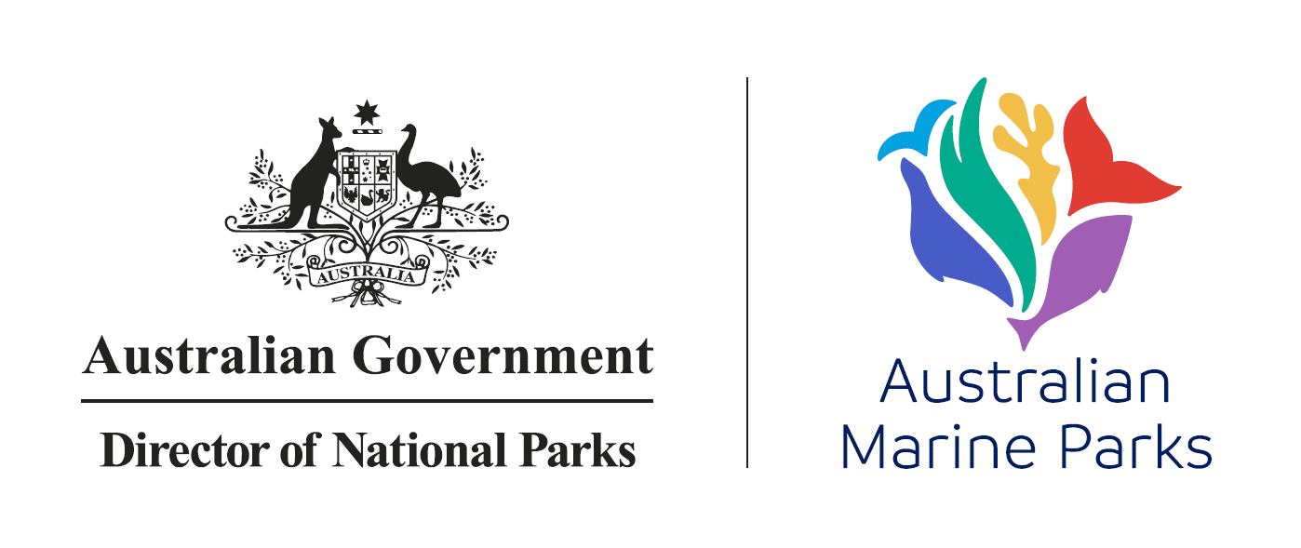
Our Marine Parks Grants Round Three – Project Plan
Please complete this template to tell us about your project.
It is a mandatory requirement that a Project Plan is completed and uploaded to your grant application form.
The detail in your project plan should be in line with the size and nature of the project. As a guide this project plan should be around 5 to 8 pages.
Please note: Your attachment is limited to 2 MB.
Name of your organisation:
_________________________________________________________________________
Application Submission Reference:
_________________________________________________________________________
Title of the project:
_________________________________________________________________________
Describe your project and key activities:
Provide a brief description of your project’s key activities and outcomes. You can use the same description as in the online application form.
Example text: The project objective is to build our understanding of environmental and cultural values within the Blue Marine Park.
This project will engage with the local Aboriginal ranger group (Blue Marine Park Rangers) to conduct seafloor mapping, and surveys of benthic and fish communities to obtain the baseline data required to understand the values found in Blue Marine Park. This will be the first time seabed mapping technologies will be undertaken within this marine park.
The reef systems near the marine park are dominated by corals and several species of sponges which provides an indication of what might be found in the Blue Marine Park. The areas in the Blue Marine Park that are most likely to support a reef system are Purple Bank, Green Shoal and Pink Shoal (Figure 1). This project will collect baseline community data for these shoals as well as oceanographic data. The baseline data collected will not only provide an understanding of the species in the Blue Marine Park but also develop an understanding about their cultural significance and improve current scientific knowledge of the marine park.
Key activities:
- Conduct the following surveys of Purple Bank, Green and Pink Shoal within Blue Marine Park:
  - Map the seafloor using multibeam echo sounder
  - Towed video surveys of benthic communities
  - Baited remote underwater video (BRUV) survey of fish communities
- Train Blue Marine Park Rangers on how to undertake BRUV surveys
- Analysis of field data
- Working with local Aboriginal groups to understand the cultural significance of species found in Blue Marine Park.
- Development of educational resources for local schools to enhance their understanding of marine park values.
- Reporting to Blue Marine Parks Council and Parks Australia.
- Presentation of findings at local events adjacent to Blue Marine Park, to Parks Australia staff and the North Marine Parks Advisory Committee.
- Submission of data to Geoscience Australia.
Insert text here:

_________________________________________________________________________
Project outcomes:
What are the expected outcomes of your project and how will you know if you have met your outcomes. Explain how those outcomes relate to Australian Marine Park management programs and their outcomes (or management strategies) (Appendix B of the Grant Opportunity Guidelines).
Example text: This project is being led by Blue Marine Park Corporation. The Blue Marine Park Rangers will be trained to undertake the survey work and assisted by Smith University.
Blue Marine Park is valued for its high biodiversity, with coral reef biodiversity estimated to be at least 65% of the Great Barrier Reef Marine Park. This, however is based in limited field data within the Blue Marine Park. This project will provide baseline data to fill this knowledge gap and help to address the marine science program outcome outlined in the North Marine Park Management Plan - ‘increase understanding of marine park values, pressures and adequacy of responses’. The specific products which will improve scientific knowledge of the region are:
- Bathymetry of Purple Bank, Green Shoal and Pink Shoal
- Coral and sponge species composition lists and distribution maps Purple Bank, Green Shoal and Pink Shoal
- Fish, shark and sea snake species diversity and abundance at Purple Bank, Green Shoal and Pink Shoal
- Cultural significance of areas mapped, and species found within Blue Marine Park.
- Educational resources
The baseline data collected during the project will be shared with the community by the Blue Marine Park Corporation. Communication of the project outcomes into the local community will assist Parks Australia to achieve their management action ‘improve awareness, understanding and support for the marine parks and park management’. Awareness will also be achieved through presentation of the project.
Insert text here:

_________________________________________________________________________
Project milestones:
You should outline the main project activities and identify who will be responsible for those activities being delivered. Outline when those activities, and other milestones in your project, will be completed.
You may consider what your public deliverables are and what potential media or outreach activities may be conducted at those milestones.
Activities cannot commence until after your grant agreement is executed which is intended to occur in June 2022. Activities must be completed by June 2024. Ensure you consider contingencies to ensure that your activity can be completed in the timeframes required. You do not need to include reporting obligations in your milestones.

Milestone description | Key parties and personnel responsible for activity | Start and end date
Example text: Meeting with Blue Marine Park Rangers and Researchers to discuss survey design | Blue Marine Park Corporation, Smith University, Mapping Team | June-July 2022

________________________________________________________________________
Key project personnel:
Provide information on the key personnel who will be responsible for the delivery of the project, including their qualifications and experience.
If success of the project requires recruitment of a project officer, provide information on how that recruitment will occur and what experience and qualifications the successful applicant would be expected to have.

Name | Organisation | Role | Experience
Example text: John Smith | Blue Marine Park Corporation | Project leader | 10 years as CEO, main researcher

________________________________________________________________________
Project Partner details
Provide details of partner organisations that will be involved in the conduct of the project and include the engagement strategy you have to ensure the success of the project.

Project Partner name | Role in the project | Engagement strategy
Example text: Smith University | Data collection and analysis | Smith University has significant experience in conducting mapping and exploratory work across marine parks in Australia. Smith University will be a partner in the project, and will be a core element in continuing our marine park management and research.

_________________________________________________________________________
In-kind and financial co-contributions:
You should include any in-kind or financial co-contributions and descriptions of how they were calculated in this section. These contributions can either be from you or from your project partners.

In-kind and financial co-contribution | Source of the contribution | How did you calculate contributions?
Example text: $150,000 | Smith University | This will provide staff time required to undertake training with the rangers and conduct in-field survey work.

_________________________________________________________________________
Risks and dependencies:
Can you think of anything that would stop you achieving the objectives of your project? How will you address these risks or dependencies?
Please note that risks associated with third parties or subcontractors should be outlined here.
Risk or dependency | How will the risk or dependency be managed?
Example text: Weather suitable for survey | Identify best weather windows and time of year to conduct surveys to minimise downtime

________________________________________________________________________
Stakeholders:
Who are the many stakeholders interested or impacted by your project? Explain their interest or impact and explain the engagement strategy you will have with that stakeholder. You can keep this high level – e.g. quarterly meetings / regular email communication – rather than identifying each individual meeting or communication.
You do not need to include project partners identified above.
Stakeholder | Interest or Impact | Engagement Strategy
Example text: Blue Town Council | Although the Council isn’t involved in Marine Park management activities, it would be courteous to keep this organisation informed of our proposed activities. | Notify Council of proposed work. Provide Council with a copy of the final report

_________________________________________________________________________
Workplace Health and Safety:
Outline the measures you will employ to ensure that this project is undertaken safely and complies with relevant Work, Health and Safety legislation.
Example text: The project will undergo an extensive risk assessment prior to the project commencing. The risk assessment will identify hazards, assess the risks that these hazards pose, and identify treatments to control hazards. The risk assessment will be reviewed and updated every 6 months. The Smith University has extensive experience operating in remote locations and is bound by strict Work, Health and Safety legislation.
Insert text here:

_________________________________________________________________________
Monitoring and Evaluation:
Outline your approach to monitoring and evaluation. Consider how you will measure the success of your project and how you will collect the relevant data.
How will you know if your project has achieved its outcomes?
Will the outcomes and data resulting from your project be available to Parks Australia?
Example text: Project outcomes will be monitored against the milestones listed in this application. The project will be considered a success if the environmental and cultural values of Blue Marine Park are identified and communicated to a broad range of stakeholders, including local school groups. The project will also be successful if the Blue Marine Park Rangers are capable of undertaking future BRUV surveys with limited direction from research staff.
The outcomes of the project will be delivered to Parks Australia as a final report and will include:
- Bathymetry of the shoals in the Blue Marine Park.
- Identification of coral, sponge and fish species at Purple Bank, Green Shoal and Pink Shoal.
- Cultural significance of areas mapped, and species found within Blue Marine Park
Insert text here:

