Adding Staff in the Grant Recipient Portal
  - New process to reduce duplicate contacts from being added to the Portal for Organisation Administrators.

Adding staff in the Portal
Changes have been made to the Portal that assist in reducing duplicate staff records from being created.
Click on the Organisation Profile tile of the home page and select Staff from the side menu. The screen below will appear. To add a new staff member click on the Add staff button on the staff screen.
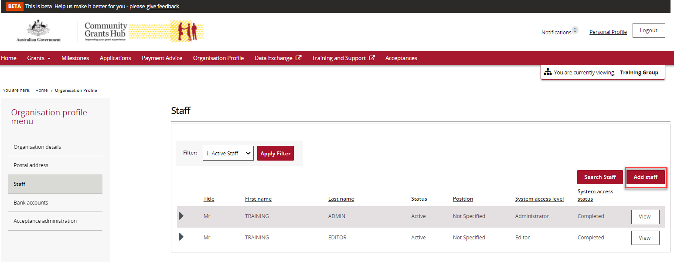

The screen below will appear. Enter the staff member’s details and system access required.
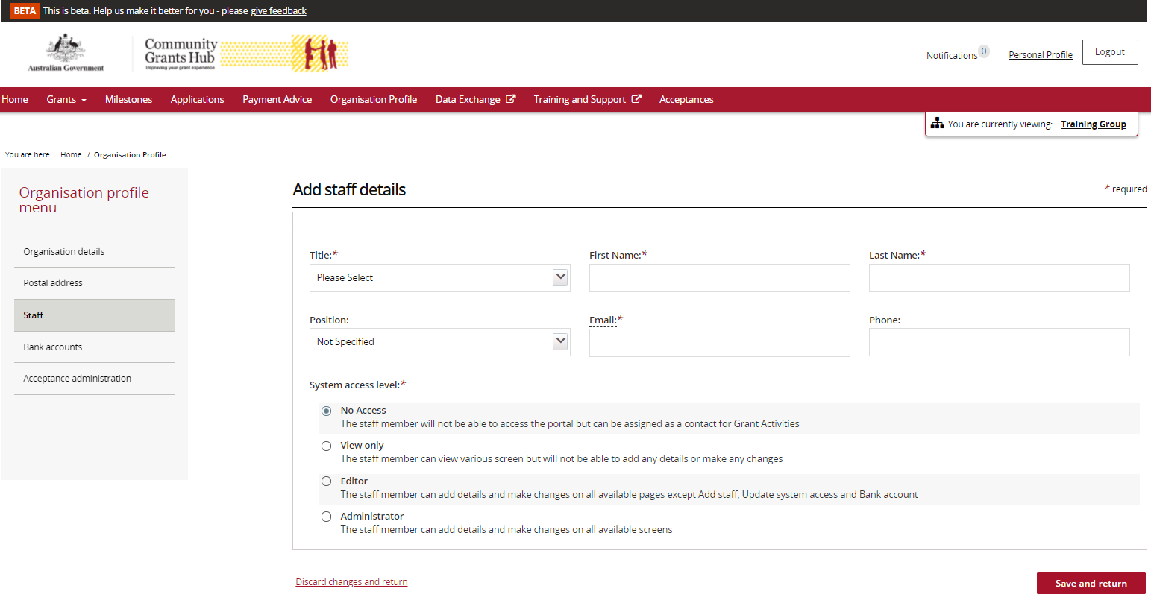
When the staff details are entered on this page and the Save and Return button is pressed, if the staff member already exists with the exact combination of first name, last name and email address, the following error will occur.
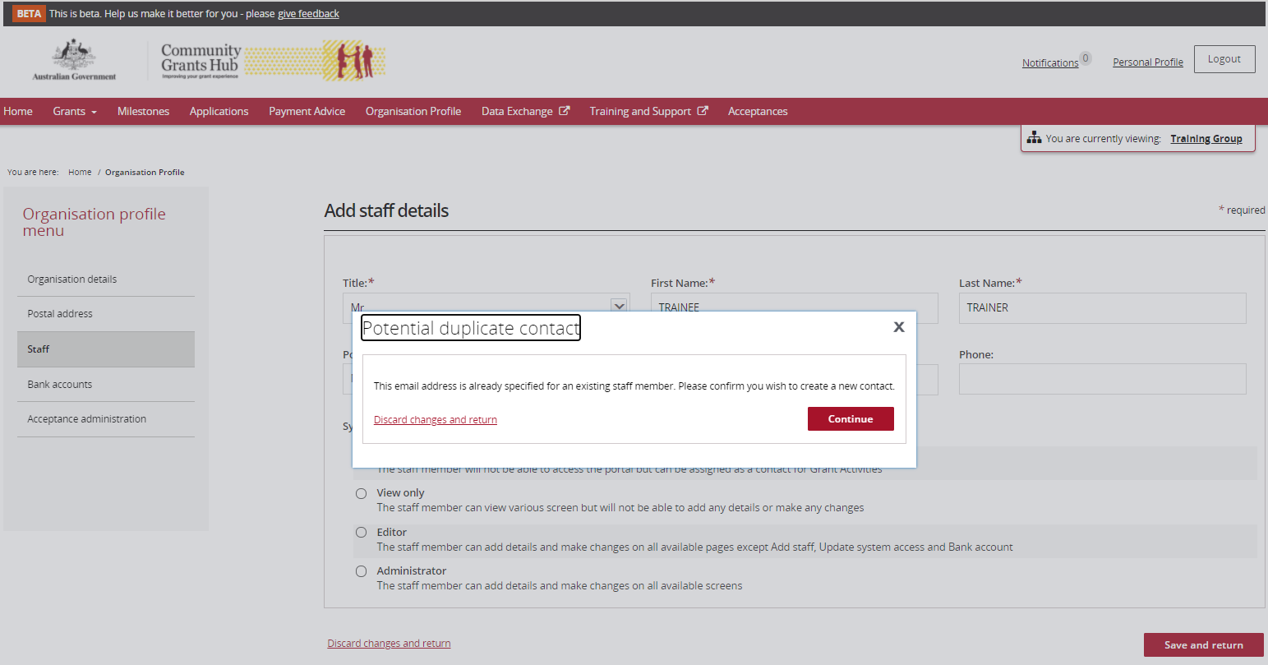
If staff details are entered into the Portal with the same email address but different first and/or last name to another staff record, the system will display a warning message indicating that the email is already used by another staff member.
This gives you the option to either proceed and create the new staff with the duplicate email address or cancel and return to the Staff list.
The staff member has now been added to the Portal.
Also note that all staff records will now display a Contact ID in various areas so you can identify the record to be kept and which can be inactivated if there is duplication of staff records against your organisation.
In the Staff area outlined above, the Contact ID is seen by clicking on the arrow at the side of each staff record.
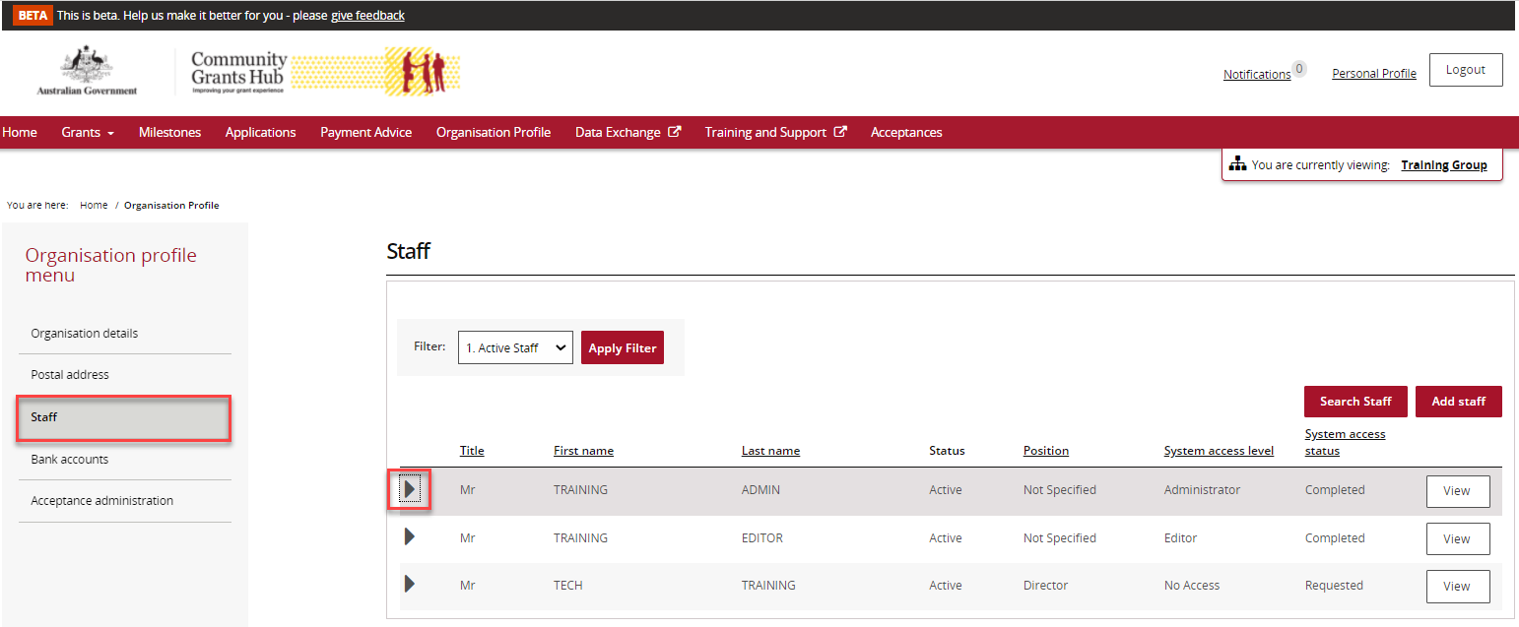
The unique Contact ID detail will show in the expanded details.
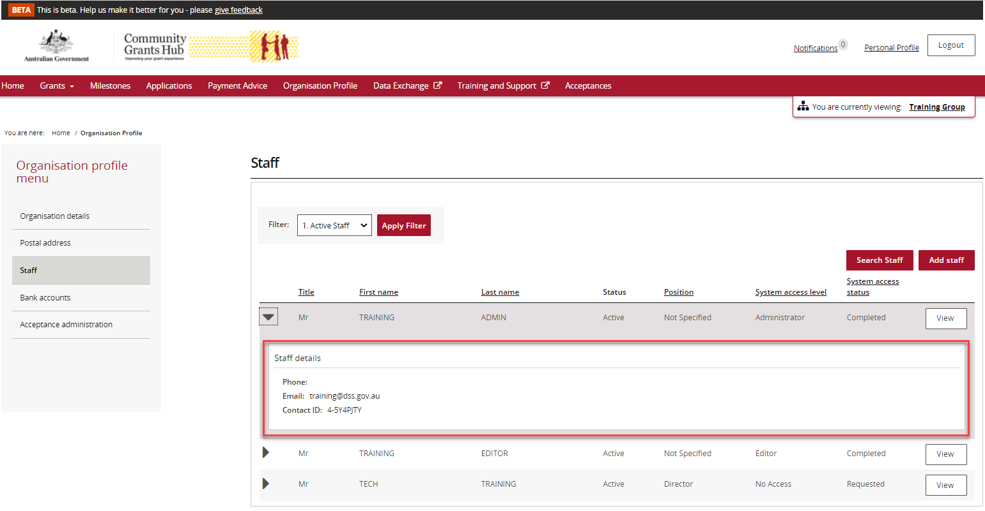

Need assistance
If you require assistance in using the Grant Recipient Portal contact the Grant Recipient Portal Helpdesk at GRP.Helpdesk@communitygrants.gov.au or on 1800 020 230 (option 5).

