Activating and Inactivating Staff in the Grant Recipient Portal
  - New fields in the Portal allowing Organisation Administrators to manage staff contacts.

Activating and Inactivating staff
Administrators of the Portal can now activate and inactivate staff through the Portal.

What does active and inactive staff mean?
Active staff are staff members who are listed on the Hub’s system as a contact for an Organisation.
Inactive staff are staff members who are listed as a contact for an Organisation in the Hub’s system but have an end date against their record as they are no longer a contact for an organisation.

Inactivating a staff record
Click on the Organisation Profile tile and then select Staff in the menu on the left hand side of the screen. Find the staff member you wish to inactivate and click on the View button.
Note that the default view that you will be presented with is for Active Staff. Alternatively you can select the views of Inactive Staff and All Staff and apply the filter to present those list views.
Also note that all staff records will now display a Contact ID in various areas so you can identify the record to be kept and which can be inactivated if there is duplication of staff records against your organisation.
In the Staff area outlined above, the Contact ID is see by clicking on the arrow at the side of each staff record.
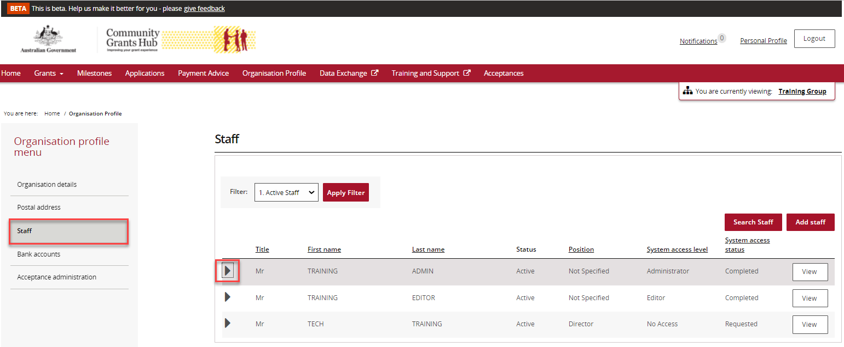
The unique Contact ID detail will show in the expanded details.
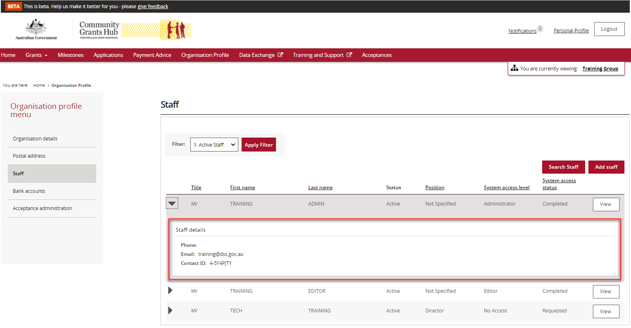

Find the staff member you wish to inactivate and click on the View button.
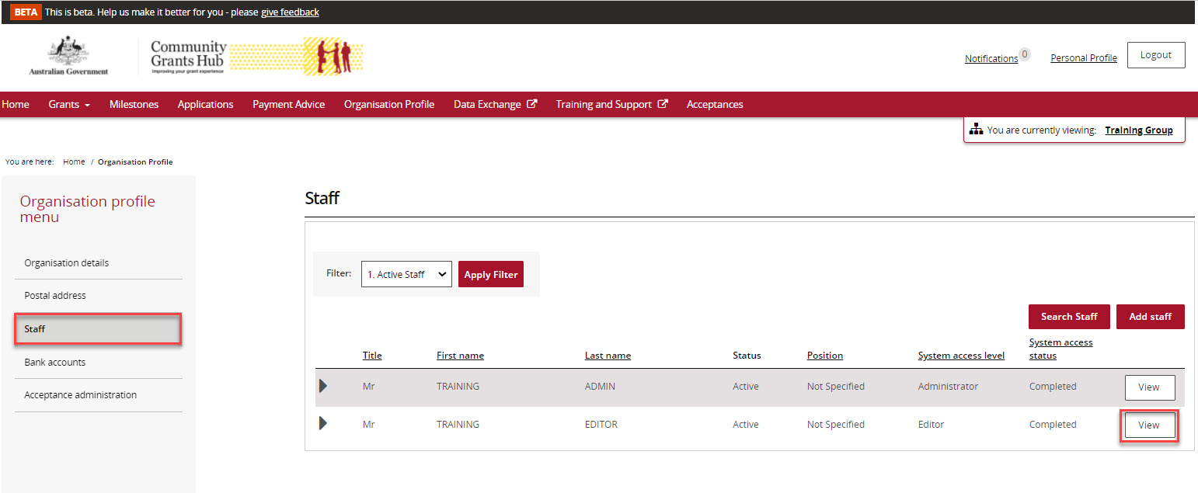
The staff details in the screen below will appear with three buttons: Activate, Inactivate and Update.
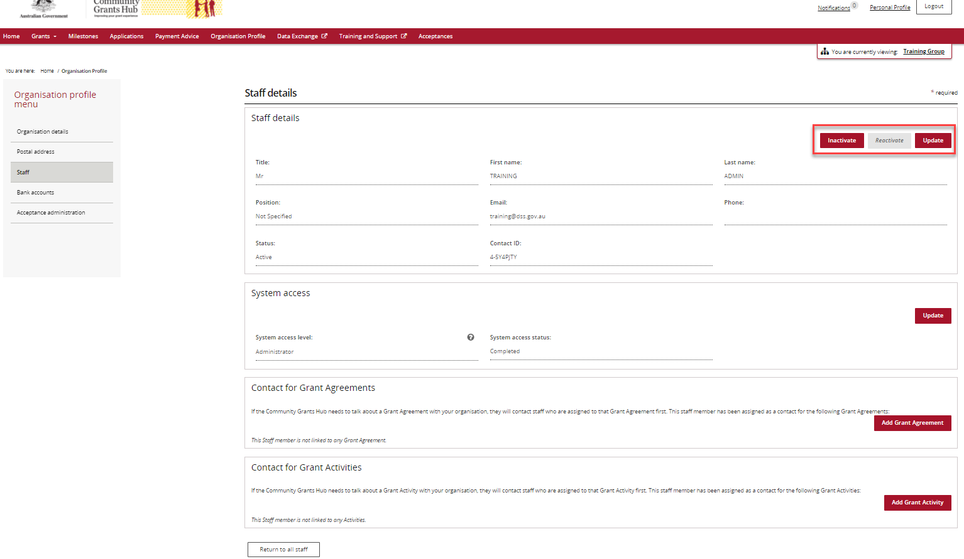
If a staff contact has been Inactivated, the Update button will be disabled. If the staff member is Active, the Update and the Inactivate buttons will be enabled.
To inactivate a staff member, click on the Inactivate tab. When the staff member is Inactivated the screen below will be displayed with the only option available to Reactivate the staff member.
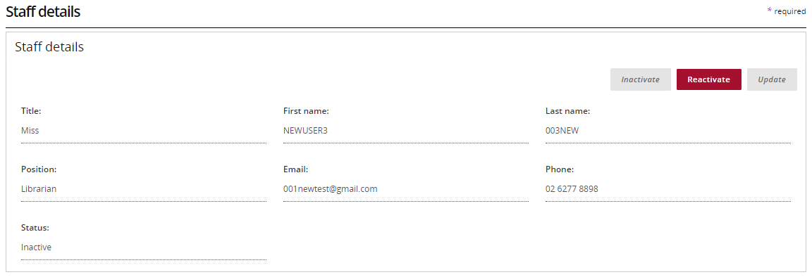
Administrators for the system cannot inactivate their own Staff record. Another Administrator will be required to do this.
If a Staff record is the Primary Contact attached to a current Agreement, Program Schedule or Activity then the staff contact record cannot be inactivated until another Primary Contact is assigned to the Agreement, Program Schedule or Activity.
If the Staff record is listed with an access status of ‘requested’ it cannot be inactivated and you will get the following error message:
“The Staff record cannot be inactivated at the moment as a system access request is already in progress for this staff member. Please try again later or contact the Helpdesk on 1800 020 283, option. 5”.

Activating a staff record
From the staff list click on the View button next to the staff member.

Their detail screen will appear and only the Reactivate button will be enabled.
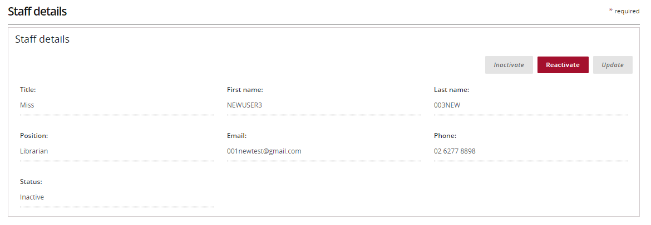
Click on the Reactivate button. This will make the Staff record an active contact for the Organisation.
Reactivating staff at this level does not re-establish any prior relationships to Agreements or Activities in the Portal.

Need assistance
If you require assistance in using the Grant Recipient Portal contact the Grant Recipient Portal Helpdesk at GRP.Helpdesk@communitygrants.gov.au or on 1800 020 230 (option 5).

