Searching Staff in the Grant Recipient Portal
  - New search functions making it easier for Organisation Administrators to find staff listed in the Portal.

Searching for Staff in the Portal
The following new features are now available on the Staff list in the Organisation Profile menu to assist you in finding staff in the Portal:
- a status column displayed in the staff list lets you know if a staff member is active or inactive in the system
- a new drop down filter – allowing you to list active staff, inactive staff and all staff on the system.
- A new search staff button where you can search for staff by name, email, position and contact ID.

What does active and inactive staff mean?
Active staff are staff members who are listed on the Hub’s system as a contact for an Organisation.
Inactive staff are staff members who are listed as a contact for an organisation in the Hub’s system but have an end date against their record as they are no longer a contact for an organisation.

How do I filter search for staff
When you select Staff in the Organisation Profile, the screen below will appear. Click on Active, Inactive or All staff and click on apply filter button to change the view. If you select All staff it will place the active contacts at the top of the list.

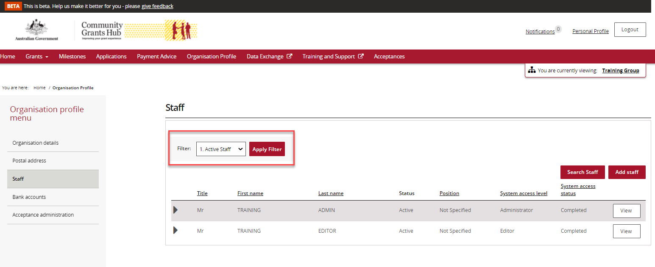

What does the status column tell me?
The status column has been added to the view to assist you in identifying staff members who are active or inactive.

How do I search for staff?
When you select Staff in the Organisation Profile the following screen will appear. Click on the Search Staff button.
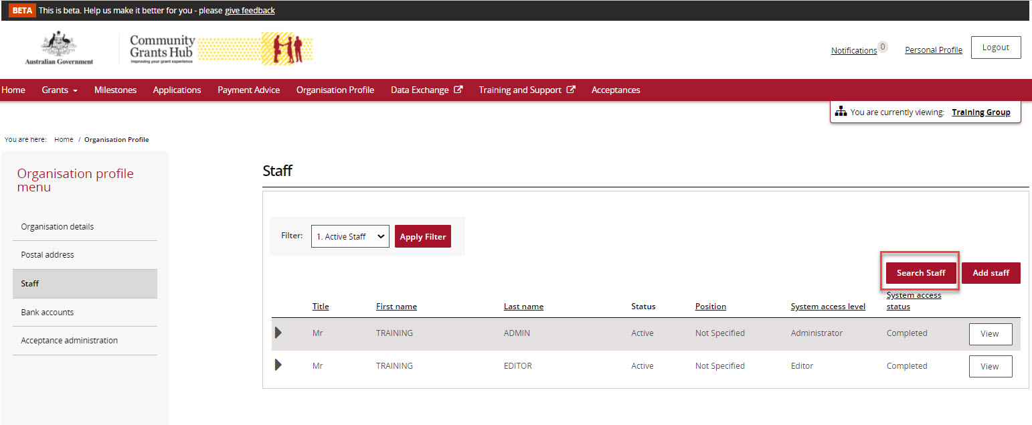

The screen below will appear that allows you to search by First name, Last name, Email, Position and/or Contact Id.
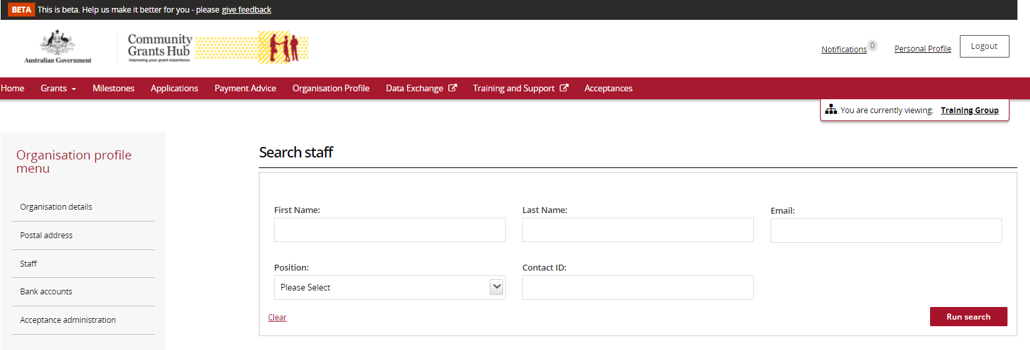
Once you have entered in the information you need to select Run Search to continue with the search or Cancel to exit the search.
When the search is complete the following screen will appear that provides you with the Name, Position, Email, System access level, System access status and Contact status of staff based on your search criteria.
Identify the staff member and click on the View button next to their name.
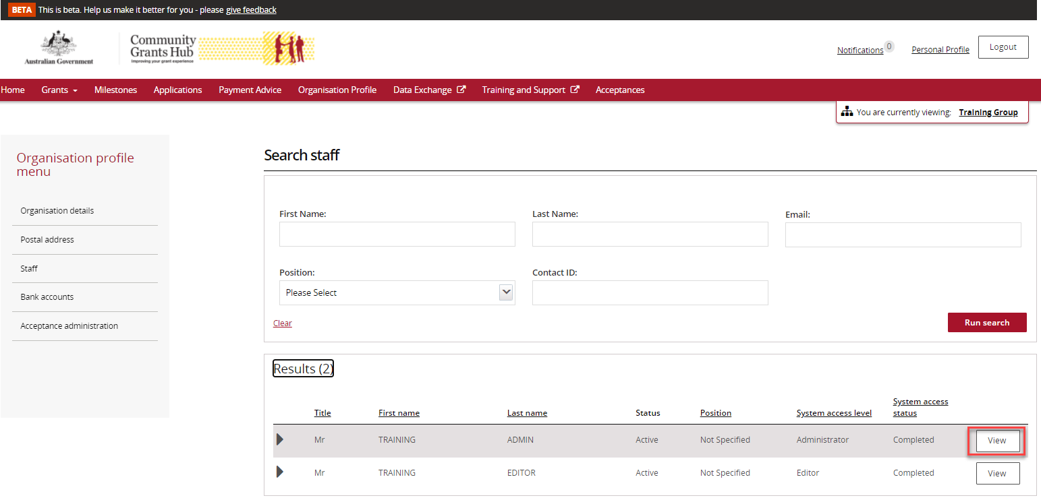

This will take you to the screen below. In this screen you can:
- Activate or Inactivate the staff member
- Update contact details
- Update their system access
- Add them as a contact to a Grant Agreement
- Add them as a contact to a Grant Activity.
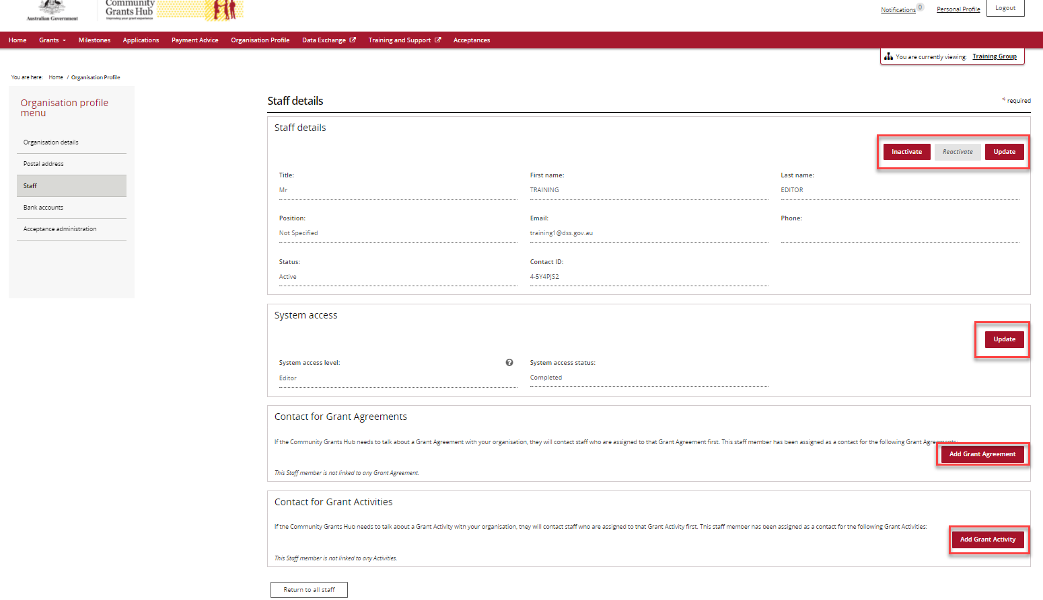

Need assistance
If you require assistance in using the Grant Recipient Portal contact the Grant Recipient Portal Helpdesk at GRP.Helpdesk@communitygrants.gov.au or on 1800 020 230 (option 5).

