Grant Activity Contacts in the Portal
  - Changes to the Staff Details page in the Portal when adding staff members as contacts for Grant Activities for Organisation Administrators.

Contacts for Grant Activities
An Organisation Administrator for the Portal, can Add and Remove a contact to a Grant Activity in the Grant Recipient Portal, either through the Organisation Profile or through the Grant Activities tile on the home page.

Organisation Profile
Click on the Organisation Profile and select Staff from the sub menu. A list of staff for your organisation will be displayed. Click on the View button next to the staff member you wish to add as a contact to an activity.
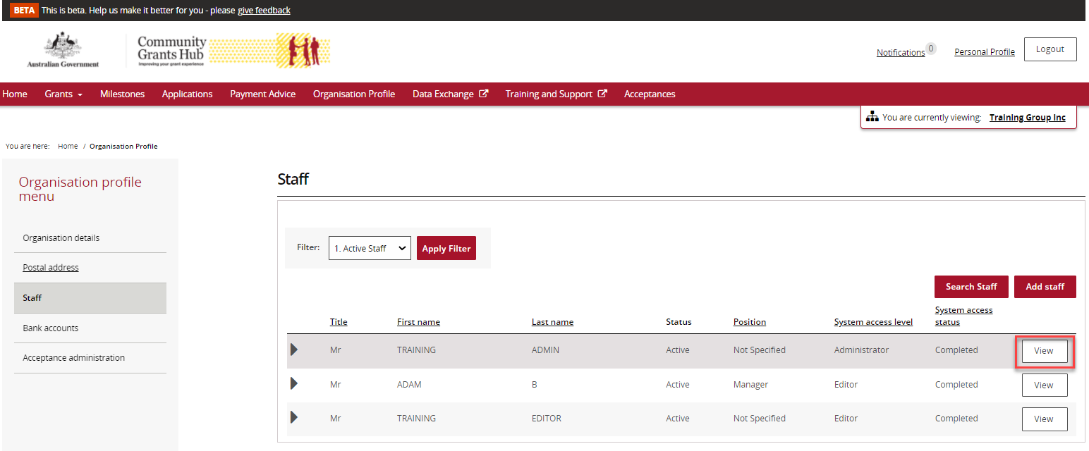

The screen below will appear with the staff details. Click on the Add Grant Activity button.
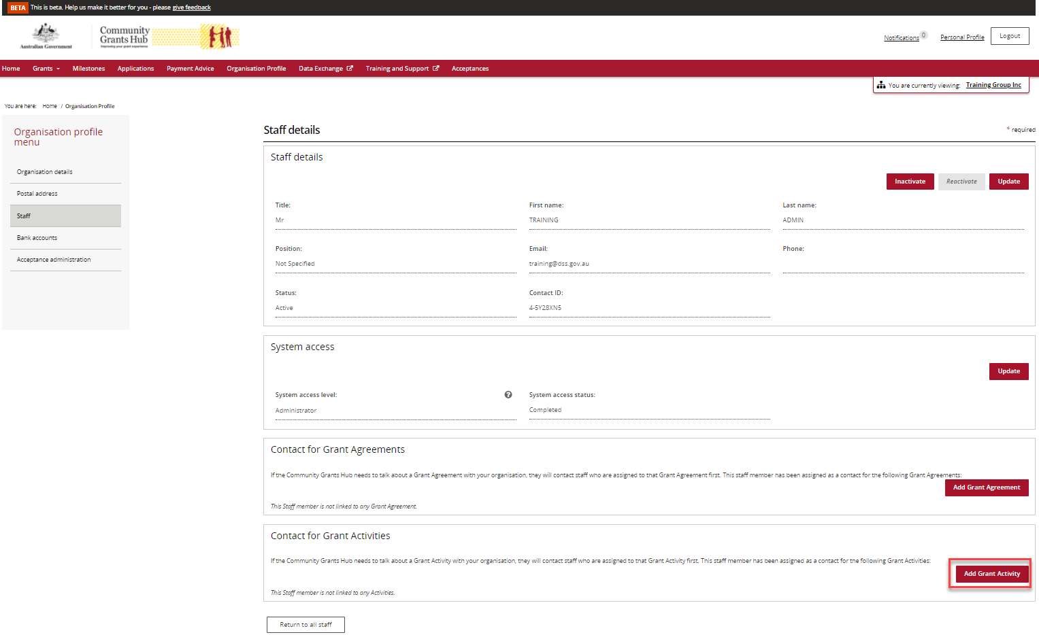
A list of Grant Activities for your organisation will appear. Click on the Action button next to the Grant Activity you wish to add the staff member as a contact and select Assign as a contact or Assign as a Primary Contact.
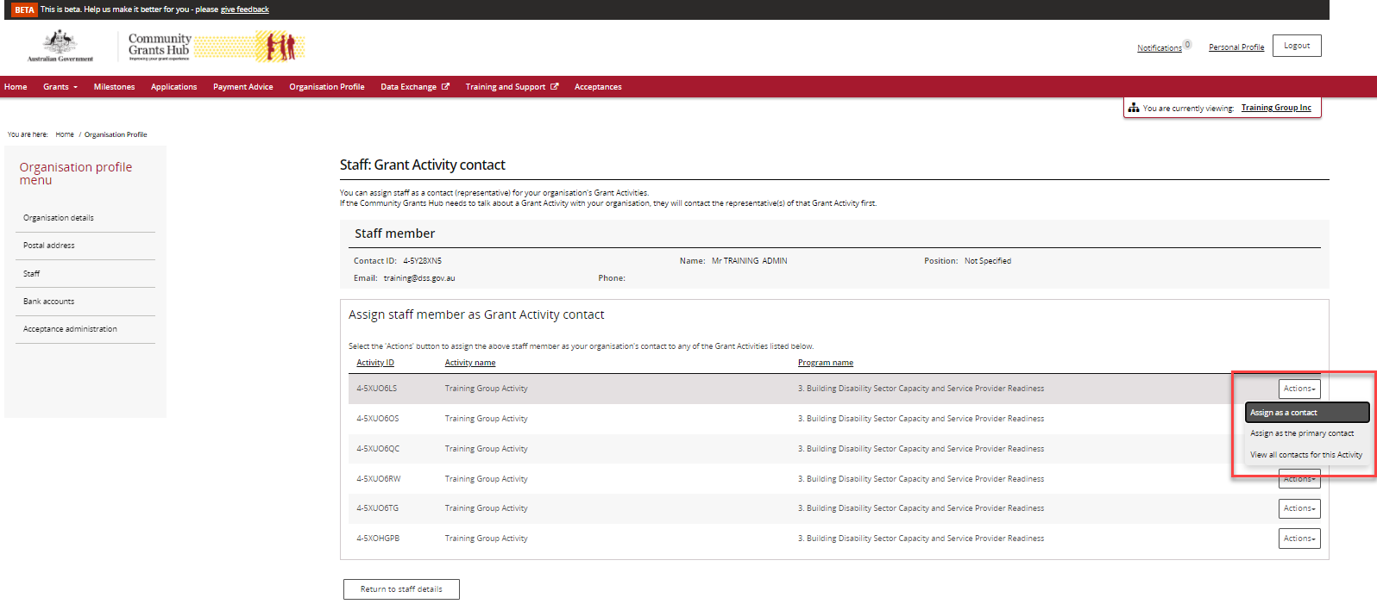

When the staff member is Assigned as a contact the confirmation message below will appear on the screen.
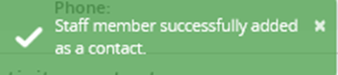
If the staff member is selected as the Primary contact the confirmation screen below will appear. Click on Continue to proceed.
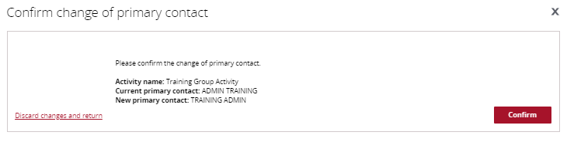
To remove the staff member as a contact, go to Organisation profile, Staff and click on the View button next to the staff member.
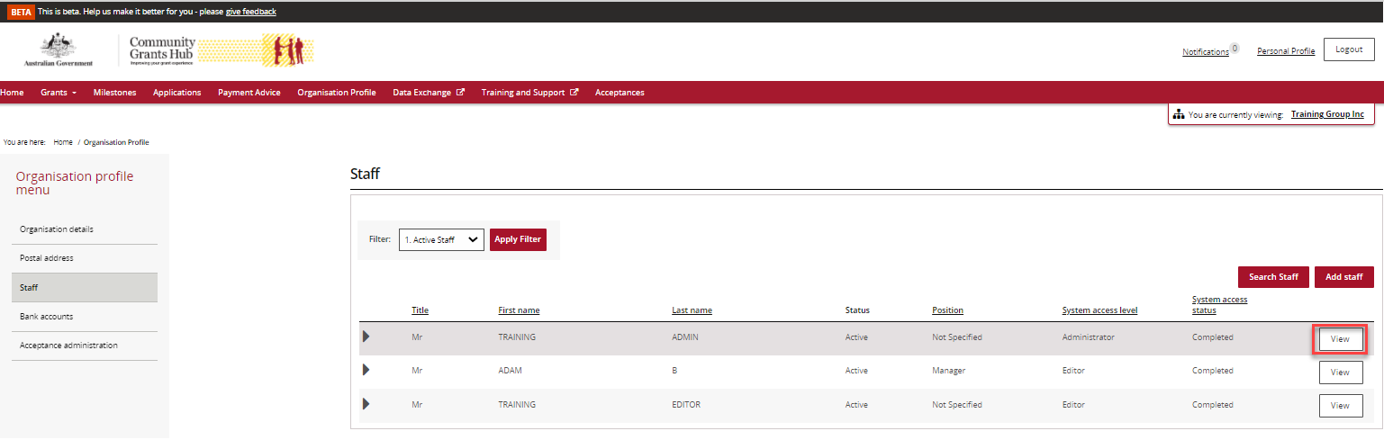

The Staff detail screen will appear. In the Contact for Grant Activity section, click on the Action button next to the Grant Activity and select Remove as contact.
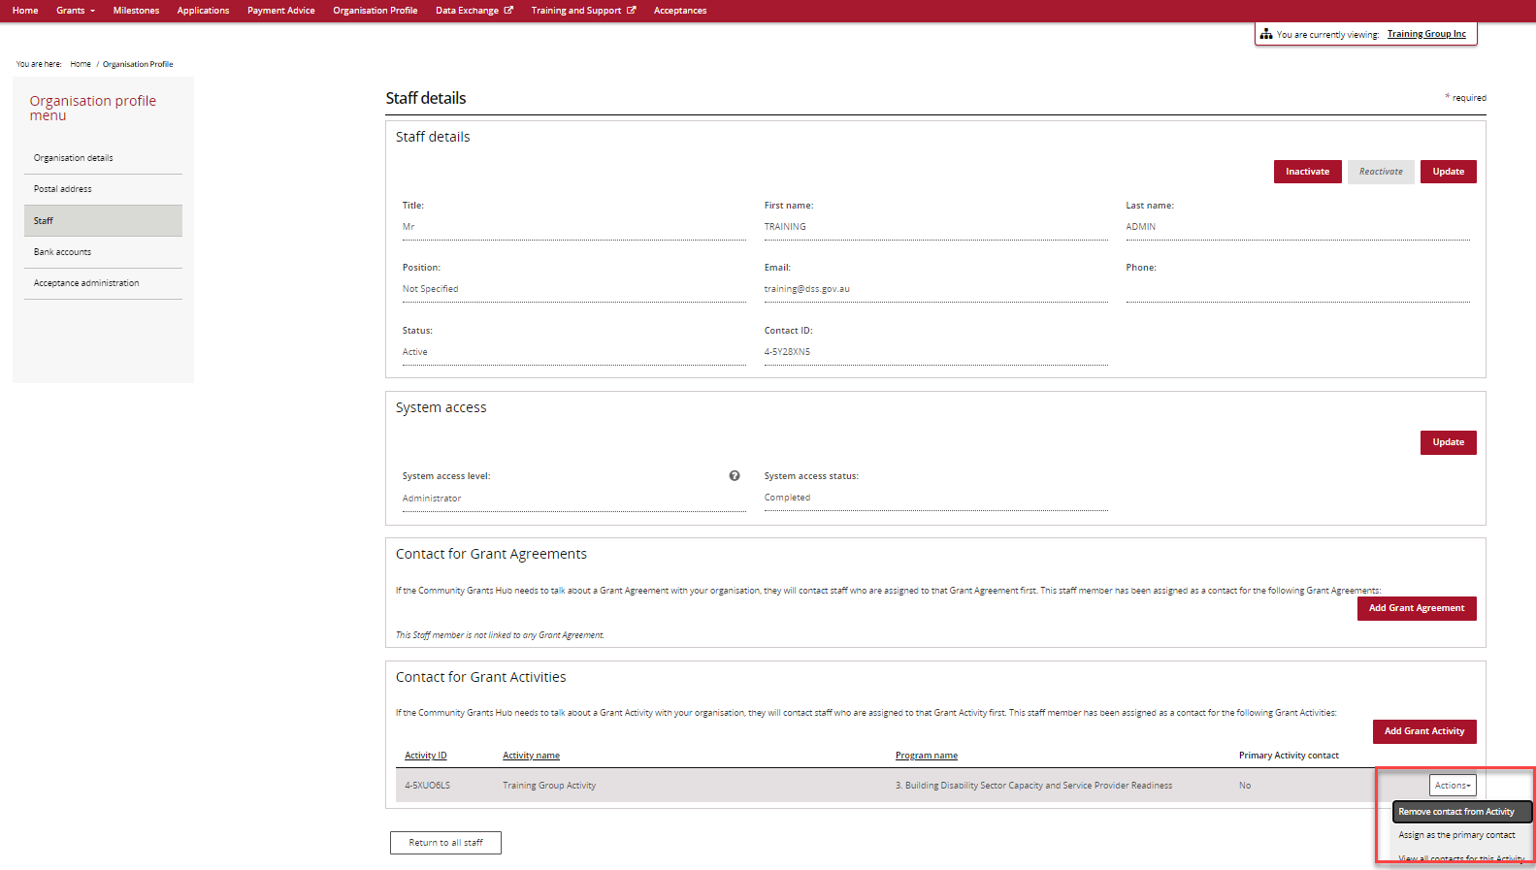

Grant Activity page
Click on the Grant Activity tile on the home page of the Portal and select the View button next to the Grant Activity you wish to add a contact.
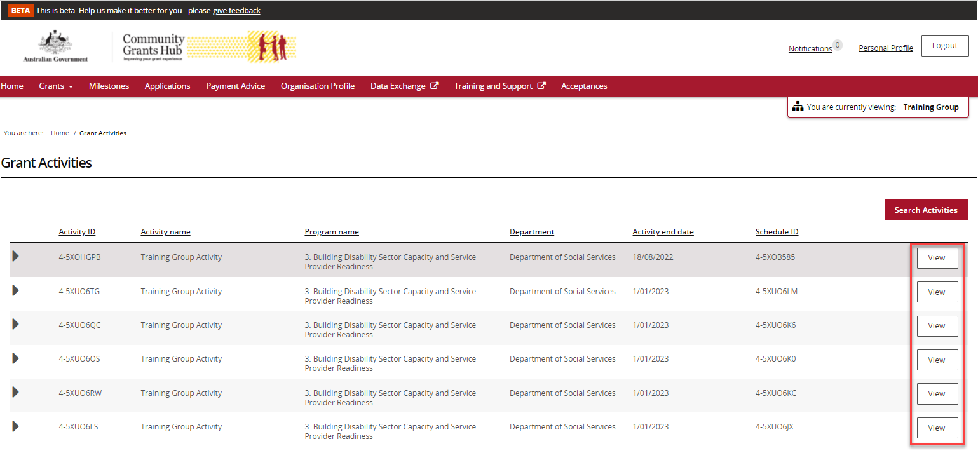
Select the Contact button from the menu on the left hand side. A list of all contacts for that Grant Activity will be displayed. Click on the red button Link another contact.
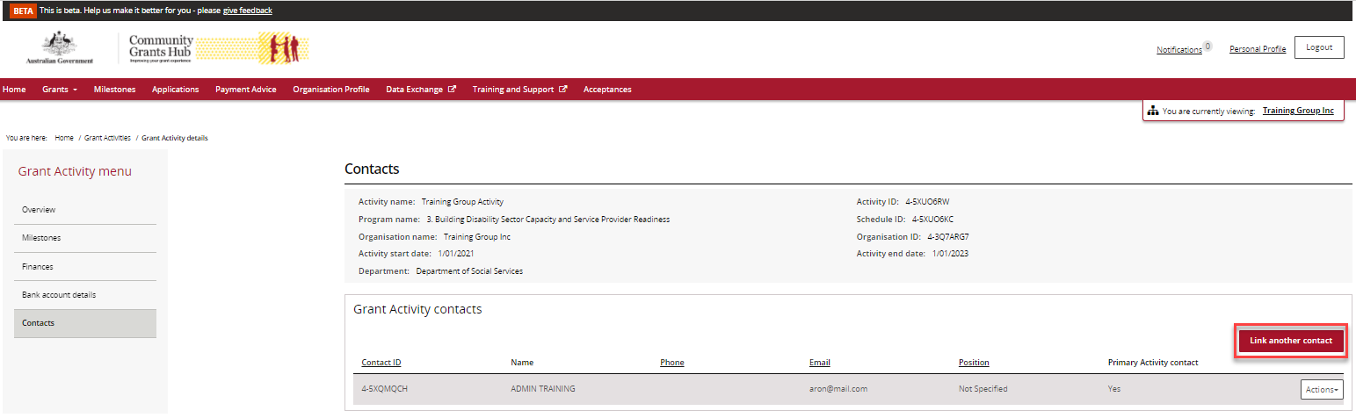
A list of active contacts in the organisation will be listed. Click on the box next to the staff member(s) you wish to add to the Grant Activity, then click on the red Confirm selection button.
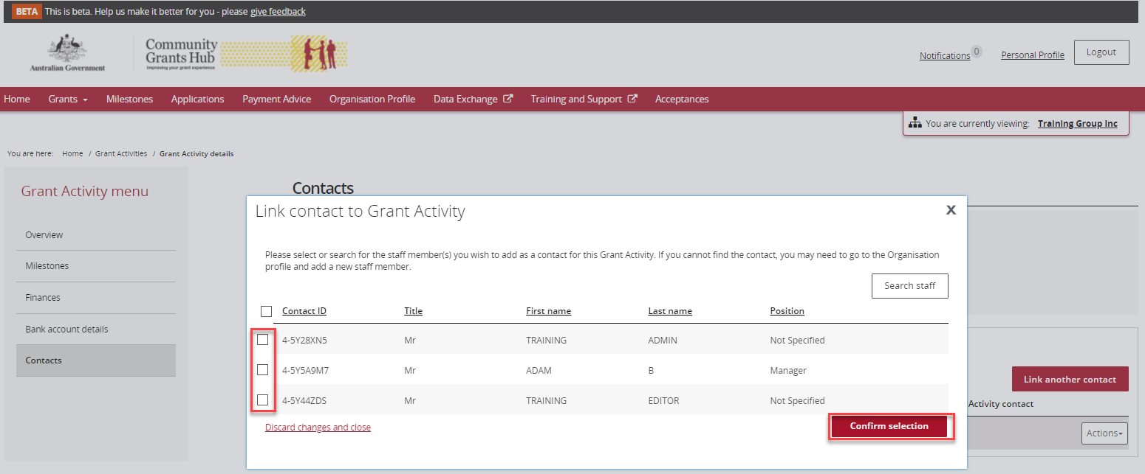
The confirmation message below will be displayed when the staff member(s) have been added as a contact for the Grant Activity.
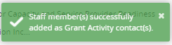

To remove a contact go to the Grant Activity, Contact screen and click on the Action button next to the contact you wish to remove. Click on Remove Contact.
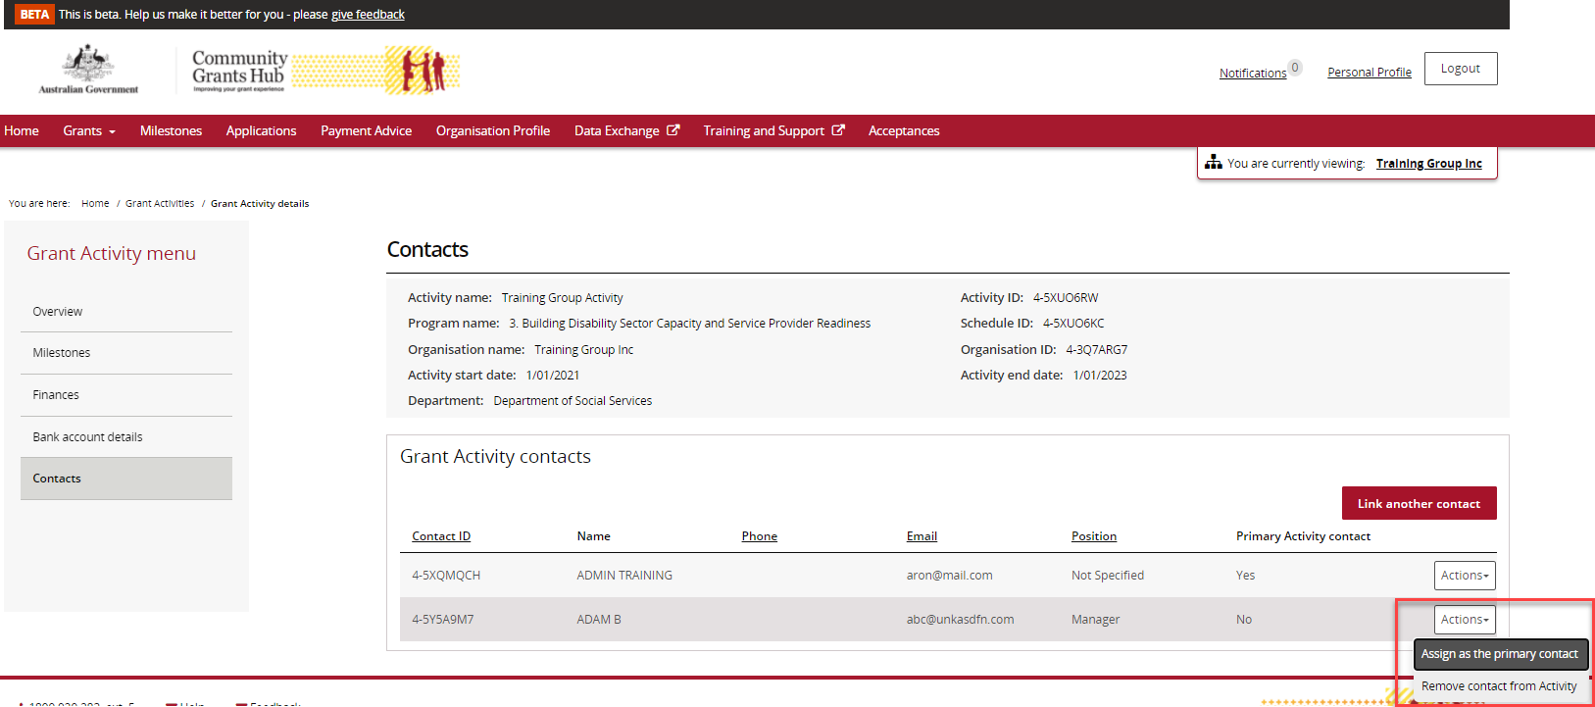
The message below will appear.
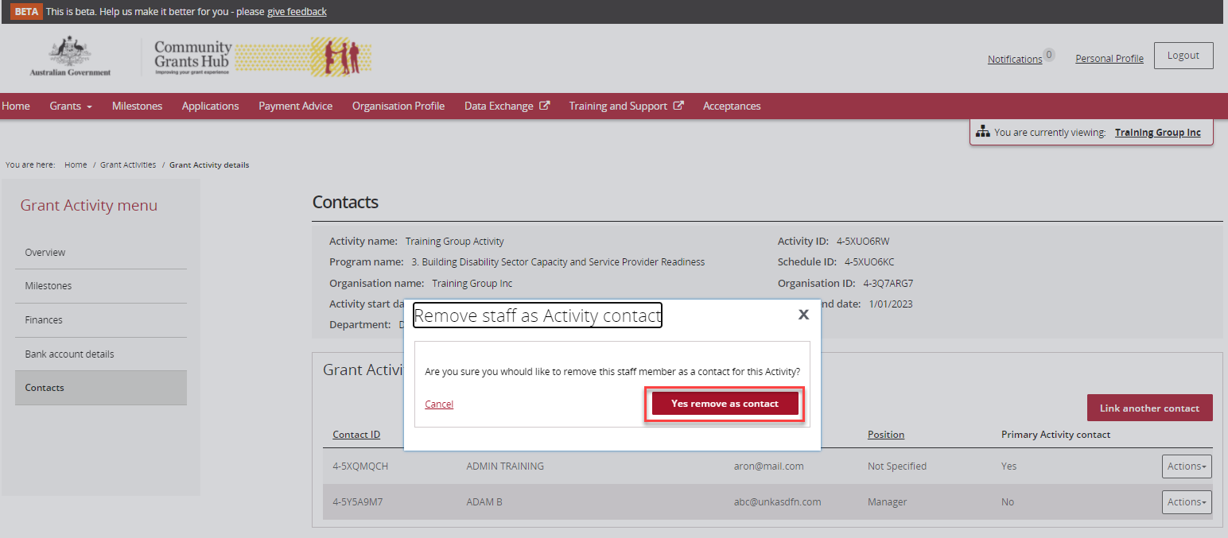
Click on the red button, Yes remove as contact, to confirm you wish to remove the contact. The contact has now been removed from the Grant Activity.

Need assistance
If you require assistance in using the Grant Recipient Portal contact the Grant Recipient Portal Helpdesk at GRP.Helpdesk@communitygrants.gov.au or on 1800 020 230 (option 5).

