Grant Agreement Contacts in the Portal
  - Changes to the Staff Details page in the Portal when adding or removing a staff member as a contact for a Grant Agreement - for Organisation Administrators

Contacts for Grant Agreement
An Organisation Administrator for the Portal, can Add and Remove a contact to a Grant Activity in the Grant Recipient Portal, either through the Organisation Profile or through the Grant Agreement tile on the home page.

Organisation – Adding a contact to a Grant Agreement
To add a staff member as a contact for a Grant Agreement, click on the Organisation tile on the home page.
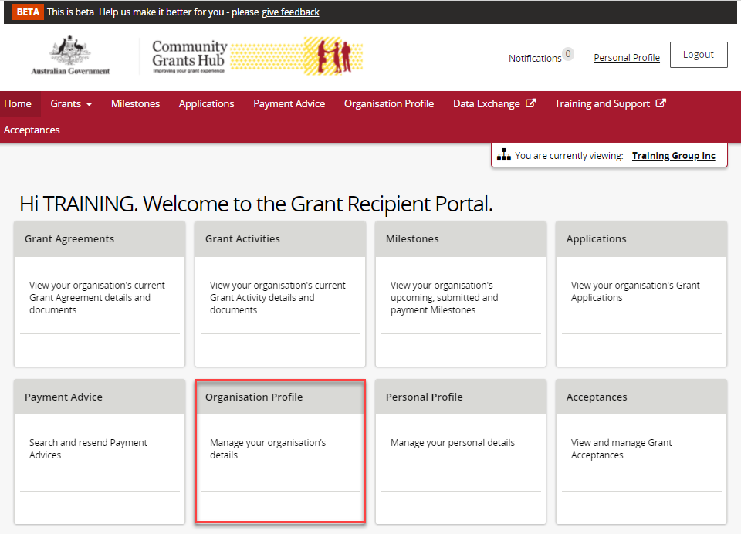
Select Staff from the side menu. Click View next to the staff member you wish to add as a contact for a Grant Agreement.
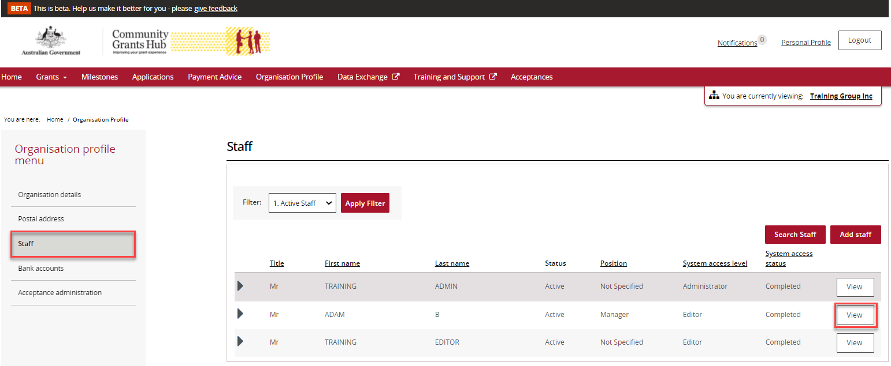
The Staff details page will be displayed. Select the Grant Agreement button.
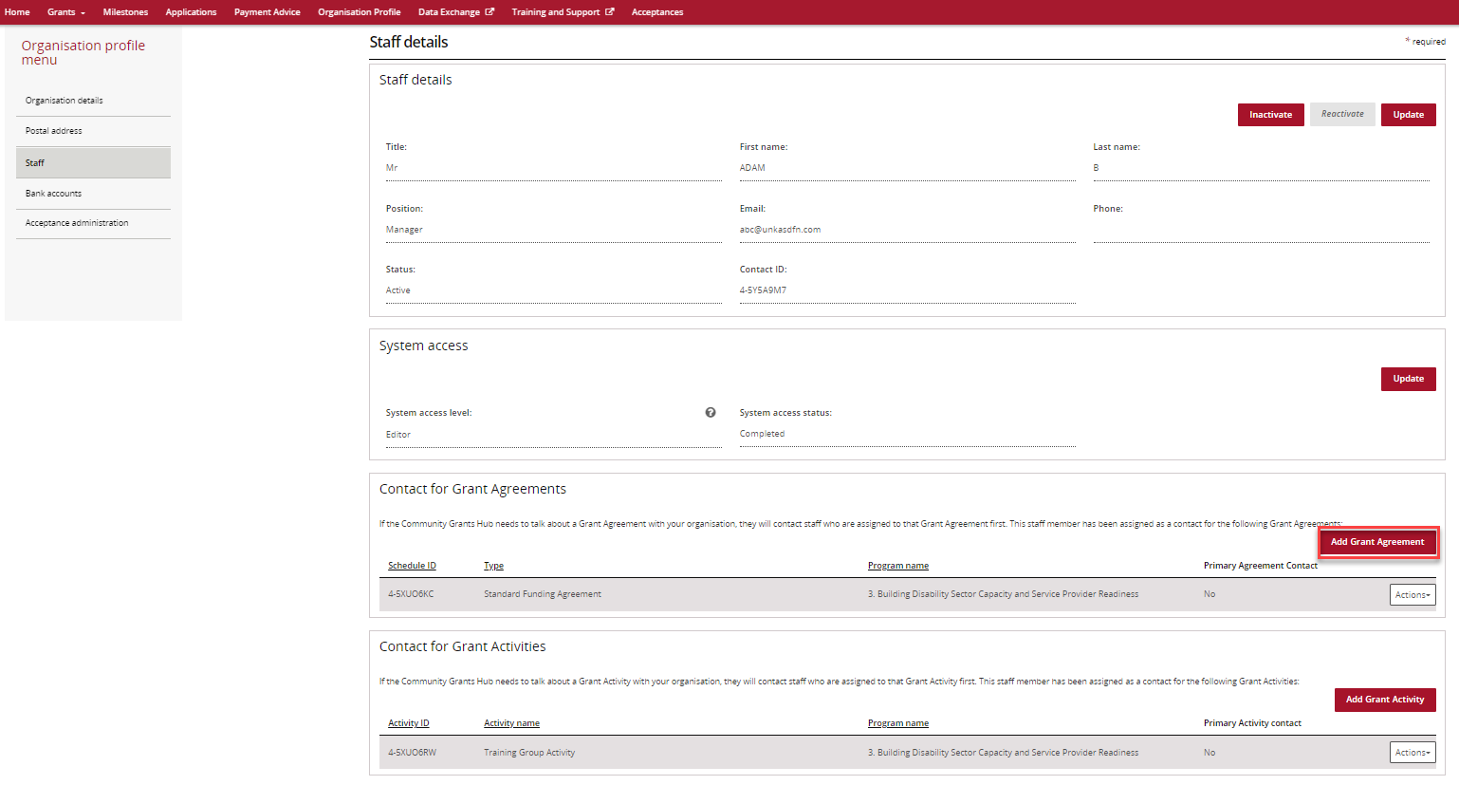

Next to the Grant Agreements listed is an Actions button that provides you with the options to Assign as a contact or Assign as a Primary Contact.
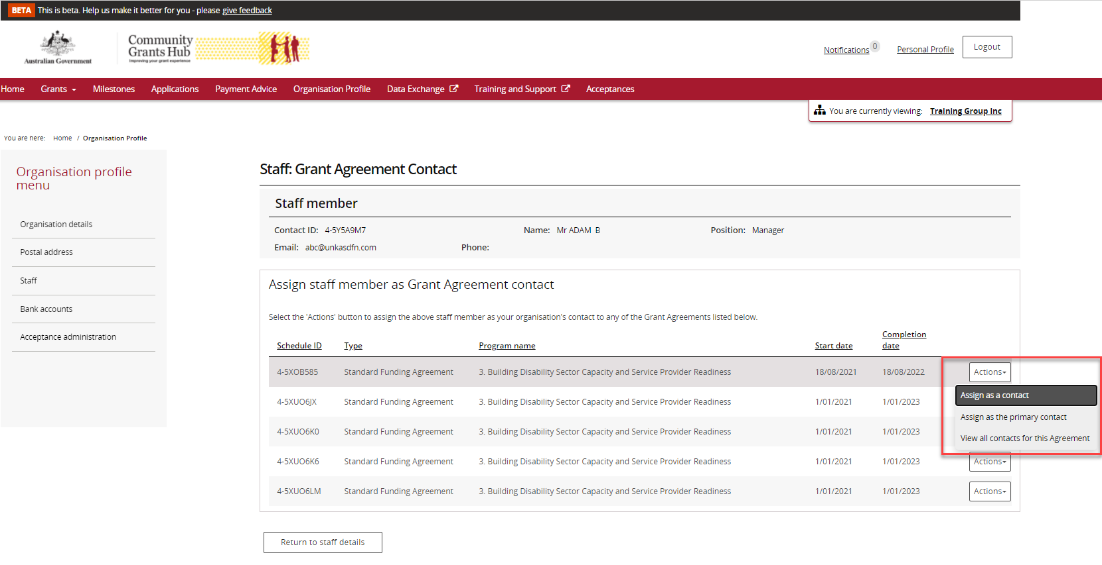
When you select the Assign as the primary contact a confirmation message will be displayed asking you to confirm the change by selecting Continue.
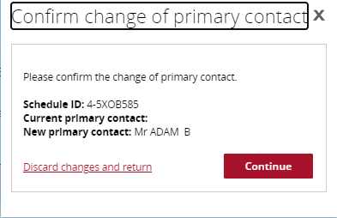

Organisation - Removing a Contact from a Grant Agreement
To remove a staff member as a contact for a Grant Agreement, go back to the Staff page and go to the Grant Agreement section. Click on the Actions button next to the Grant Agreement you wish to remove the staff member as a contact and select Remove contact from Agreement.
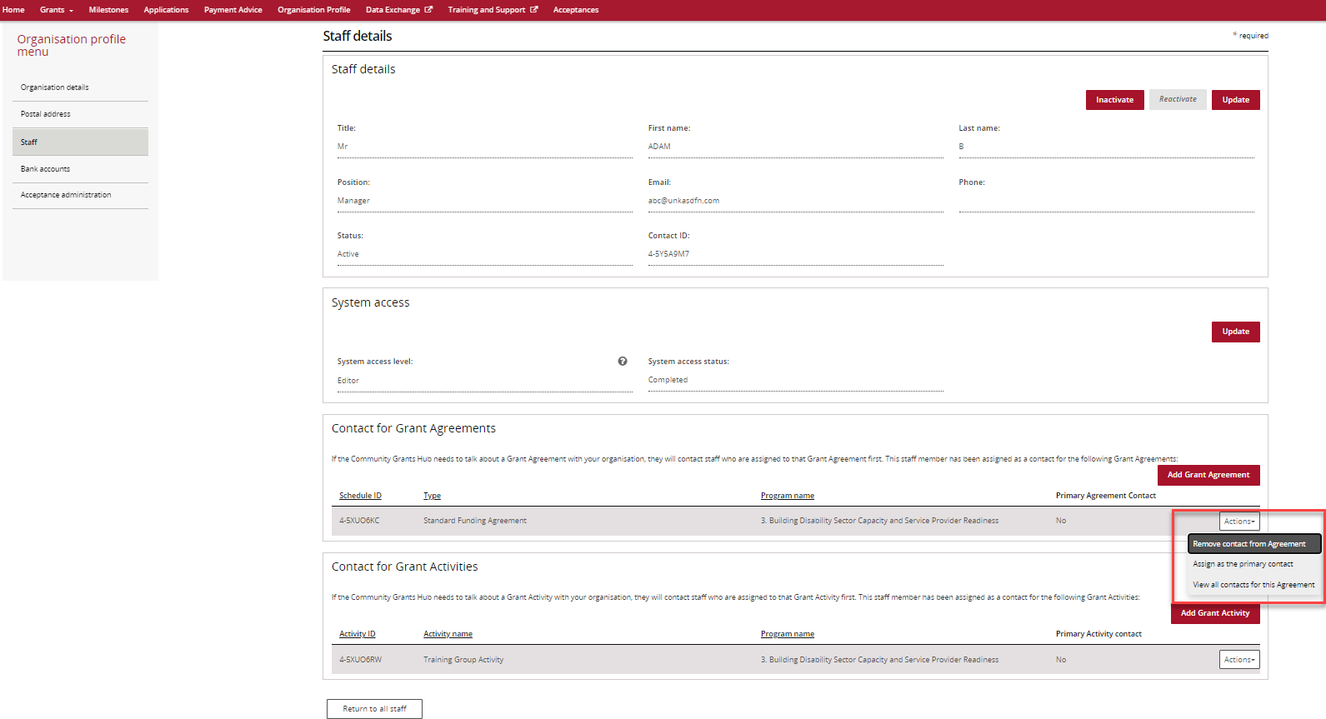

Grant Agreement – Adding a contact
Click on the Grant Agreement tile on the Home page.
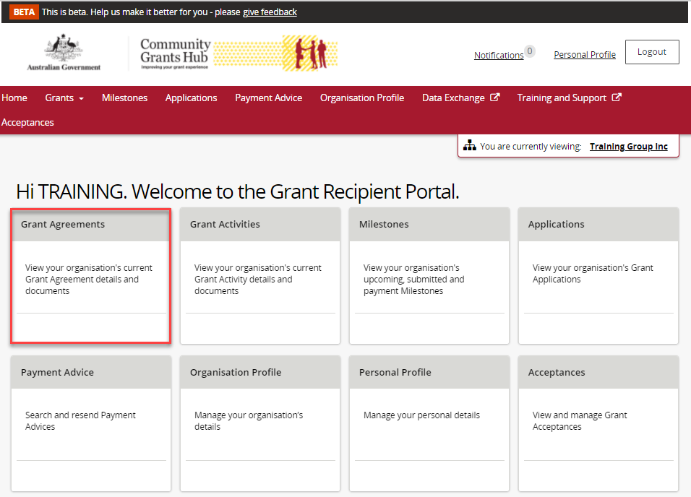
A list of Grant Agreements for your organisation will be displayed. Click on the View button of the Grant Agreement you wish to add the contact.
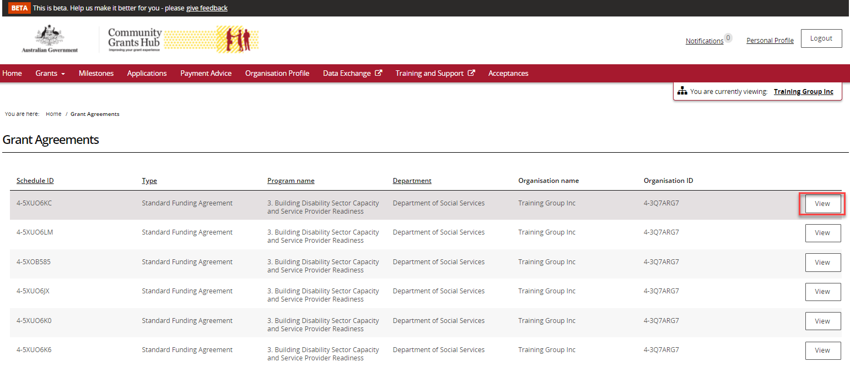
The Agreement details page will be displayed. Click on Contacts in the sub menu, then click on the Add another contact button.
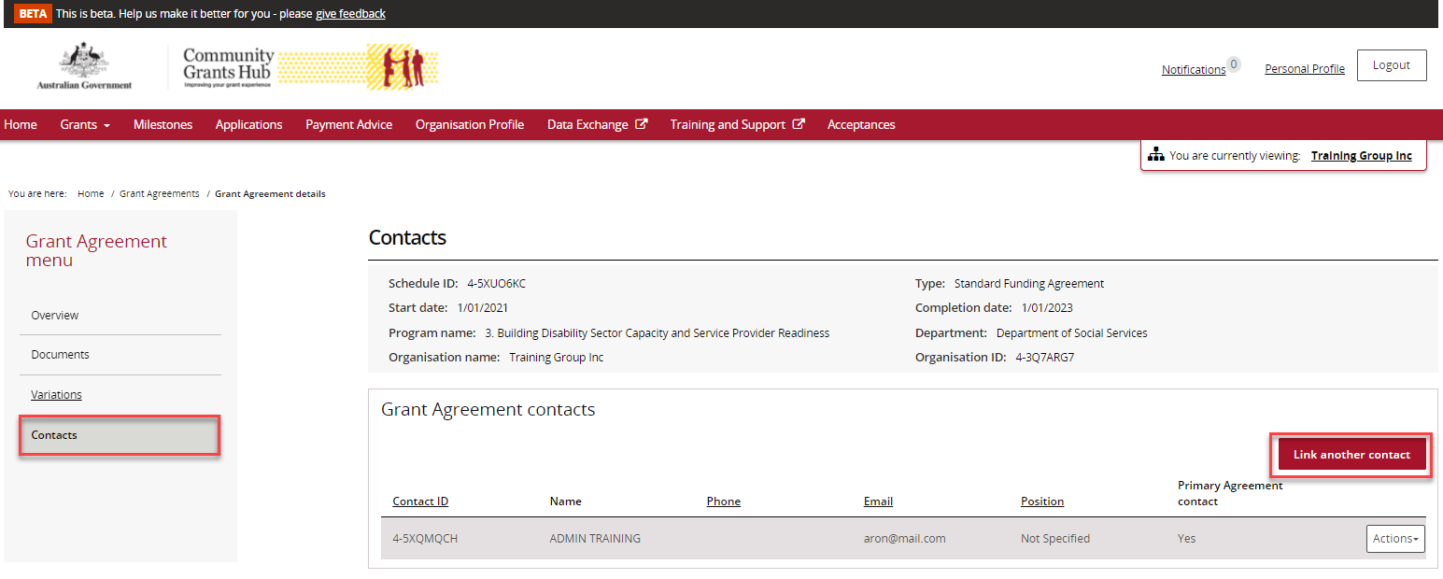
A list of staff for the organisation will be displayed. Click on the box next to the staff member(s) you wish to add as a contact for the Grant Agreement and then click on the Confirm selection button. Your contact has now been added to the Grant Agreement.
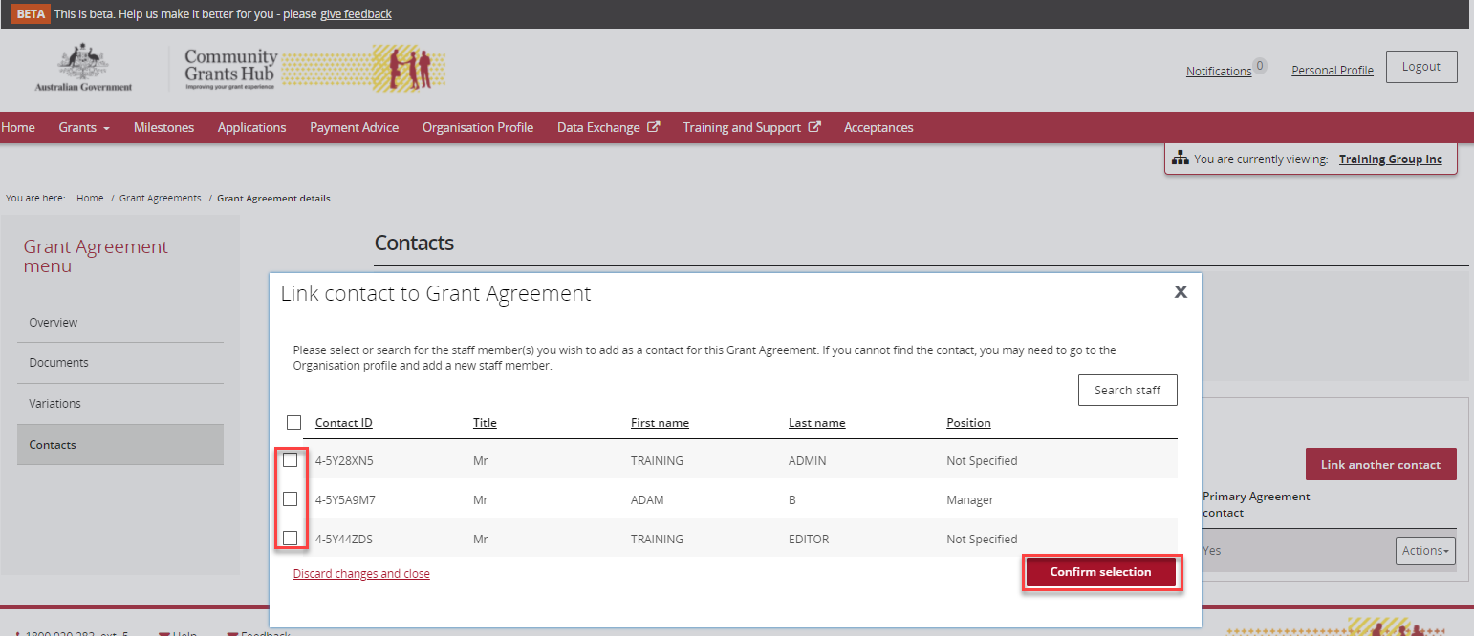
A message will be displayed advising the contact was successfully added to the Grant Agreement.

Grant Agreement – Removing a contact
You can also remove a contact from the Grant Agreement, Contact screen by selecting the Actions box next to the contact and selecting Remove contact from Agreement.
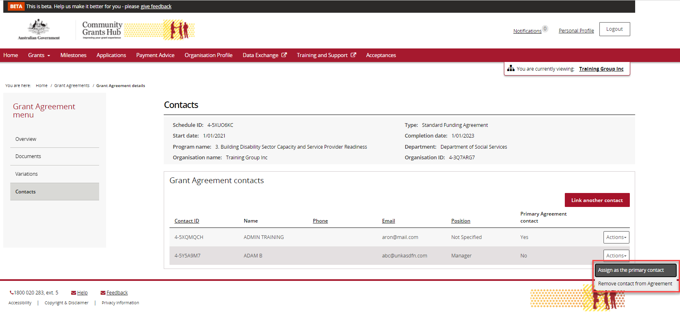
The message box below will be displayed. Click on the Yes remove as Agreement contact.
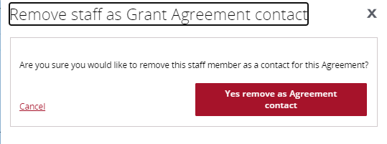

Need assistance
If you require assistance in using the Grant Recipient Portal contact the Grant Recipient Portal Helpdesk at GRP.Helpdesk@communitygrants.gov.au or on 1800 020 230 (option 5).

