Online Acceptance – Introduction
  - Introduction to the Online Acceptance process in the Grant Recipient Portal

Please note this functionality will not be operating in the Grant Recipient Portal until March 2022. This information sheet is to provide your organisation with visibility of upcoming functions to the Portal.

Introduction
This is the first of a series of information sheets to assist you in understanding and using the Online Acceptance process in the Grant Recipient Portal. The Online Acceptance process allows the Hub to send funding offers through the Portal where grant recipients can accept, decline or acknowledge the offer online. The information sheets in the series cover:
- Introduction to the Online Acceptance process.
- Online Method of accepting a funding offer through the Portal
- Proxy Method of accepting a funding offer through the Portal.
- Managing your Acceptance Administration in the Portal.
- Managing your signatories for funding offers in the Portal.
For both the Online and Proxy method, organisations will need to set up their acceptance administration and funding offer signatories.

Acceptance methods for funding offers in the Portal.
There are two methods available in the Portal for accepting funding offers, Online or Proxy. The current process of Offline where your organisation receives the agreement via email, will still be available.

Online Method
The Online Acceptance process allows a grant recipient to receive and accept the funding offer fully online through the Portal by digitally accepting the offer. This has been developed for organisations where their internal processes and legal entity structure allow for digital approval of funding offers.

Online Process
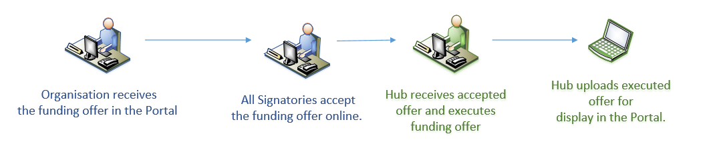

Proxy Method
The Proxy process allows a grant recipient to receive the funding offer online but will require the grant recipient to download, print, sign and upload the signature page to the Portal to accept the funding offer.
This process has been developed to allow organisations requiring approval and signature of funding offers by their organisation/board while still streamlining the function by receiving and submitting the accepted funding offer through the Portal.

Proxy process
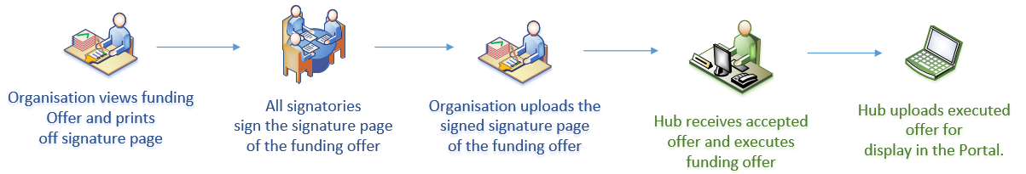

Offline
The Offline process is the current process for organisations not provisioned to the Portal and is managed directly through the Community Grants Hub via email. Organisations provisioned to the Portal can change their acceptance method from Online or Proxy to Offline by contacting the Grant Recipient Portal Helpdesk at GRP.Helpdesk@communitygrants.gov.au or on 1800 020 230 (option 5).

Preferences and Signatories for funding offers
If you are using the Online or Proxy method to accept your funding offers, you will first need to set up your signatories and preferences in the Portal. Below is an overview of the process however we recommend using the “Funding Acceptance - Administration Information Sheet” when setting up your signatories.

Acceptance administration
The Acceptance administration is where you identify your organisation’s preferred acceptance parameters for funding offers. Acceptance administration is located in the sub menu of the Organisation Profile tile on the home page of the Portal.
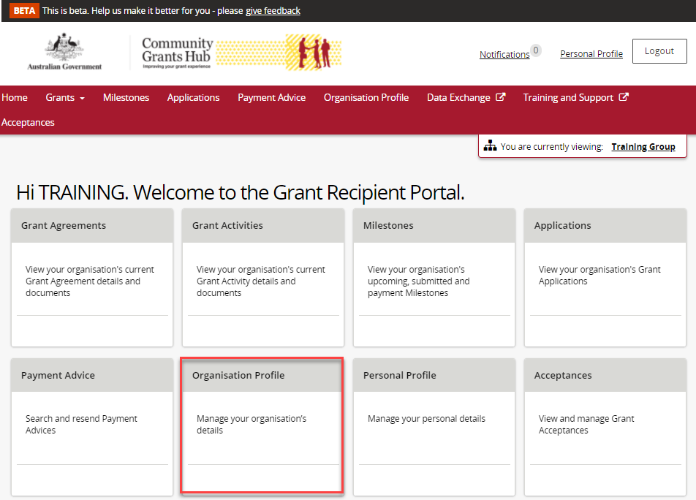

There are two sections within the screen, Acceptance Parameters and Recipient Signatories.
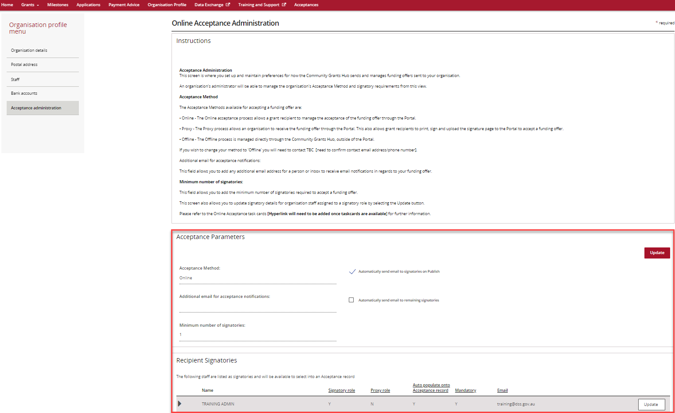

Acceptance Parameters
The Acceptance Parameters section allows you to:
- Identify what method of acceptance you wish to use e.g. Online or Proxy.
- Add an additional email for funding offer Portal notifications. Signatories will receive Portal notifications during the funding offer process.
- Identify the minimum number of signatories so it aligns with your organisation’s process for accepting funding offers.
- Identify the email notifications you wish to receive through the Portal during the acceptance process.

Recipient Signatories
The Recipient Signatories section is where all staff in the organisation are listed. This area shows you if they have been identified as a signatory for the organisation and in what role. You can also update their information and role in in this section.
The signatory roles for staff will default to N – No signatory delegation. To change their status to a signatory you must update their information (see the Funding Acceptance - Administration Information Sheet for more information on how to setup your signatories).
In the Recipient Signatories section you can see the roles delegated to staff. The example below shows that ‘Training Admin’ has been identified as:
- Having a Signatory role – meaning they can accept funding offers through the online method
- Not having a Proxy role – meaning they cannot accept a funding offer using the proxy method
- automatically populated as a signatory in any funding offers using the online method
- a Mandatory signatory – meaning they must accept any funding offers using the online method.

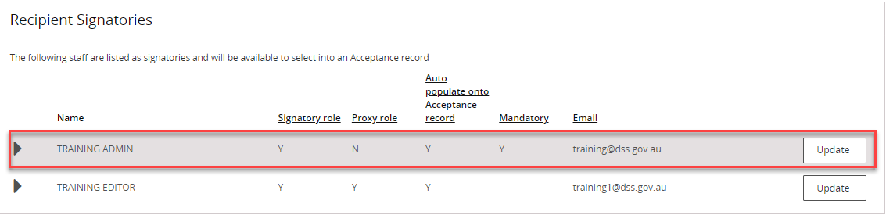

Managing individual funding offer Signatories
Once you have setup the permissions for individuals within your organisation the Provider Signatories section is where you can add or remove signatories for a particular funding offer. We recommend using the Funding Acceptance - Managing Signatories Information Sheet for more information around this process.
Staff who have been identified as a Mandatory signatory cannot be removed from this section. You must update their information to not mandatory in the Acceptance Administration section under Organisation Profile in order to remove them as a signatory (see Preferences and Signatories for funding offers above).
Provider Signatories is located in the Acceptances tile on the home page of the Portal.

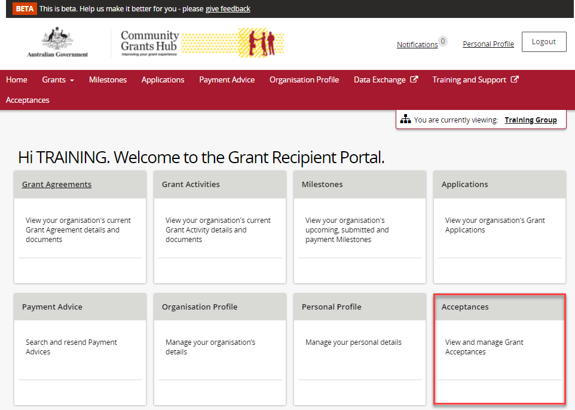

When you view a funding offer, you will be taken to the Acceptance Details page. At the bottom of the page is where the Provider Signatories section is located.
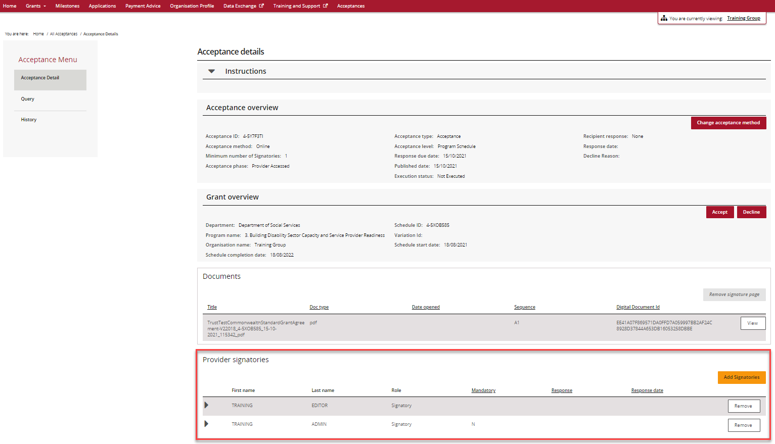
In this section staff who have been identified as a signatory for the funding offer are displayed. You can add signatories to the funding offer by clicking on the Add Signatory button or remove signatories for the funding offer by clicking on the Remove button.
When you click on the Add Signatory button, a list of available signatories with the appropriate role will be displayed for selection e.g. If Proxy method is identified for the funding offer, all staff identified as proxy signatories that are not already listed for the funding offer, will be displayed.
For more information see the Funding Acceptance - Managing Signatories Information Sheet.

Further Information
For more information see the training resources on the Grant Recipient Portal page of the Community Grants Hub website, listed below.
- Online Method of acceptance – Funding Acceptance - Online Method Information Sheet
- Proxy Method of acceptance – Funding Acceptance - Proxy Method Information Sheet
- Setting up Signatories and Preferences for funding offers – Funding Acceptance - Administration Information Sheet.
- Managing Signatories for individual funding offers – Funding Acceptance - Managing Signatories Information Sheet

Need assistance
If you require assistance in using the Grant Recipient Portal contact the Grant Recipient Portal Helpdesk at GRP.Helpdesk@communitygrants.gov.au or on 1800 020 230 (option 5).

