2. Funding Acceptance – Online Method
  - Organisation Administrator process for accepting funding offers online through the Grant Recipient Portal.

Please note this functionality will not be operating in the Grant Recipient Portal until March 2022. This information sheet is to provide your organisation with visibility of upcoming functions to the Portal.

Online Acceptance
The Online Acceptance process allows the Hub to send funding offers through the Portal where your organisation can accept, decline or acknowledge the offer online. There are three ways you can accept this offer:
- Online - The Online Acceptance process allows your organisation to receive and accept the funding offer online through the Portal.
- Proxy - The Proxy process allows your organisation to receive the funding offer online through the Portal. In this process, you will be required to download, print, sign and upload the signature page to the Portal to accept the funding offer.
- Offline - this is the current process for organisations not provisioned to the Portal and is managed directly through the Community Grants Hub via email. Organisations provisioned to the Portal can change their acceptance method from Online or Proxy to Offline by contacting the Grant Recipient Portal Helpdesk at GRP.Helpdesk@communitygrants.gov.au or on 1800 020 230 (option 5).

Online method
The Online method allows your organisation to electronically sign agreements within the Portal. This process will increase the turnaround time for the execution of your offers while also providing you with greater visibility of the process.
As your organisation will be digitally signing the agreement, it requires you to identify who is able to sign agreements on behalf of your organisation. Please refer to GRP Enhancement – 4. Funding Acceptance - Administration and GRP Enhancement – 5. Funding Acceptance - Managing Signatories information sheets for instructions on how to setup your organisations signatories. Once this setup has been completed you will not need to update this information unless there is a personnel change within your organisation.

Process
The below covers how your organisation accepts offers online through the portal.
Click on the Acceptances tile on the Home page of the Portal.
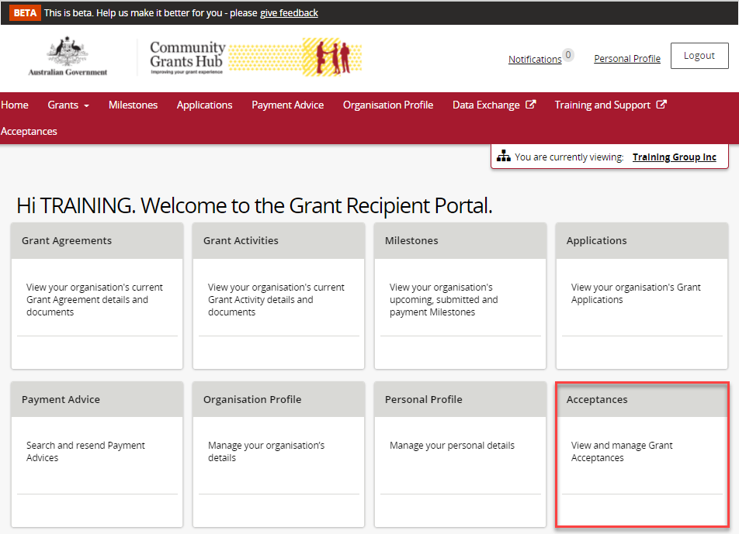

A list of all funding offers for your organisation will be displayed. To action the online process for a funding offer, click on the View button.
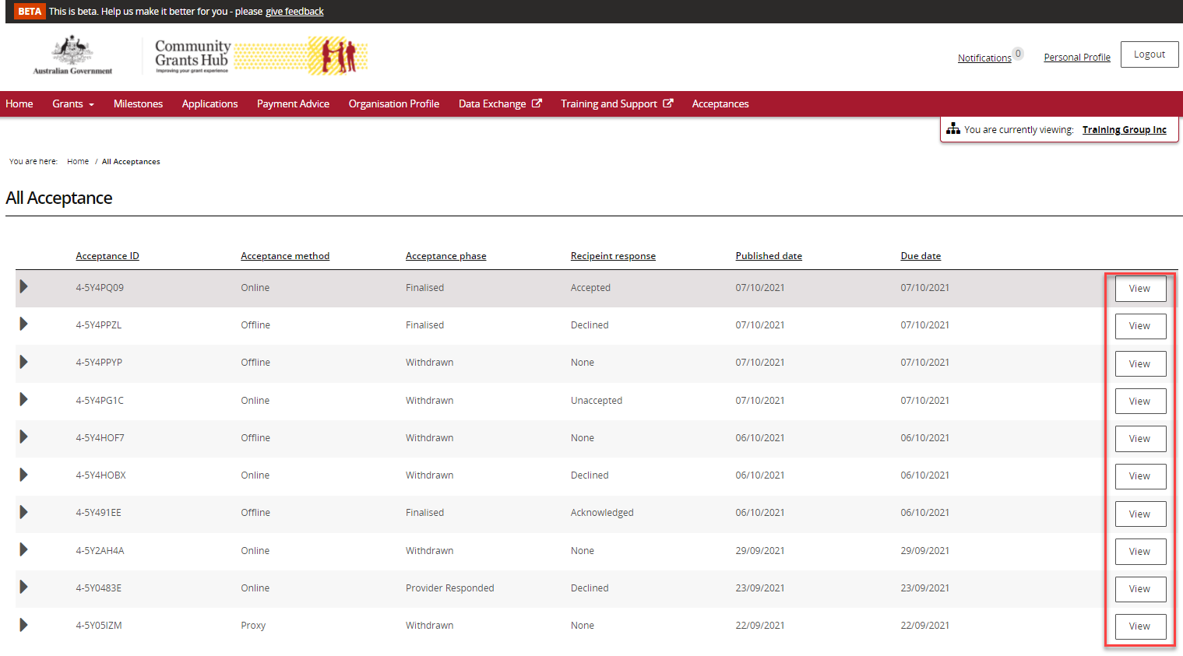

In the Acceptance Details view you will see information and links to assist you in performing the online acceptance process.
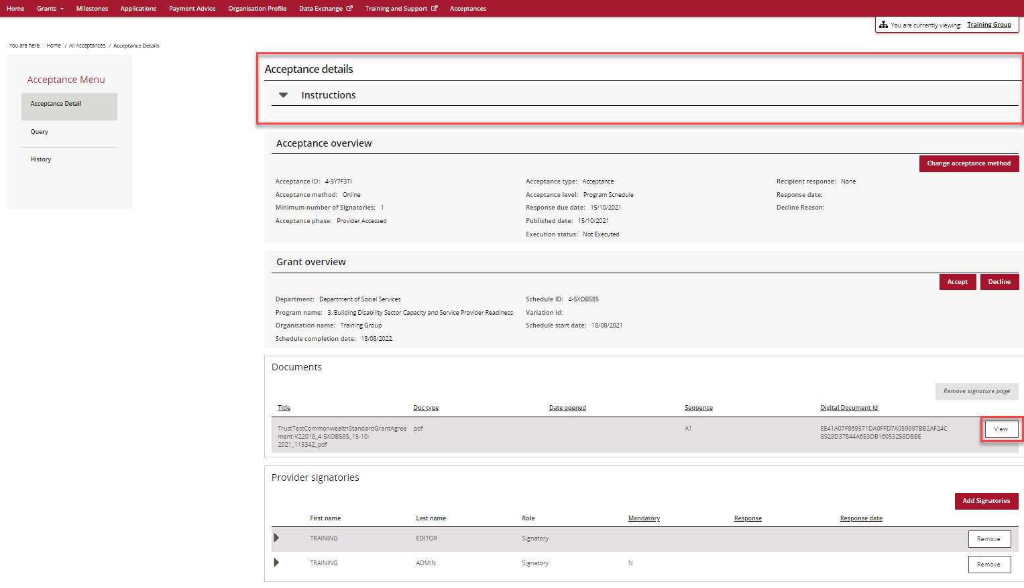

In this page you will also see the Acceptance overview that shows the:
- Acceptance Method currently set for the funding offer (Online, Proxy, Offline)
- Minimum Number of Signatories required to accept the funding offer. Please refer to the Funding Acceptance - Administration Information Sheet for further information on how to set up your signatory profile.
- Response Due Date.
To change the acceptance method from Online to Proxy click on the Change acceptance method button (for information on how to perform the Proxy method, see the Funding Acceptance - Proxy Method Information Sheet).

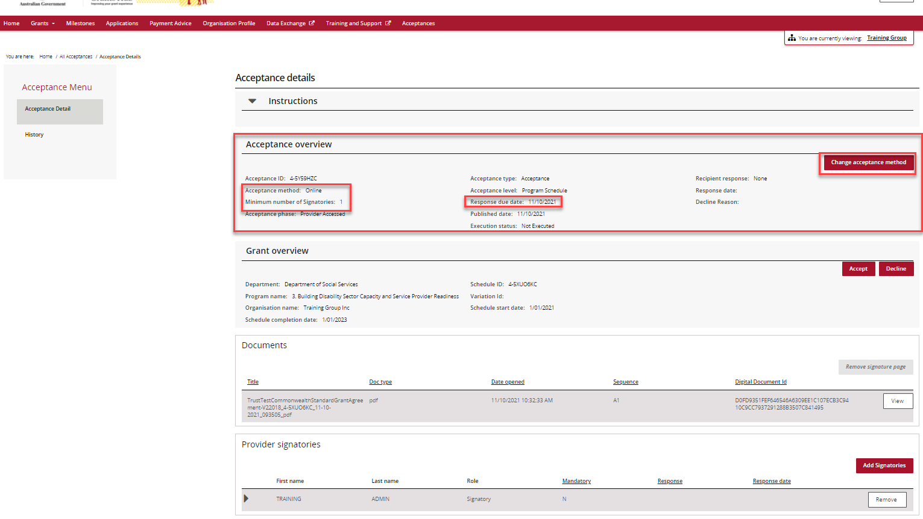

Further down the Acceptance Details view you will see the Grant overview section. This has information on the program and this is where you can Accept or Decline the funding offer.
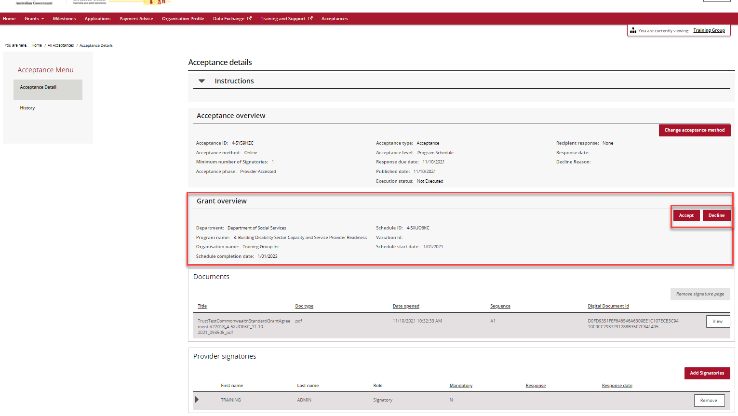

In the documents section of the page you will see a list of documents related to the funding offer.
You are required to view or download each document before accepting the funding offer. To download each of the documents click on the View button.
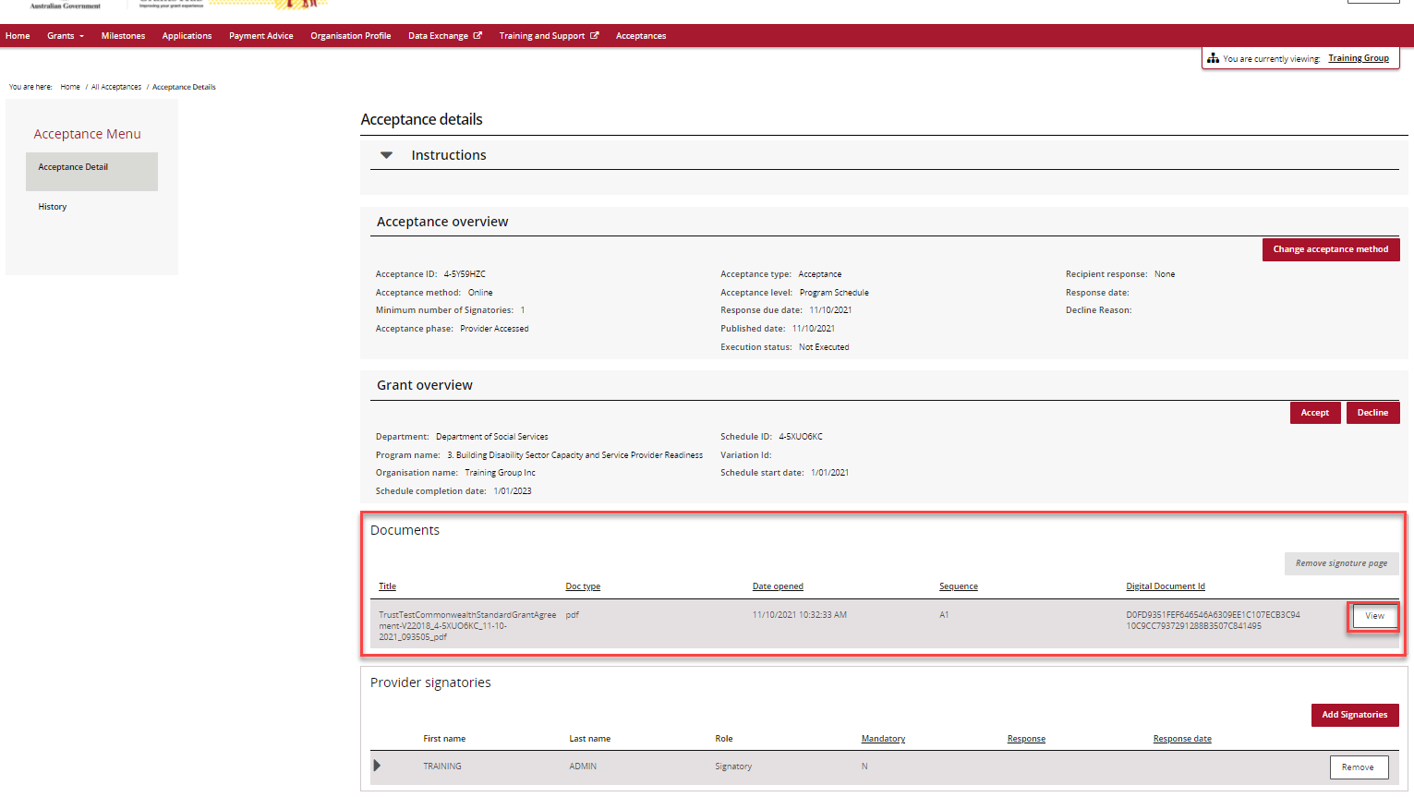

The following message asking you to download the funding offer will appear.
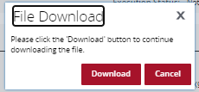

Please note the following error message will appear when you try to accept the offer if at least one person in your organisation has not download the documentation. This is to ensure your organisation has read and understood the terms of the grant agreement before accepting the funding offer.

The minimum number of signatories must Accept the offer.
Note: only one signatory is required to Decline the offer.
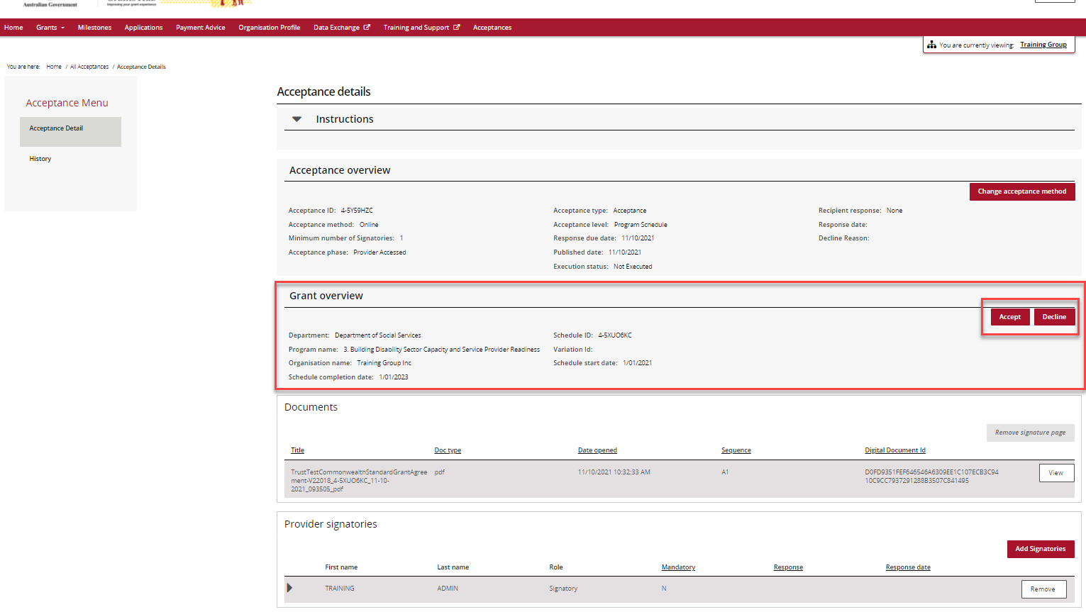

In the above example this organisation only requires one individual to accept the agreement. This individual will receive a popup which will allow them to accept and submit to the Hub.

If your organisation requires three signatories to accept the offer, only after two signatories have accepted the offer will the system allow the third signatory to submit the acceptance to the Hub.
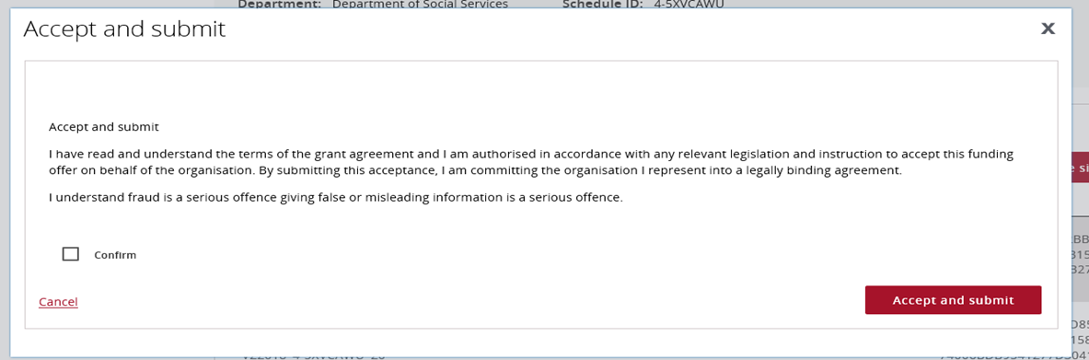
When the required number of Signatories have accepted the offer or your organisation has declined the offer, a notification will be sent to the Hub informing them of your decision.
If you have accepted the funding offer, a delegate from the Hub will execute the agreement. Once executed, your organisation will receive an email notification informing you a copy of the executed agreement is available for you to access in the Portal.
In the Provider signatories section you will see a list of your organisation’s signatories. Signatories can be added or removed by a Portal Administrator in your organisation. For information on how to add and remove signatories, see Funding Acceptance - Managing Signatories Information Sheet
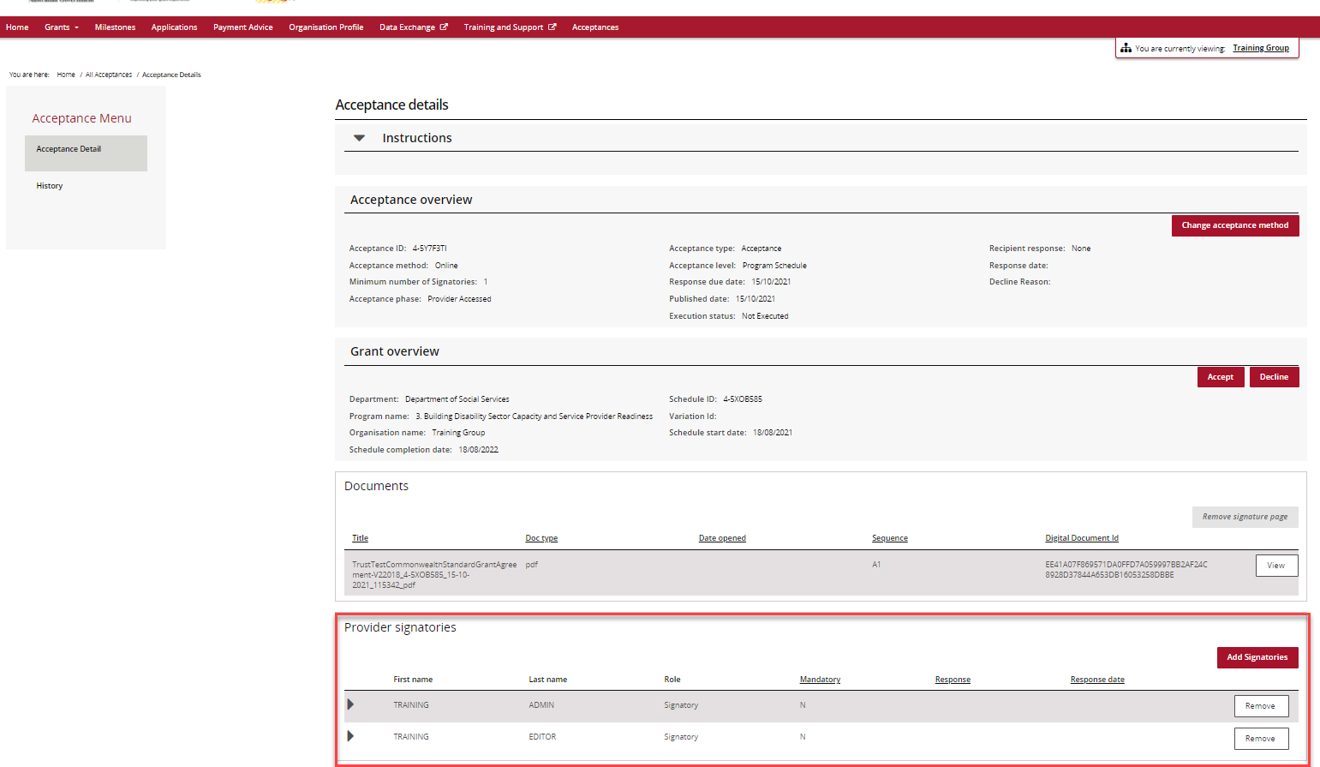

Need assistance
If you require assistance in using the Grant Recipient Portal contact the Grant Recipient Portal Helpdesk at GRP.Helpdesk@communitygrants.gov.au or on 1800 020 230 (option 5).

