3. Funding Acceptance – Proxy Method
  - Organisation Administrator process for accepting funding offers using the proxy method of online acceptance.

Please note this functionality will not be operating in the Grant Recipient Portal until March 2022. This information sheet is to provide your organisation with visibility of upcoming functions to the Portal.

Online Acceptance
The Online Acceptance process allows the Hub to send funding offers through the Portal where your organisation can accept, decline or acknowledge the offer. There are three ways you can accept an offer:
- Online - The Online Acceptance process allows your organisation to receive and accept the funding offer online through the Portal.
- Proxy - The Proxy process allows your organisation to receive the funding offer online through the Portal. In this process, you will be required to download, print, sign and upload the signature page to the Portal to accept the funding offer.
- Offline - this is the current process for organisations not provisioned to the Portal and is managed directly through the Community Grants Hub via email. Organisations provisioned to the Portal can change their acceptance method from Online or Proxy to Offline by contacting the Grant Recipient Portal Helpdesk at GRP.Helpdesk@communitygrants.gov.au or on 1800 020 230 (option 5).

Proxy method
The Proxy method requires your organisation to print, sign and upload the signature page to the Portal to accept a funding offer. We have created this option to ensure organisations who require documents to be physically signed are able to undertake the process through the Grant Recipient Portal.

Process
Click on the Acceptances tile on the Home page of the Portal.
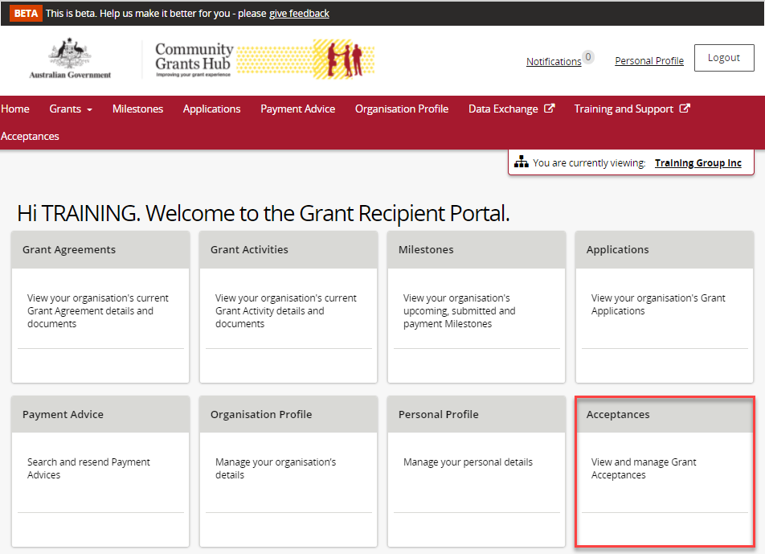

A list of all funding offers for your organisation will be displayed. To action the proxy online process for a funding offer, click on the View button.
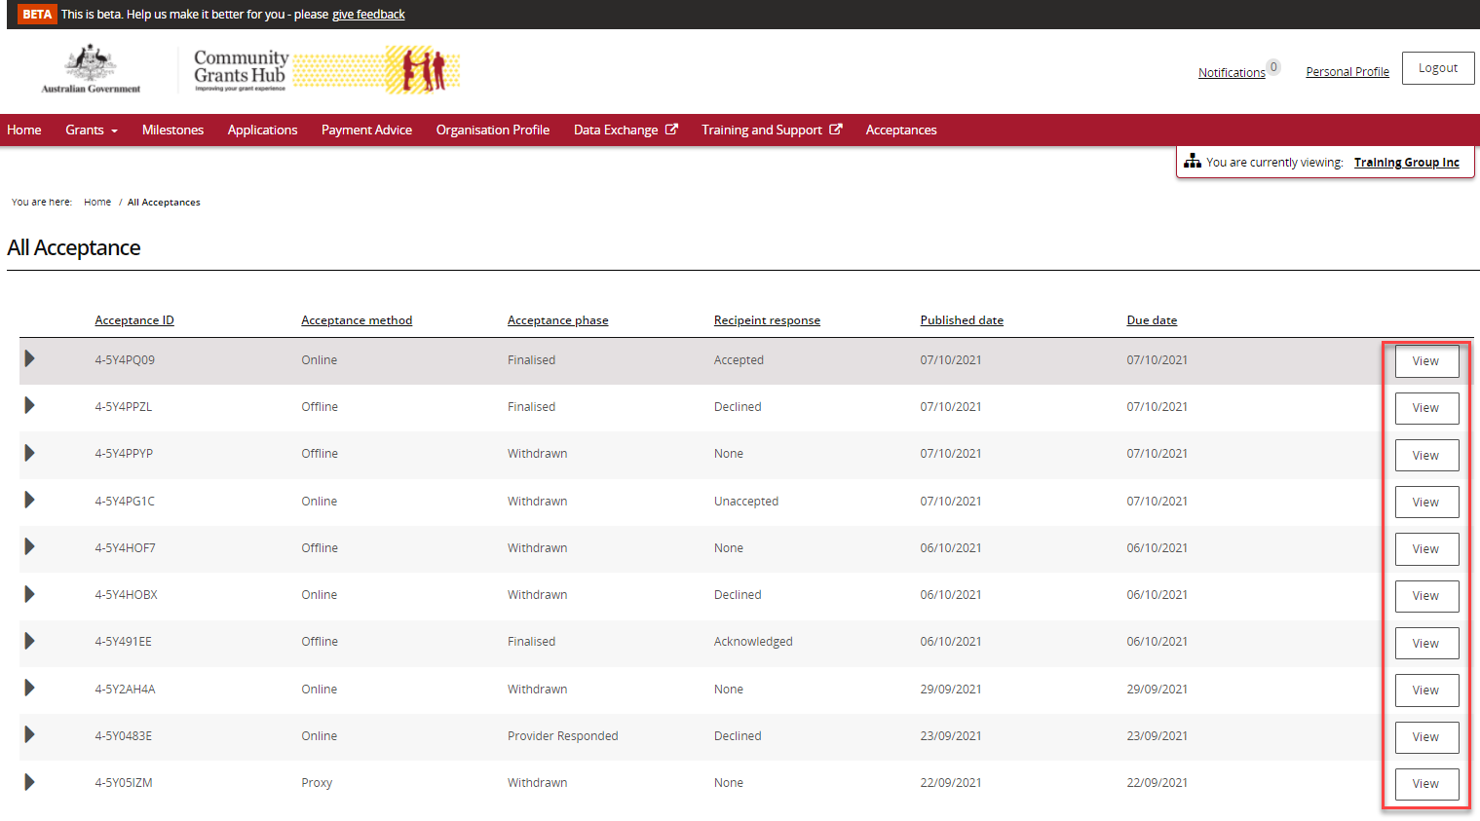

This will take you to the Acceptance Details page where you will find instructions on how to perform the Proxy method of acceptance.
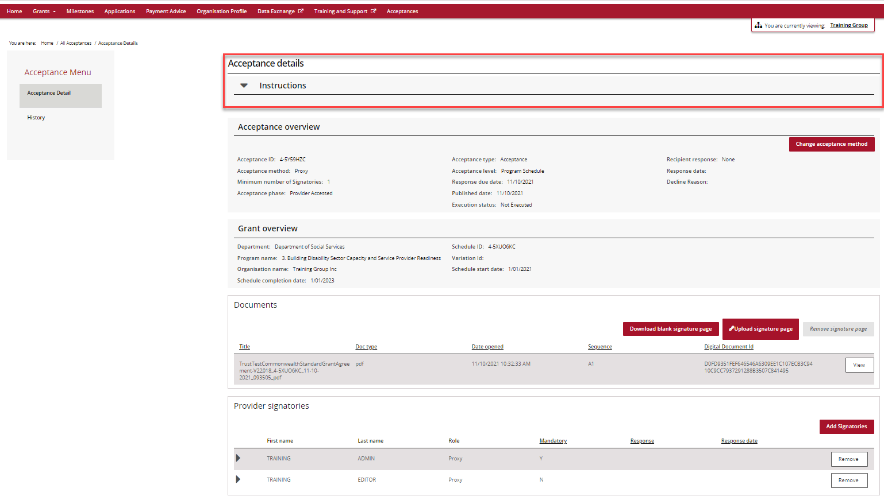

The Acceptance overview section shows the:
- Acceptance Method currently set for the funding offer
- Minimum Number of Signatories required to accept the funding offer. Please refer to the Funding Acceptance – Proxy Method Information Sheet for further information on how to set up your signatory profile.
- Response Due Date.

To change the acceptance method from Proxy to Online click on the Change acceptance method (for information on how to perform the Online method, see the Funding Acceptance – Online Method Information Sheet).
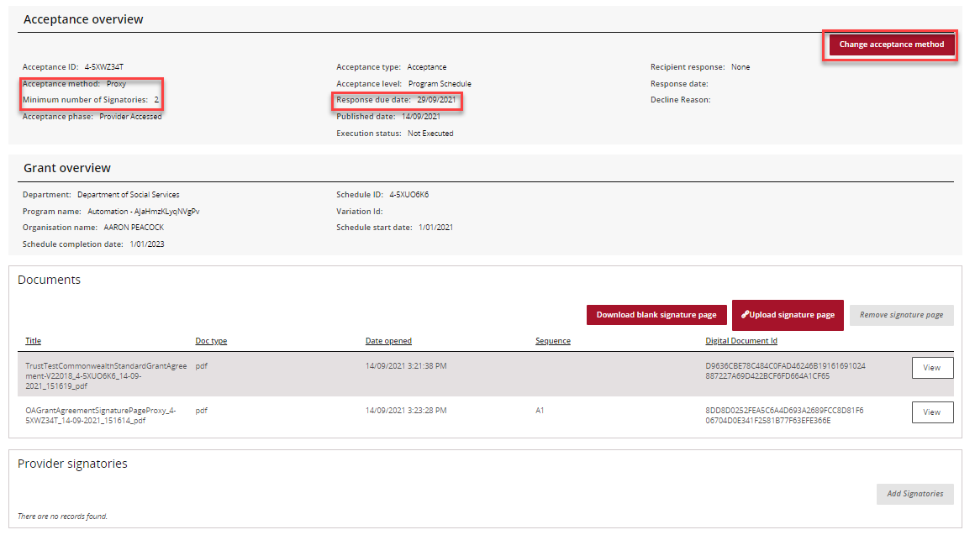

Further down the Acceptance Details view you will see the Grant overview section. This has information on the program and is where you can Accept or Decline the funding offer. As the individual accepting the offer may only be submitting the signed agreement on behalf of your organisation, we rely on the signatures within the agreement to be from staff who have the legal authority to accept the offer.
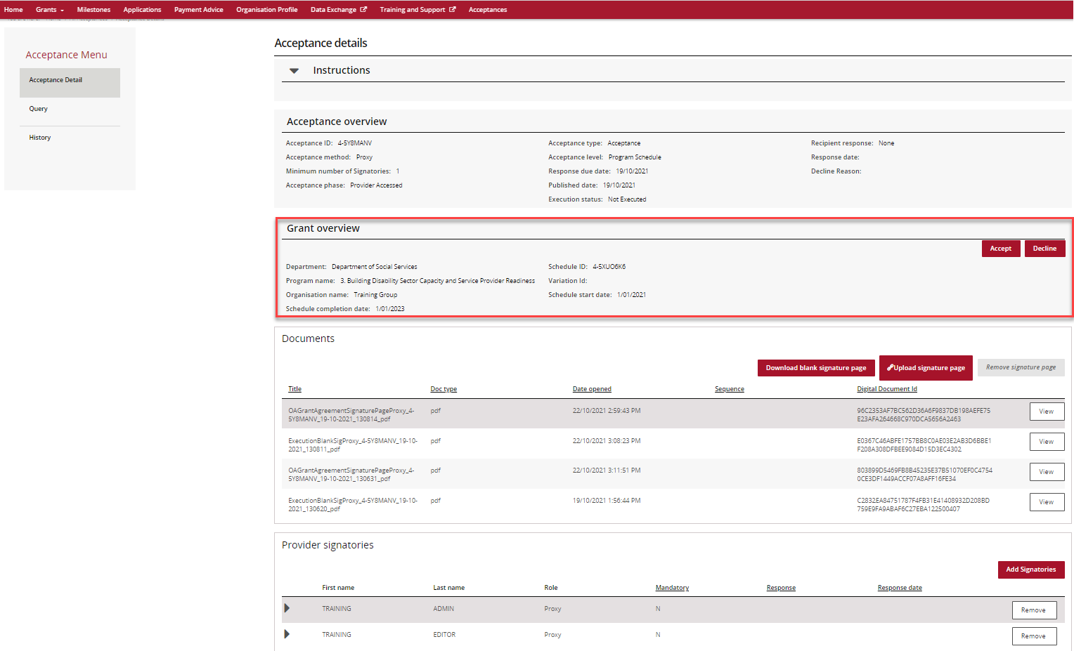

In the documents section of the page you will see a list of documents related to the funding offer. You are required to view or download each document before accepting the funding offer. To download each of the documents click on the View button.
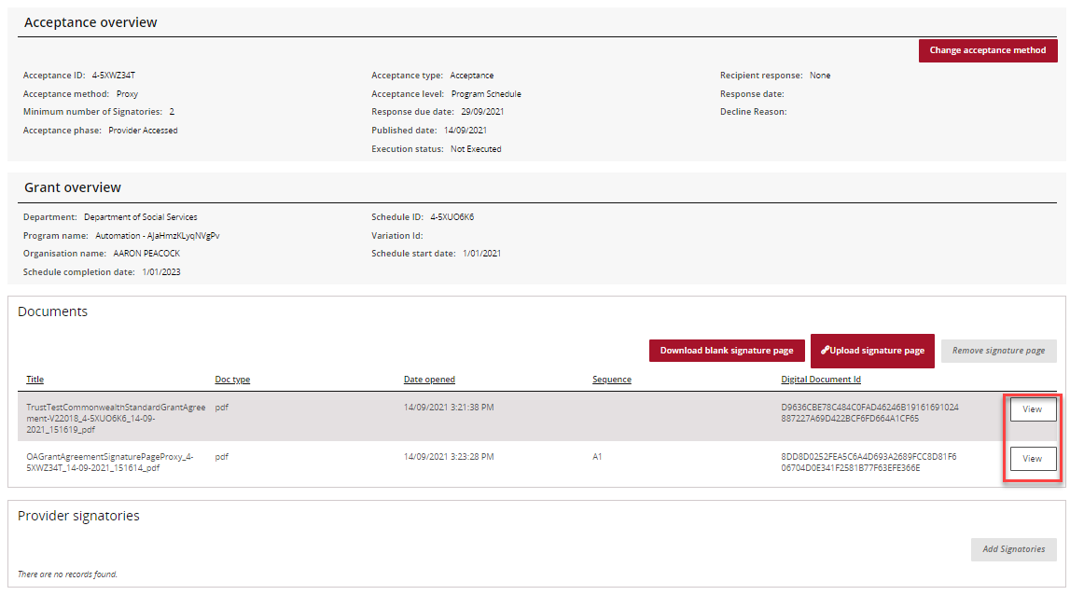
The following message asking you to download the document will appear.
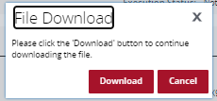

To download the signature page, click on the Download blank signature page button. The Signature page will contain a signature and witness section. If your organisation requires a different signature page due to your corporate structure please contact the Hub.

Once completed, scan and save Only the Signature Page on your computer then click the Upload signature page button.
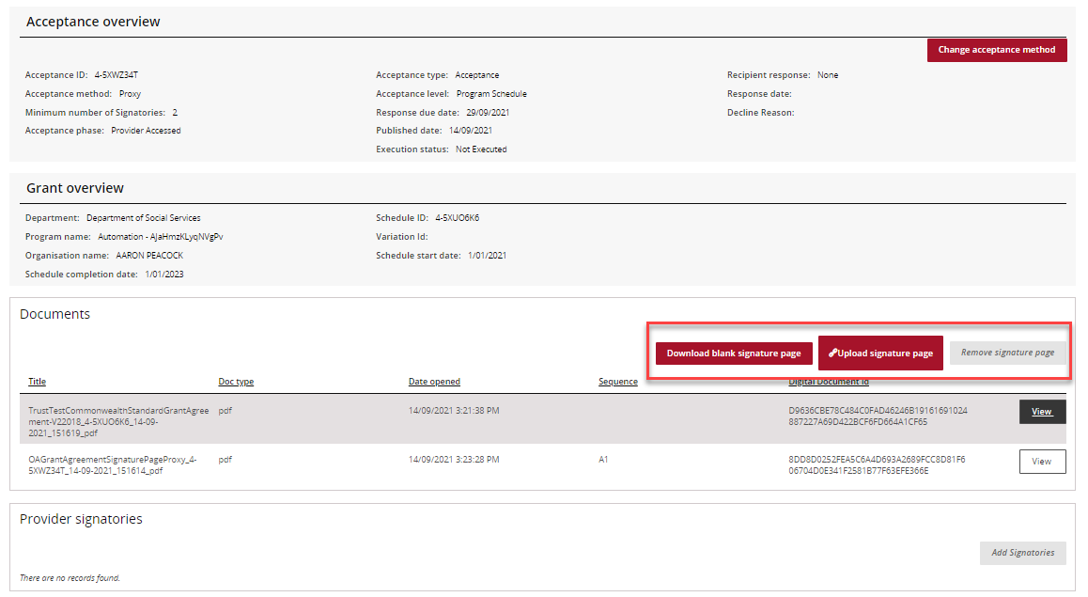

Once the signature page has been uploaded onto the Portal, you will need to click on the Accept button. A notification will be sent to the Hub stating you have accepted the offer.
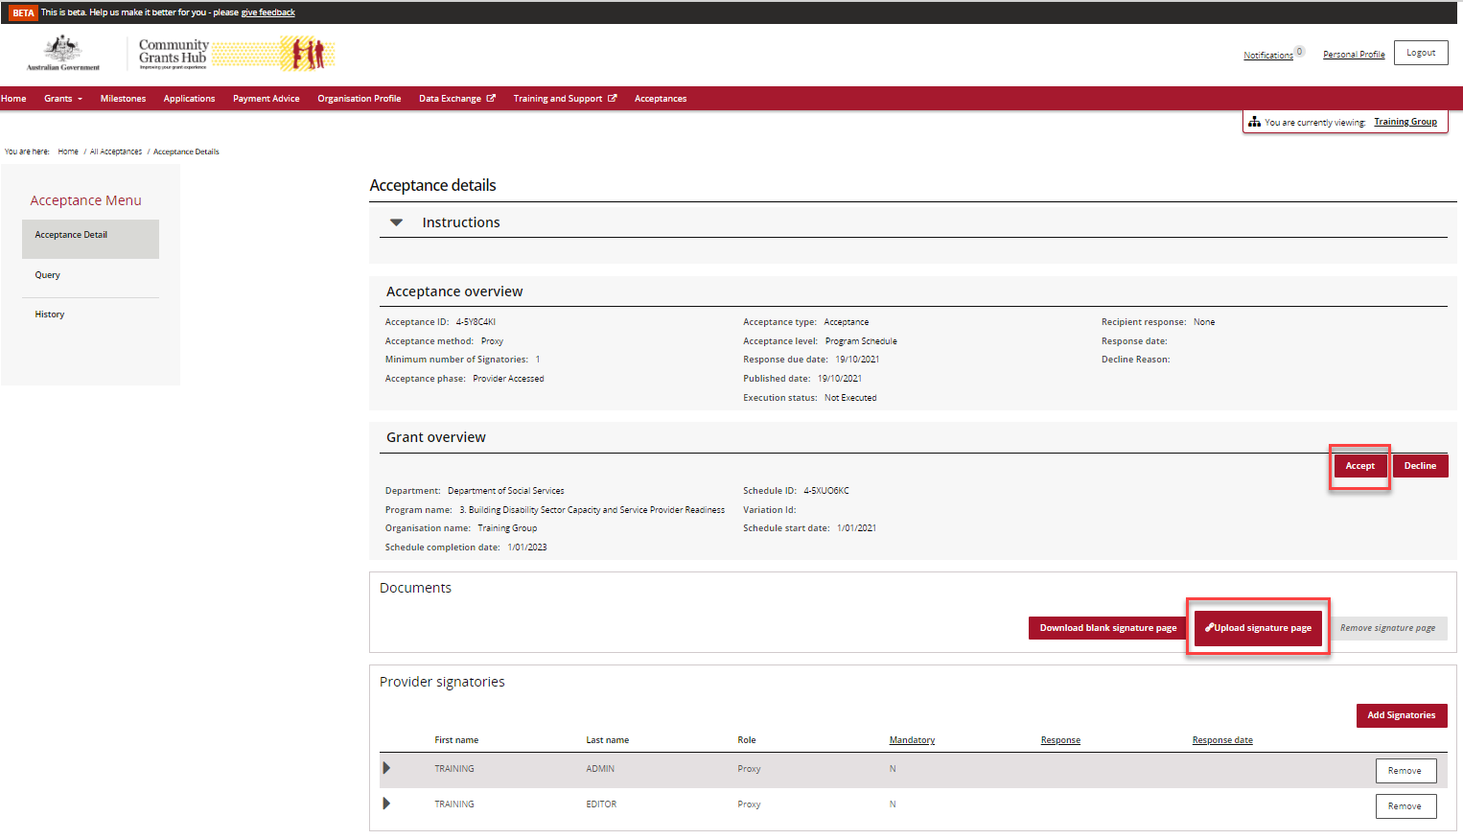

Please note the following error message will appear if the funding offer has not been downloaded. This is to ensure you have read and understood the terms of the grant agreement before accepting the funding offer.

Once you have uploaded your signature page and your proxy had accepted the offer, a delegate from the Hub will execute the agreement. Once executed, your organisation will receive an email notification informing you a copy of the executed agreement is available in the Portal.

In the final section on the page you will see Provider Signatories. Here you can add or remove signatories including your proxy representative for your organisation. This can only be undertaken by your organisation’s Administrator within the Portal. For more information on how to add and remove signatories see Funding Acceptance - Managing Signatories Information Sheet.
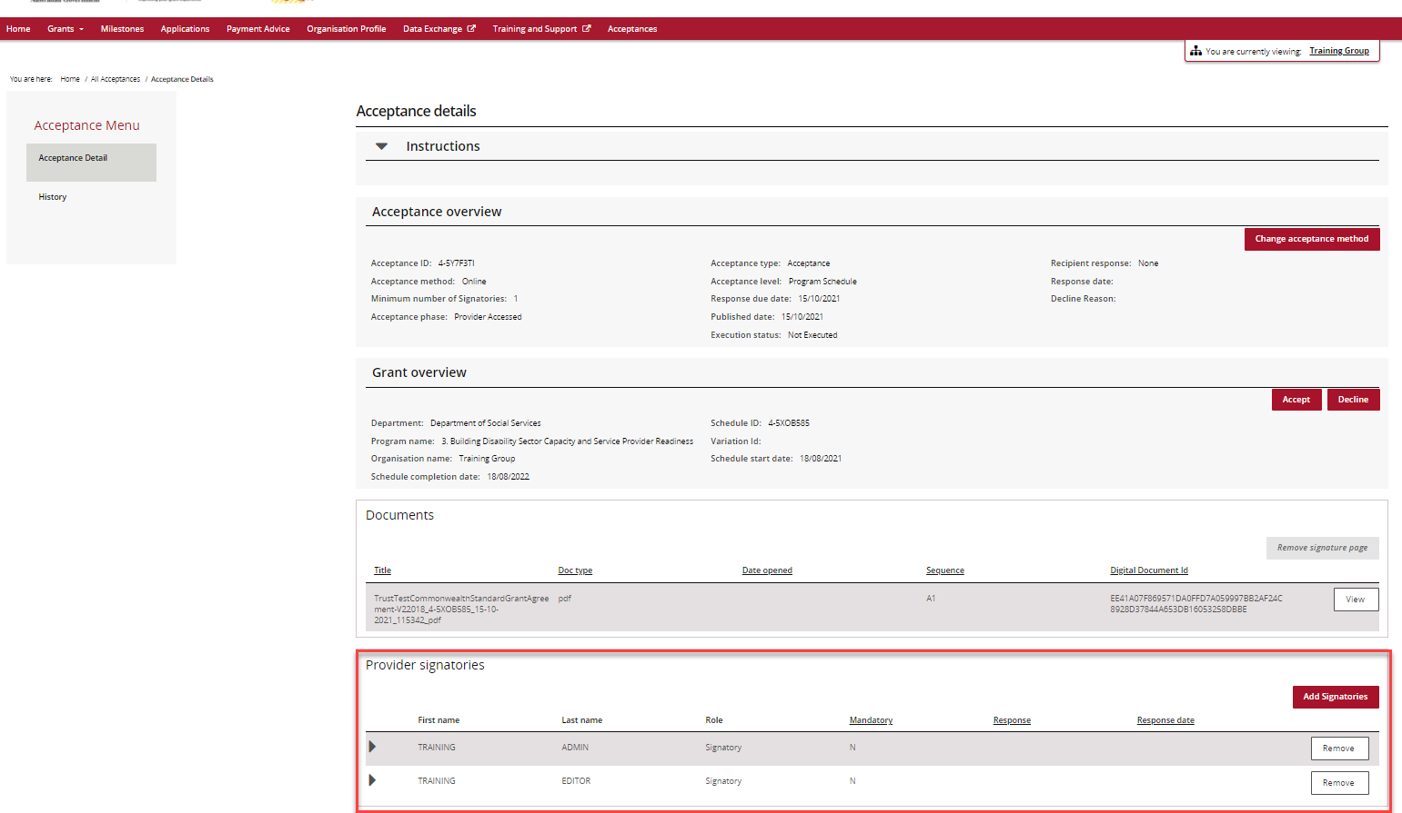

Need assistance
If you require assistance in using the Grant Recipient Portal contact the Grant Recipient Portal Helpdesk at GRP.Helpdesk@communitygrants.gov.au or on 1800 020 230 (option 5).

