4. Funding Acceptance -Administration
  - Organisation Administrator process for setting up users in the Grant Recipient Portal to accept funding offers for your organisation.

Please note this functionality will not be operating in the Grant Recipient Portal until March 2022. This information sheet is to provide your organisation with visibility of upcoming functions to the Portal.

Online Acceptance
The Online Acceptance process allows the Hub to send funding offers through the Portal where your organisation can accept, decline or acknowledge the offer online. There are three ways you can accept this offer:
- Online - The Online Acceptance process allows your organisation to receive and accept the funding offer online through the Portal.
- Proxy - The Proxy process allows your organisation to receive the funding offer online through the Portal. In this process, you will be required to download, print, sign and upload the signature page to the Portal to accept the funding offer.
- Offline - this is the current process for organisations not provisioned to the Portal and is managed directly through the Community Grants Hub via email. Organisations provisioned to the Portal can change their acceptance method from Online or Proxy to Offline by contacting the Grant Recipient Portal Helpdesk at GRP.Helpdesk@communitygrants.gov.au or on 1800 020 230 (option 5).

Process
As part of accepting a funding offer online you will need to set up your acceptance administration in the Organisation Profile, such as who can approve funding offers within your organisation and how many staff members need to sign the funding offer.

To set up your acceptance administration go to the Organisation Profile tile on the home page.
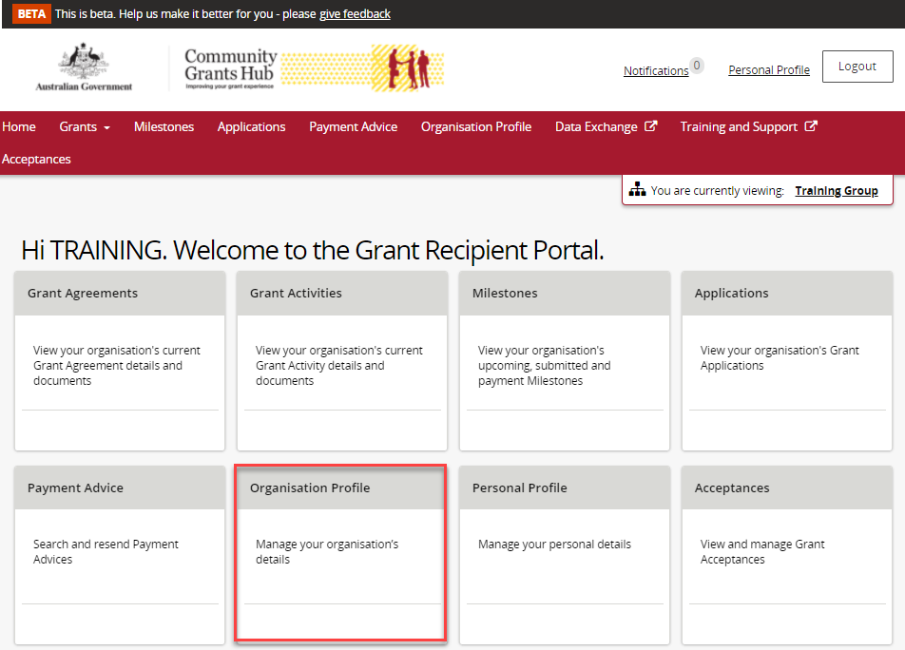

In the Organisation Profile sub menu on the right hand side of the screen select Acceptance administration. The Online Acceptance Administration page will be displayed. At the top of the page you will find information links to additional resources to assist you in the process.
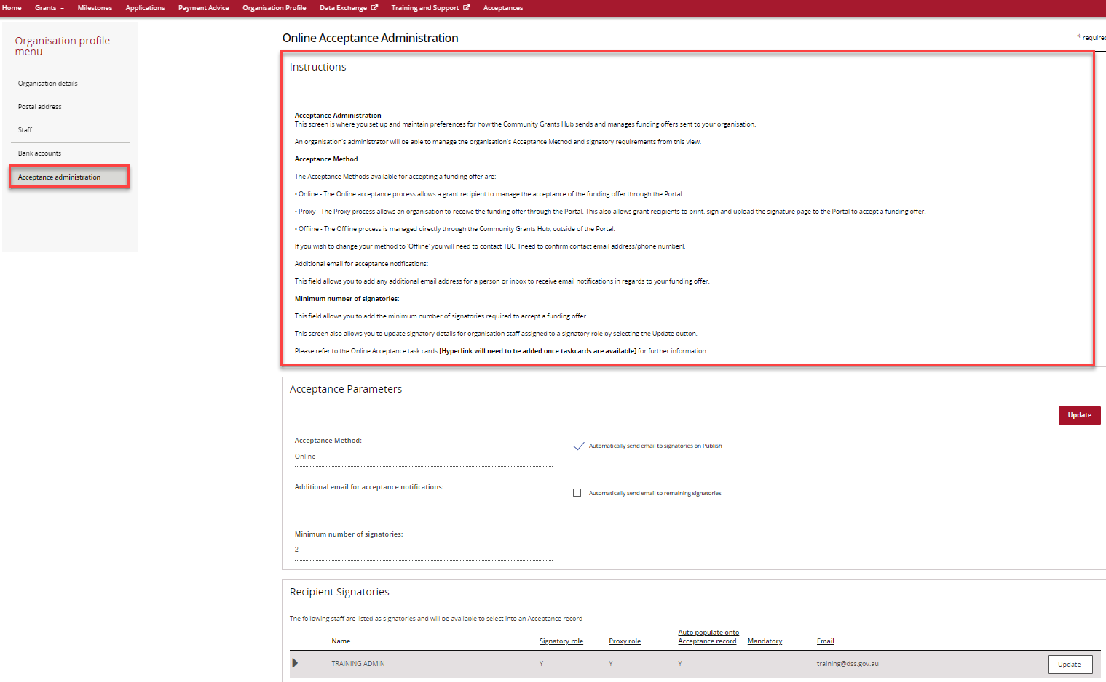

Acceptance Parameters Section
The Acceptance Parameters section is where you can set up how your organisation will receive and action funding offers through the Portal including:
- Changing Acceptance method
- Adding an additional email for acceptance notifications
- Updating Minimum number of signatories
- Adding/Removing signatories and assigning signatory roles.
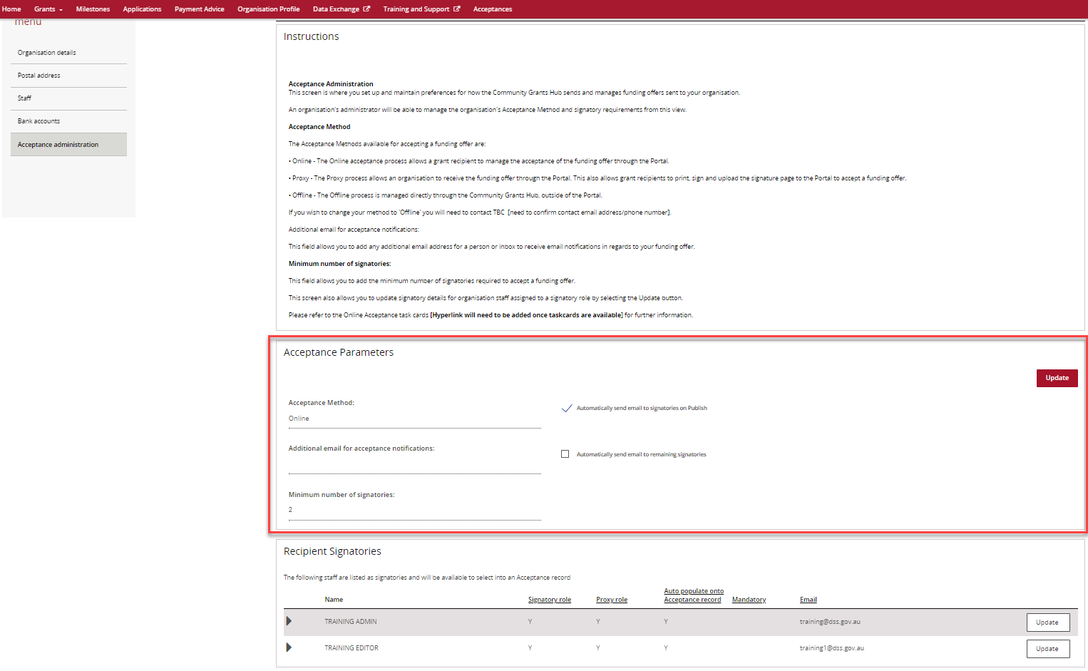

To make changes to the Acceptance Parameters, click on the Update button.
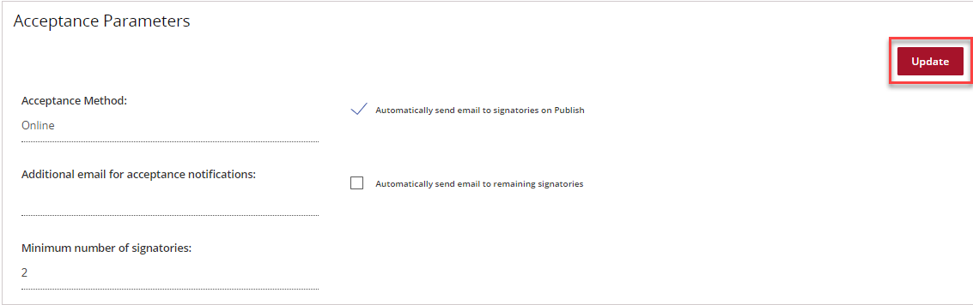

Acceptance Method
This is where you can change the method of acceptance to either Online or Proxy.
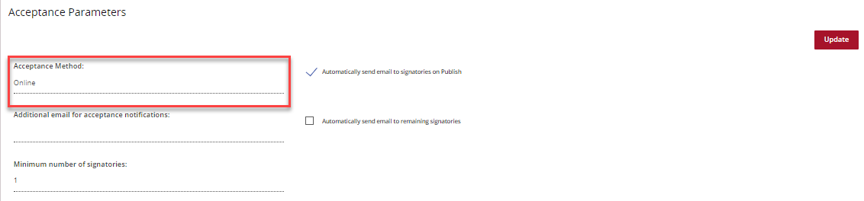

Additional email for acceptance notifications
You can include an additional email for funding offer notifications through the Portal.
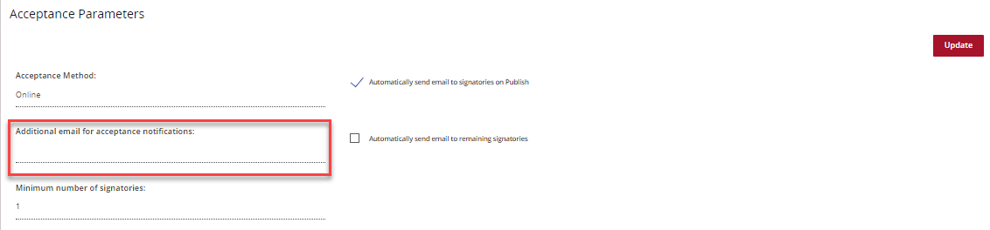

Minimum number of signatories (Online Method only)
You can set the minimum number of signatories required by the organisation when accepting funding offers.
Signatories must have the relevant authority to accept the funding offer and enter into a legally binding agreement on behalf of the organisation.
The minimum number of signatories must be updated in accordance with the requirements of your legal entity.
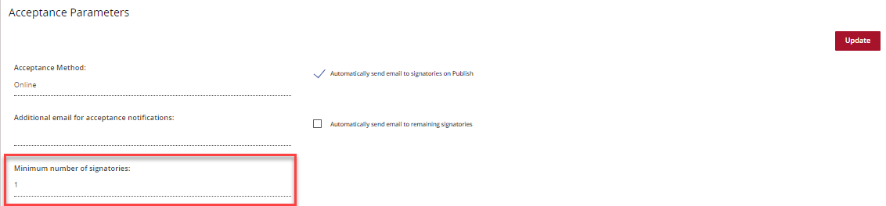

Notifications (Online Method only)
There are also two notification types that you can select in this screen by clicking on the box.
- Automatically send email to signatories on Publish, will send a notification to all signatories when the funding offer is available through the Portal.
- Automatically send email to remaining signatories will send a notification to signatories who have not accepted the funding offer when one signatory has accepted.

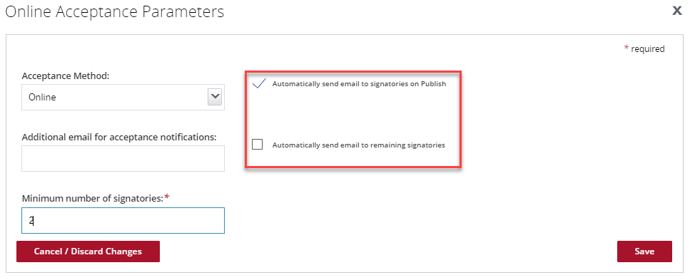

Recipient Signatories Section
In the Recipient Signatories section you will see a list of current signatories for the organisation. You can update the parameters for the role of the signatory by pressing the Update button.
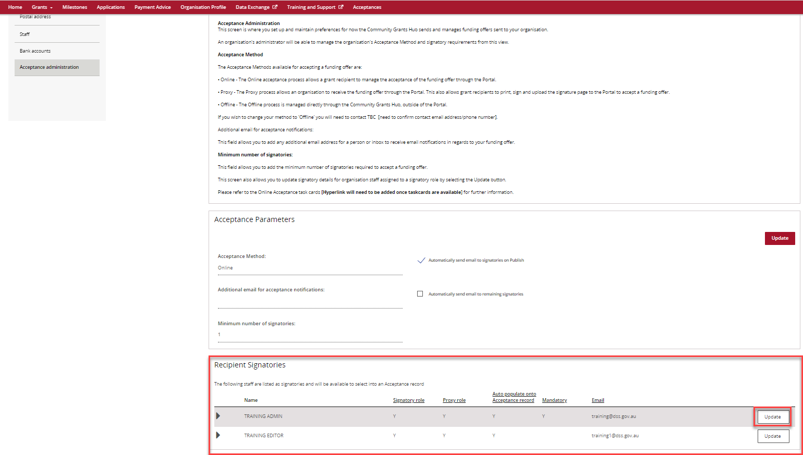

The screen below will be displayed. You can choose if the staff member has a:
Signatory role - meaning they can accept funding offers using the Online method.
Proxy role - meaning they are can accept funding offers using the Proxy method.
A staff member can be assigned both the signatory and proxy role allowing them to accept funding offers for both Online and Proxy acceptance methods.
Mandatory is ticked if it is mandatory for this signatory to accept all offers for your organisation.
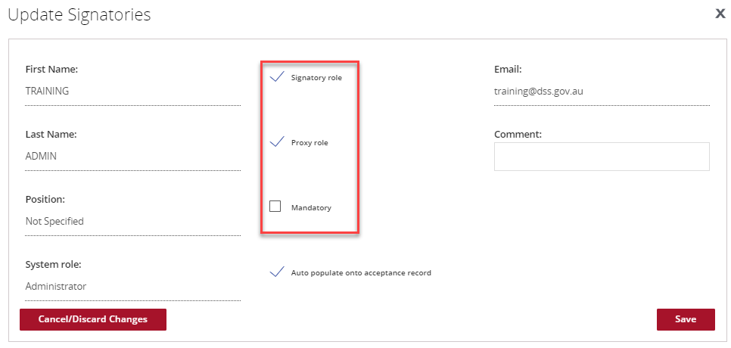

Auto populate onto acceptance record
You will need to tick the box next to the Auto populate onto acceptance record if you want the signatory to be populated under the Provider Signatories section under the Acceptances tile for every funding offer received through the Portal.
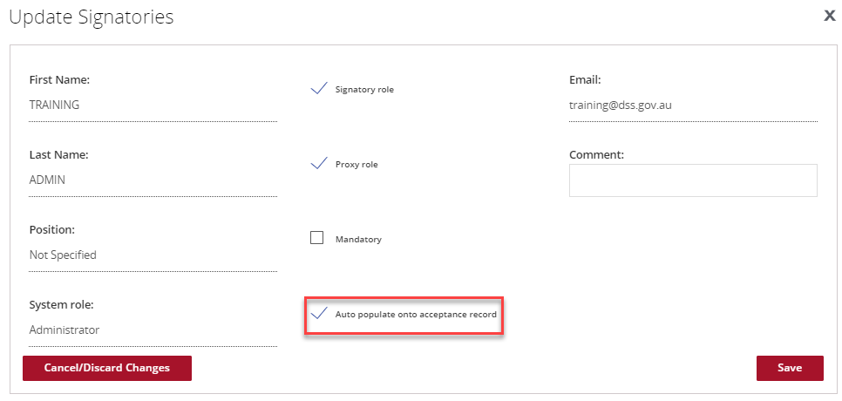
Once you have finished updating the Acceptance Parameters press the Save button.

Need assistance
If you require assistance in using the Grant Recipient Portal contact the Grant Recipient Portal Helpdesk at GRP.Helpdesk@communitygrants.gov.au or on 1800 020 230 (option 5).

