5. Funding Acceptance – Managing Signatories
  - Organisation Administrator process for managing online acceptance signatories after a funding offer has been received in the Grant Recipient Portal.

Please note this functionality will not be operating in the Grant Recipient Portal until March 2022. This information sheet is to provide your organisation with visibility of upcoming functions to the Portal.

Online Acceptance
The Online Acceptance process allows the Hub to send funding offers through the Portal where your organisation can accept, decline or acknowledge the offer online. There are three ways you can accept this offer:
- Online - The Online Acceptance process allows your organisation to receive and accept the funding offer online through the Portal.
- Proxy - The Proxy process allows your organisation to receive the funding offer online through the Portal. In this process, you will be required to download, print, sign and upload the signature page to the Portal to accept the funding offer.
- Offline - this is the current process for organisations not provisioned to the Portal and is managed directly through the Community Grants Hub via email. Organisations provisioned to the Portal can change their acceptance method from Online or Proxy to Offline by contacting the Grant Recipient Portal Helpdesk at GRP.Helpdesk@communitygrants.gov.au or on 1800 020 230 (option 5).

Process
When you receive an offer for funding, you will need to identify from all your available signatories who will accept the offer. Your organisation may have a number of individuals who can accept however, under your legal framework you may only need one of these individuals to accept.
To identify who is going to accept the offer, click on the Acceptances tile on the home page.
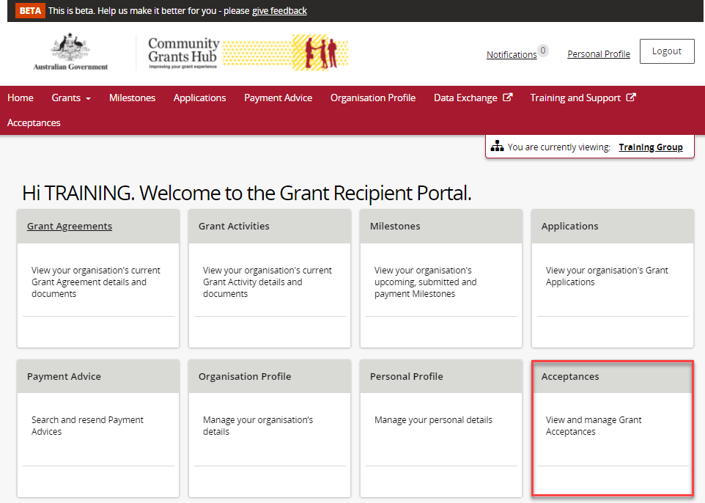

A list of all funding offers for your organisation will be displayed. To manage the signatories for an offer click on the View button.
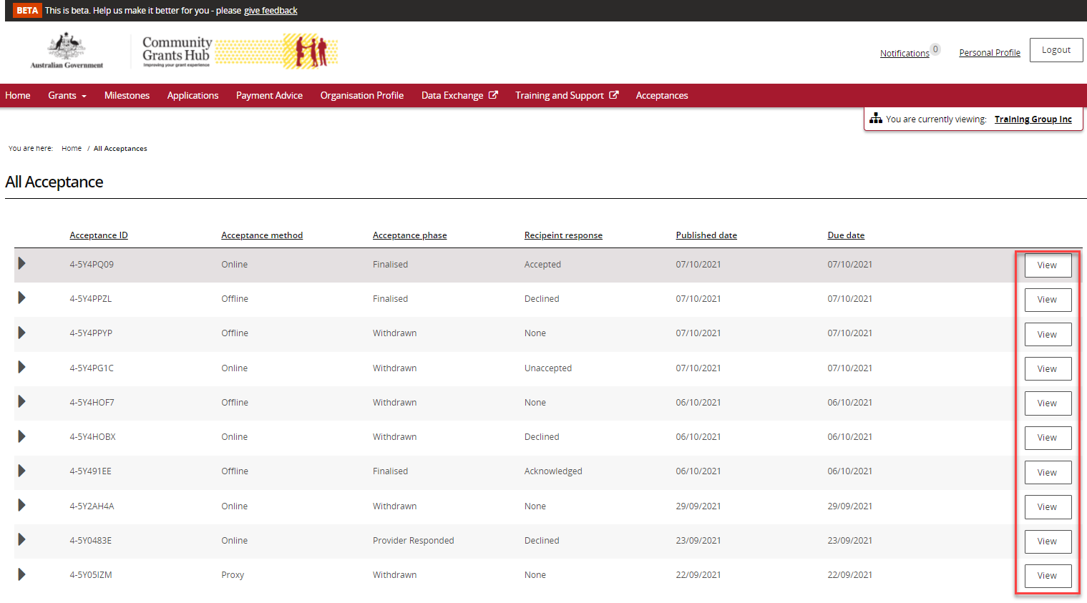

In the Recipient Signatories section on the Acceptance Details Page you can add or remove staff as a signatory for a funding offer. To add a signatory click on the Add Signatories button.
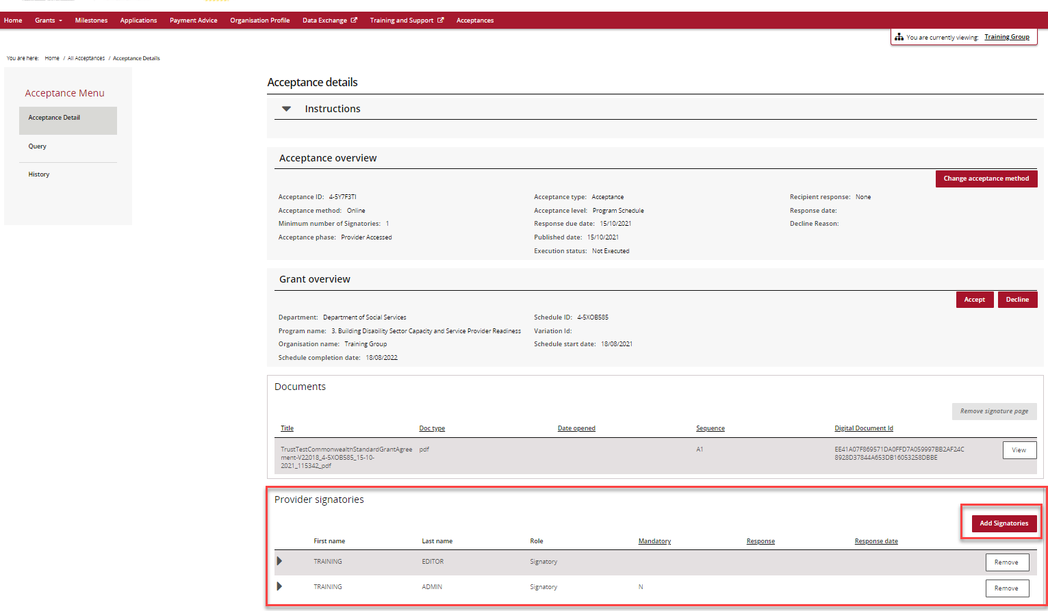

A list of available signatories for your organisation will be displayed for selection.
Note: Only signatories with the appropriate signatory role for the funding offer will be displayed in the list e.g. if your organisation only accepts offers via a proxy method only individuals with a proxy role will be shown.
Click on the box next to the staff member you wish to add as a signatory and press the Confirm selection button.
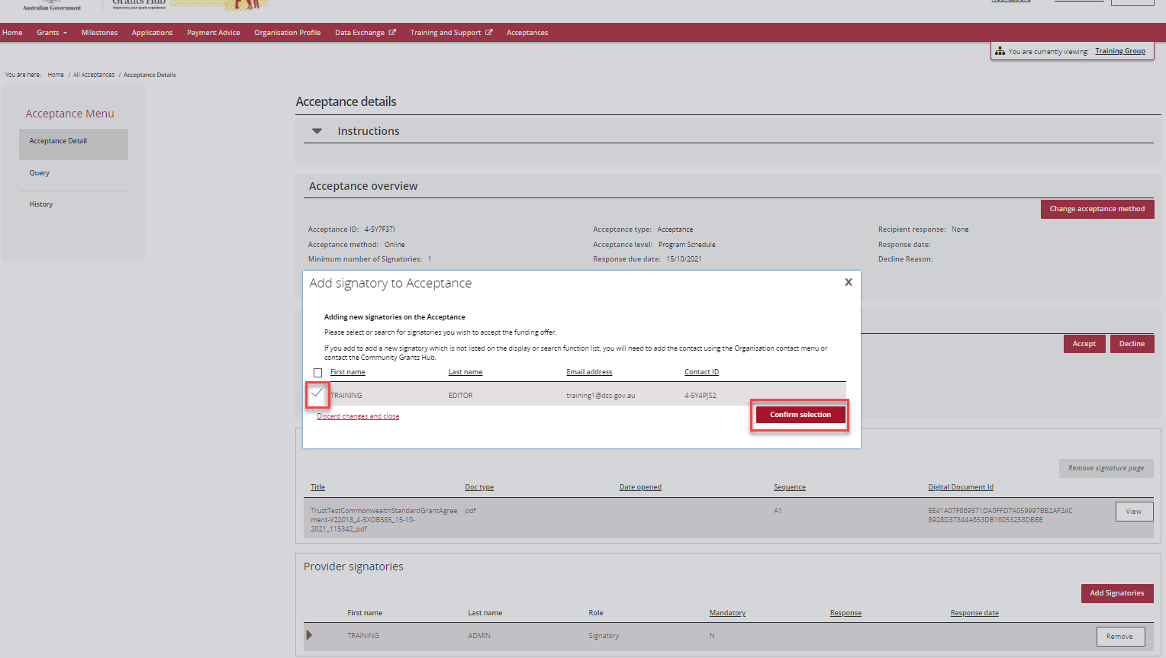

To remove a staff member as a signatory for the funding offer click on the Remove button.
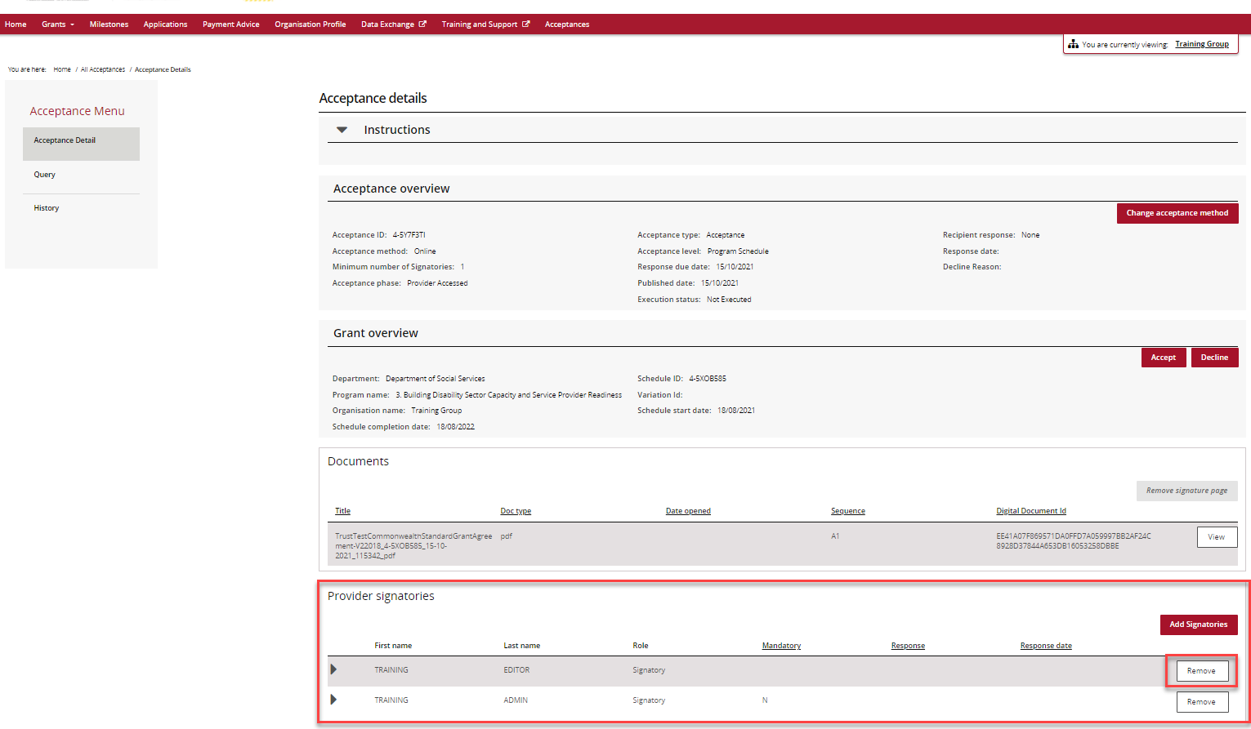
The message below will be displayed. To confirm the removal of the selected signatory click Remove.
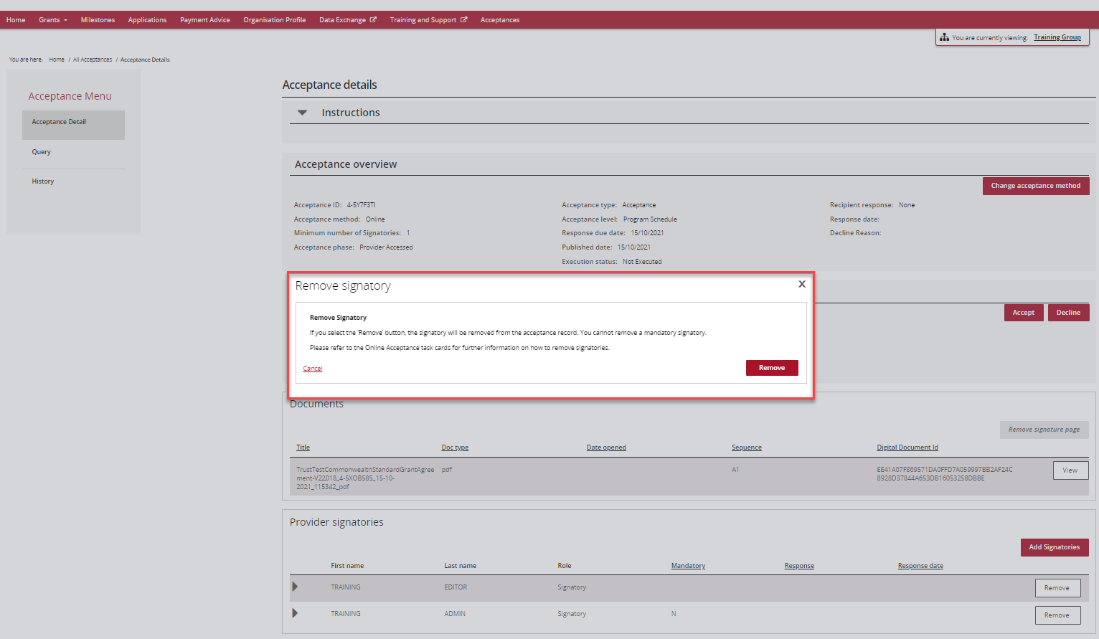

Need assistance
If you require assistance in using the Grant Recipient Portal contact the Grant Recipient Portal Helpdesk at GRP.Helpdesk@communitygrants.gov.au or on 1800 020 230 (option 5).

