Add and Update Bank Account
  - Process on how to add and update bank accounts details in the Grant Recipient Portal.
Portal Access required: Administrator.
The Portal enables Grant Recipients to view and request changes to their bank account details. This task card describes the process for viewing and making changes to bank account details.

Navigating to bank accounts
From the Home screen select the Organisation Profile tile or select the Organisation Profile link from the navigation menu.
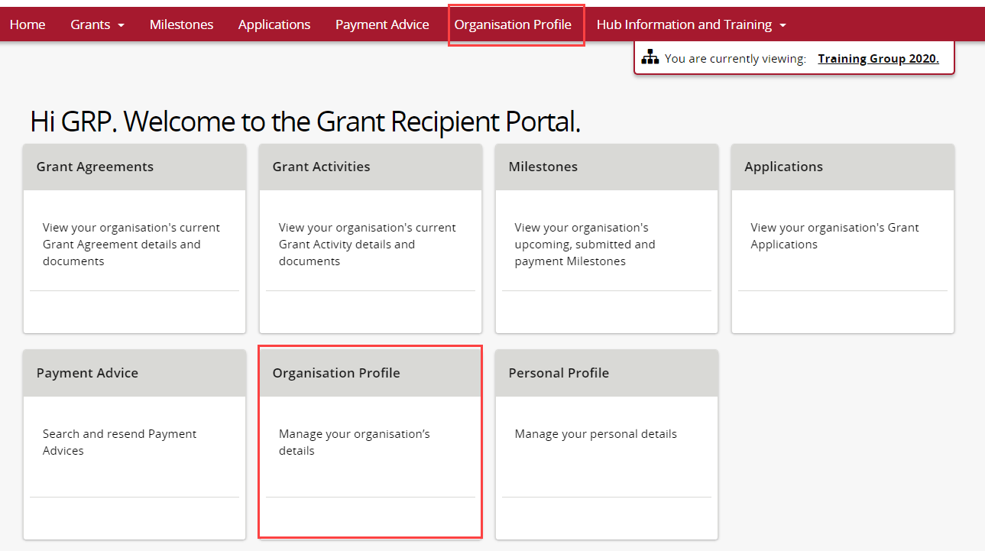

Select Bank accounts from the Organisation profile menu.
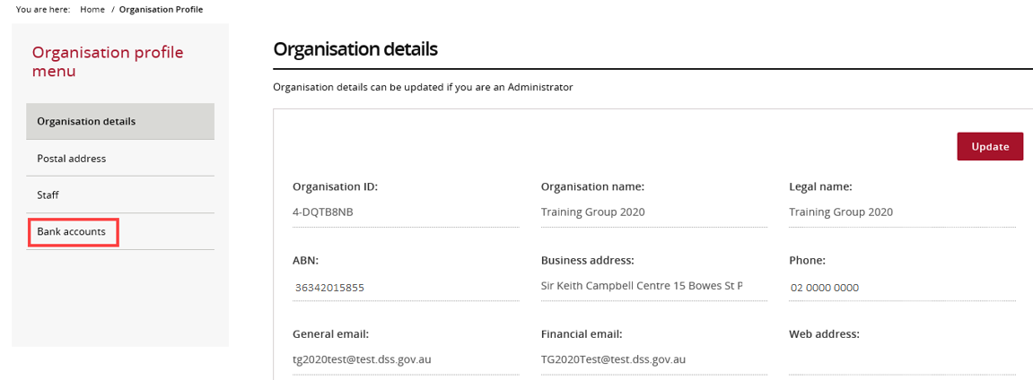

Updating a bank account name
The Bank accounts screen will display. Select the View button to display additional information about the bank account.
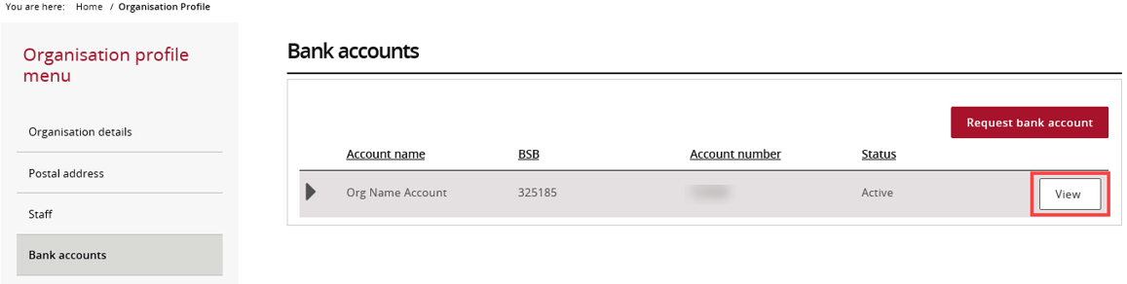
The Bank account details screen will display. To update the Account name select Update.
Note: the existing BSB and Account number cannot be changed. If a change is required to these fields a new bank account must be requested.
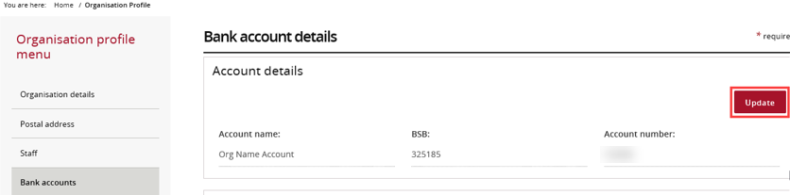

The mandatory fields marked with an asterisk must be populated at all times. Once the Account name has been changed, select Save and return.
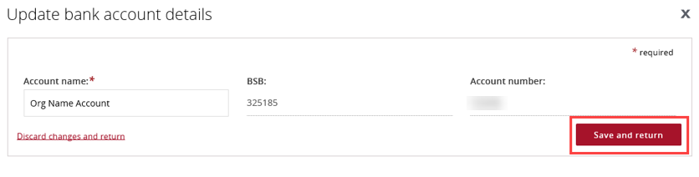

Add bank account to Grant Activities
To view or update Grant Activities linked to an existing bank account, select View against the appropriate bank account.
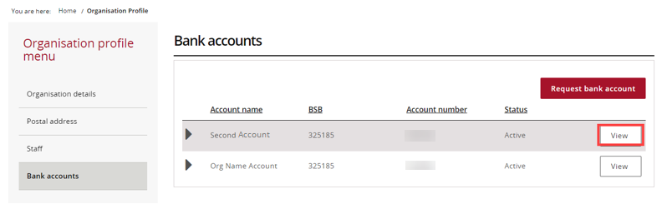
This will display the Grant Activities linked to the chosen bank account, select Add Grant Activity.
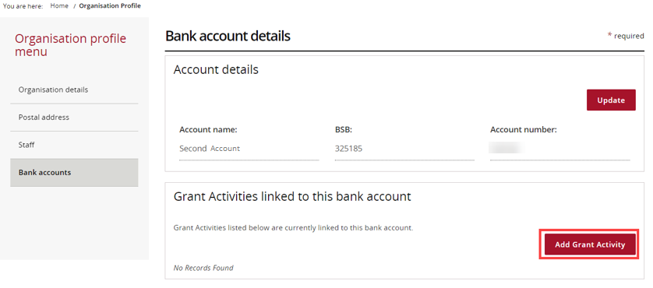

The Link Grant Activities to bank account screen will display.
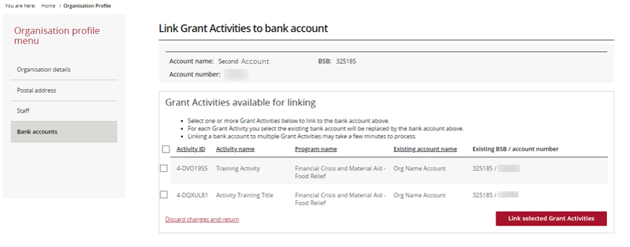
Select the checkbox against the appropriate Grant Activities and select Link selected Grant Activities to link the bank account.
Note: To choose all Grant Activities, select the checkbox to the left of Activity ID.
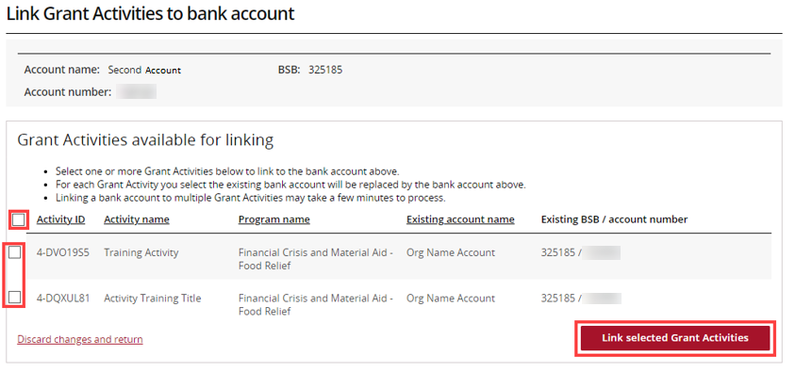

A confirmation page will display. Select Submit to finalise the update.
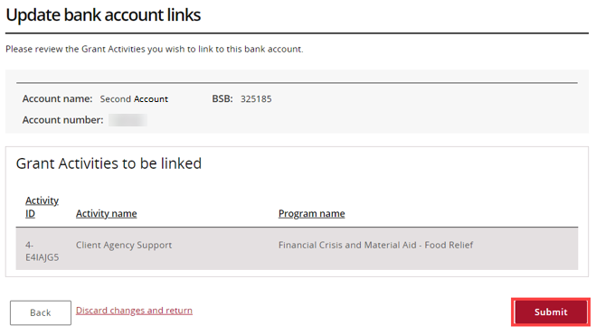

Add a Bank Account
In the Bank accounts screen select the Request bank account button to add new account details.
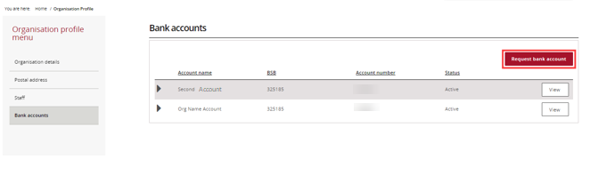
The Request bank account screen will display. Complete the Account name, BSB and Account number and select Continue.
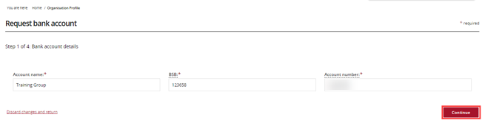
Proof of bank account details will be required. Select Add file to select a file from your computer.
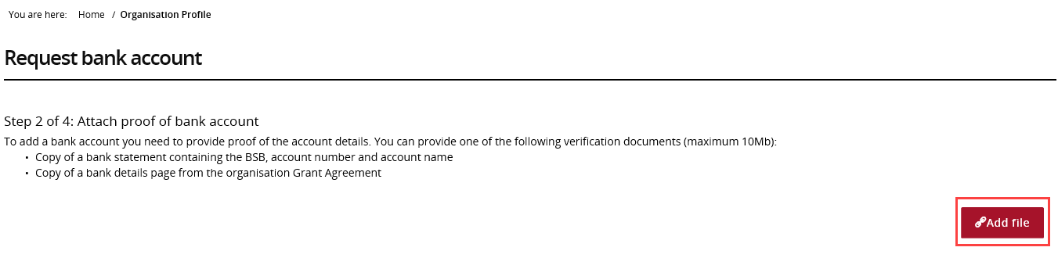
The file will attach. To View or Delete a file, select Actions.
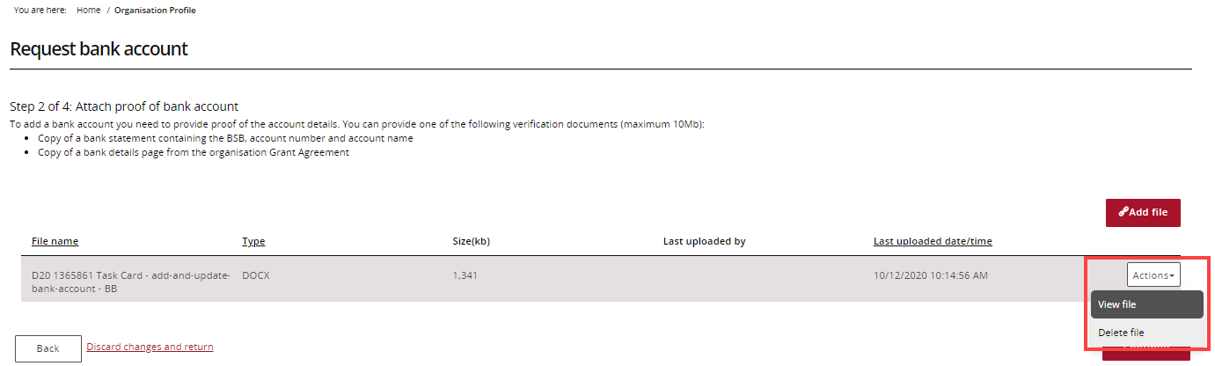
Select Continue to proceed to next step.
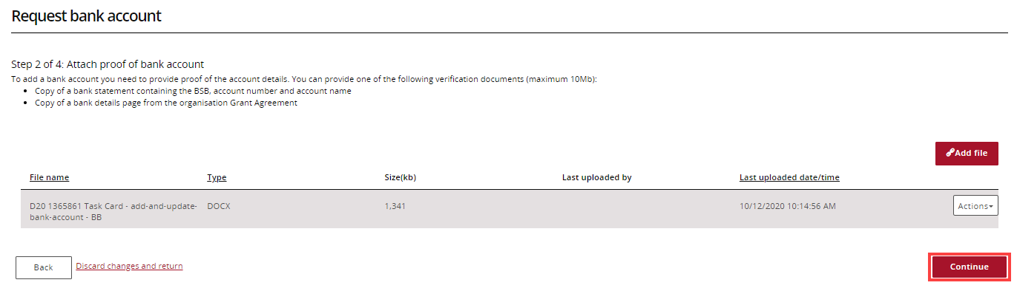

Select the checkbox against the Activities that should be linked to the new bank account and select Continue to proceed to the next step.
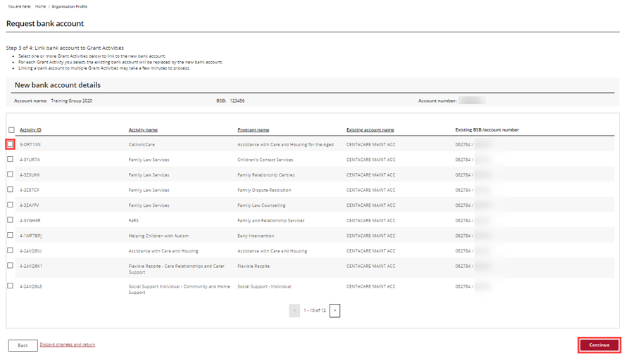
To finalise the new bank account, review the new bank account details and select Submit.
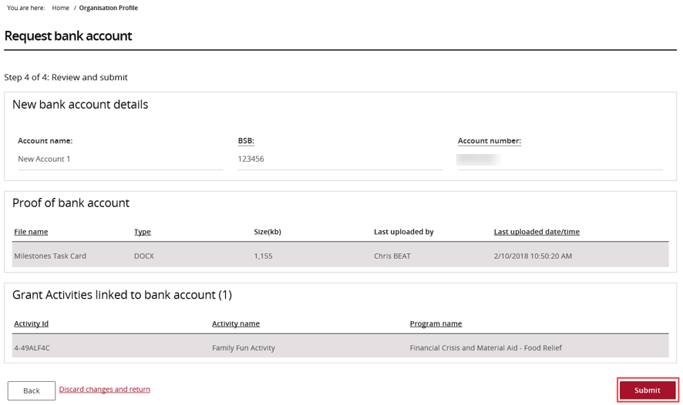
The new bank account details have been submitted to the Community Grants Hub for review and approval. If further information about this change is needed, contact the Funding Arrangement Manager listed on the Grant Agreement.

Need Help?
For further assistance, contact the Grant Recipient Portal Helpdesk:
Email: GRP.Helpdesk@communitygrants.gov.au
Phone: 1800 020 283 (Option 5)
Operating Hours: Monday to Friday 8:30am – 5:30pm (AEST/AEDT)

