Updating Staff details
  - Updating staff details in the Grant Recipient Portal
Portal Access required: Administrator.
The Portal enables Grant Recipients to review and self-manage their details through the Organisation Profile. This task card will describe the process for updating staff details in the Portal.

Updating existing staff details
From the Home screen select the Organisation Profile tile or select the Organisation Profile link from the navigation menu.
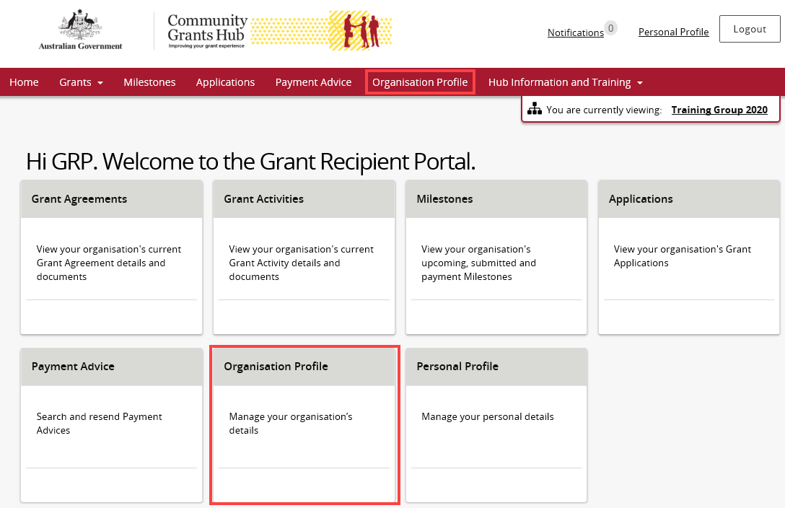
Under the Staff screen, navigate to the Staff record that needs updating and select View.
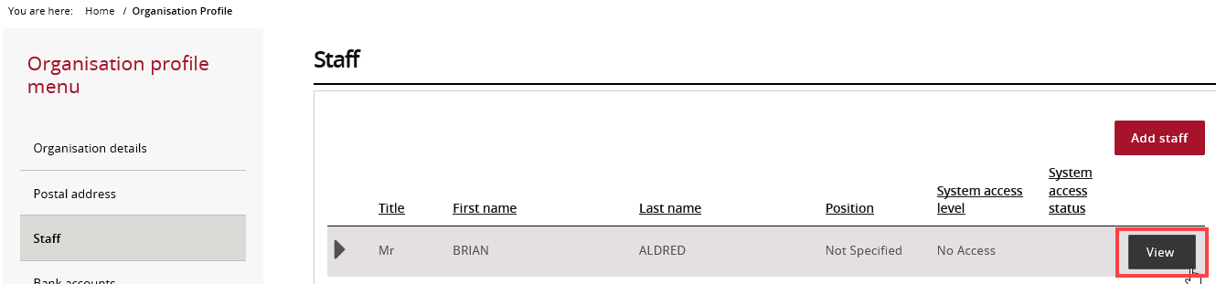
The Staff details screen will display. Select Update under the Staff details section to change the details.
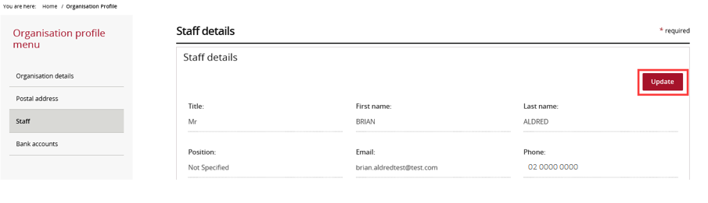
Make changes to the Staff’s details and select Save and return when complete.
Note: A Staff email address cannot be updated if they have already have access to the Portal. If the email address has been entered incorrectly or is no longer valid, the system access must be updated to ‘No Access’ and the Staff’s details must be re-entered.
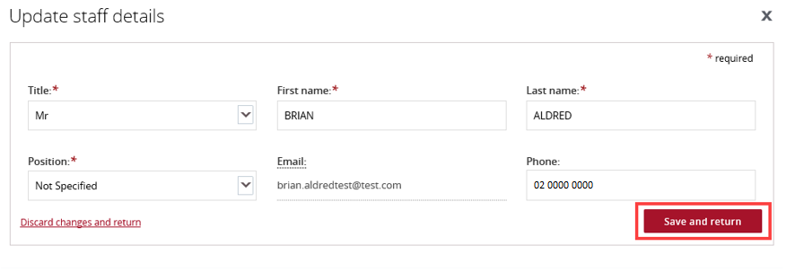
To change the access level for Staff, select Update under the System access section.
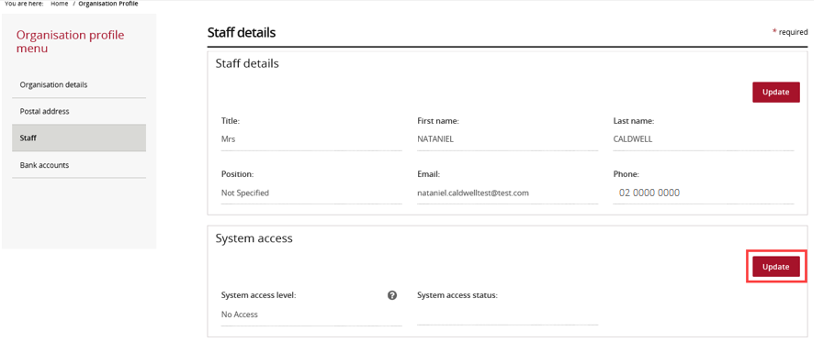

The Update system access screen will display. Pick an access level by selecting the radio button on the left then select Save and return.
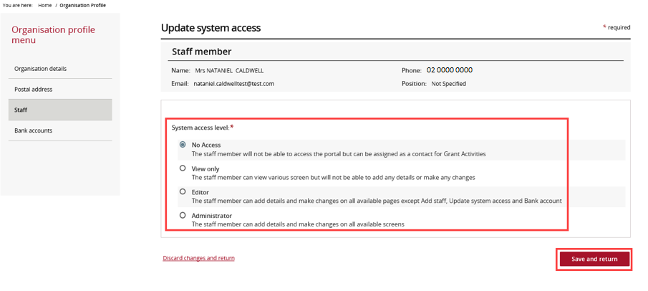
Need Help?
For further assistance, contact the Grant Recipient Portal Helpdesk:
Email: GRP.Helpdesk@communitygrants.gov.au
Phone: 1800 020 283 (Option 5)
Operating Hours: Monday to Friday 8:30am – 5:30pm (AEST/AEDT)

