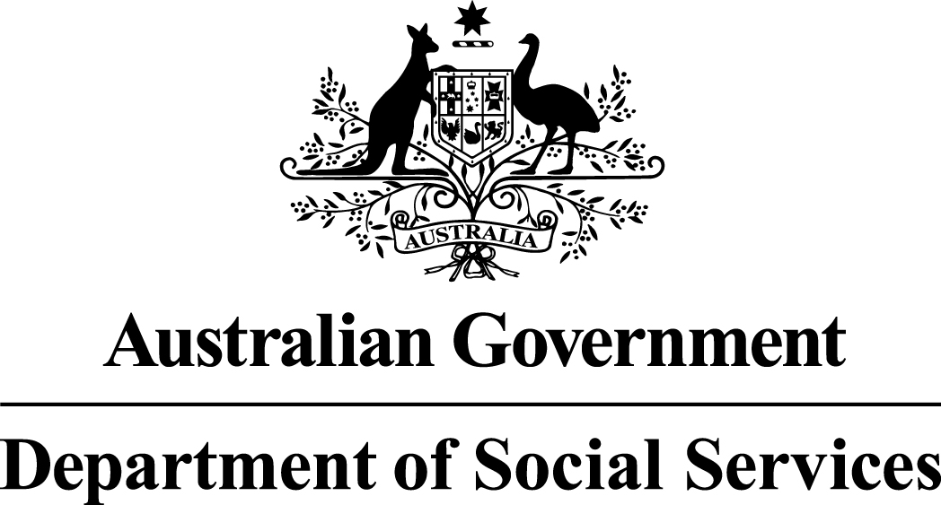

Families and Communities Program

National Plan to Reduce Violence against Women and their Children 2010-2022
Culturally and Linguistically Diverse Communities Leading Prevention
Funding Round Summary

National Initiatives
The Department of Social Services (DSS) provides leadership in Australian Government policy on issues affecting women and children’s safety.
DSS works with state and territory governments as well as portfolios across the Commonwealth through the National Framework for Protecting Australia’s Children 2009-2020 and the National Plan to Reduce Violence against Women and their Children 2010-2022 to help support and bring about change for our most vulnerable children, women and families.
The implementation of the National Framework and the National Plan is supported through National Initiatives funding. Funded activities have an emphasis on supporting and improving systems and services for those affected by violence and abuse.
The National Initiatives aim to achieve positive outcomes for families, women and their children by working across sectors to improve the safety and wellbeing of children, advancing gender equality and reducing violence against women and their children.
The sub-activities capture DSS’ business, in line with the Commonwealth Government’s priorities and responsibilities, and aim to contribute to a substantial and sustained reduction in child abuse and neglect and violence against women and their children in Australia over time, and include:
- National Framework for Protecting Australia’s Children 2009-2020;
- National Plan to Reduce Violence against Women and their Children 2010-2022;
- Support for Trafficked People Program; and
- Women’s Safety Package.

National Plan to Reduce Violence against Women and their Children
The National Plan to Reduce Violence against Women and their Children 2010-2022
(the National Plan) is a long-term partnership between the Commonwealth Government and state and territory governments, working with the non-government sector, business and communities, to deliver a significant and sustained reduction in violence against women and their children in Australia.
Under the Third Action Plan 2016-2019 of the National Plan, prevention and early intervention
is outlined as a National Priority Area. Action 1.2 seeks to support local communities to take effective action to reduce violence against women, with specific interest in supporting culturally and linguistically diverse (CALD) women, young people and communities to lead efforts to reduce violence against women in their communities.
The Community Grants Hub, on behalf of DSS, is inviting organisations to apply for funding for the Culturally and Linguistically Diverse Communities Leading Prevention Activity.

Selection type
This selection is an open process to select providers to deliver the Culturally and Linguistically Diverse Communities Leading Prevention Activity.
An open competitive selection process is open to all providers operating in the market place.
Open processes are advertised on the Community Grants Hub website and through other sources such as the media (if required) in order to attract as much interest as possible. Open rounds have nominated open and close dates, with applications being assessed against the designated selection criteria.

Applicant eligibility
Applications will be assessed against the criteria to ensure public accountability and meet program outcomes. Organisations must be in one of the following categories to have their application considered:
- Incorporated Associations (incorporated under state/territory legislation, commonly have 'Association' or 'Incorporated' or 'Inc.' in their legal name);
- Incorporated Cooperatives (also incorporated under state/territory legislation, commonly have ‘Cooperative' in their legal name);
- Companies (incorporated under the Corporations Act 2001 – may be proprietary companies (limited by shares or by guarantee) or public companies);
- Aboriginal Corporations (incorporated under the Corporations (Aboriginal and Torres Strait Islander) Act 2006);
- Organisations established through a specific piece of Commonwealth or state/territory legislation (public benevolent institutions, churches, universities, unions etc.);
- Partnerships;
- State and territory governments; and
- Local Governments.

Available funding for this activity
Total funding of up to $1.674 million is available across 2017-18 and 2018-19. Applications will be considered for one-off proposals of up to a total of $100,000 over this two-year period.
Applicants can apply for grants for up to three projects only. Should an Applicant submit more than three Applications, only the three latest on time Applications received will be progressed. If duplicate Applications are received (applications that are for the same project and delivered in the same locations), the latest of the duplicate Applications received will be progressed. More information can be found in the questions and answers for this grant round available on the Community Grants Hub website.

Closing date and time
Applications must be submitted by 2:00pm AEST Thursday 25 May 2017.
Late applications – information on the late application policy is available on the Community Grants Hub website.

Questions
Questions and answers for this funding round are available on the Community Grants Hub website.
If you cannot find an answer to your question, relating to this selection process or the activity, please send your question to support@communitygrants.gov.au.
Answers to questions will be published on the funding round page within five working days of receipt, unless the answers are available in the Application Pack. The Community Grants Hub will only answer questions to explain the requirements of the Application Form and Program Guidelines. The Community Grants Hub will not advise how to respond to specific selection criteria.
The question and answer period will close at 5:00pm AEST Thursday 18 May 2017.
Following this time, only questions relating to using and/or submitting the Application Form will be answered.
If you would like help or support in using and/or submitting the Application Form, please call 1800 020 283 or TTY 1800 555 677 or email support@communitygrants.gov.au.

Grant objectives
DSS is seeking applications from eligible organisations across Australia to develop and implement locally-led solutions to drive long term, sustainable changes in community awareness, attitudes and behaviours – with the aim of reducing violence against women and their children in CALD communities. This may involve, but is not limited to, activities that address complex forms of violence such as female genital mutilation (FGM), forced marriage and human trafficking.
Activities may be targeted to support a particular cultural or religious community and/or within a specific geographic location or area.
The grants will provide one-off non-ongoing funding in order to develop and implement CALD community owned and driven strategies. Organisations should have the influence and cultural capital required to drive work to address domestic and family violence issues that exist within their communities. Projects should address an identified need within the specified community, and have strong community investment and ownership to help achieve sustainable change beyond the life of the project itself.

Statement of Requirement
When completing your Application you must provide all information as directed. Your application/s will not be considered if you do not do so.
Up to $100,000 (GST exclusive) per proposal will be provided to support strategies that:

- address specific domestic and family violence issues within the specified community. This could involve, but is not limited to, activities which address complex forms of violence such as FGM, forced marriage and human trafficking;
- successfully engage with key stakeholders and the local CALD community to drive sustainable changes in community awareness, attitudes and behaviours that lead to or contribute to violence against women and their children;
- utilise a culturally relevant approach to ensure that activities are appropriate and targeted. This may involve developing culturally relevant resources in languages other than English, and promoting and distributing these so they are accessible to community; and
- promote existing support available within local CALD communities.
Successful applicants will be required to participate in an action research component. This will involve working with a specialist research organisation contracted by DSS to support applicants to:

- throughout the life of the project, document the implementation of the project, and reflect on lessons learnt; and
- participate in discussions with other grant recipients to assist in information sharing – this may include up to three face-to-face workshops and participation in webinars and online forums. Successful applicants must meet the cost of workshop attendance from their grant funding.
These experiences will be captured in a report to inform future projects.
Consideration will be given to:
- location of projects being proposed (preference may be given to projects in areas with significant prevalence of family and domestic violence);
- aim and purpose of each project in a location;
- participation in action research and sharing of research learnings; and
- number of projects proposed in each state and territory.
This will help ensure a mix of projects across different locations and communities as well as a mix of different approaches across the successful projects. It is intended there will be projects in all states and territories.

Restrictions
The grants may only be used to deliver:
- resources;
- products;
- research; and
- services outlined in the agreed grant agreement.
In addition to the development and delivery of specified products and outcomes, funding may be used for:
- delivery of services which meet the Program Guidelines;
- staff salaries and on-costs for project implementation and ongoing management;
- evaluation and review of the project;
- staff training;
- materials and equipment directly related to the implementation of the project;
- operating expenses directly related to the activity;
- assets as defined in the Terms and Conditions that can be reasonably attributed to meeting agreement deliverables; and
- travel within Australia directly and specifically related to the project.
Grants are not provided for:
- purchase of land;
- retrospective costs;
- costs incurred in the preparation of a grant application or related documentation;
- major construction/capital works;
- overseas travel; and
- activities for which other Commonwealth, state, territory or local government bodies have primary responsibility.

Intellectual property
The Commonwealth retains ownership of any material it provides to the funding recipient (or material which is created) for the purposes of the funding agreement. The Commonwealth grants the service provider a licence to use the material for the purposes of the funding agreement.
The funding recipient retains ownership of any material it brings into existence in performing the funding agreement. The funding recipient grants the Commonwealth a licence to this material (excluding secret and sacred material) for any Commonwealth purpose.

Value for Money
In assessing the extent to which applications represent value for money, consideration will be given to the information provided at the ‘Achieving value for money’ section 3.3 of the Program Guidelines available on the DSS website or in the Application Pack available on the Community Grants Hub website.

Selection Criteria
The selection criteria are equally weighted.
Criterion 1 – Demonstrate your understanding of the need for the funded activity in the specified community and/or the specified target group.
Your response must demonstrate an understanding of all of the following:
- the target CALD community and ethnic groups;
- the need and the extent of violence or violence-supportive attitudes and behaviours toward women and their children within the target community; and
- the gendered-nature of violence against women, its causes and the ways it may manifest in relationships.
Criterion 2 – Describe how the implementation of your proposal will achieve the activity objectives for all stakeholders, including value for money within the Grant funding.
Your response must demonstrate all of the following:
- a description of the intended project, how it will be implemented, how it is relevant to the specified community, and how it contributes to a reduction in violence against women and their children;
- if partnering with other organisations, you must outline the commitment of these organisations within the community to deliver the project; and
- how the project is community-owned and driven, and how the work and outcomes of this project will be sustained in-community after the funding period.
Criterion 3 – Demonstrate your organisation’s capacity and your staff capability (experience and qualifications) to deliver the activity objectives in the specified community and/or specified target group.
Your response must demonstrate all of the following:
- experience in community engagement, awareness raising and attitudinal and behavioural change activities (community-led) related to violence against women;
- a proven track record or demonstrated capability in providing quality and culturally competent services, activities or strategies; and
- your strong relationship and influence in target CALD communities, including how partnerships with other community organisations or agencies will be developed and sustained.

Attachments
For this round, no attachments are requested. Documents attached to applications will not be assessed.

Feedback for this funding round
A Feedback Summary will be published on the Community Grants Hub website following the finalisation of the funding round.
The Feedback Summary will provide general round-specific information and will include main strengths and areas of improvement for the applications received in this round.

Multicultural Access and Equity Policy
Australia’s Multicultural Access and Equity Policy: Respecting diversity. Improving responsiveness means that Australian Government agencies make sure that cultural and linguistic diversity is not a barrier for people who need to access government and community services. This means, for example, that appropriate language services should be provided. Grant applicants should consider whether professional translating or interpreting services may be needed to deliver services, projects, activities or events to non-English speakers. If your Application Form states that a budget is required, costs for translating and interpreting services should be included in your budget.

Assessment
The Assessment Team may be comprised of Australian Government officers from each state/territory and national offices. Teams will undertake training so that applications are assessed consistently. The Assessment Team will be bound by the APS Code of Conduct and the departmental Secretary’s Instructions.

Probity and fairness
The selection of funding recipients must be fair, open and demonstrate the highest level of integrity.

The following principles will be applied throughout the selection process:
- fairness and impartiality;
- consistency, accountability and transparency of process;
- security and confidentiality of information;
- identification and resolution of conflicts of interest; and
- compliance with legislative obligations and government policy.

These principles are intended to achieve an equitable, justifiable and sound process.
The Community Grants Hub may engage a Probity Advisor to help meet its obligations to make selection processes defensible and able to stand up to external and internal scrutiny. The Probity Advisor also advises The Community Grants Hub on, and monitors, the procedures used in the selection process to make sure they comply with the published relevant Program Guidelines. The Probity Advisor plays no part in the assessment of applications.

Program Guidelines
The Program Guidelines provide the starting point for parties considering whether to apply for funding and are the basis for the business relationship between DSS and the funding recipient. Applicants are strongly advised to read the Program Guidelines before completing an Application Form.

How to apply
Once you have completed your Application Form, you must submit it electronically by using the submission section at the end of the form. Following electronic submission, a message with your Submission Reference ID will appear on your screen. An email will be sent to the main email contact provided in the Application Form. A function is also available on the submission page to allow you to send a receipt email to the address of your choosing. Please save this email receipt for future reference and use it in all correspondence about this Application.

If you do not receive a confirmation email or you have difficulties submitting the Application Form, please call the Community Grants Hub Hotline on 1800 020 283 or TTY on 1800 555 677.

Grant Agreement information
The Grant Agreement is a performance-based, legally enforceable agreement between the Commonwealth (represented by DSS) and the successful applicant that sets out the Terms and Conditions governing the funding to be provided.

The type of Grant Agreement entered into will depend on the activity, the assessed activity risk level, the length of the activity and the amount of the grant.

