Viewing milestones
  - Process to view milestones in the Grant Recipient Portal
Portal access required: Administrator, Editor.
The portal enables grant recipients to view their Grant Agreement milestones. Milestones represent actions, deliverables or payments applicable to your organisation, as detailed in the Grant Agreement. This task card will describe the process for reviewing Grant Agreement milestones.

Navigating to milestones
From the Home screen, select the Milestones tile or Milestones link in the navigation menu.
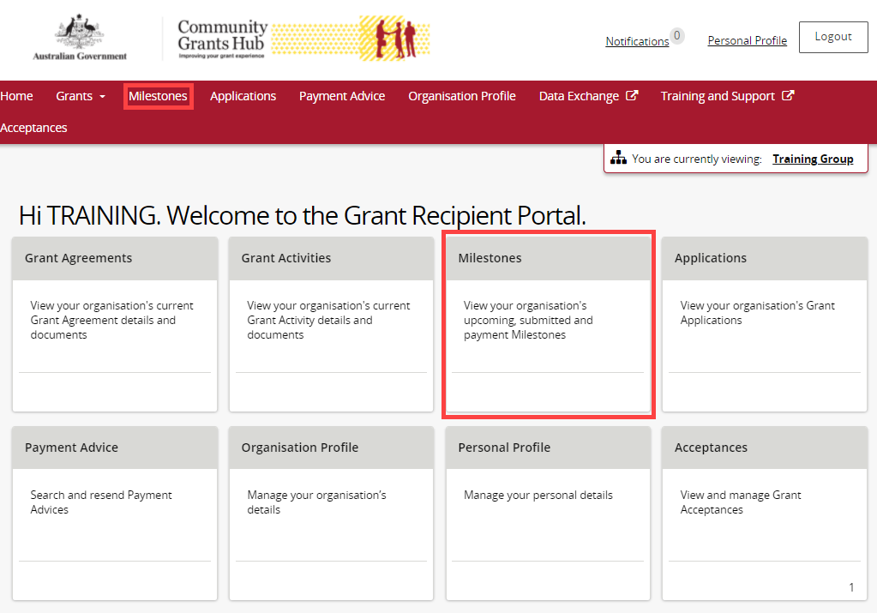

The Milestones screen will display and the Filter: Upcoming Milestones will be applied by default. This will show all milestones which are yet to be completed.
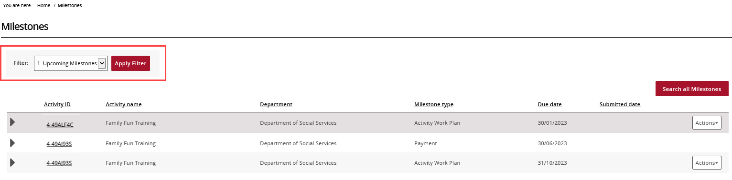
Choose the appropriate option from the drop down and select Apply Filter.
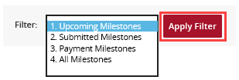
Once the filter is applied, the applicable Milestones view will display. To view information about the milestone, select the expand arrow next to the Activity ID.
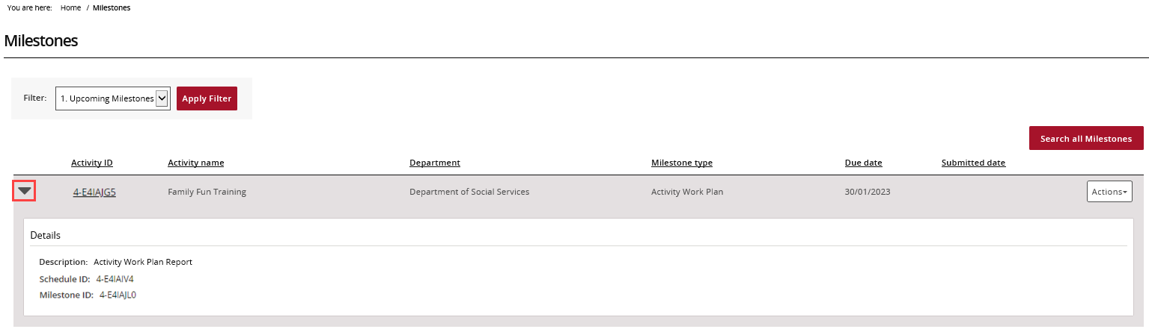
To navigate to the Activity details, select the Activity ID hyperlink.
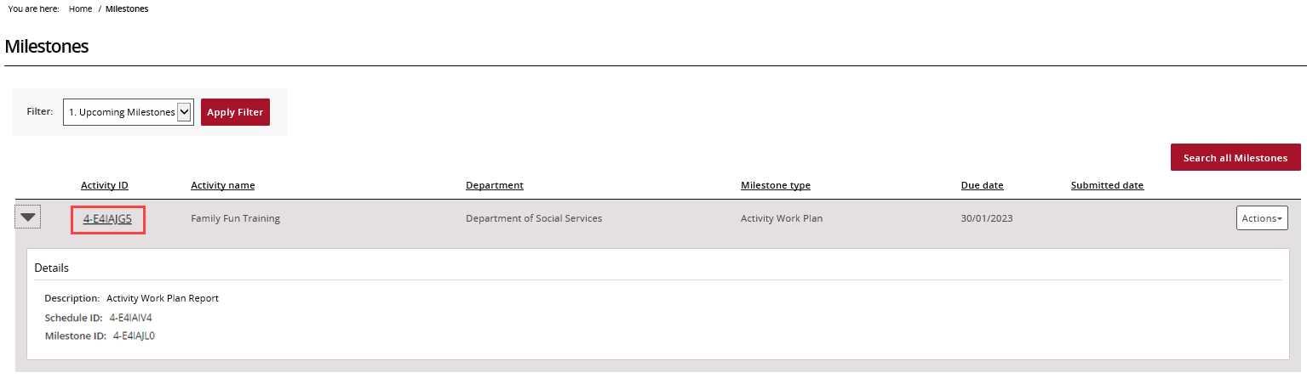

Searching for a milestone
To locate a specific milestone select Search all Milestones.
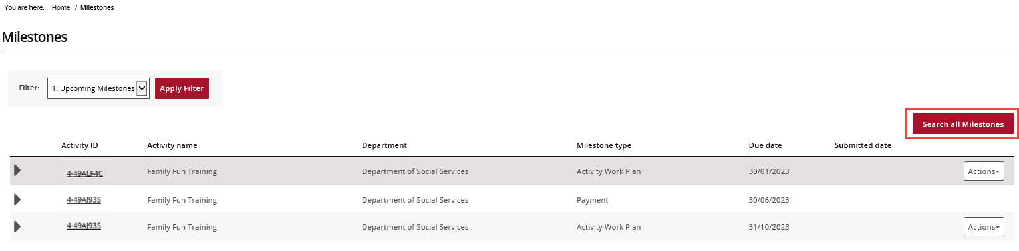
The Search all Milestones screen will display. Enter at least one search criteria and
select Run search.
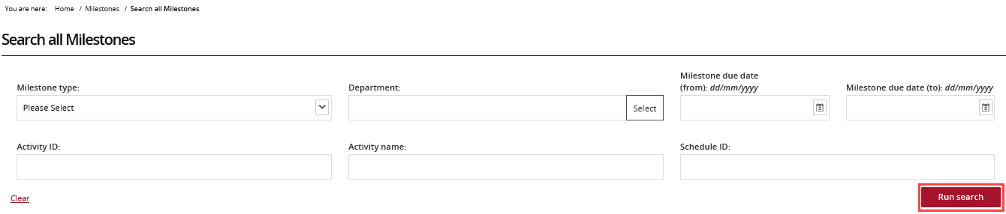
The results will display underneath the search fields. To export the results, choose the Format from the drop down followed by Export.
The default Format option is ‘Tab Separated’. This allows you to export the data in a table structure which can be viewed in Microsoft Excel.
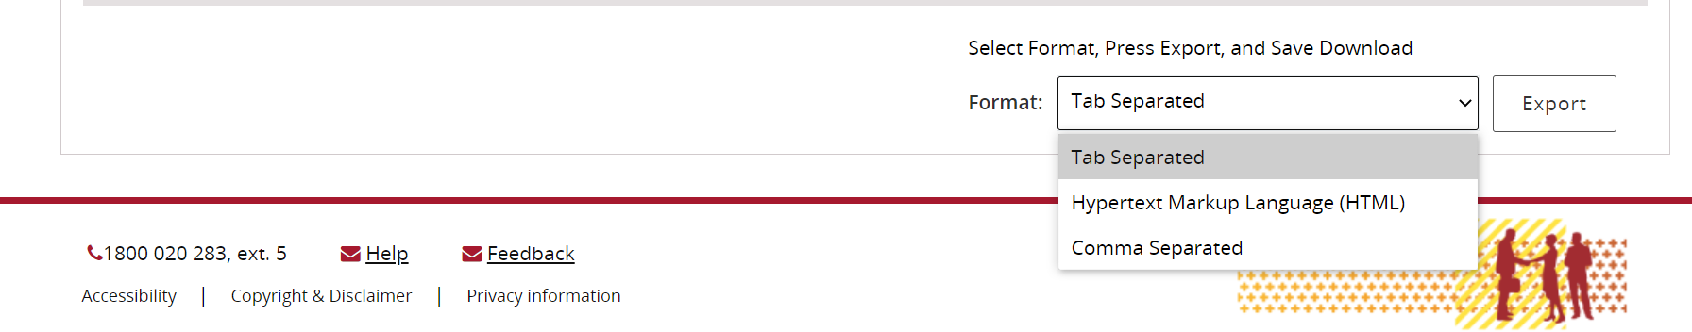

Need help?
For further assistance, contact the Grant Recipient Portal Helpdesk:
Email: GRP.Helpdesk@communitygrants.gov.au
Phone: 1800 020 283 (option 5)
Operating Hours: 8:30 am and 5:30 pm (AEST/AEDT) Monday to Friday, excluding public holidays.

