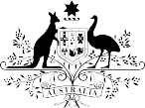
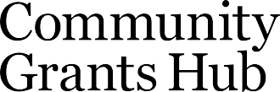
Grant Recipient Portal
The Community Grants Hub delivers community grants on behalf of Australian government agencies. The Hub works with Australian Government agencies, grant applicants and grant recipients to deliver a more streamlined, simpler and consistent approach to grants administration.

What is the Grant Recipient Portal?
One way the Hub is making it easier for grant recipients to manage their grants is through the Grant Recipient Portal.
The Portal is an intuitive, online system for grant recipients to self-manage their grants administration needs more easily, such as:
- accessing their grants information in one place, anytime
- viewing their activities and milestones
- getting copies of their payment advices
- updating their organisational details, adding additional organisational users
- updating their organisation’s bank account details,
- submit a Financial acquittal
- submit an Activity Work Plan

What are the benefits of using the Portal?
- more consistent and improved user experience
- reusable data within the Hub using the ‘tell us once’ principle
- reduction in red tape
- expanded self-service capability
- improved accessibility and information

How do I get access to the Portal?
To access the Portal, you will need a Digital Identity, such as myGovID. Once you have created your myGovID you will need to link it to your organisation's ABN using Relationship Authorisation Manager (RAM). RAM is an authorisation service that allows you to act on behalf of linked organisations online. How you link depends on whether you are a:

- principal authority – person responsible for the business or entity
- authorised user or administrator - someone who acts on behalf of a business or entity. For more information, see Relationship Authorisation Manager.

How do grant recipients use the Portal?
An overview video showing how easy it is to use the Portal is available on the Community Grants Hub website.

How can I keep up-to-date with what is happening with the Portal?
All grant recipients are encourage to subscribe to the Community Grants Hub Website so you can be kept informed on what is happening in the Hub.
Updates regarding the Grant Recipient Portal will be published on the News page of the Community Grants Hub website.

How do I get help if I need it?

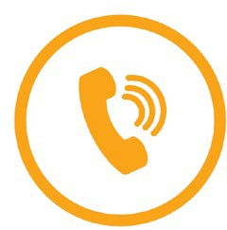
By phone
1800 020 283 (Option 5) between 9:00 am and 5:00 pm EST, Monday to Friday
TTY: 1800 555 677

By email
Technical: GRP.Helpdesk@communitygrants.gov.au General enquiries: GRP.Project@communitygrants.gov.au

