Grant Recipient Portal

Quick Start Guide

Prior to gaining access to the Grant Recipient Portal (the Portal), you must set up your Digital Identity and link it to your organisation’s ABN in Relationship Authorisation Manager (RAM).

myGovID is the Australian Government’s Digital Identity app. For more information on setting up your myGovID and linking it to a business in RAM, please follow the instructions on the [myGovID](https://www.mygovid.gov.au/set-up) and [RAM](https://info.authorisationmanager.gov.au/get-started) websites or speak to your IT Administrator.

To alleviate the need to submit multiple access request forms, it is recommended that the first person to access the Portal within an organisation be the designated Administrator. The Administrator will be able to manage user access for the organisation.

Anyone requesting Administrator access will need to complete a user access request form and submit this to the Portal Helpdesk. An organisation will need only one Administrator; however, multiple Administrators can be set up if the organisation desires. Once the Administrator account has been created, the Administrator can create additional users, outlets and activities.

# Step 1 – Setting up your Digital Identity

myGovID is the Australian Government’s Digital Identity app which you can download to your smart device. myGovID allows you to prove who you are when accessing government online services.

Each user of the Portal will need to set up their own myGovID using a **personal** email address, it should not be a shared or work email address.

Set up your myGovID in three easy steps:

* download the myGovID app - only download the app from the official Apple App Store or the Google Play Store
* enter your details – including your name, date of birth and personal email address
* choose your identity strength - you need at least a Basic identity strength to access the Portal.

More information about setting up myGovID is available on the [myGovID website](http://www.mygovid.gov.au/setup).

# Step 2 – Linking your myGovID to an ABN using RAM

Relationship Authorisation Manager (RAM) is an authorisation service that allows you to act on behalf of a business online when linked with your myGovID.

How you link depends on your role.

**Principal Authority**

A principal authority is a person responsible for the entity. They need to link to the organisation’s ABN in RAM first. Once linked, the principal authority can authorise others to access government online services, like the Portal, on behalf of the organisation.

More information about linking as a principal authority can be found on the [RAM website.](https://info.authorisationmanager.gov.au/principal-authority)

**Authorised user or administrator**

An authorised user or administrator is someone who acts on behalf of an organisation.

A principal authority or authorisation administrator needs to authorise you before you can access the Portal. You will use your myGovID to log into RAM and accept the authorisation request.

More information about accepting an authorisation request can be found on the [RAM website.](https://info.authorisationmanager.gov.au/authorised-users-and-administrators)

# Step 3 – How to sign in to the Portal using myGovID

Once you’ve set up your myGovID, linked to the ABN in RAM and your Portal user account is created, go to the [Grant Recipient Portal](https://mygrants.communitygrants.gov.au/mygrants) and select **Continue with Digital Identity.**

Select myGovID as your Digital Identity – you will be asked to provide consent to sharing the information outlined on screen. You can select ‘Remember my choice’ to automatically progress to the myGovID login screen next time.

The myGovID login screen will display, as shown in Figure 1. Enter your myGovID email address. You can select ‘Remember me’ to make logging in faster and easier. This means next time you will not need to enter your email address and the four-digit code will be pre-filled in your app for you to accept.

*Figure 1 – myGovID login screen*

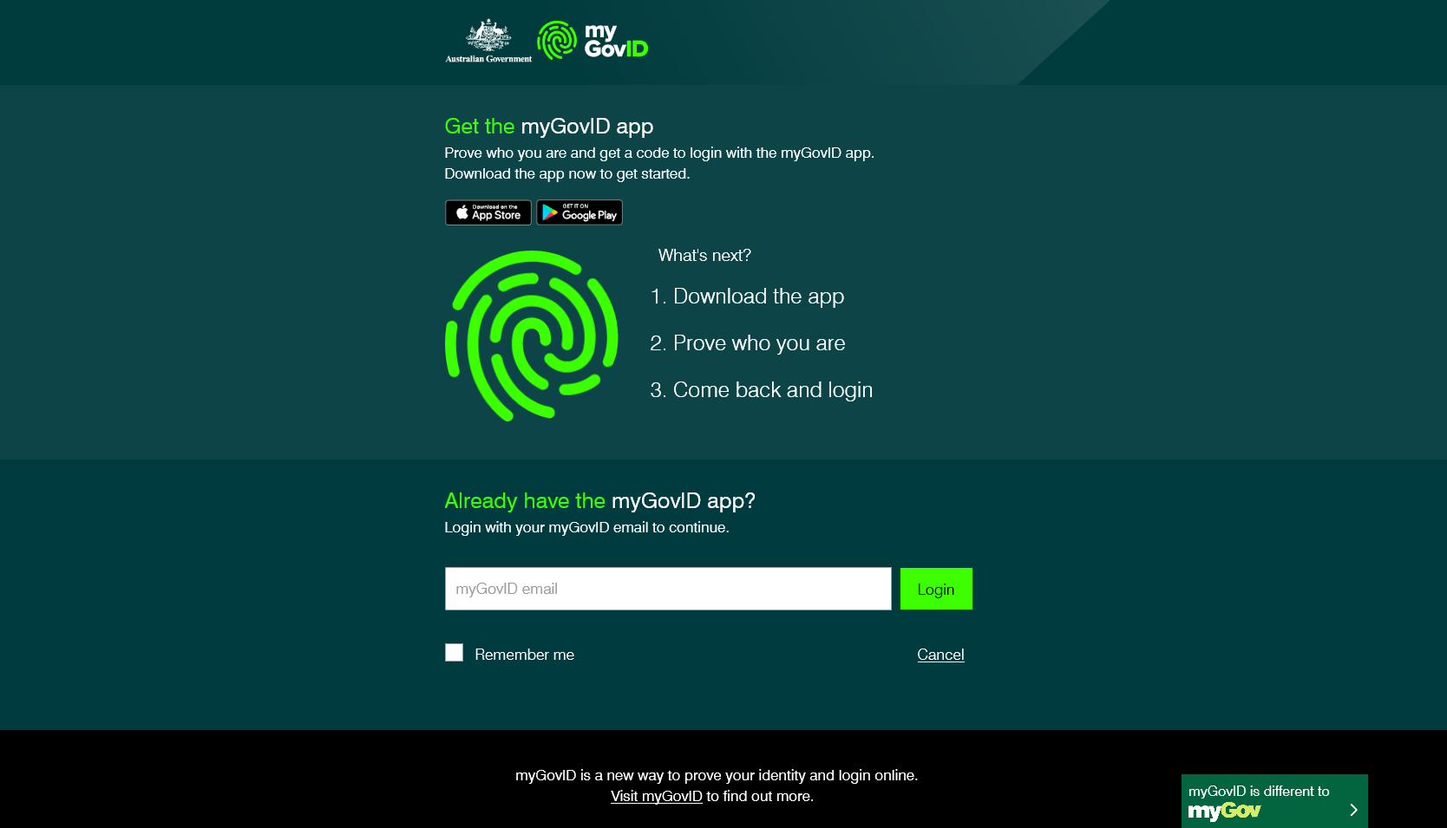

The following screen will display a four-digit code, as shown in Figure 2.

*Figure 2 – Four digit code screen*

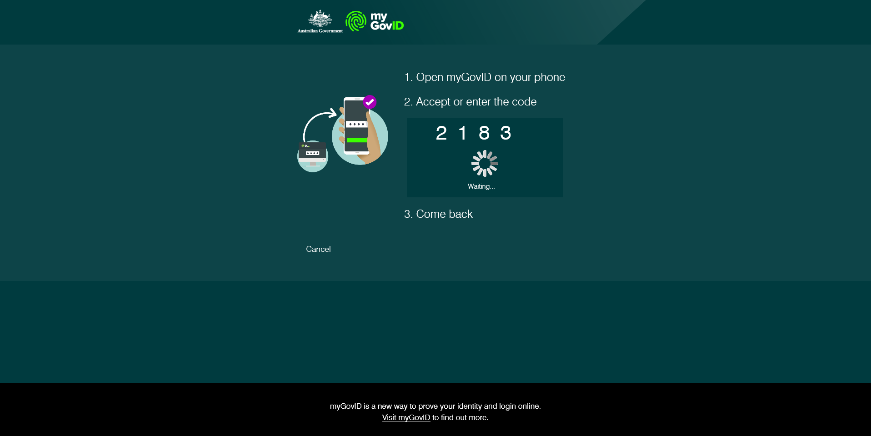

Open the myGovID app on your smart device. Enter or accept the four-digit code displayed, as shown in Figure 3.

*Figure 3 – Entering four-digit code in the myGovID app.*

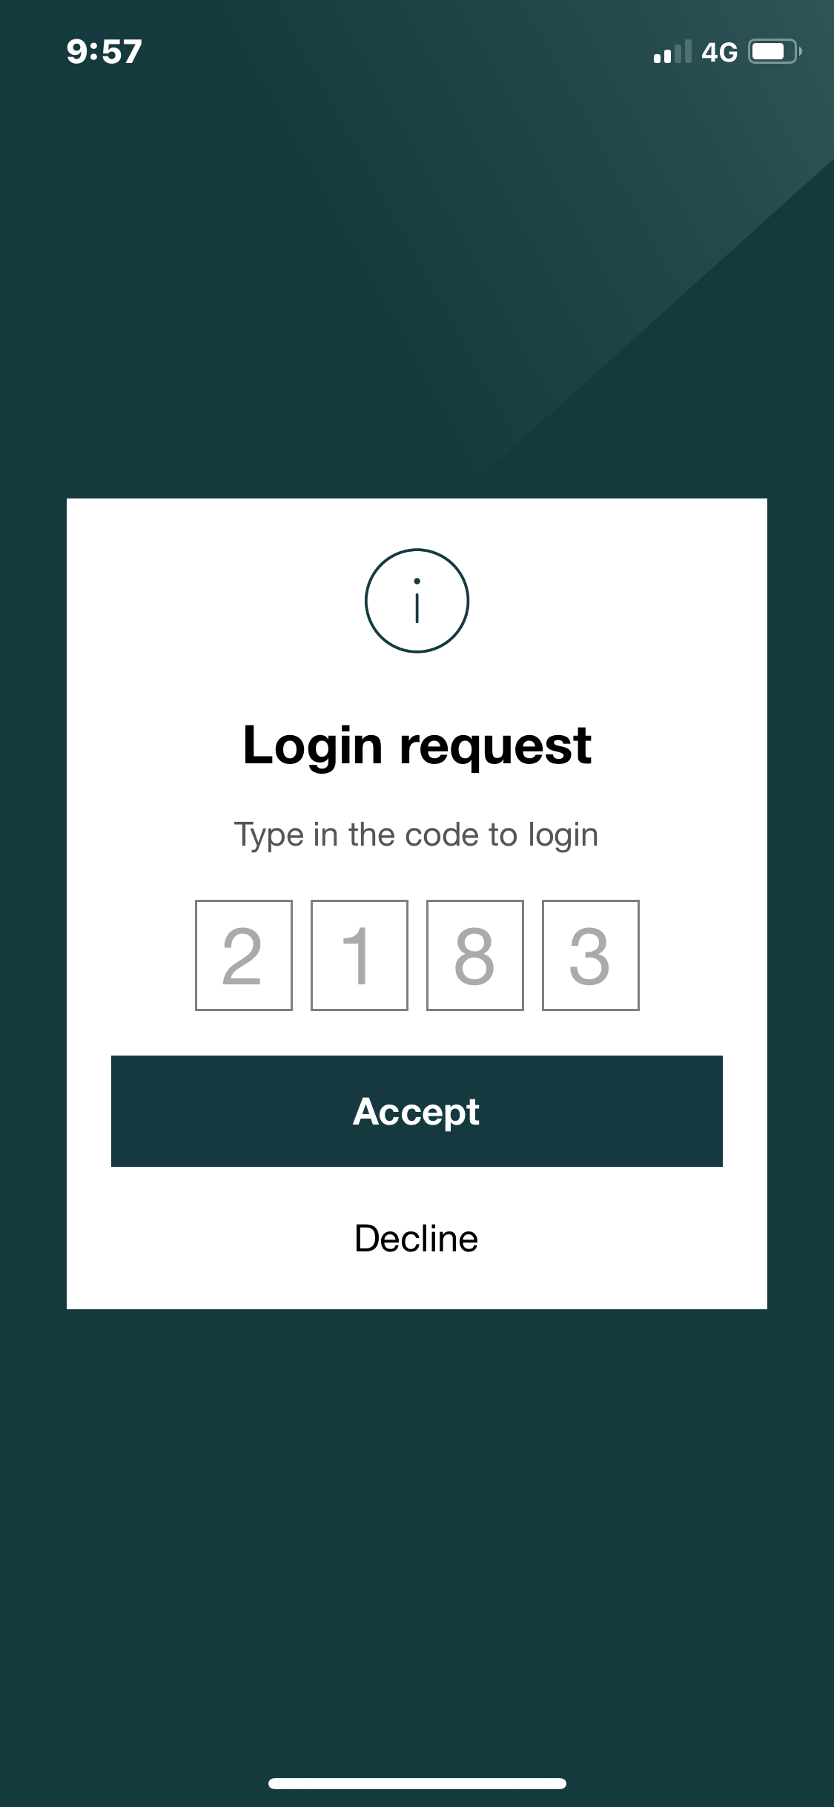

Go back to the [Grant Recipient Portal](https://mygrants.communitygrants.gov.au/mygrants).

When logging into the Portal for the first time using myGovID, you will need to complete the account activation process. The screen in Figure 4 will display. Enter the email address on screen that was provided in your user access request form.

*Figure 4 – Account activation*

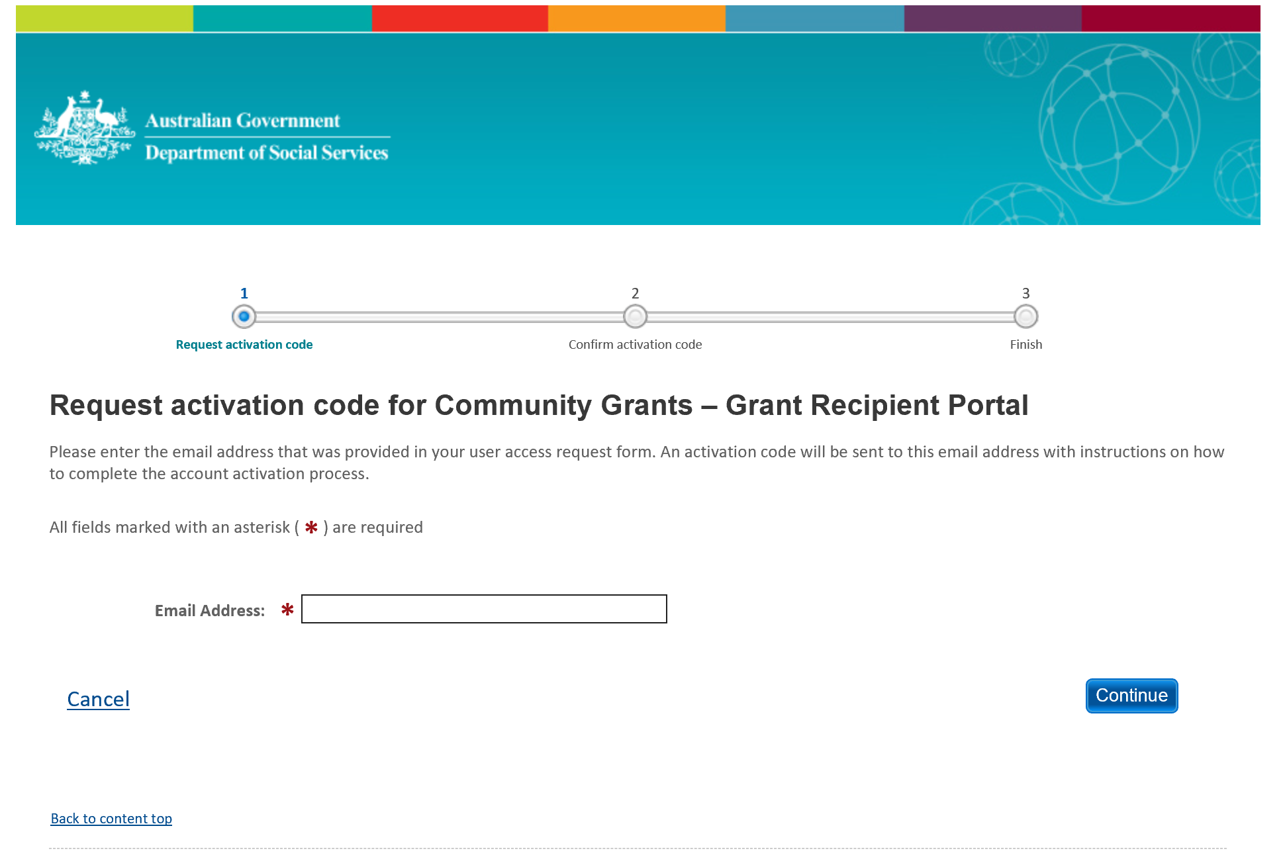

An eight digit activation code will be sent to the email address provided, and the screen shown in Figure 5 will display. Enter the activation code and select Confirm.

*Figure 5 – Activation code*

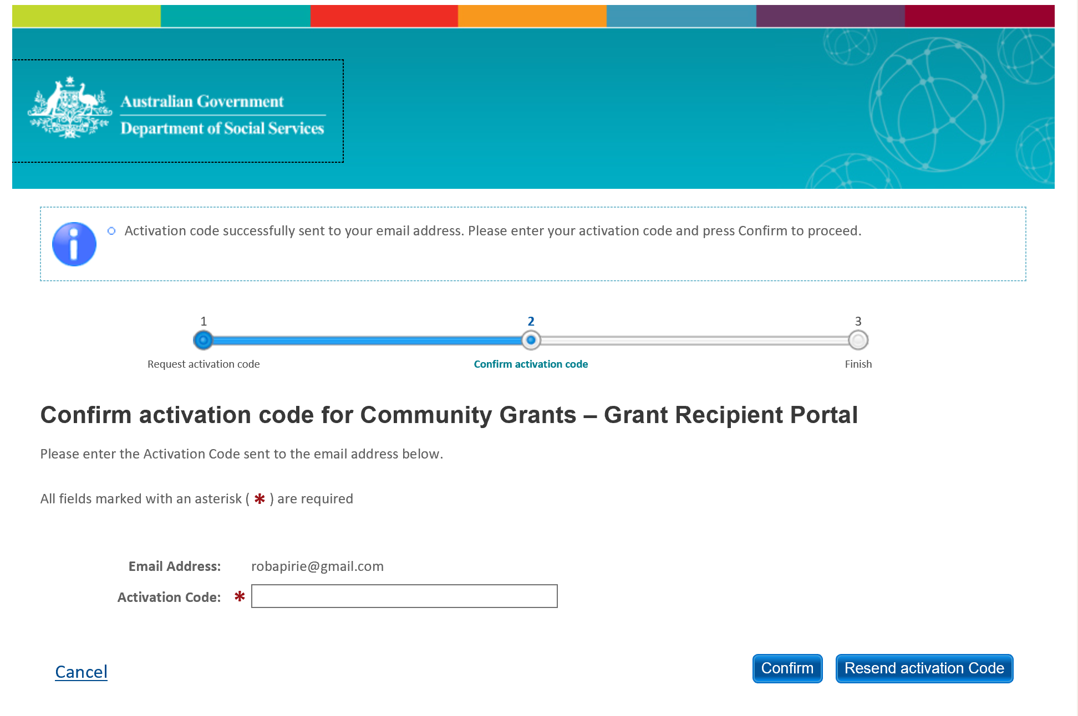

# Step 4 – Login to the Grant Recipient Portal

Once an activation code has been successfully entered, you will be prompted to continue through to the Portal login page. Enter your password into the password field and select ‘Continue’.

The Welcome screen will display, as shown in Figure 6. Select ‘I Agree’ to accept the terms and conditions and you will be logged into the Portal.

*Figure 6 – Welcome screen*

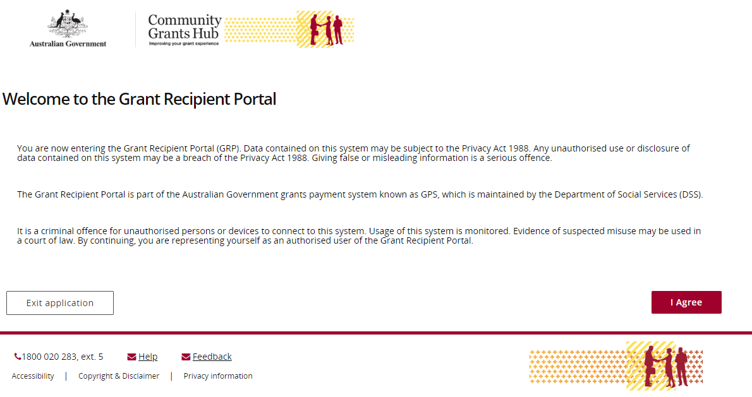

# Need Help?

For further assistance with Digital Identity, please see the resources available on the Digital Identity and myGovID websites.

**URL:** <https://www.digitalidentity.gov.au/support>

**URL:** <https://www.mygovid.gov.au/help>

**Phone**: 1300 287 539 (Select Option 2 for myGovID)  
**Operating Hours: Monday to Friday 8.00am – 6.00pm (AEST/AEDT)**

If you require assistance with Relationship Authorisation Manager visit the RAM website.

**URL:** <https://info.authorisationmanager.gov.au/help>

For further assistance with the Grant Recipient Portal, please contact the Community Grants Hub:

**Email:** [GRP.helpdesk@communitygrants.gov.au](mailto:GRP.helpdesk@communitygrants.gov.au)

**Phone:** 1800 020 283 (Option 5)

**Operating Hours:** Monday to Friday 9:00am – 5:00pm (AEST/AEDT)