View Applications
  - Grant Recipient Portal Task Card
Portal Access required: Administrator, Editor or View Only
The Grant Recipient Portal (Portal) enables grant recipients to view a list of their submitted Grant Applications. A Grant Recipient can request a copy of a submitted Grant Application by contacting the Community Grants Hub Hotline on 1800 020 283 or emailing support@communitygrants.gov.au.
This task card describes the process of viewing a list of submitted Grant Applications.
Viewing Applications
Step | Action
From the Home screen select on the Applications tile or select the Applications link from the Navigation menu.
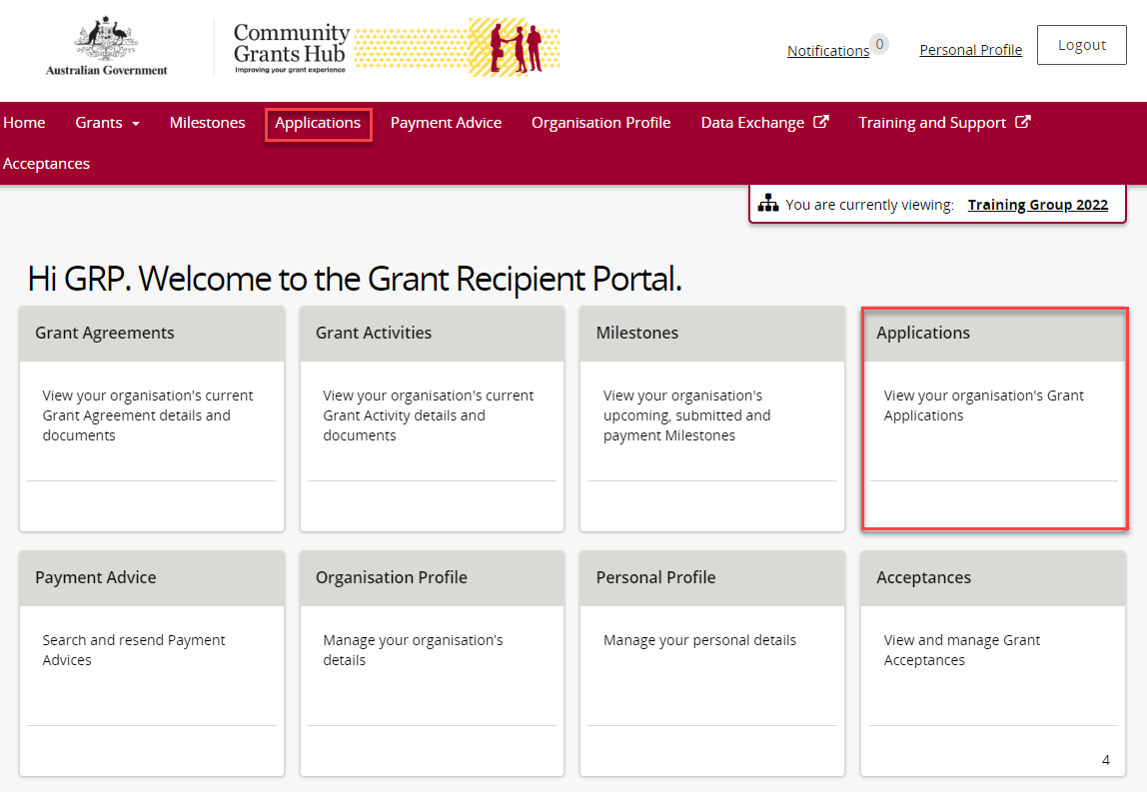

The Applications screen will display showing a list of submitted applications with the following information.
- Application ID | - Department
- Funding Round Name | - Funding Round Category

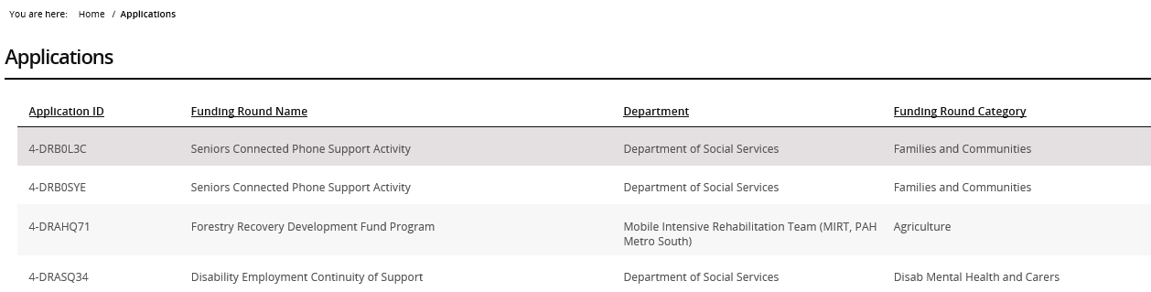
Need Help?
For further assistance, contact the Grant Recipient Portal Helpdesk:
Email: GRP.Helpdesk@communitygrants.gov.au
Phone: 1800 020 283 (Option 5)
Operating Hours: Monday to Friday 9:00am – 5:00pm (AEST/AEDT)

