View Grant Information
  - Grant Recipient Portal Task Card
Portal Access required: Administrator, Editor or View Only
The Grant Recipient Portal (Portal) enables grant recipients to view their grant details, including Grant Agreement documentation, Variation documentation and Grant Activity details. This includes details of the Funding Arrangement Manager, Milestones, Contacts, Bank Accounts and a Financial Overview.
This task card describes the process of viewing Grant Agreement and Grant Activity details.

Viewing Grant Agreements
Step | Action
From the Home screen, select the Grant Agreements tile. Alternatively, select Grants in the Navigation menu and select Grant Agreements from the drop down menu.
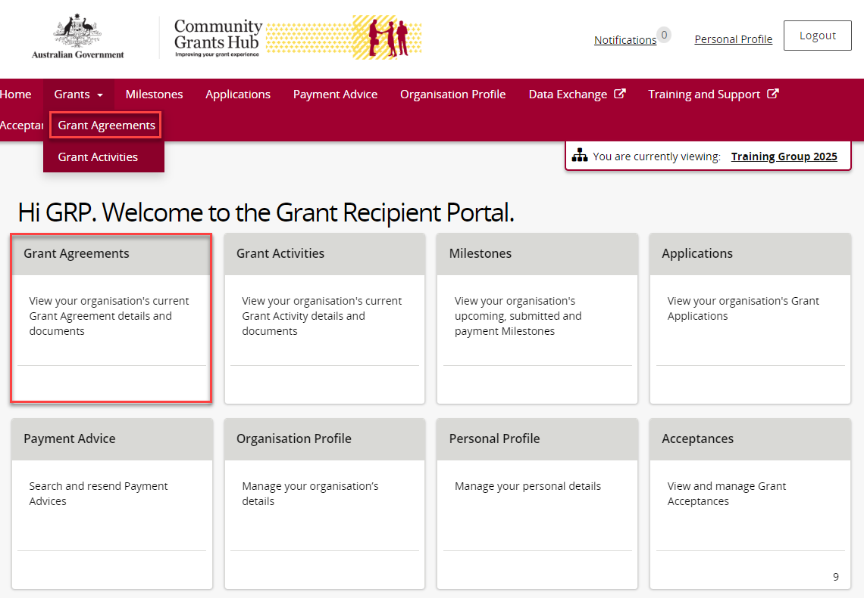

The Grant Agreements screen will display. To view a particular Grant Agreement, select the Grant Agreement’s View button.
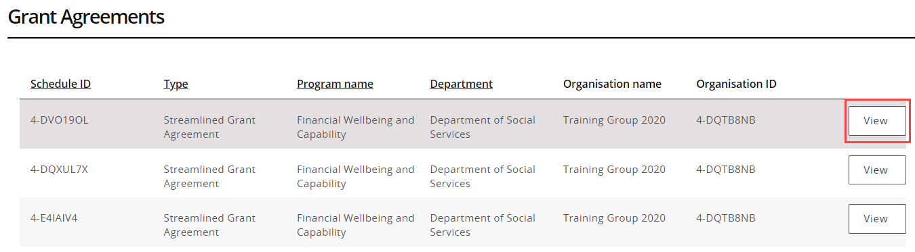

Viewing the Grant Agreement details
Step | Action
The Grant Agreement menu screen displays an overview of the Agreement by default. The below information related to the Grant Agreement can be viewed:
- Schedule ID | - Agreement Type
- Start date | - Completion date
- Program name | - Department
- Organisation name | - Organisation ID
A list of Grant Activities associated with the Grant Agreement are displayed below. To view the Activities linked to this Agreement select the View button.
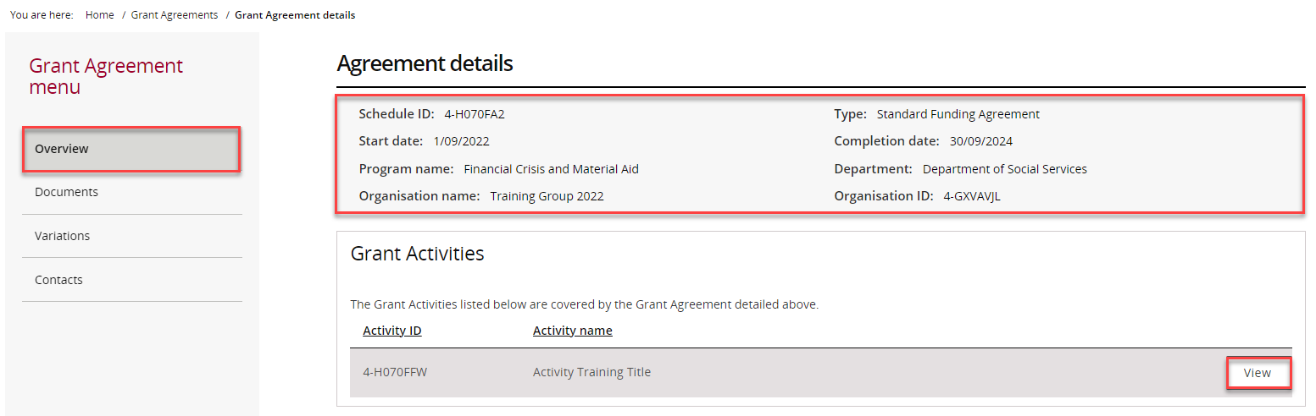

The Grant Agreement menu allows grant recipients to obtain a copy of their Grant Agreement Documents.
From the menu, select the Documents link. The Documents screen will display. To download the signed Executed Grant Agreement, select the View button.
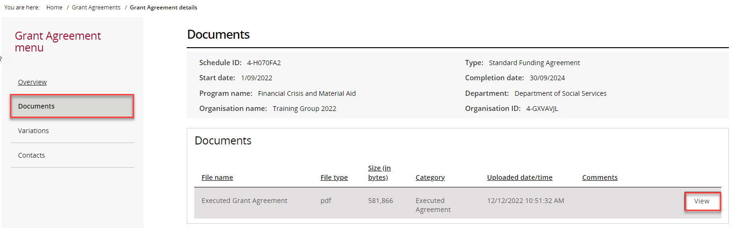
The File Download message will appear. Select Download to save a copy of the Executed Grant Agreement.
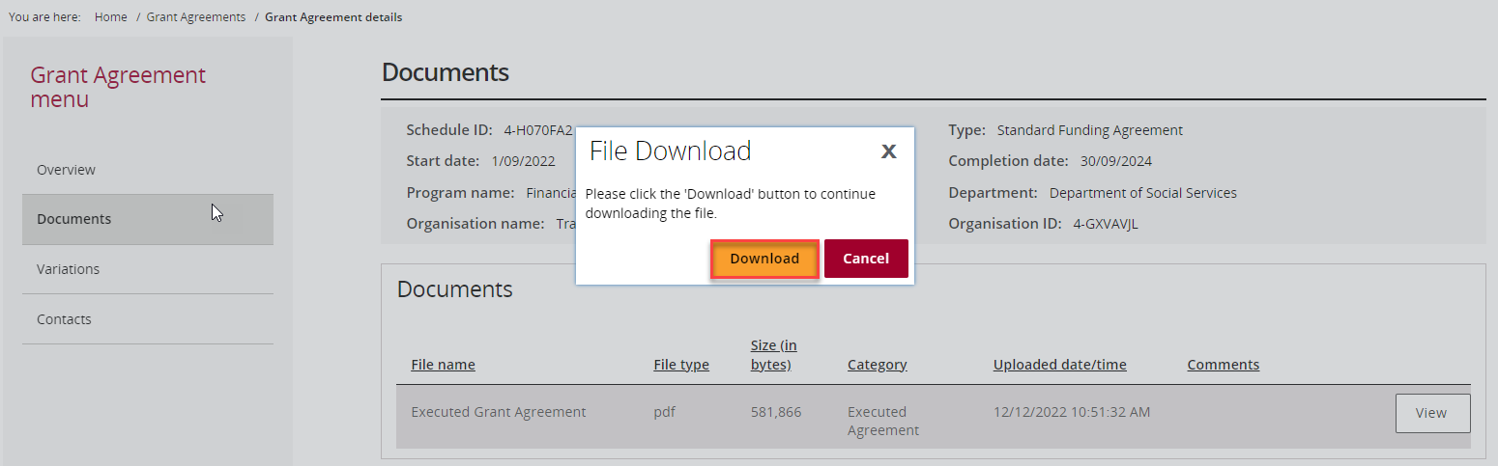
The Grant Agreement menu also allows grant recipients to view their Grant Agreement Variations if applicable.
From the menu, select the Variations link. The Variations screen will display. To download the signed Executed Variation, select the View button.
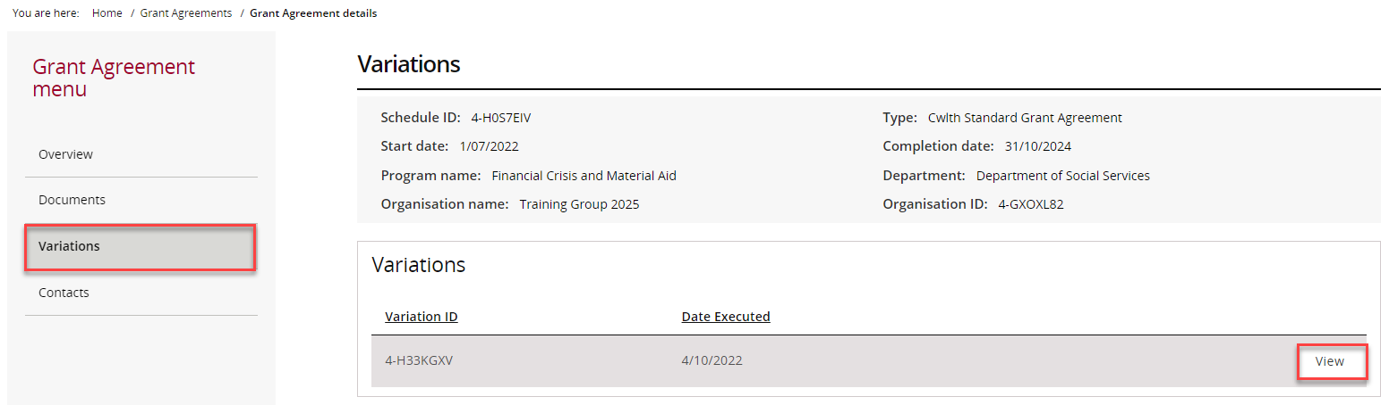
A popup window will appear showing the variation document, select View.
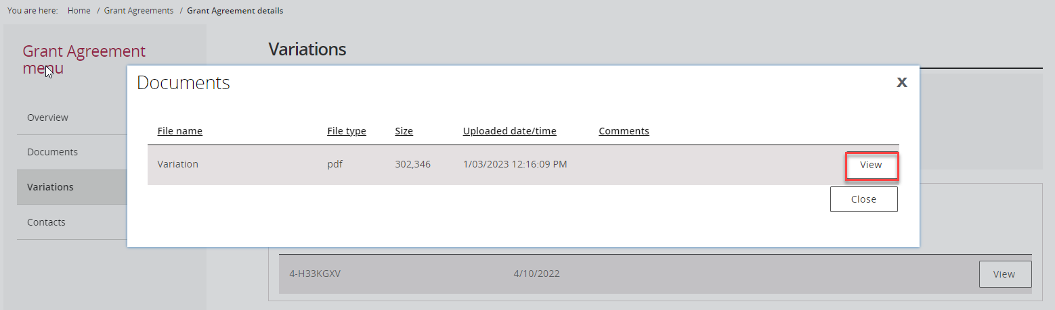
The File Download message will appear. Select Download to save a copy of the Executed Variation.
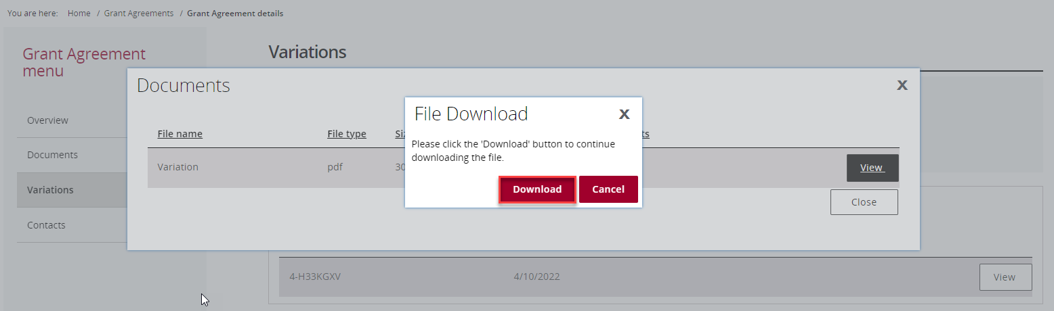
The Grant Agreement menu also allows grant recipients to view their Grant Agreement Contacts.
From the menu, select the Contacts link. The Contacts screen will display a list of Contacts associated with the Grant Agreement.
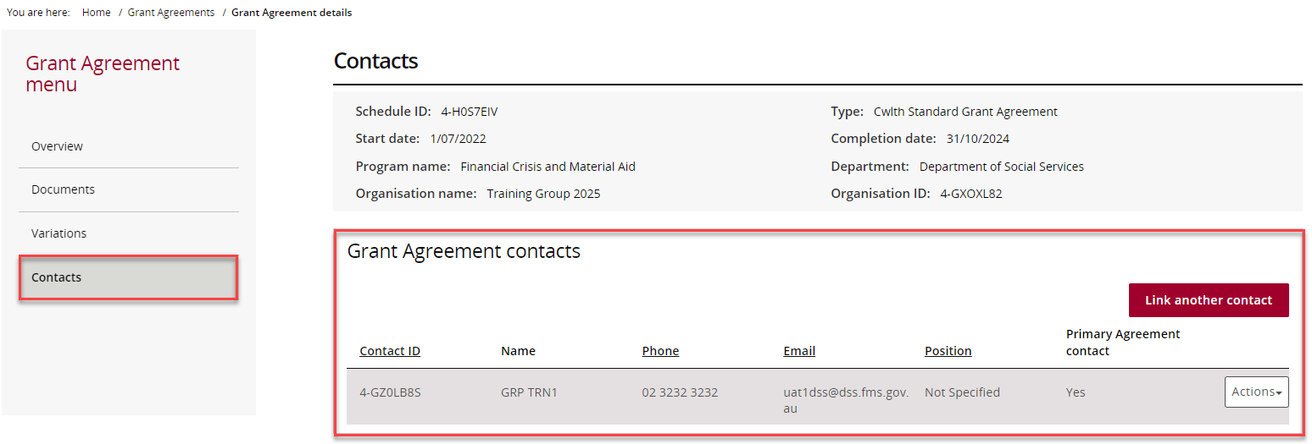

Viewing Grant Activities
Step | Action
From the Home screen, select the Grant Activities tile. Alternatively, select Grants in the Navigation menu and select Grant Activities from the drop down menu.
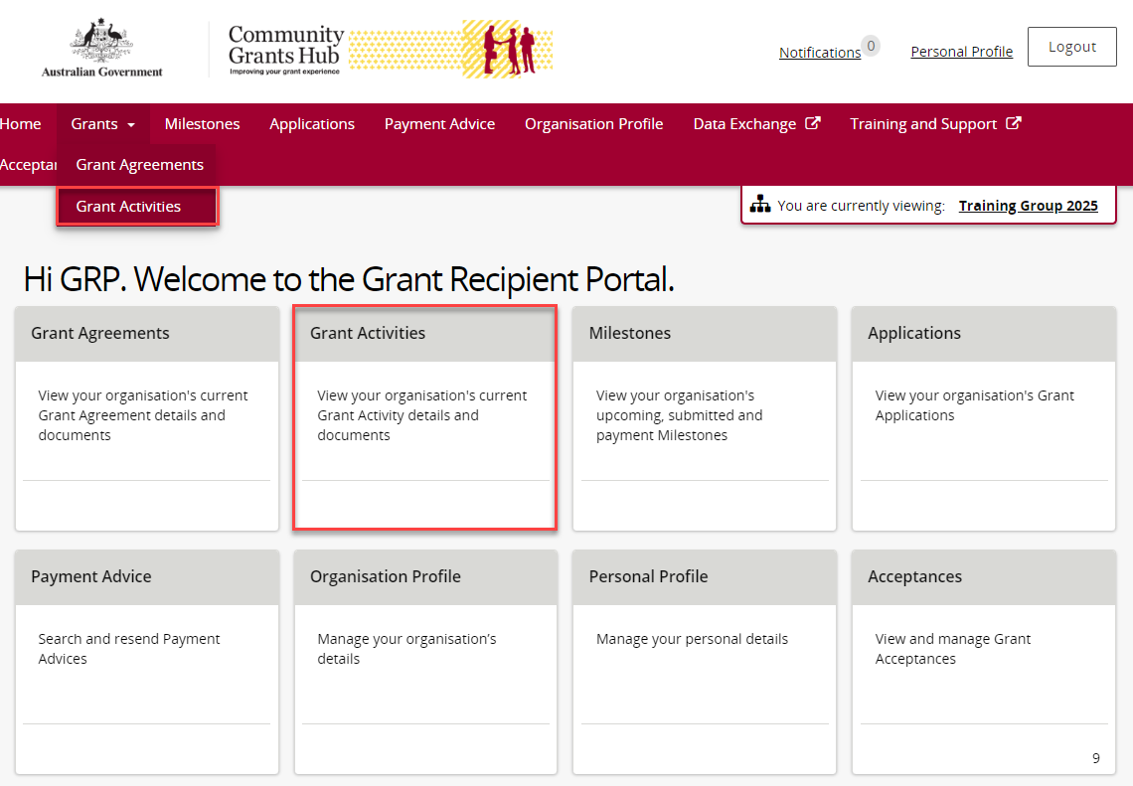
The Grant Activities screen will display. Select the expansion arrow next to an Activity ID to show additional information about the Activity.
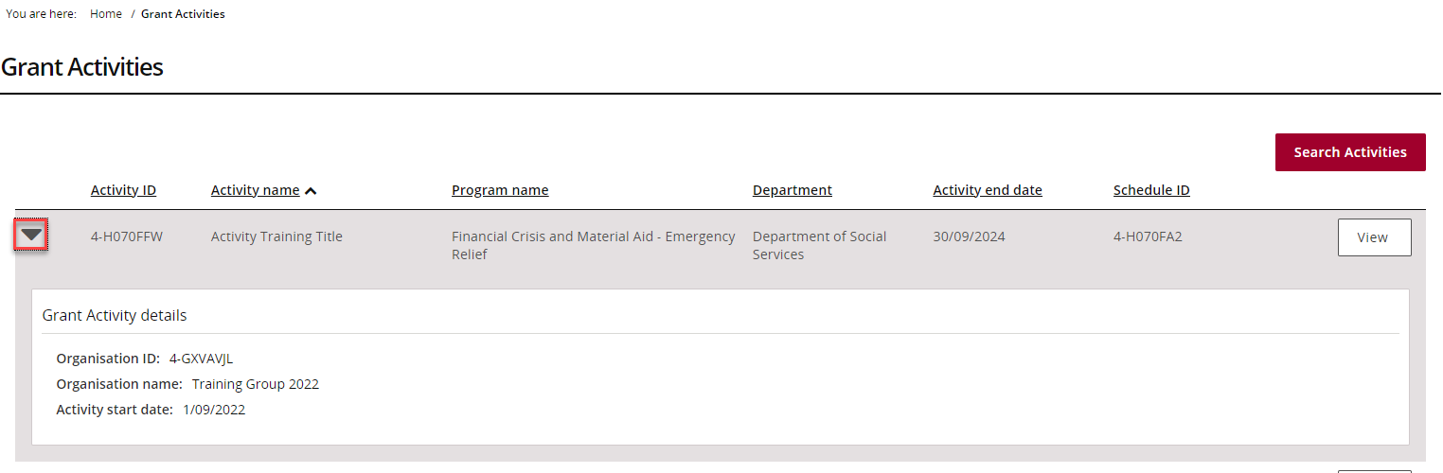
To view more details for a particular Grant Activity, select the View button next to the Grant Activity record.
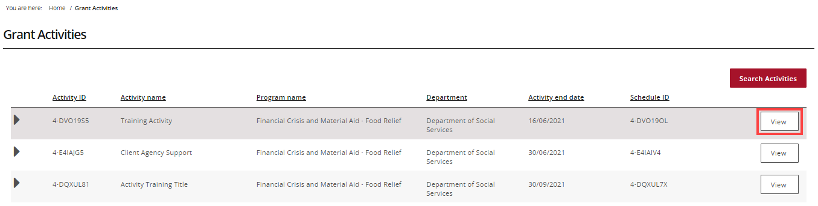

Viewing the Grant Activity details
Step | Action
The Grant Activity menu screen displays an Overview of the Grant Activity by default. The below information related to the Grant Activity can be viewed.
- Activity name | - Activity ID
- Program name  - Organisation name  - Activity start date  - Department | - Schedule ID  - Organisation ID  - Activity end date  - Funding Arrangement Manager
To view additional information about the Activity, use the Grant Activity menu to view:
- Milestones | - Bank account details
- Finances | - Contacts
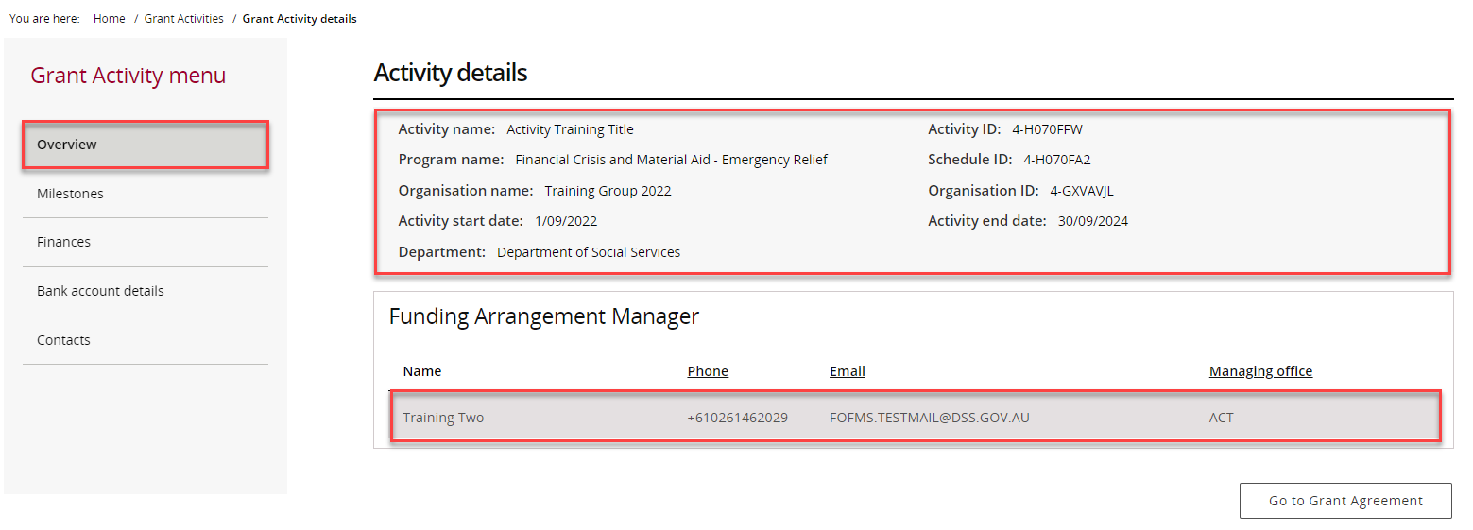
Select the Go to Grant Agreement button to view the Grant Agreement associated with this Activity.
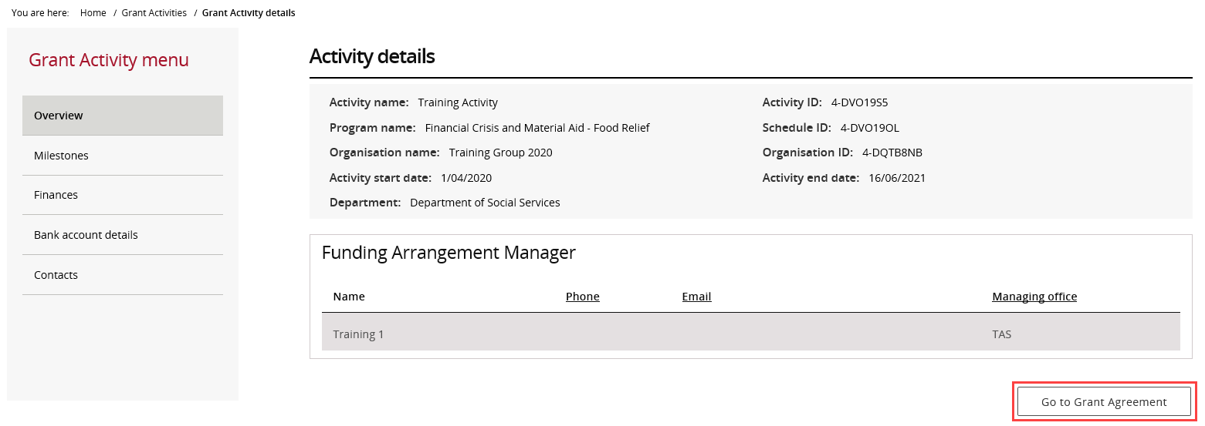
Need Help?
For further assistance, contact the Grant Recipient Portal Helpdesk:
Email: GRP.Helpdesk@communitygrants.gov.au
Phone: 1800 020 283 (Option 5)
Operating Hours: Monday to Friday 9:00am – 5:00pm (AEST/AEDT)

