Search and Resend Payment Advice
  - Grant Recipient Portal Task Card
Portal Access required: Administrator, Editor or View Only
The Grant Recipient Portal (Portal) enables grant recipients to search and resend their payment advice(s) (also known as a Recipient Created Tax Invoice (RCTI) or Remittance Advice).
This task card describes the process of searching and resending payment advice(s) in the Portal.

Navigating to Payment Advice
Step | Action
From the Home screen, select the Payment Advice tile. Alternatively, select the Payment Advice link from the Navigation menu.
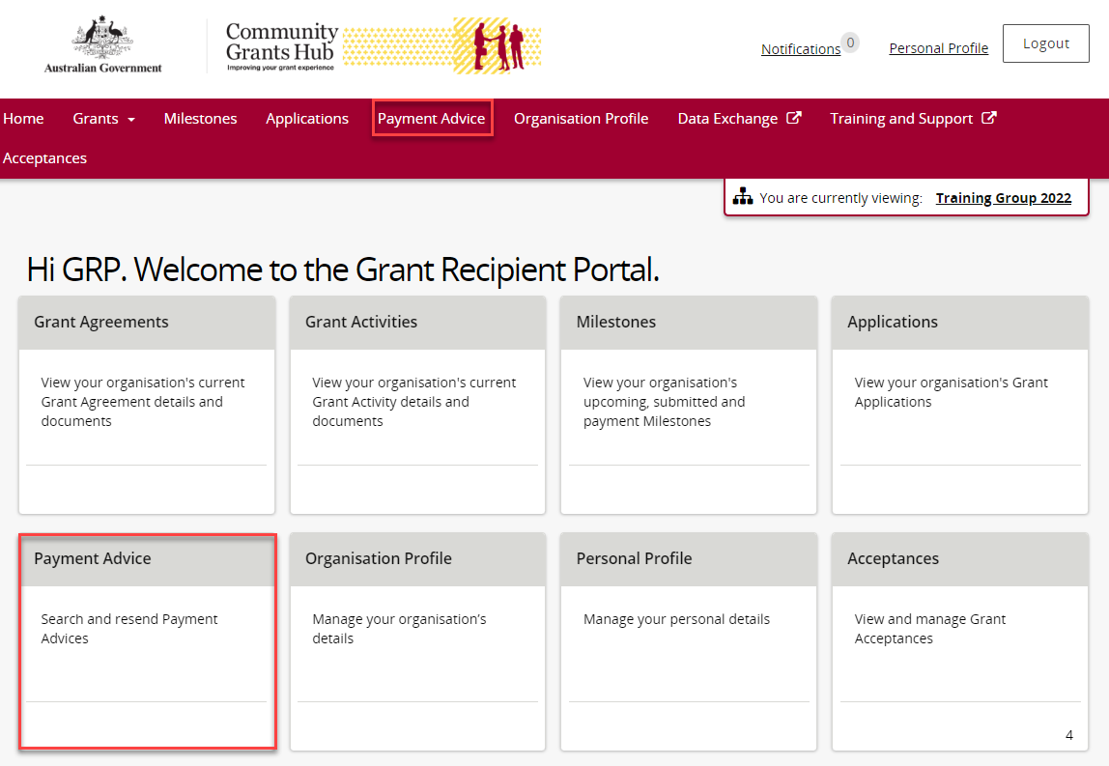

The Payment Advice search screen will display.
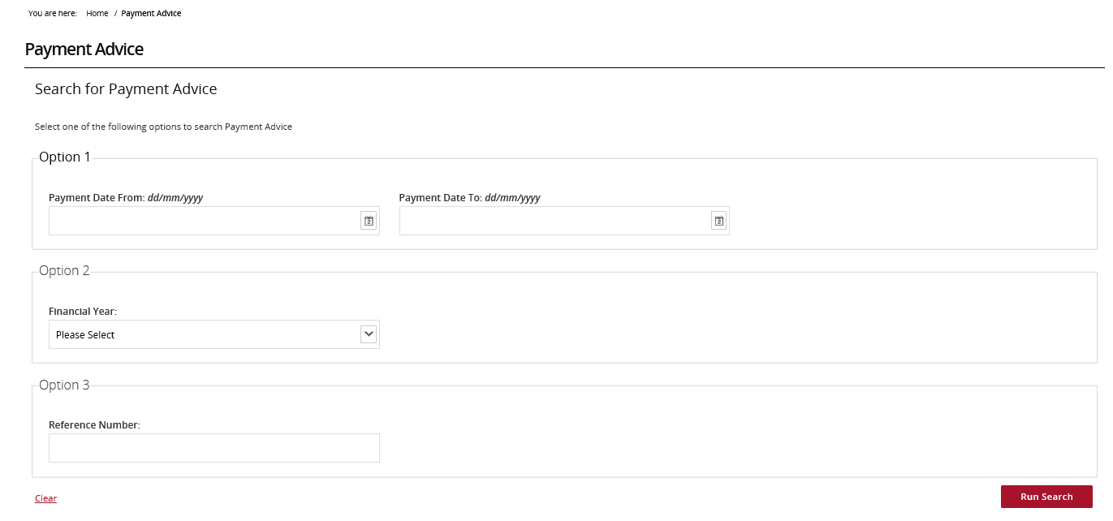

Search for Payment Advice(s)
Step | Action
Search for a payment using one of the three available options:
- Option 1 – Payment Date Range – Allows users to search for a payment using a specific date or date range.
- Option 2 – Financial Year – Allows users to search all payments made during a financial year.
Note: the financial year is the second year listed in the date range. For example, searching 2022 will return results for the 2021-2022 financial year.
- Option 3 – Reference Number – Allows users to search using the payment’s reference number.
Note: the reference number can be found on the bank statement and typically starts with 150 or 015.
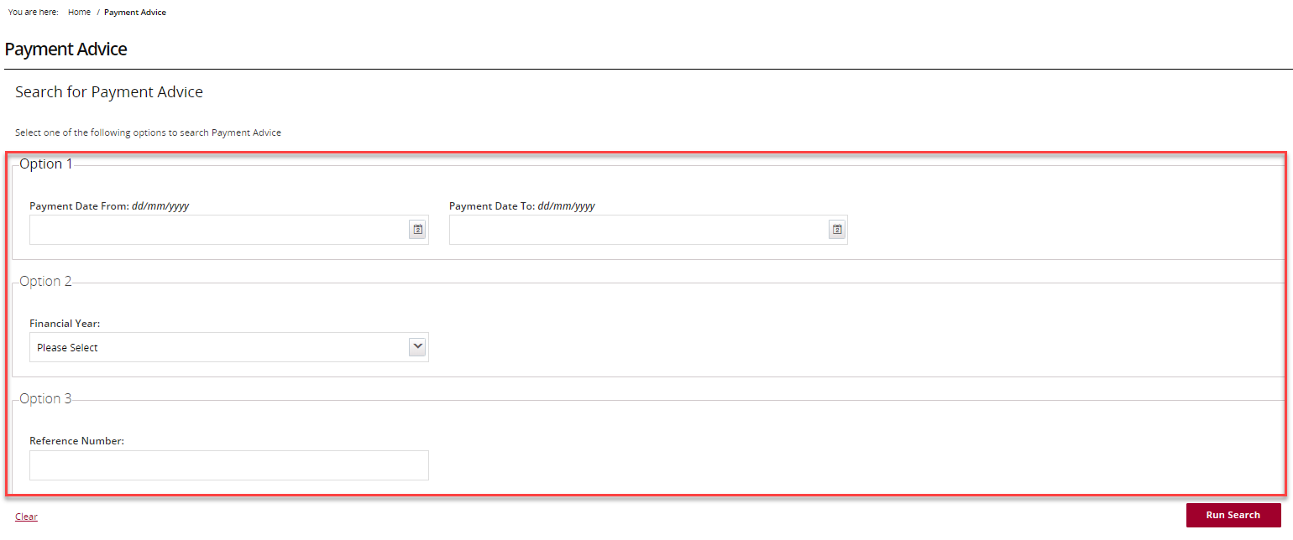
Once the appropriate information has been populated, select the Run Search button.
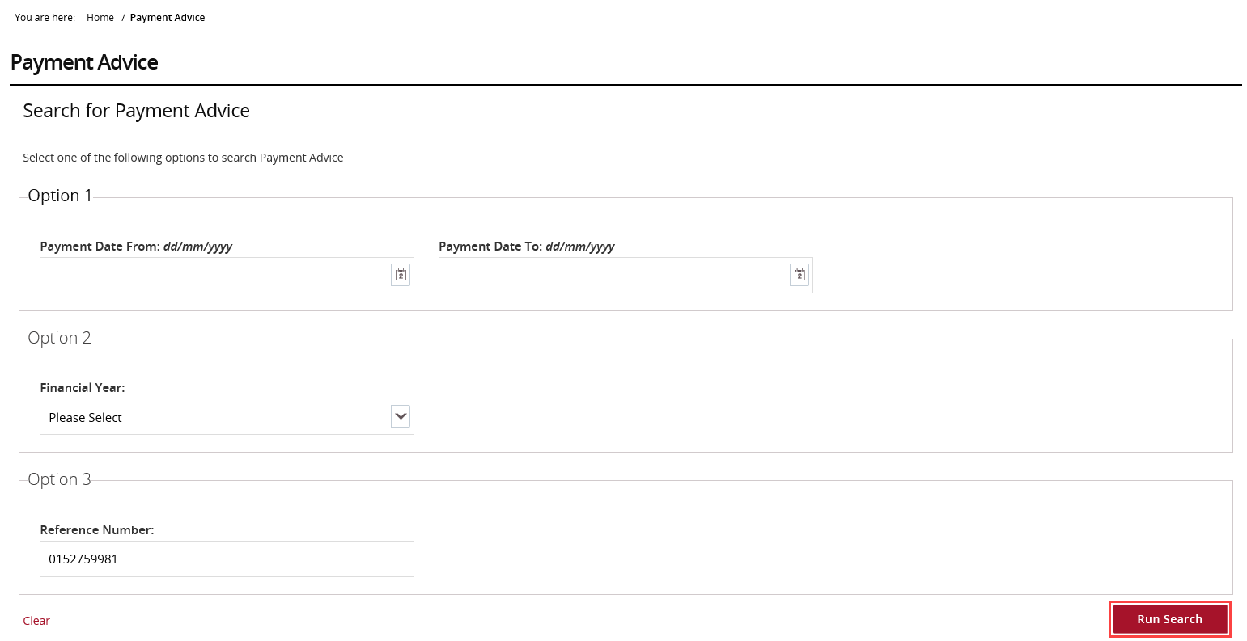
The search results will display. Select the checkbox next to the Payment Advice(s) then select the Resend Selected button.
Selecting the checkbox next to Payment Date will select all results.
Note: Payment Advice(s) cannot be viewed before resending.
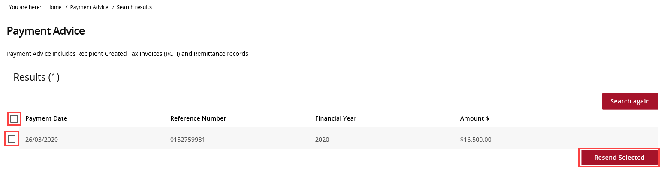

Email the Payment Advice(s)
Step | Action
After selecting Resend Selected, a dialogue box will display. Enter the appropriate email address/es and select Resend.
Copies of the selected Payment Advice(s) will be sent to the nominated email addresses.
Note: If the payment advice is not received within 24 hours, please contact the Grant Recipient Portal Helpdesk.
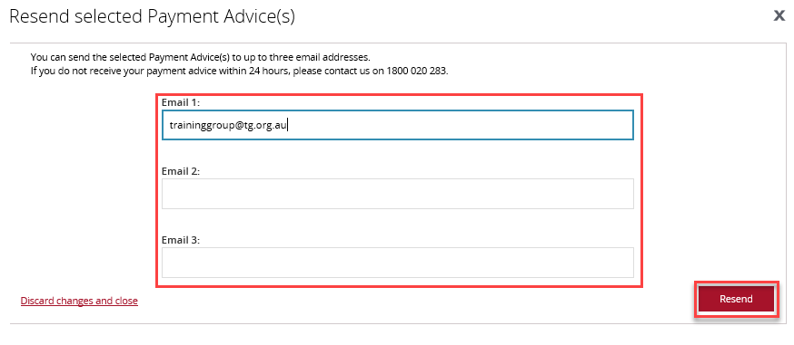
Need Help?
For further assistance, contact the Grant Recipient Portal Helpdesk:
Email: GRP.Helpdesk@communitygrants.gov.au
Phone: 1800 020 283 (Option 5)
Operating Hours: Monday to Friday 9:00am – 5:00pm (AEST/AEDT)

