Update your Personal Profile
  - Grant Recipient Portal Task Card

Portal Access required: Administrator, Editor or View Only
The Grant Recipient Portal (Portal) enables grant recipients to view and self-manage their Personal Profile information as well as selecting which Organisation information to view (where a user has access to multiple organisations).
This task card describes the process of updating their Personal Profile and selecting an Organisation to view.

Updating your Personal Profile Information
Step | Action
From the Home screen, select the Personal Profile tile. Alternatively, select the Personal Profile link in the top right hand corner.
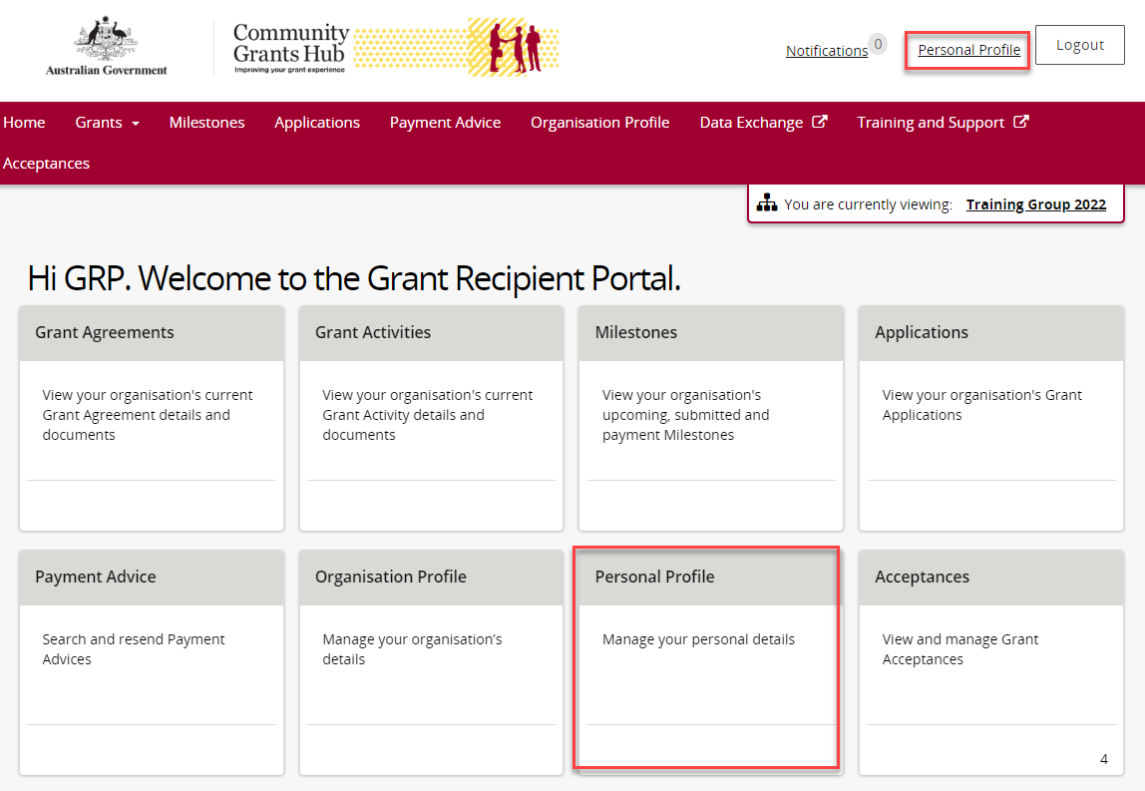
The Personal Profile screen will display. This screen has two sections:
- Personal Profile
- Organisation selection
The below information related to your Personal Profile can be viewed:
- First Name | - Last Name
- Job Title  - Mobile  - Preferred method of communications | - Work Phone  - Email Address  - Contact Id
The Organisation selection section displays organisations you have access to.
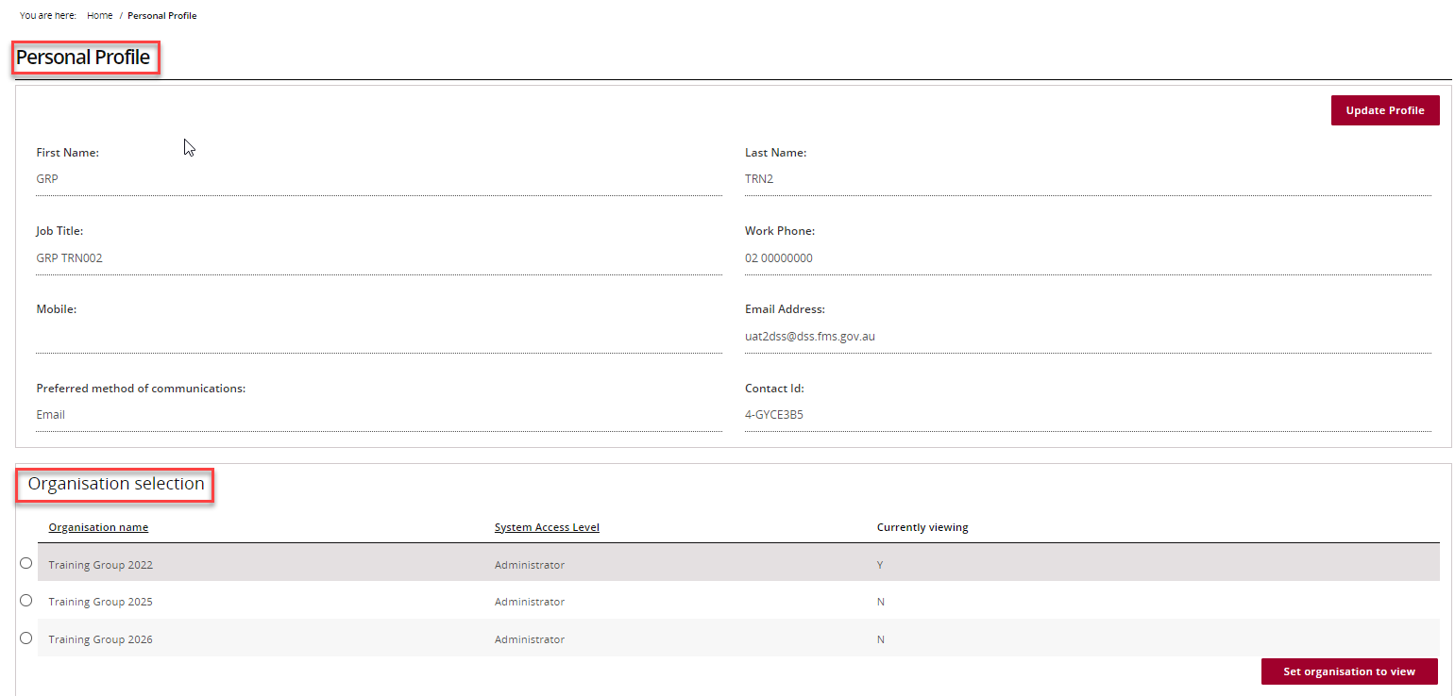
To update your personal details, select Update Profile.
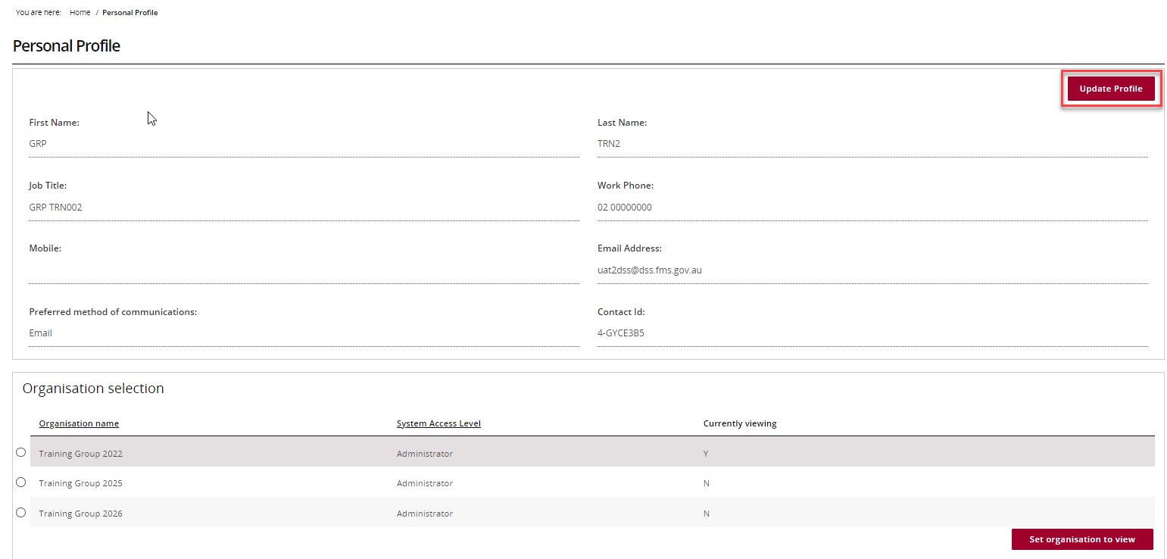
The Update Personal Profile page will display. All mandatory fields marked with an asterisk must be populated at all times.
The following personal details can be changed:
- Job Title | - Preferred method of communications
- Mobile | - Work Phone
Once the changes have been made, select the Save button.
Note: All other fields are linked to your access and cannot be changed through this page on the Portal. If changes are required to these fields contact the Grant Recipient Portal Helpdesk.
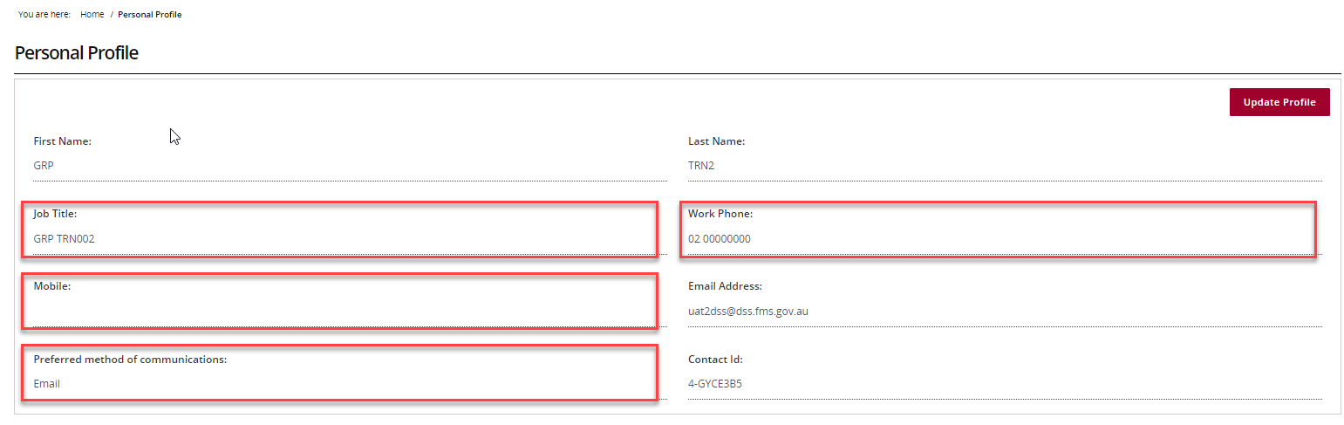

Updating your Organisation view
Step | Action
In the Personal Profile screen under Organisation selection, will be a list of organisations you have access to.
Note: Some users have access to multiple Organisations. To access an organisation with a different ABN, Grant Recipients must have a separate account and access to the ABN in Relationship Authorisation Manager (RAM).
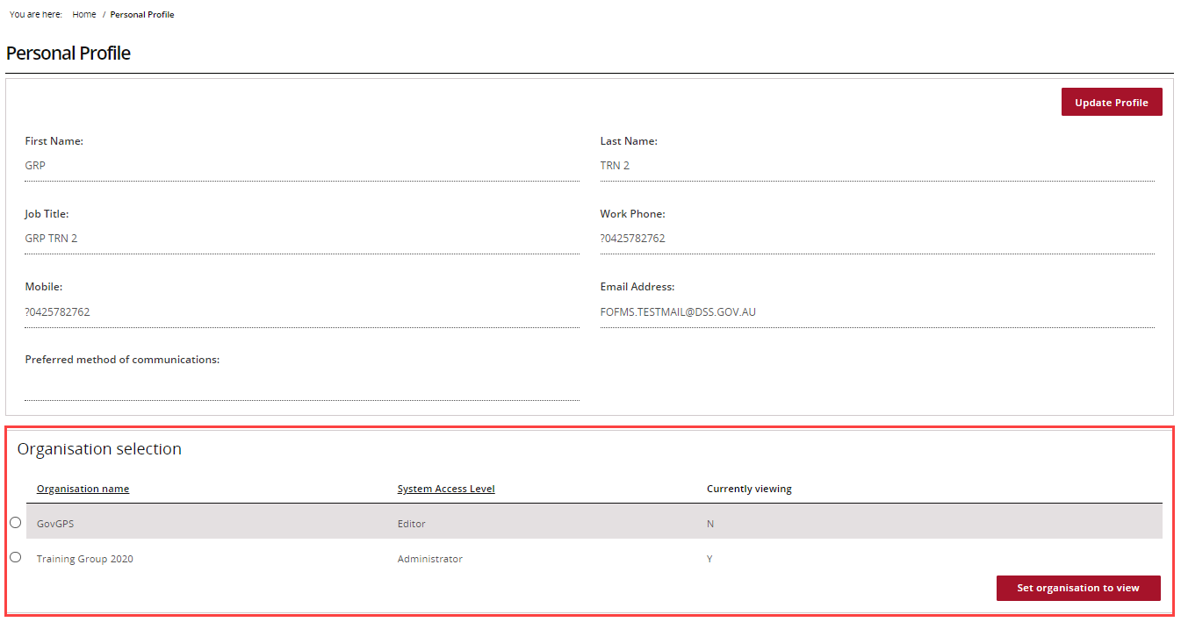
To change the Organisation, select the Organisation and select Set organisation to view.
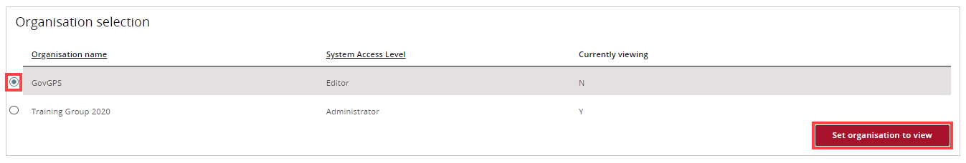
The Organisation you are currently viewing in the Portal will be marked as ‘Y’.
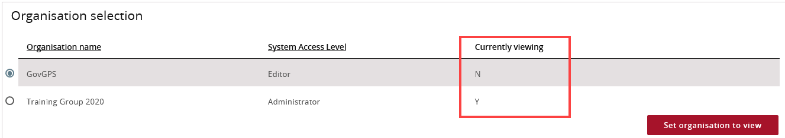
Need Help?
For further assistance, contact the Grant Recipient Portal Helpdesk:
Email: GRP.Helpdesk@communitygrants.gov.au
Phone: 1800 020 283 (Option 5)
Operating Hours: Monday to Friday 9:00am – 5:00pm (AEST/AEDT)

