Update Organisational Information
  - Grant Recipient Portal Task Card
Portal Access required: Administrator
The Grant Recipient Portal (Portal) enables grant recipients to view and self-manage their organisational details through the Organisation Profile.
This task card describes the process of viewing and updating Organisational information including postal address.

Viewing your Organisation Profile
Step | Action
From the Home screen select the Organisation Profile tile. Alternatively, select the Organisation Profile link from the Navigation menu.
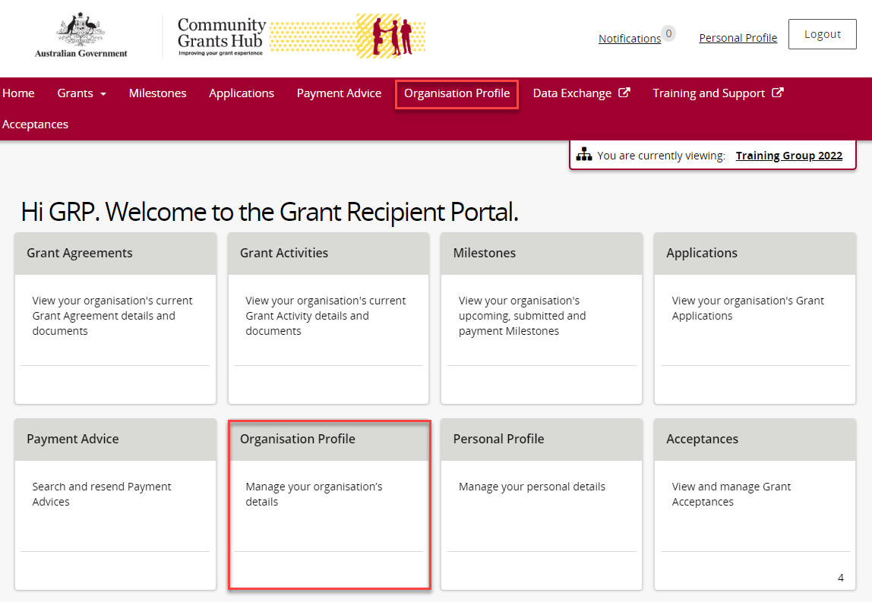
The Organisation Profile menu screen displays an overview of the Organisation by default. The below information related to the Organisation can be viewed:
- Organisation ID | - Organisation name | - Legal name
- ABN | - Business address | - Phone
- General email | - Financial email | - Web address
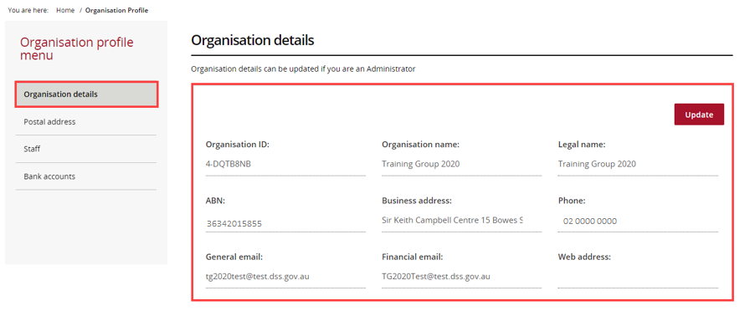

Updating your Organisational Information
Step | Action
Under the Organisation details screen select Update to edit Organisation details.
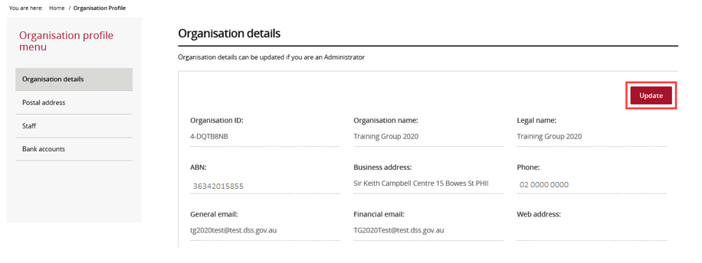
The following Organisation details can be changed:
- General email | - Phone number
- Financial email | - Web address
Note: All other fields are linked to the ABN and cannot be changed through the Portal. To have these fields updated contact your Funding Arrangement Manager. If unsure whom this is, refer to the Grant Activity details screen.
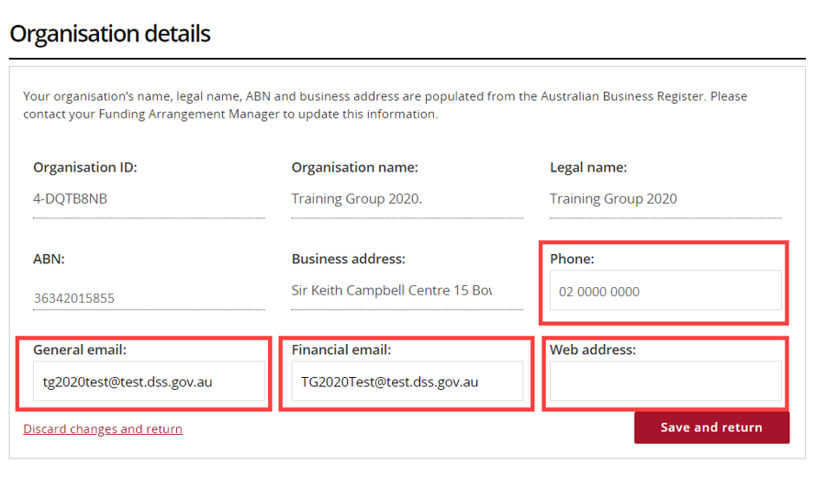
Select Save and return when complete.
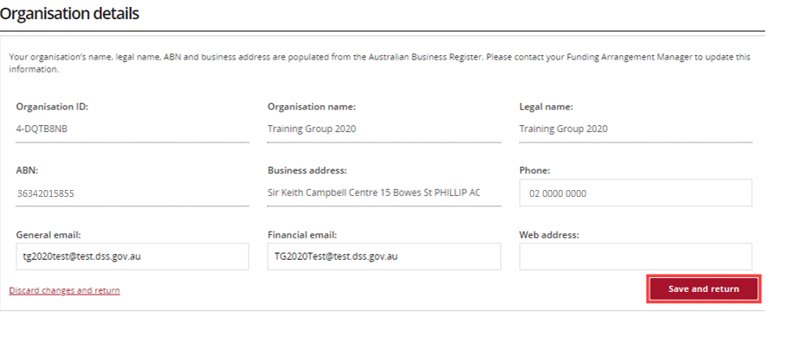

Updating the Postal Address
Step | Action
Select Postal address on the Organisation profile menu.
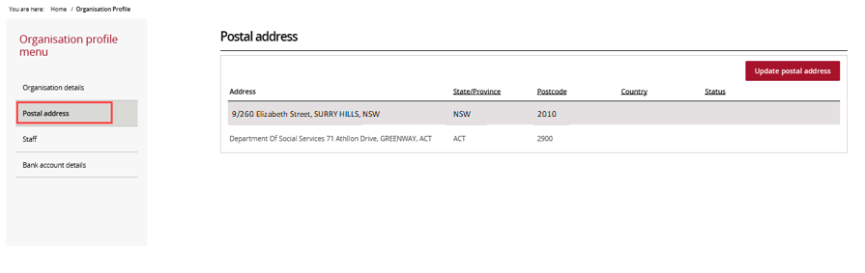
The Postal address screen will display. Select Update postal address to update the address.
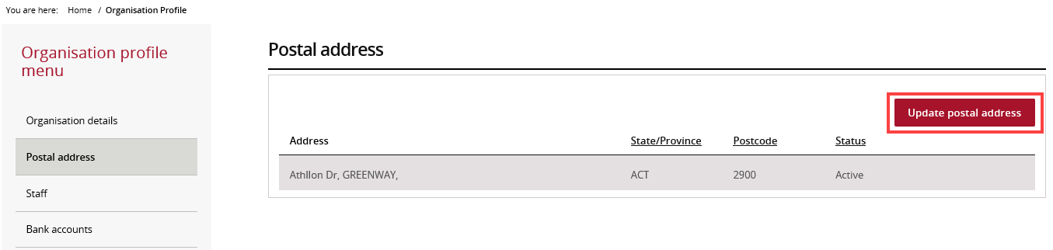
An auto-complete box appears. When typing the new address, options will appear in a list.
Select the correct address from the drop down, select Save when complete.
If the correct address does not appear in the list of options, select I don’t see my address and proceed to the next step.
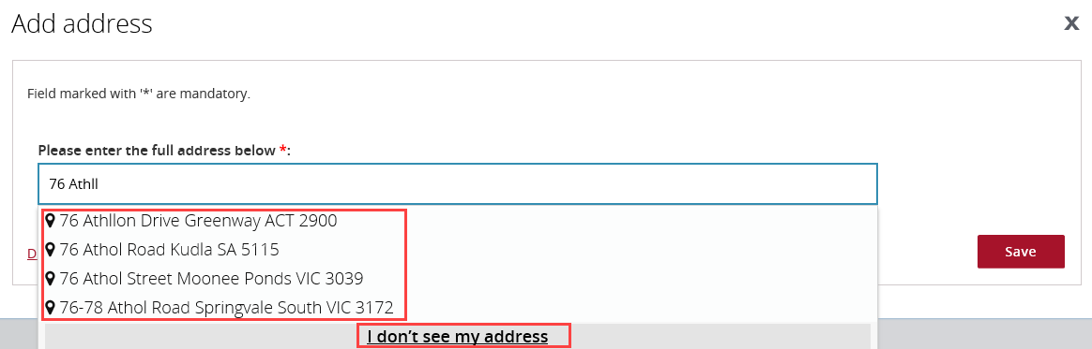
A pop-up box will appear allowing the address to be manually entered. Mandatory fields are marked with a red asterisk. Select Save when complete.
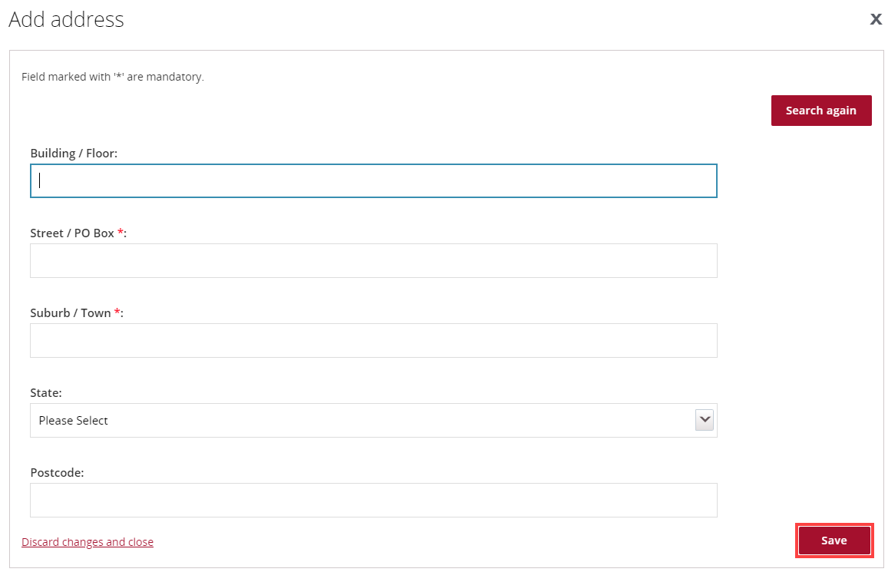

Need Help?
For further assistance, contact the Grant Recipient Portal Helpdesk:
Email: GRP.Helpdesk@communitygrants.gov.au
Phone: 1800 020 283 (Option 5)
Operating Hours: Monday to Friday 9:00am – 5:00pm (AEST/AEDT)

