  - Submit Reports
  - Grant Recipient Portal Task Card
Portal Access required: Administrator or Editor
The Grant Recipient Portal (Portal) enables grant recipients to submit some of their reporting milestones including Financial Acquittals, Activity Work Plan (AWP) Reports and Child Safety Statements of Compliance online. Reporting milestones are displayed on both the Milestones and Grant Activities pages in the Portal.
This task card describes the process of submitting a Financial Acquittal, AWP Report and Child Safety Statement of Compliance online through the Portal.

Navigating to Milestones
Step | Action
From the Home screen, select the Milestones tile. Alternatively, select the Milestones link in the Navigation menu.
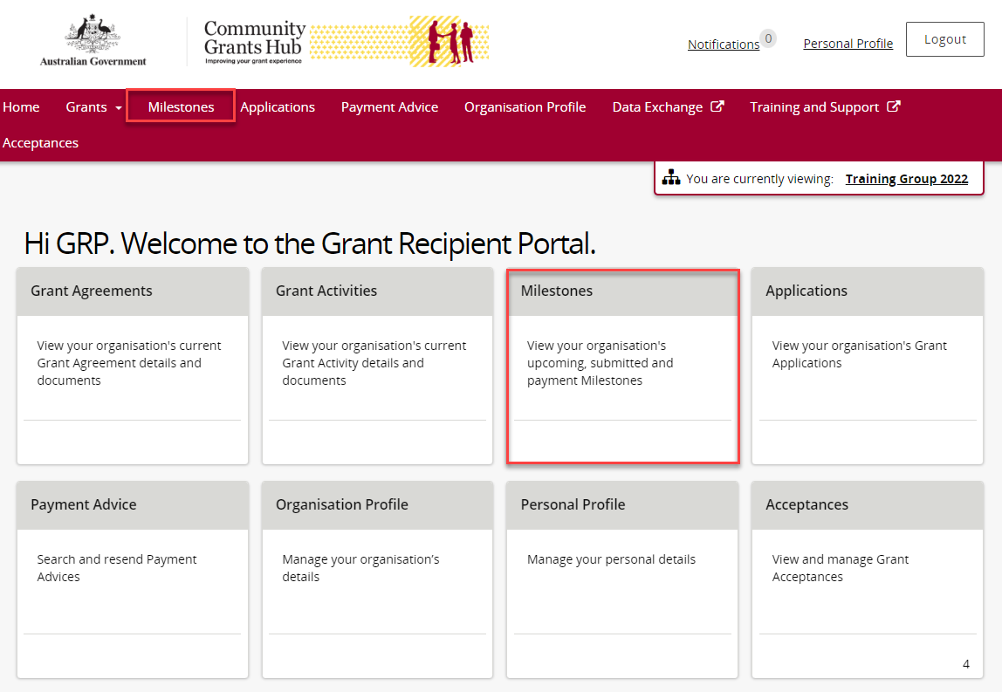
The Milestones screen displays upcoming milestones for the organisation by default.
To display upcoming milestones, use the dropdown menu to select 1. Upcoming Milestones then select Apply Filter.
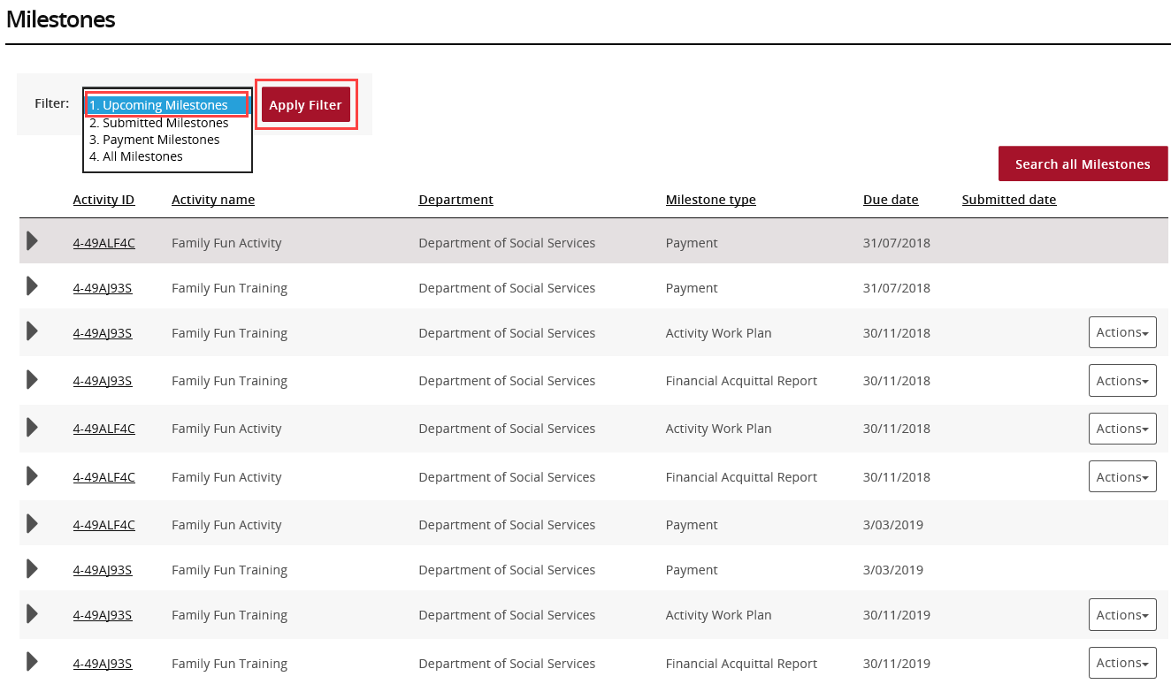
Once the filter has been applied, the 1. Upcoming Milestones will be displayed.
When the correct milestone has been identified, select Actions to submit the report.
To submit a Financial Acquittal, proceed to step 9. To submit an AWP Report, proceed to step 21.
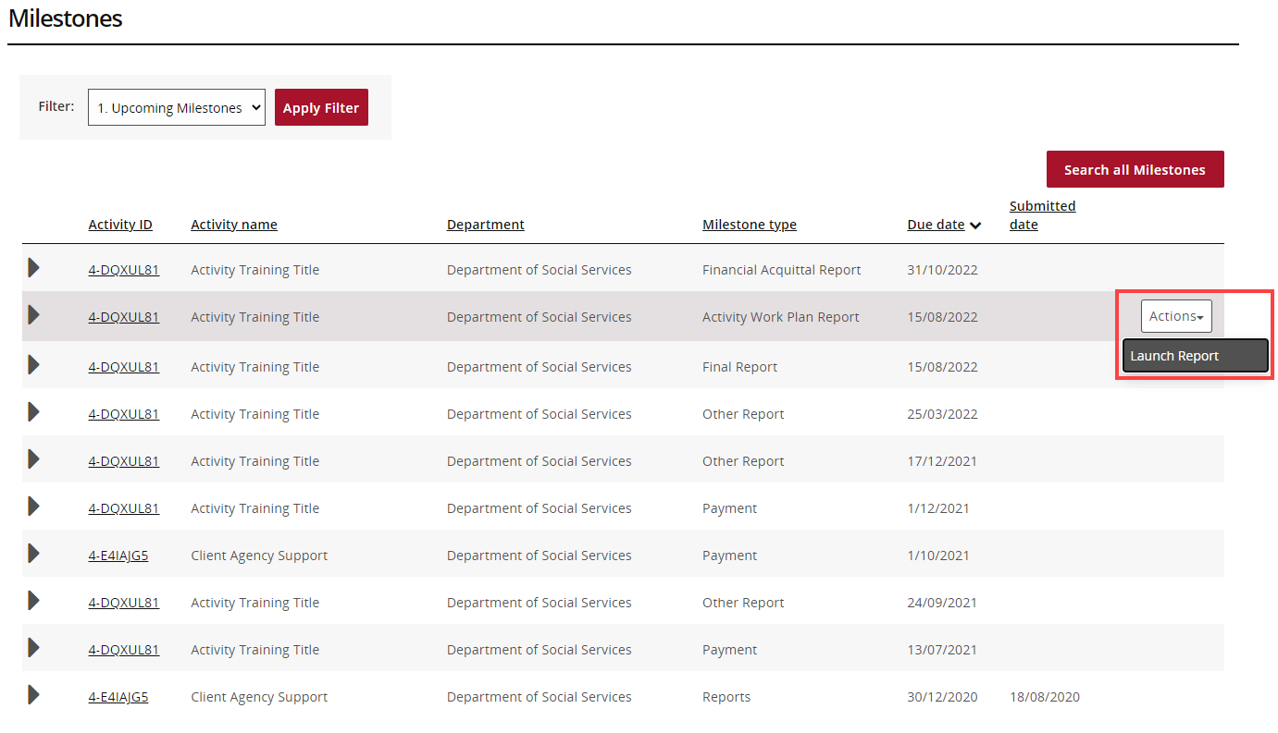

Navigating to Milestones from Grant Activities
Step | Action
From the Home screen, select the Grant Activities tile. Alternatively, select Grants in the Navigation menu and select Grant Activities from the drop down menu.
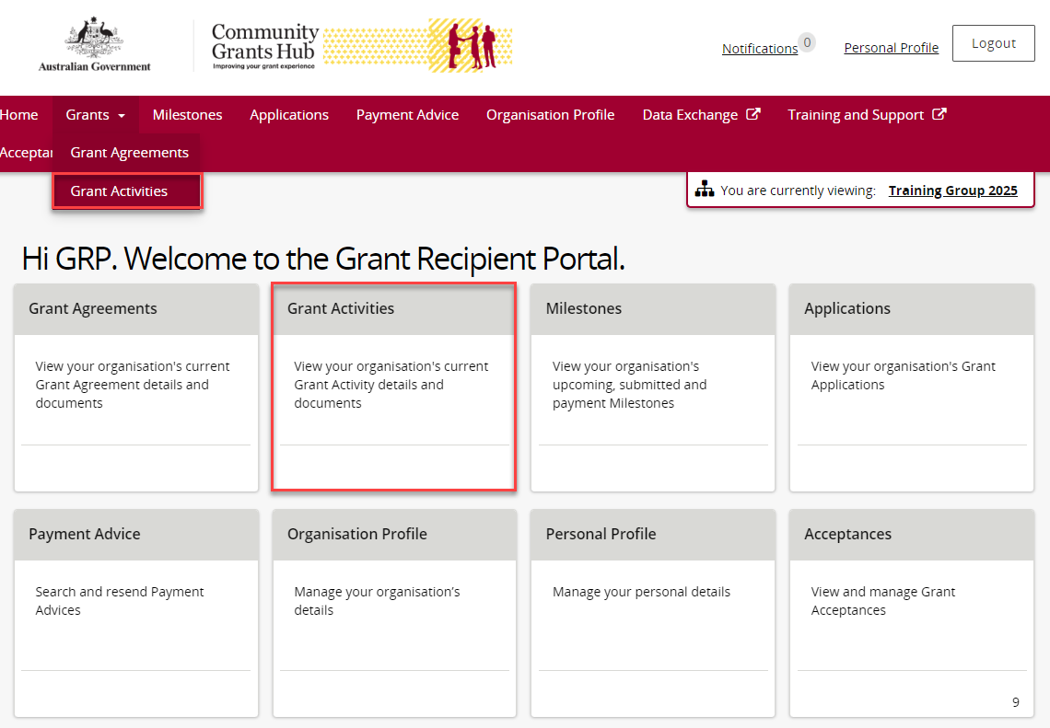
The Grant Activities screen will display. Select the expansion arrow next to an Activity ID to show additional information about the Activity.
Select the View button next to the Grant Activity record to open the Activity details.
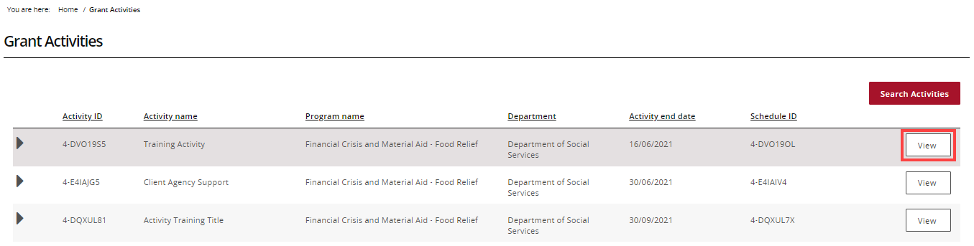
The Activity details screen will display. Select Milestones from the Grant Activity menu.
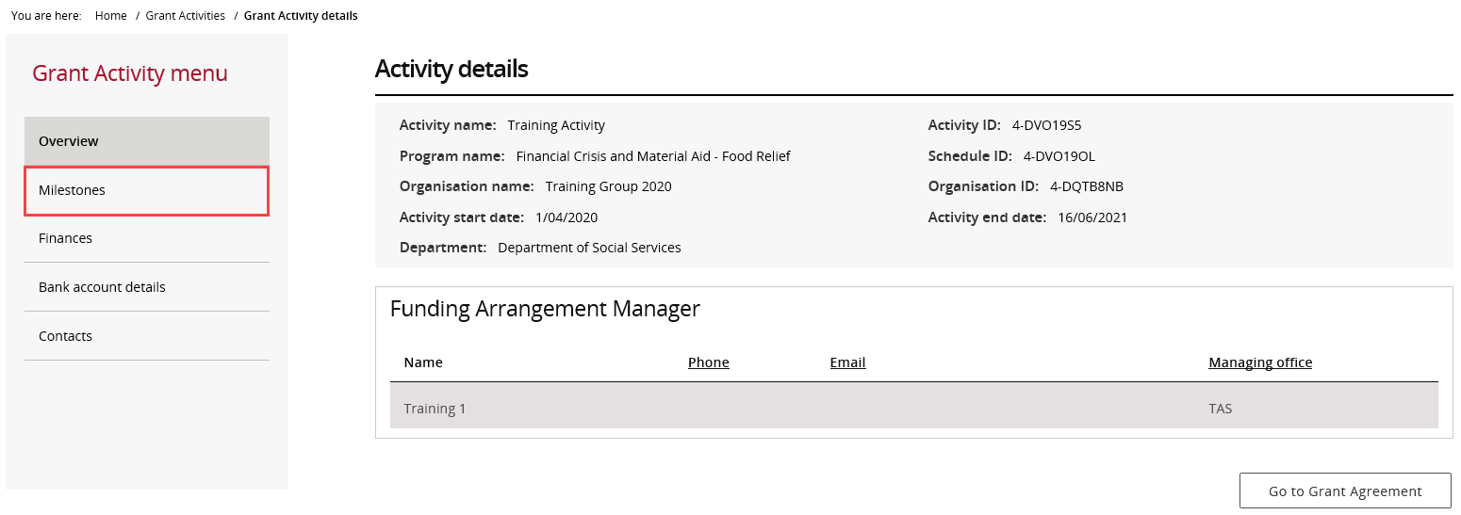
The Milestones screen will display. By default, Filter 1. Upcoming Milestones will be presented.
To change the filter, use the drop down menu and select Apply Filter or
To locate a specific Milestone, perform a search by selecting Search all Milestones.
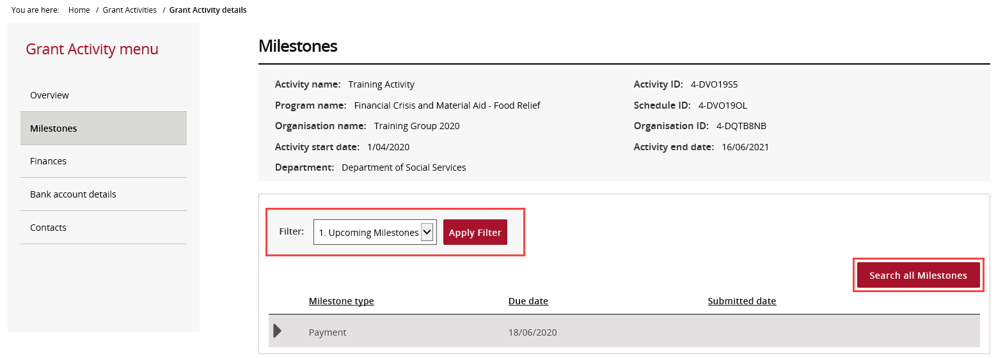
When the correct milestone has been identified, select Actions to submit the report.
To submit a Financial Acquittal, proceed to step 9. To submit an AWP Report, proceed to step 21. To submit a Child Safety Statement of Compliance, proceed to step 34.

Submitting a Financial Acquittal
Step | Action
 | Select the Actions button to Launch Report.
The Financial Acquittal Report screen will display.
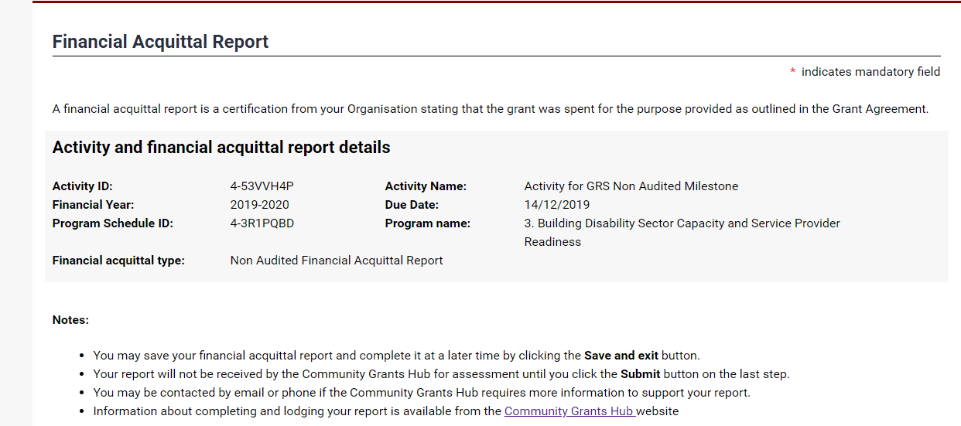
The Activity funding received from the prior financial year will need be declared. The mandatory fields marked with a red asterisk need to be completed.
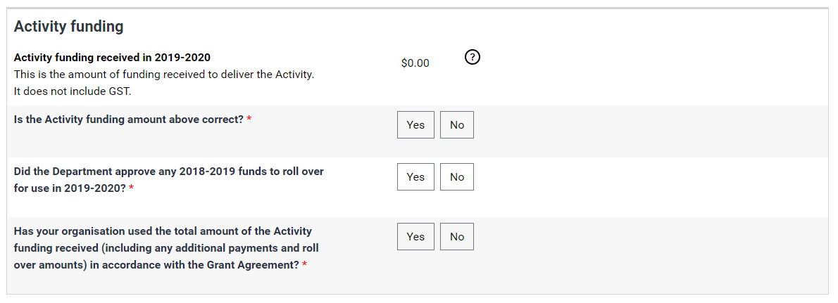
Supporting documents must be provided if the Grant Agreement requires an Audited or Non-audited Financial Acquittal.
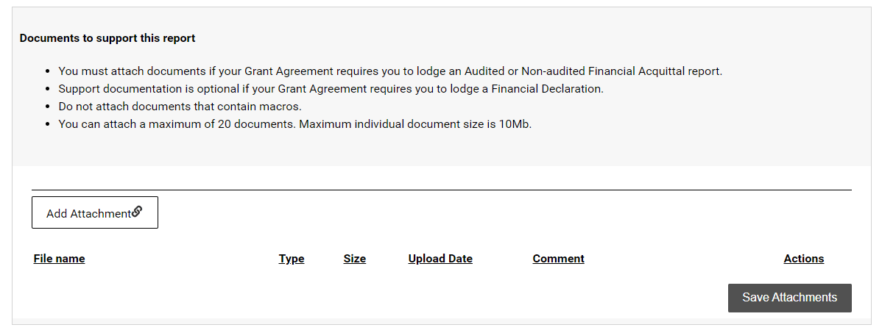
Select Add Attachment to choose the appropriate documents to attach.
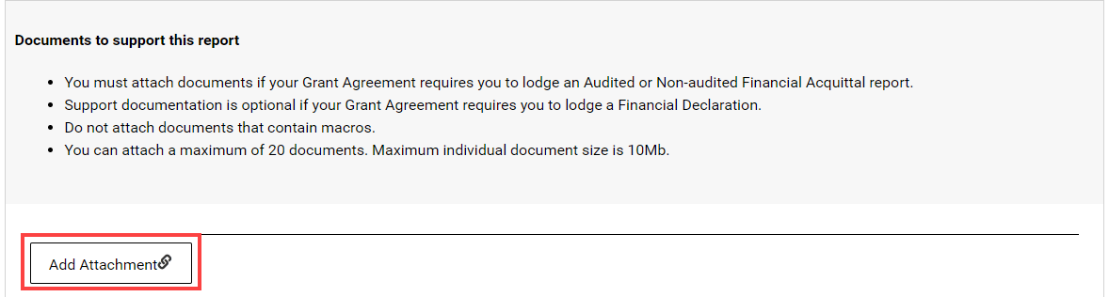
After attaching the documents, you can select the Actions drop down menu to View, Remove or Edit comment for each attachment.
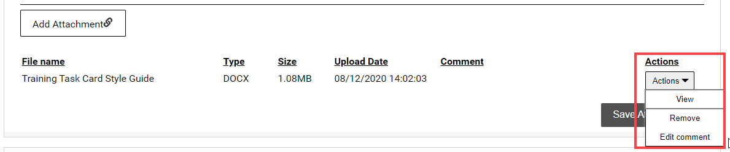
Once all attachments to support the Acquittal have been added, select Save Attachments.
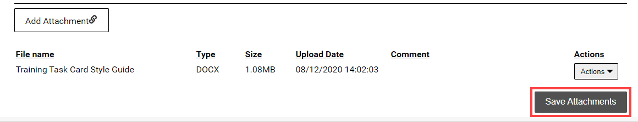
Do not leave this screen while data is being submitted. Once the message disappears, continue to complete the report.
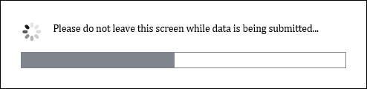
A message will display to advise if the documents were successfully saved.
Note: To attach more documents, select Return to list.
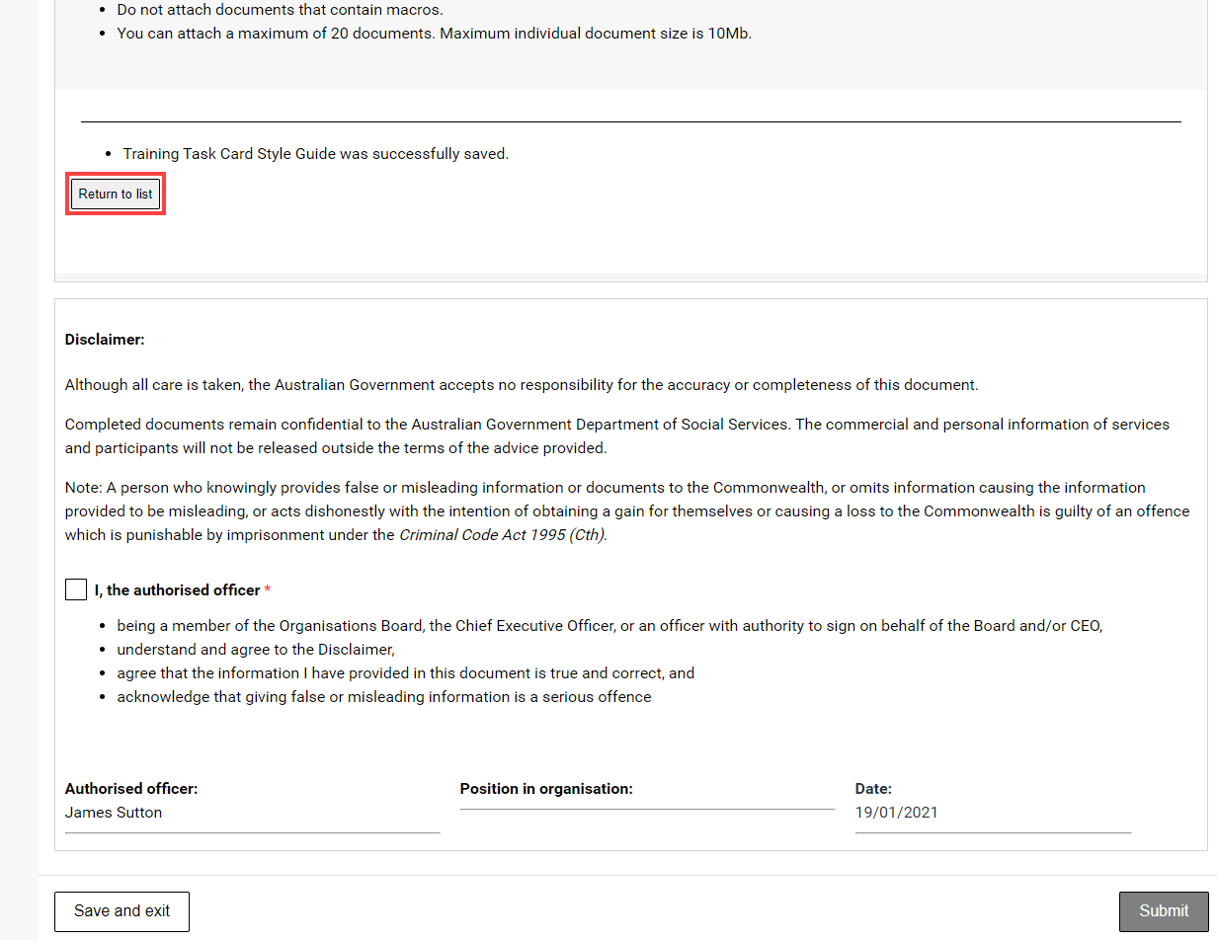
Review the Disclaimer and select the checkbox to agree to the Disclaimer then select Submit.
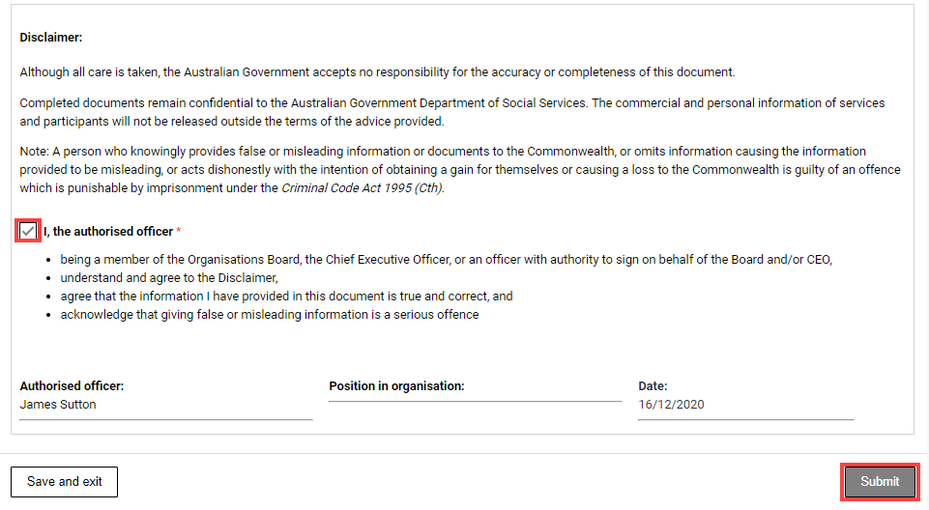
A message will appear advising to stay on this screen until the data has been submitted.
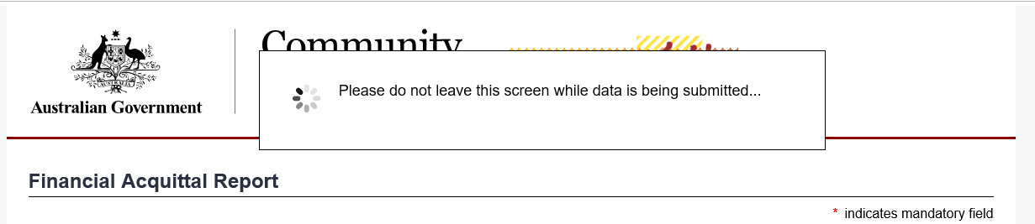
A confirmation page will display. Select Save and exit to close the form.
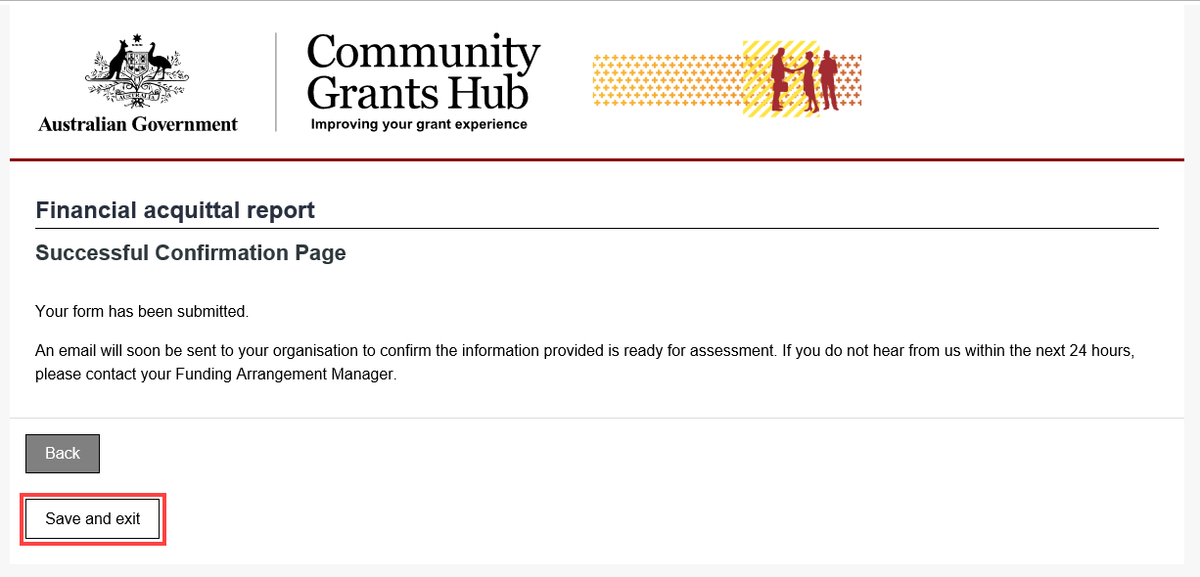

Submitting an Activity Work Plan Report
Step | Action
Select the Actions button to Launch Report.
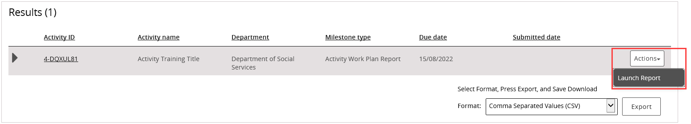
The Upload Report screen will display. The AWP Report template will need to be completed and saved before attaching it in this view.
If an AWP Report template is required, select the Activity Work Plan (AWP) report template link.
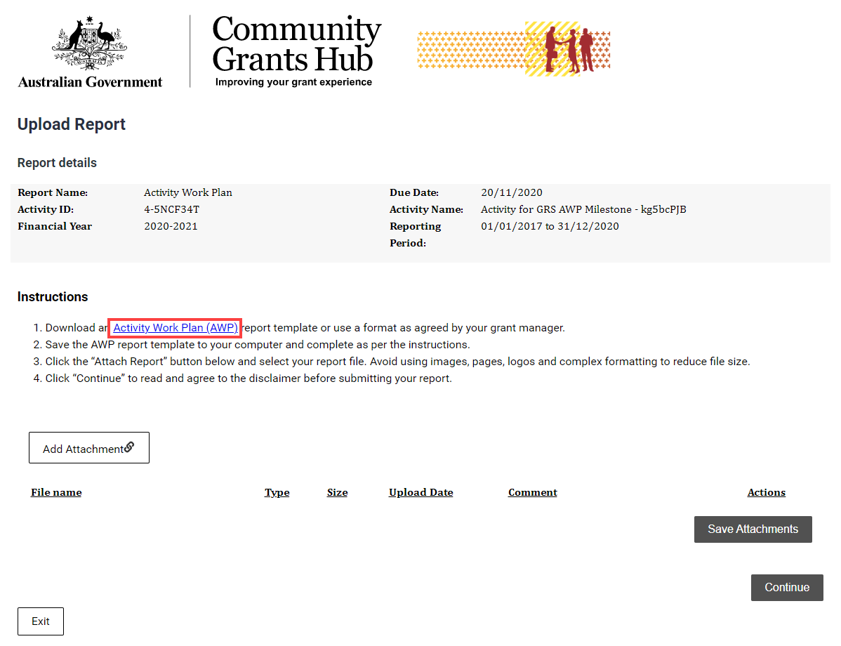
The link will display the Department of Social Services webpage. Select the Standardised AWP report template link.
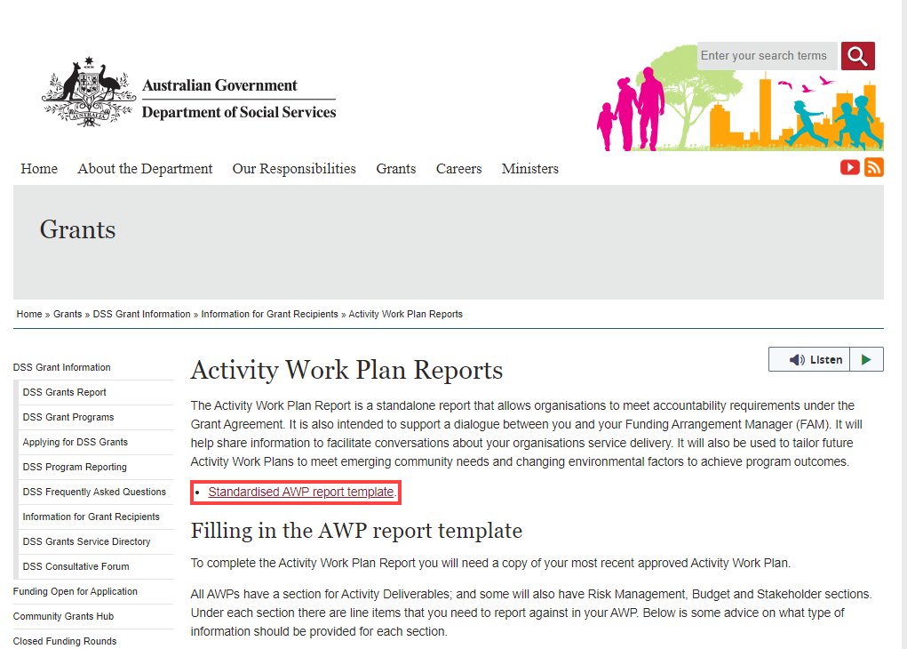
Use the word version for completing the AWP Report and save the document to upload it into the Portal.
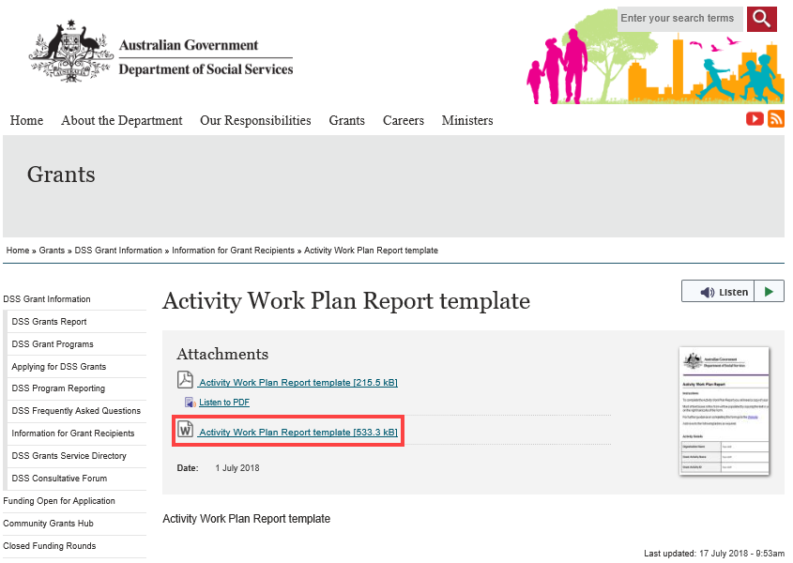
Select Add attachment to choose the appropriate documents to attach.
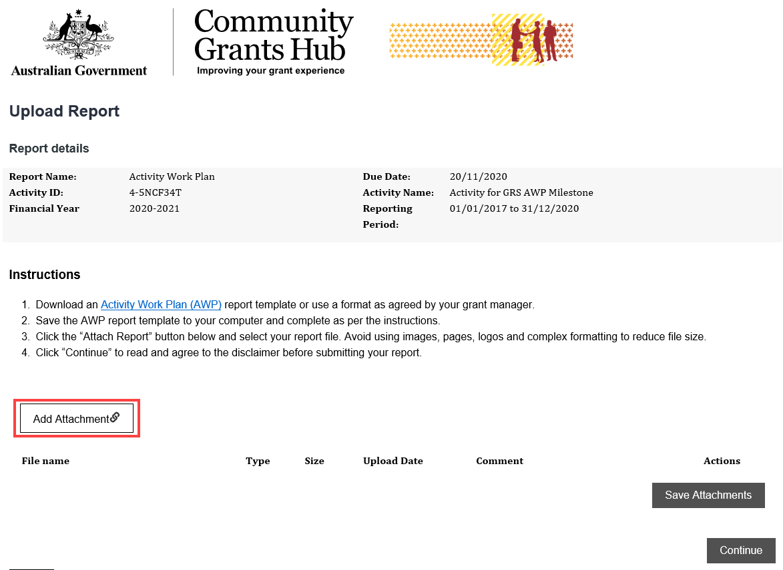
 | After attaching the documents, you can select the Actions drop down menu to View, Remove or Edit comment for each attachment.
 | Once all attachments to support the AWP Report have been added, select Save Attachments.
 | Do not leave this screen while data is being submitted. Once the message disappears, continue to complete the report.
A message will display to advise if the documents were successfully saved.
Note: To attach more documents, select Return to list.
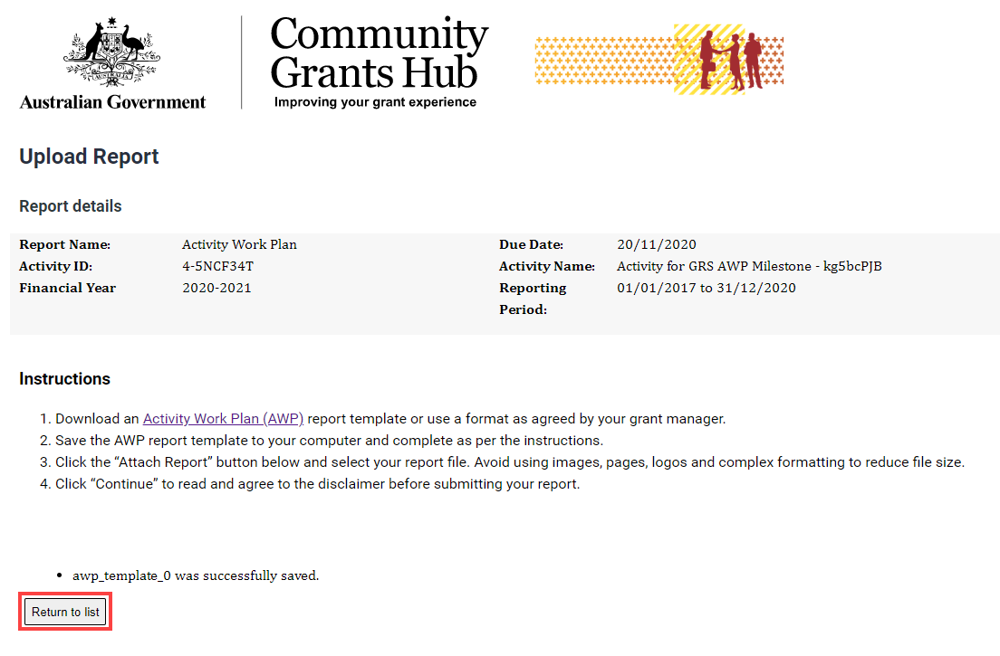
Select Continue to go to the next step.
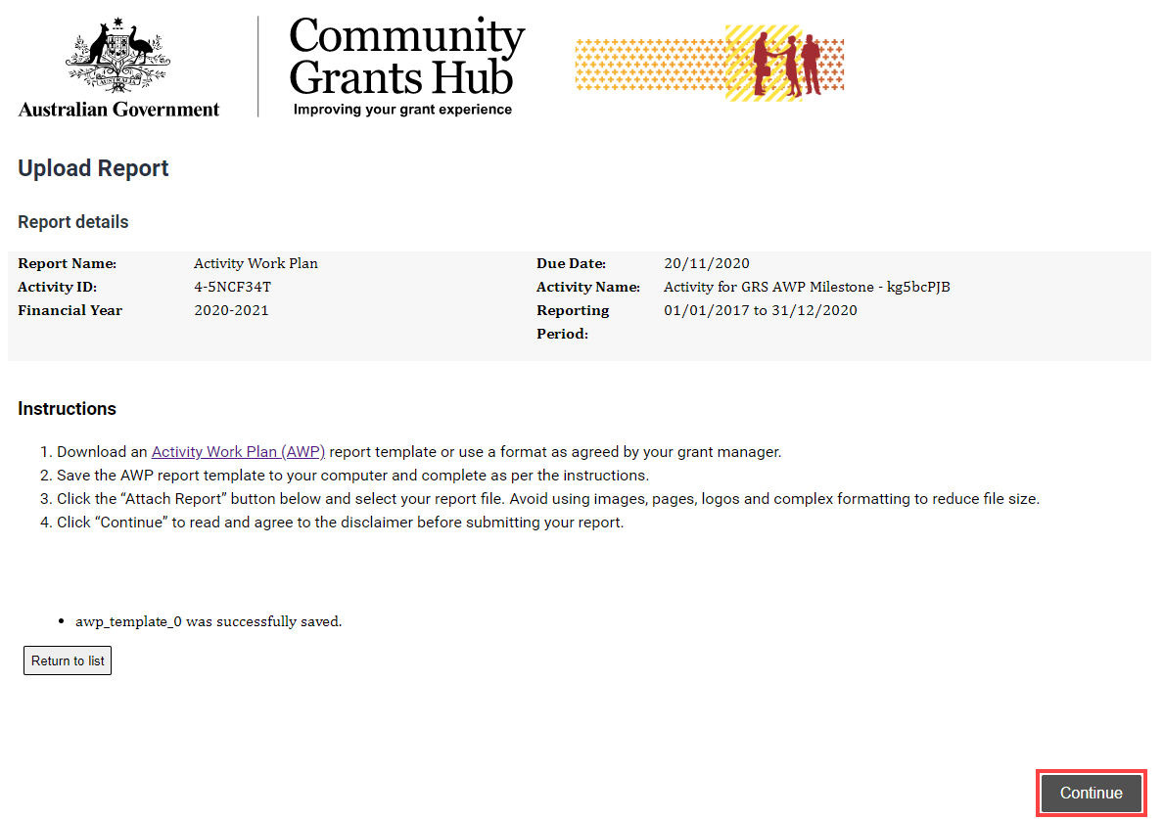
Review the Disclaimer and select the checkbox to agree to the Disclaimer then select Submit.
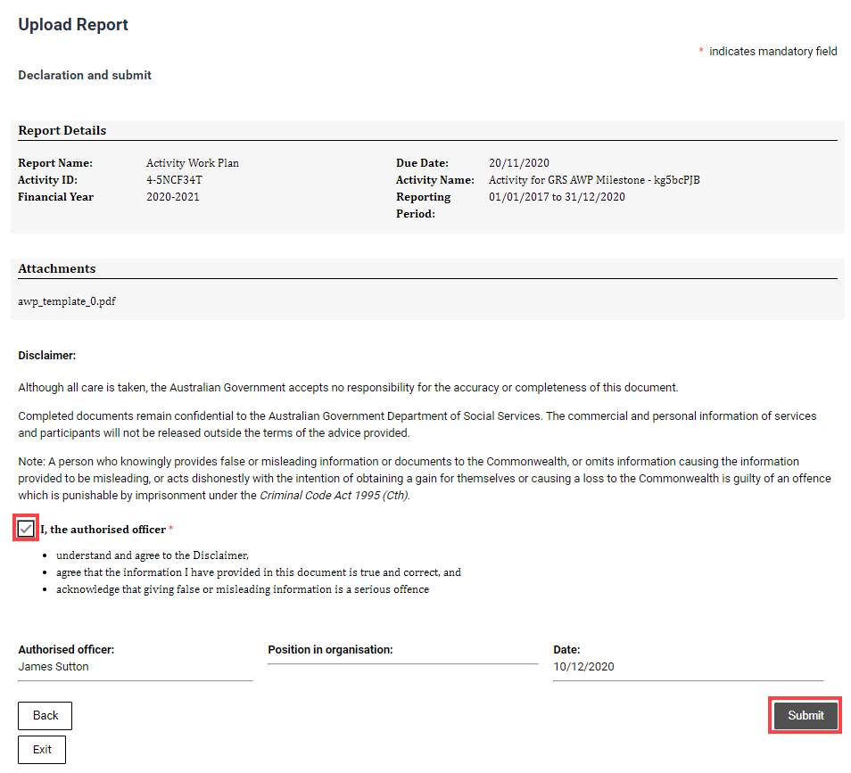
A message will appear advising to stay on this screen until the data has been submitted.
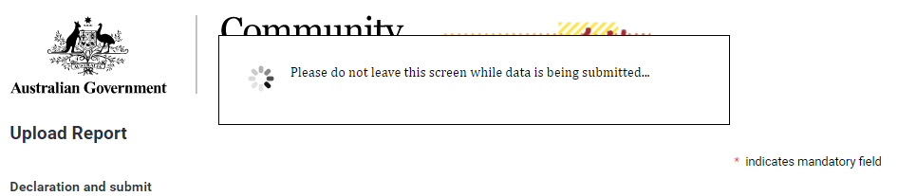
A confirmation page will display. Select Exit to close the form.
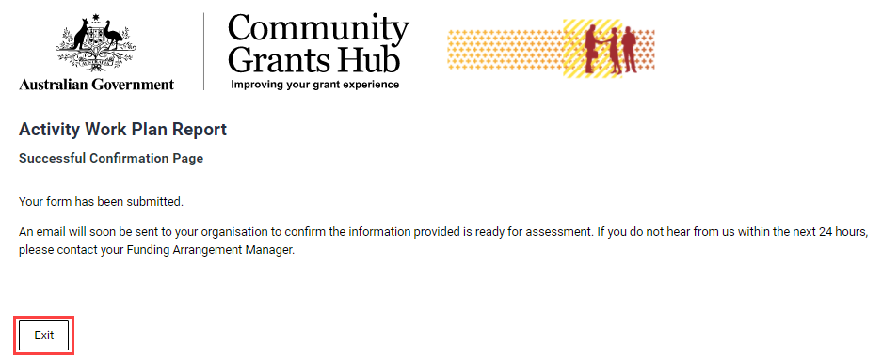

Submitting a Child Safety Statement of Compliance
Step | Action
34 | Select the Actions button to Launch Report.  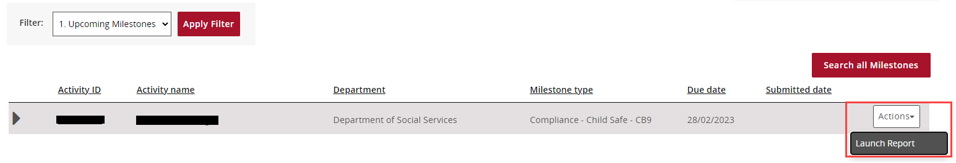
35 | The Instructions Cover Page screen will display. Select Next at the bottom of the page to proceed to the Statement of Compliance.  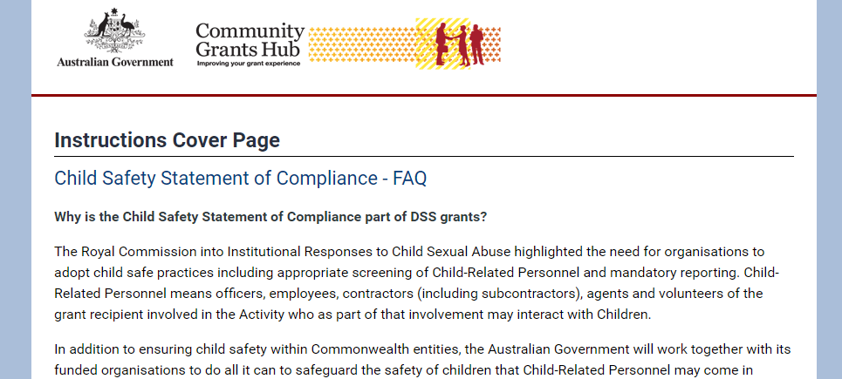  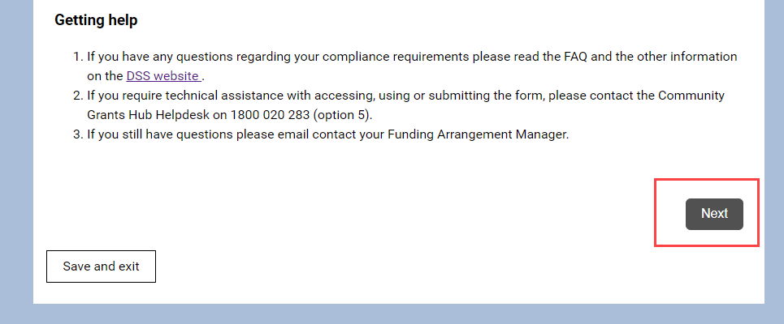
36 | The Statement of Compliance page will load. Details of the grant and the declaration will appear.  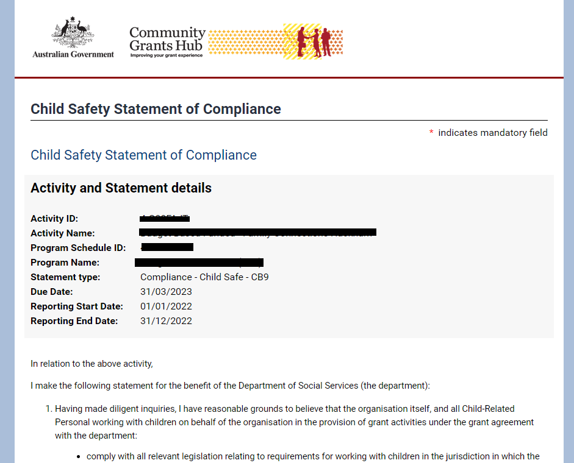
37 | Scroll down to the bottom of the Statement and complete all applicable fields.  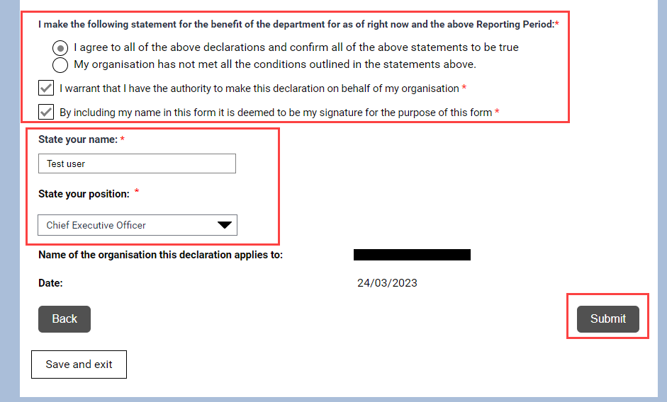  Press Submit to complete the Statement of Compliance.
38 | A confirmation page will display. Select Save and exit to close the form.  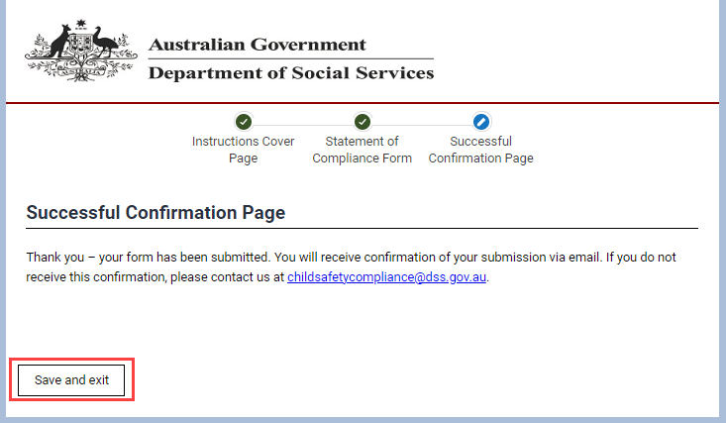  A submission confirmation email will be sent to the Program Schedule primary contact of the grant.  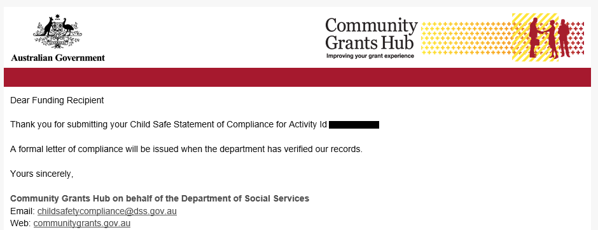

Need Help?
For further assistance, contact the Grant Recipient Portal Helpdesk:
Email: GRP.Helpdesk@communitygrants.gov.au
Phone: 1800 020 283 (Option 5)
Operating Hours: Monday to Friday 9:00am – 5:00pm (AEST/AEDT)

