Navigating the Grant Recipient Portal

Word version of the Flowchart

# Grant Recipient Portal Home Screen

The Grant Recipient Portal (Portal) Home screen features separate navigation tiles for grant recipients to access different areas of the Portal.

To help grant recipients locate their grant information with ease, the attached reference guide provides an overview of the information available under each navigation tab.

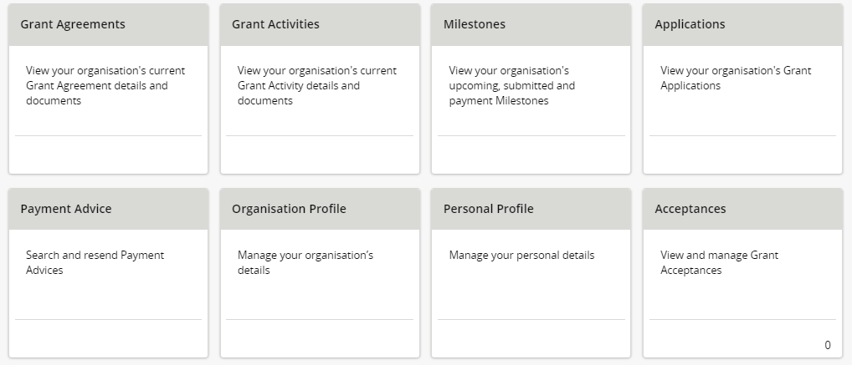

# Image for Grant AgreementsGrant Agreements

Under Grant Agreements you can:

* View your Grant Agreements
* View and download your Executed Agreements
* View and download your Executed Variations
* View and update your Grant Agreement Contacts.

# Image for Grant ActivitiesGrant Activities

Under Grant Activities you can:

* View your Grant Activities
* Search and export a list of your Grant Activities
* Find your Funding Arrangement Manager
* View your Milestones
* View your Finances
* View your Bank Account Details
* View and update your Grant Activity Contacts.

# Image for MilestonesMilestones

Under Milestones you can:

* View your Milestones
* View your Payments
* Search and export a list of your Milestones
* Check your reporting requirements
* Submit your Financial Acquittals *
* Submit your Activity Work Plan (AWP) Reports *
* Submit your Child Safety Statements of Compliance *

* Currently only available for some programs

# Image for ApplicationsApplications

Under Applications you can:

* View your submitted Applications including Application ID, Funding Round Name, Department and Funding Round Category.

# Image for Payment AdvicePayment Advice

Under Payment Advice you can:

* Search your Payments
* View payment details including Payment Date, Reference Number, Financial Information and $ Amount
* Resend your Payment Advice to a nominated party.

# Image for OrganisationsOrganisation Profile

Under Organisation Profile you can:

* View your organisation information
* Update your organisation’s staff/contacts including activating and inactivating
* Add/modify/remove Portal access for your organisation’s staff
* Update Grant Agreement/Activity contacts (including primary contacts)
* Update your organisation’s email addresses, phone number and web address
* Update your organisation’s postal address
* View, add and request changes to your organisation’s Bank Account Details
* Update your organisation’s Acceptance parameters and Signatories.

# Image for Personal ProfilePersonal Profile

Under Personal Profile you can:

* View your personal information
* Update your Job Title
* Update your phone numbers
* Update your preferred method of communications
* View a list of organisations you are linked to and your Portal access
* Set your organisation to view in the Portal (where a user has access to multiple organisations).

# Image for AcceptancesAcceptances

Under Acceptances you can

* View and search for your Acceptances
* View History of your Acceptances
* View and download your Executed Agreements (where available)
* View and download your Executed Variations (where available).

Need Help?

For further assistance, contact the Grant Recipient Portal Helpdesk:

**Email**: [GRP.Helpdesk@communitygrants.gov.au](mailto:GRP.Helpdesk@communitygrants.gov.au)

**Phone**: 1800 020 283 (Option 5)

**Operating Hours:** Monday to Friday 9:00am – 5:00pm (AEST/AEDT)