Financial Acquittals
  - How to complete the online form

Purpose
This task card details the process for Grant Recipients to complete the online Financial Acquittal report.
If you have any questions regarding the Financial Acquittal report, please contact the Financial Assurance Centre of Expertise through the relevant inbox:
Agency Name | Financial Acquittal Inbox
Department of Social Services | DSSacquittals@communitygrants.gov.au
Department of Social Services – Volunteer Grants | vgacquittals@communitygrants.gov.au
Attorney-General’s Department | AGD.acquittals@communitygrants.gov.au
Department of Veterans’ Affairs | DVAacquittals@communitygrants.gov.au
Department of Home Affairs | DHA.Acquittals@communitygrants.gov.au
Department of the Prime Minister and Cabinet | PMC.Acquittals@communitygrants.gov.au
Department of Agriculture, Water and the Environment | DAWE.Acquittals@communitygrants.gov.au
Department of Education, Skills and Employment | DESE.Manage@communitygrants.gov.au

If you experience technical difficulties with the online form or the Grant Recipient Portal please contact our helpdesk at GRP.Helpdesk@communitygrants.gov.au or on 1800 020 283, ext. 5. If these issues persist, you can submit your report manually by completing the template at Appendix A – Manual Financial Declaration and sending via email to the above.
Please note if you have a Non-Audited or Audited Financial Acquittal requirement and you cannot submit online, this can be emailed directly to the above email.

Process
You will receive a reminder email 30-days before the acquittal due date. The email will include instructions on how to access the online financial acquittal form.
If your Organisation is registered for the Grant Recipient Portal, you will be prompted to access your acquittal form directly from the portal links. If you require assistance to access the Grant Recipient Portal, please visit the Community Grants Hub website here. If you are a registered funding recipient, please start at Step 1.
Please note only some programs can be submitted through the Portal. If your acquittal is due and you receive an error that states a ‘report cannot be submitted against this Milestone’, you may be required to submit directly to your Funding Arrangement Manager listed against the Grant Activity.
If your Organisation is not registered for the Grant Recipient Portal, you will be provided with a link and code to access the Financial Acquittal report. Please note that each acquittal has a unique link and access code, you cannot complete your acquittal using an old or alternate link. If you are not a registered funding recipient, please start at Step 6.

Accessing the Financial Acquittal report - Portal

Step 1 - Portal
From the Home screen of the Portal, select the Grant Activities tile. Alternatively, select Grants in the Navigation menu and select Grant Activities from the drop down menu.
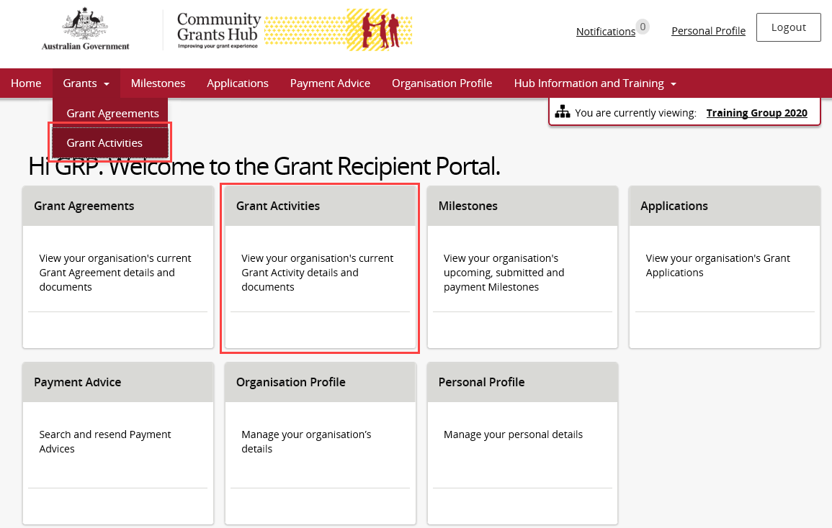
Step 2
The Grant Activities screen will display. Select the View button to open the relevant Activity details.
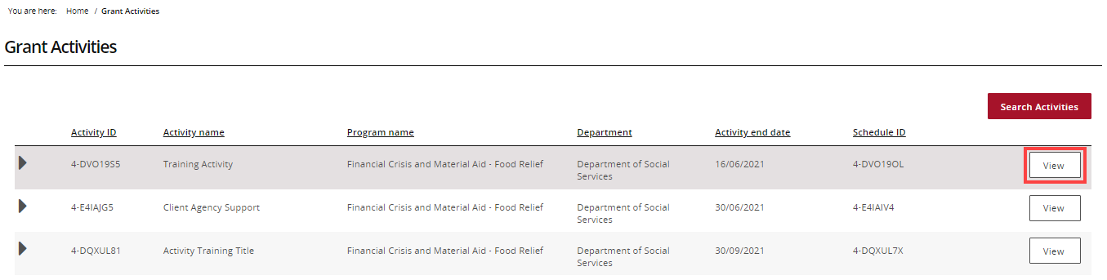
Step 3
The Activity details screen will display. Select Milestones from the Grant Activity menu.
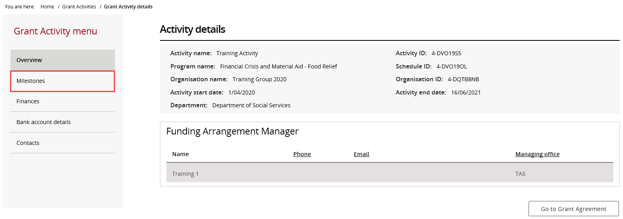

Step 4
The Milestones screen will display. By default, Filter 1. Upcoming Milestones will be presented.
To change the filter, use the drop down and select Apply Filter or,
To locate a specific Milestone, perform a search by selecting Search all Milestones.
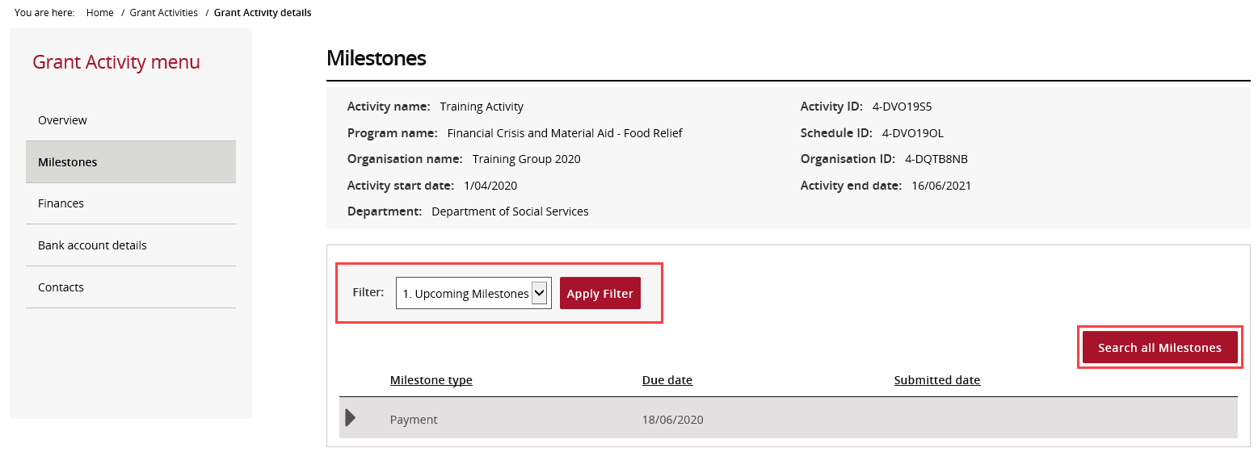

Step 5
When the correct milestone has been identified, select Actions and then Launch Report to open the online report form.
Proceed to Step 11 to complete your online Financial Acquittal Report.

Accessing the Financial Acquittal report – Non-Portal

Step 6 – Non-Portal
30 days before the acquittal due date, you will receive an email with a link and unique access code to complete your Financial Acquittal report.
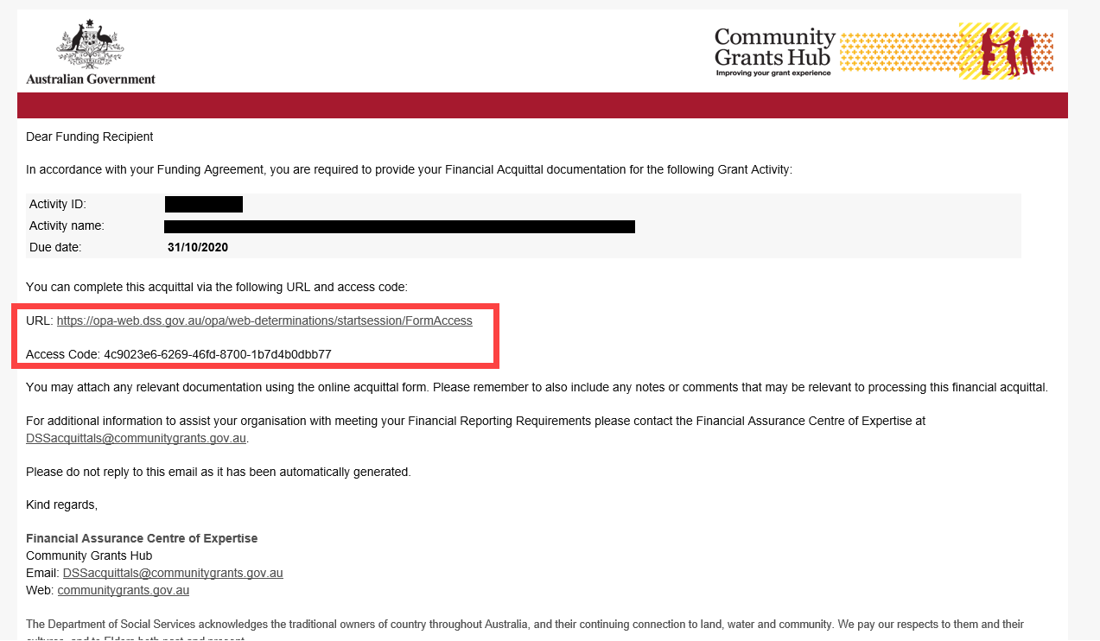

Step 7
Click the URL, or copy and paste into your browser search bar, to open your form. Copy the access code from the email and paste it into the into the Access Code box. Press Next.
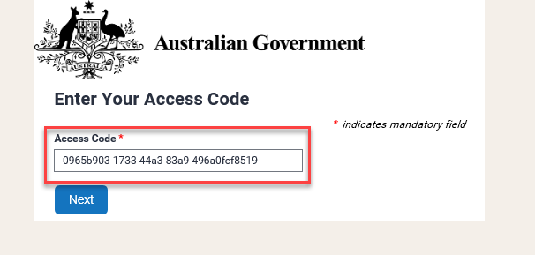
Step 8
Enter in your password and press Next. Please skip to Step 10 if you know your password.
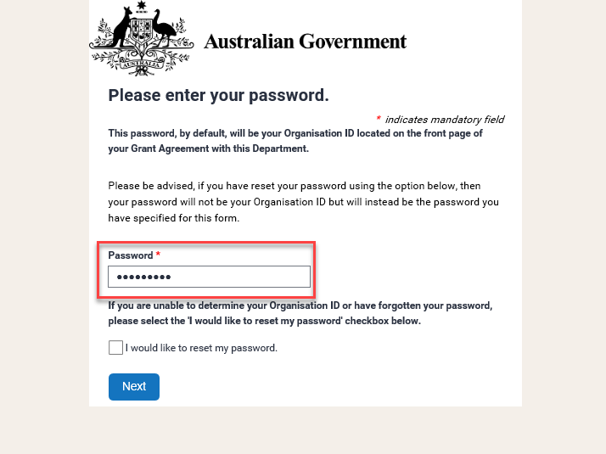
Your password is your Organisation ID and can be found on the front page of your Grant Agreement.
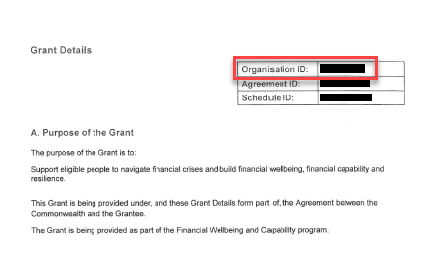
If you do not know your Organisation ID, please check the ‘I would like to reset my password’ checkbox and press Next. Please continue to Step 9.
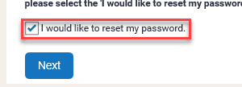
Step 9
This step is only applicable if you have checked the ‘I would like to reset my password’ box.
In order to reset the password, please:
- Enter in your email address and press Next.
Please note only the email that received the original acquittal email will be able to reset the password.
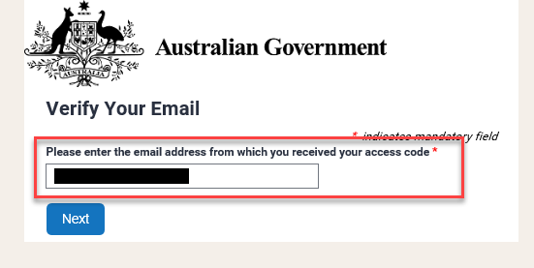
- You will receive an email with a reset token.
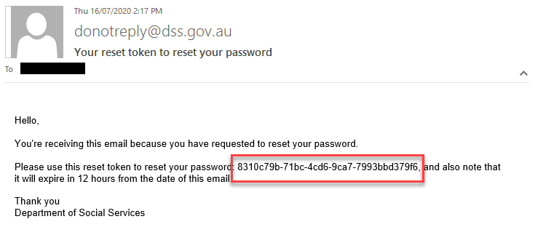
- Copy the reset token and paste it into the Reset Token field. Press Next.
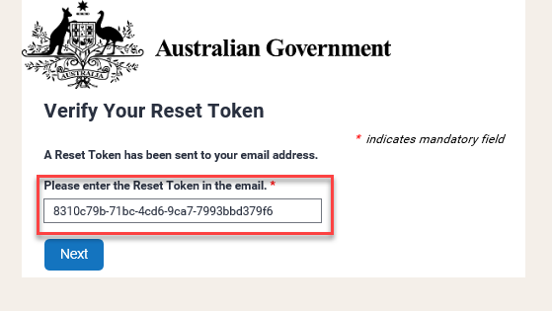
- Set and confirm a new password and press Next.
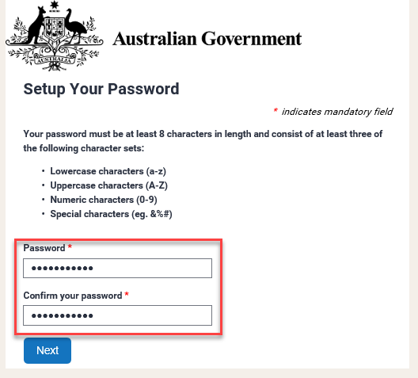
Step 10
When you have entered in your password (or reset your password), you will be directed to the ‘Financial Acquittal Report’ page.
Proceed to Step 11 to complete your online Financial Acquittal Report.

Completing the online Financial Acquittal report
Step 11
The Financial Acquittal Report screen will display and include details about your grant.
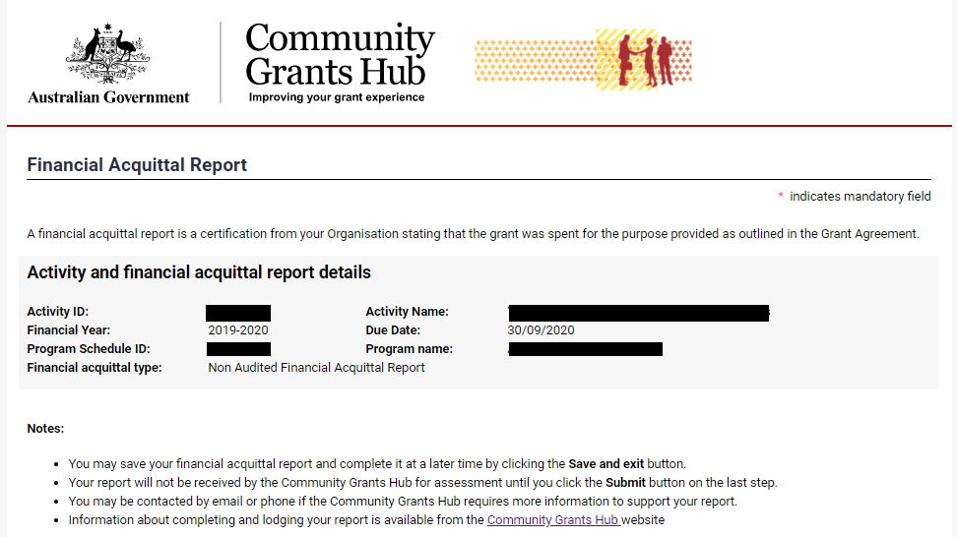
Step 12
The form will prepopulate with funding details for the relevant financial year. The first section will be for the Base Funding. Please note all values are GST Exclusive and do not include SACS funding. SACS funding is referenced in a later field.
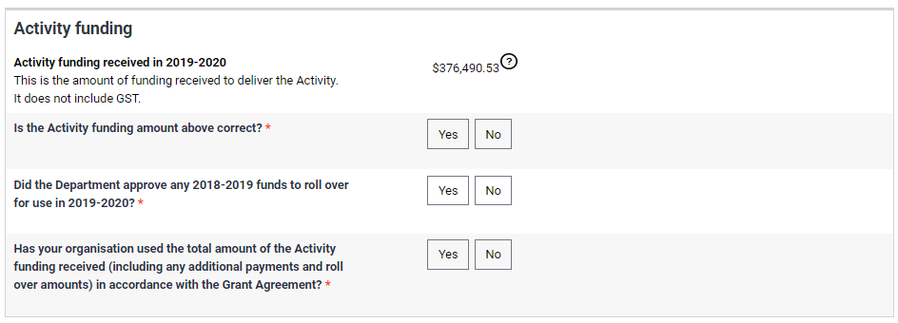

You will be prompted to:
a) Confirm the funding is correct. If the prepopulated funding value is not correct, you will be prompted to provide the correct value and a reason for the correction,
b) Declare any funds approved for roll-over from the previous financial year. This refers to formal roll-over approval detailed in your last acquittal outcome letter, and;
c) Confirm that you have expended the total value of activity funding, including any additional payments and/or roll overs, for the approved purpose.
If you have not expended all funds, you will be prompted to enter the value of unexpended funds and provide information about the reasons the funds were not expended.
You will also be promoted to select a reason for the unspent funds. Please select the most appropriate category, you can provide additional detail in the free text box to explain the circumstances.
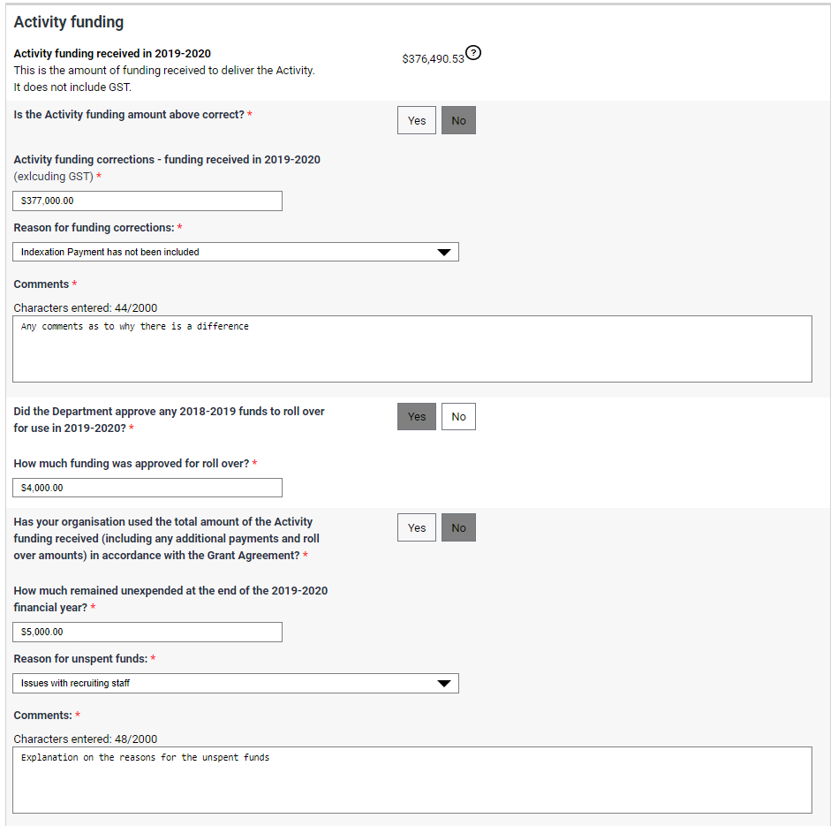

Step 13
If your Organisation has also received Social and Community Services (SACS) funding, you will be required to declare that in a separate section of the acquittal.
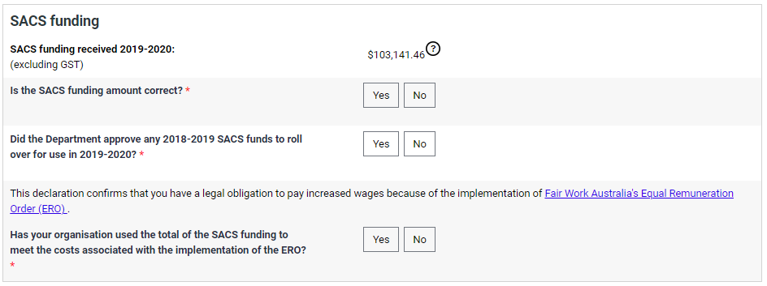
Once again, you will be prompted to:
a) Confirm the funding is correct. If the prepopulated funding value is not correct, you will be prompted to provide the correct value and a reason for the correction,
b) Declare any funds approved for roll-over from the previous financial year. This refers to formal roll-over approval detailed in your last acquittal outcome letter, and;
c) Confirm that you have expended the total value of activity funding, including any additional payments and/or roll overs, for the approved purpose.
If you have not expended all funds, you will be prompted to enter the value of unexpended funds and provide information about the reasons the funds were not expended.
You will also be promoted to select a reason for the unspent funds. Please select the most appropriate category, you can provide additional detail in the free text box to explain the circumstances.
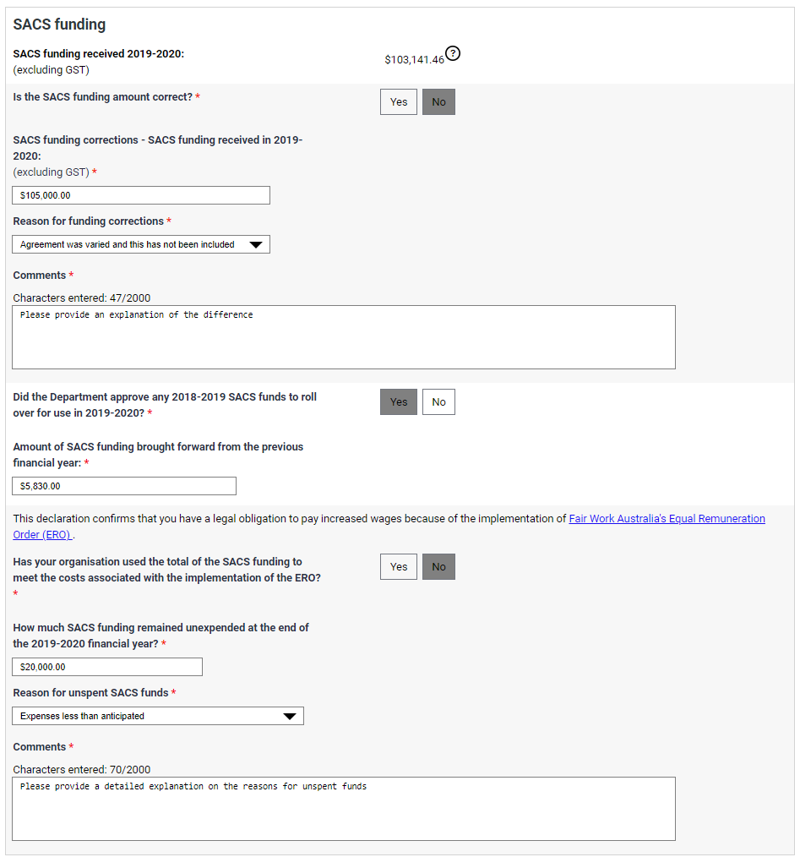
If your acquittal requirement is a Financial Declaration, proceed to Step 15 to lodge your report.

Step 14 – Non-Audit and Audited Acquittals only
If your Financial Acquittal reporting requirement is a Non-Audited Financial Acquittal Report or an Audited Financial Acquittal Report, you will be required to attach the Non-Audited / Audited report to the online form.
For further information on the types of documents required to meet your Non-Audited or Audited Acquittal requirements, please see Appendix B before proceeding.
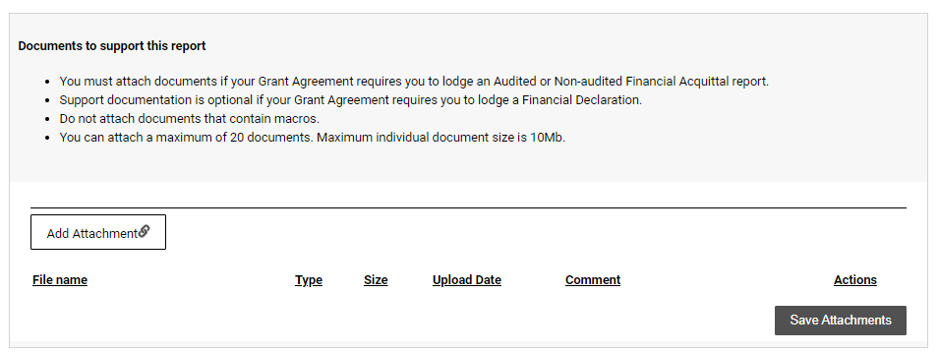
Select Add Attachment to include documents saved on a desktop.
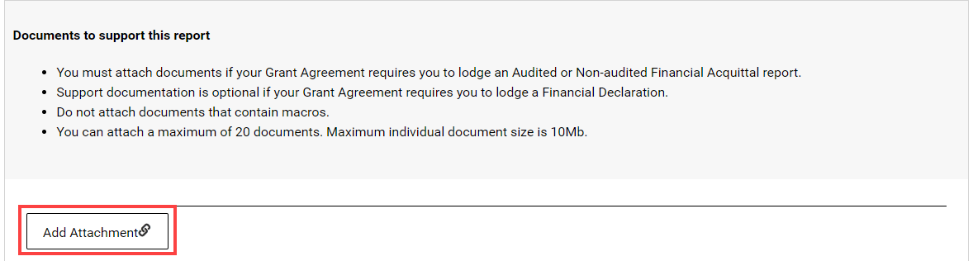
If required, select the Actions drop down to View, Remove or Edit comment for the attachment.
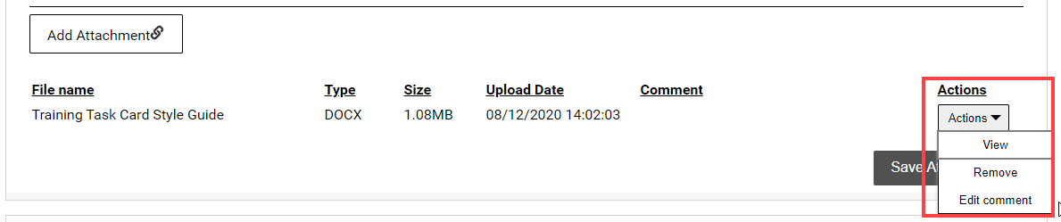
Once all attachments to support the Acquittal have been provided, select Save Attachments.
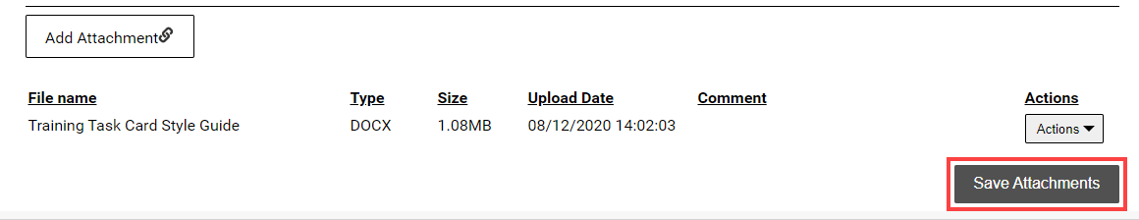
Do not leave this screen while data is being submitted. Once the message disappears, continue to complete the report.
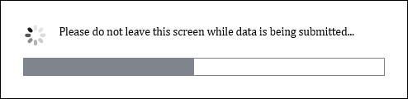
A message will display to advise if the documents were successfully saved.
If more documents need to be attached, select Return to list.
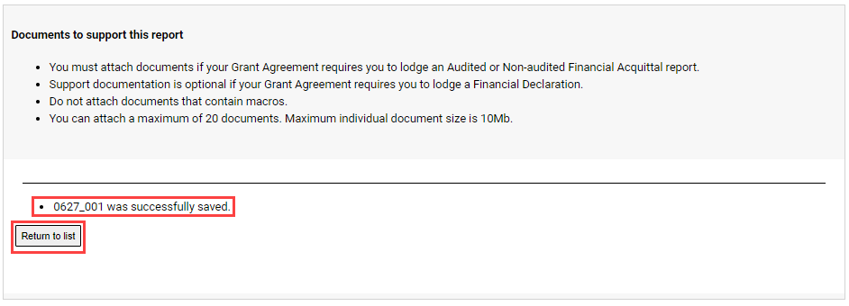
Step 15
Review the Disclaimer and select the checkbox to agree to the Disclaimer. Select Submit.
Please note that by completing the checkbox and entering your name and position you are electronically signing the acquittal document, declaring that the information you have provided is accurate and that you are authorised to make this declaration on behalf of the organisation.
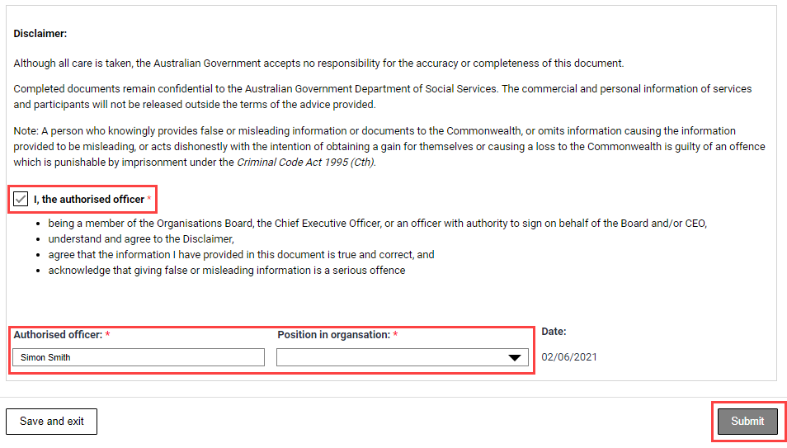
A message will appear to advising to stay on this screen until the data has been submitted.
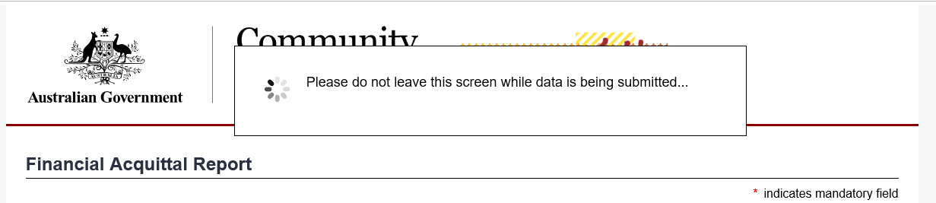
Step 16
A confirmation page will display. Select Save and exit to close the form.
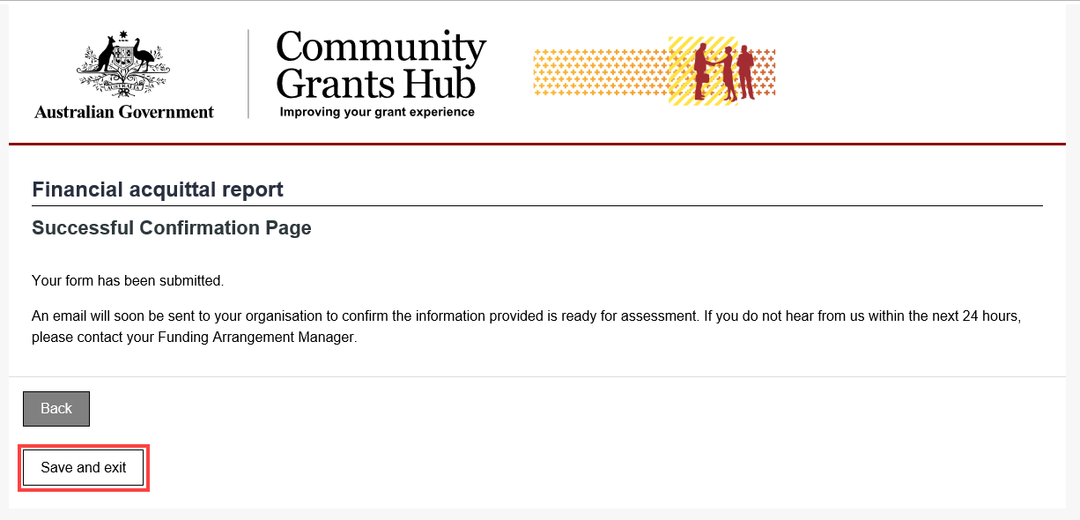
You will also receive an email to confirming the submission of the online Financial Acquittal report.
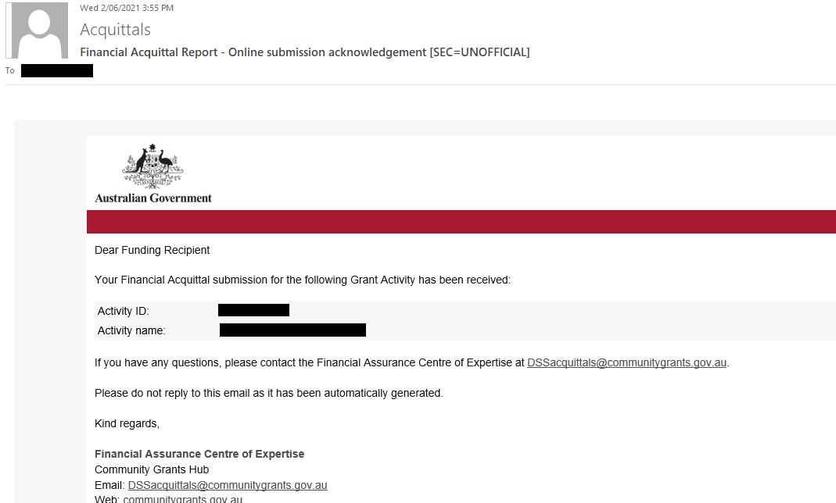

Need further assistance?
If you require any clarification regarding your financial reporting obligations, please contact the Financial Assurance Centre of Expertise via email below:
Agency Name | Financial Acquittal Inbox
Department of Social Services | DSSacquittals@communitygrants.gov.au
Department of Social Services – Volunteer Grants | vgacquittals@communitygrants.gov.au
Attorney-General’s Department | AGD.acquittals@communitygrants.gov.au
Department of Veterans’ Affairs | DVAacquittals@communitygrants.gov.au
Department of Home Affairs | DHA.Acquittals@communitygrants.gov.au
Department of the Prime Minister and Cabinet | PMC.Acquittals@communitygrants.gov.au
Department of Agriculture, Water and the Environment | DAWE.Acquittals@communitygrants.gov.au
Department of Education, Skills and Employment | DESE.Manage@communitygrants.gov.au

If you require an extension to the due date to meet your financial reporting obligations, please contact your Funding Arrangement Manager.

If you experience technical difficulties with the online form or the Grant Recipient Portal please contact our helpdesk at GRP.Helpdesk@communitygrants.gov.au or on 1800 020 283, ext. 5.

Appendix A – Manual Financial Declaration
Organisation Name | enter organisation name
Activity ID | enter Activity Id
Name of Activity | enter Name of Activity

PART 1 – Grant Funding
Grant funding received in enter financial year (excluding GST and SACS) | $ enter amount received
Grant funding approved for roll-over from the previous financial year (excluding GST and SACS) | $ enter amount  approved for roll-over
Grant funding spent on the activity in accordance with the grant agreement (excluding GST and SACS) | $ enter amount spent
Grant funding which remains unspent and uncommitted from this financial year (excluding GST and SACS) | $ enter amount unspent
NOTE – If you have entered an underspend, please provide details of the underspend on the next page

PART 2 – Social and Community Services (SACS) Funding
Is Social and Community Services (SACS) funding paid to your organisation? | Yes No
If YES, please enter amount of SACS received for FY above (excluding GST) | $ enter amount received
SACS funding approved for roll-over from the previous  financial year (excluding GST) | $ enter amount  approved for roll-over
If YES, this declaration confirms that you have a legal obligation to pay increased wages due to implementation of Fair Work Australia’s Equal Remuneration Order (ERO)
Has your organisation used the total of the SACS funding to meet the costs associated with the implementation of the ERO? | Yes No
If NO, please enter the amount of unspent SACS funding (excluding GST) | $ enter amount unspent
NOTE – If you have entered an underspend, please provide details of the underspend on the next page

This declaration must be certified on behalf of the Funding Recipient by one of the following:
- the organisation's board;
- chief executive officer; or
- an officer with authority to do so.

Name of person making the Declaration | enter name
Signature of person making the Declaration | insert signature
Position in Organisation | position
Date of Declaration | date
Witnessed by | witness name

Reason for unspent funds (if applicable)

Please tick all that apply:

Funds received from the department late in the financial year | Yes
Reduced demand for services | Yes
Issues with recruiting staff | Yes
Delay in project implementation | Yes
Expenses less than anticipated | Yes
Failure to manage expenses | Yes
Other | Yes

Please provide an explanation of the reason/s for the underspend:

enter reason for underspend here

Appendix B – Notes on Non-Audited and Audited Financial Acquittals
Non-Audited Financial Acquittal Reports
A non-audited financial acquittal report is an income and expenditure statement for the grant and confirmation that the funding has been spent on the activity in accordance with the Grant Agreement, Schedule and Terms and Conditions.
There is no specific format for a non-audited financial acquittal, however it must;
- adhere to the applicable Australian Accounting Standards and be based on proper accounts and records;
- verify that the funding has been spent on the activity in accordance with the Agreement, Schedule and Terms and Conditions;
- pertain to Departmental funding only (an income and expense statement for your whole organisation is not acceptable);
- clearly differentiate income and expenditure relating to each grant you are funded for;
- include SACS (Social and Community Services Supplementation) funding if applicable;
- include any other matters as specified in the Grant Agreement, and
- be certified by the Board, chief executive officer or an authorised officer of the Organisation.
A non-audited financial acquittal is submitted by completing the online form and then attaching your income and expenditure statement (e.g. Word, PDF, excel format etc)

Audited Financial Acquittal Reports
An audited financial acquittal report is prepared by someone independent to the organisation. It includes an income and expenditure statement for the grant audited by a:
- Registered Company Auditor under the Corporations Act 2001 (Cth); or
- member of CPA Australia; or
- member of the Institute of Public Accountants in Australia; or
- member of the Institute of Chartered Accountants in Australia.
There is no specific format for an audited financial acquittal, however it must;
- be accompanied by an audit opinion;
- adhere to the applicable Australian Accounting Standards and be based on proper accounts and records;
- verify that the funding has been spent on the activity in accordance with the Agreement, Schedule and Terms and Conditions;
- pertain to Departmental funding only (an audited statement for your whole organisation is not acceptable);
- clearly differentiate income and expenditure relating to each grant you are funded for;
- include SACS (Social and Community Services Supplementation) funding if applicable, and
- include any other matters as specified in the Grant Agreement.

An audited financial acquittal is submitted by completing the online form and then attaching your audit and audit opinion documents (e.g. Word, PDF, excel format etc).

