Add Organisation Staff
  - Grant Recipient Portal Task Card
Portal Access required: Administrator
The Grant Recipient Portal (Portal) enables grant recipients to add staff from their Organisation to the Portal.
This task card describes the process of adding Organisation staff as contacts to the Portal including system validations to assist with reducing duplicate contacts from being added.

Access levels for the Portal
- Organisation Viewer – The staff member can view various screens but will not be able to add details or make any changes
- Organisation Editor – The staff member can add details and make changes on selected available screens
- Organisation Administrator (the highest level of access) – The staff member can add details and make changes on all available screens.
Note: the access level of No Access is to be used for staff members who do not require access to the Portal but need to be added as an Organisation contact so they can be assigned to grant agreements or grant activities.
The table below details the functionality for each access level:
Portal Functionality | Organisation Viewer | Organisation Editor | Organisation Administrator
Update Bank Accounts  (certain information only) | No | No | Yes
Give staff access to the Portal | No | No | Yes
Create / edit staff | No | No | Yes
Edit Organisation details | No | No | Yes
Accept funding offers or variations  (if set up as a signatory) | No | Yes | Yes
Submit Reporting Obligations | No | Yes | Yes
Update personal profile | Yes | Yes | Yes
View grant information | Yes | Yes | Yes

Adding Staff in the Portal
Step | Action
From the Home screen, select the Organisation Profile tile. Alternatively, select the Organisation Profile link from the Navigation menu.
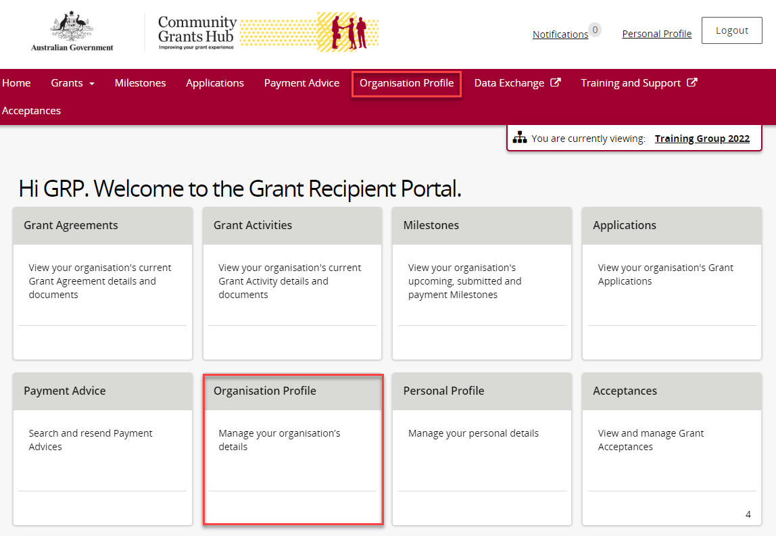
The Organisation Profile screen will display. Select Staff from the Organisation profile menu to display the Organisation’s Staff screen.
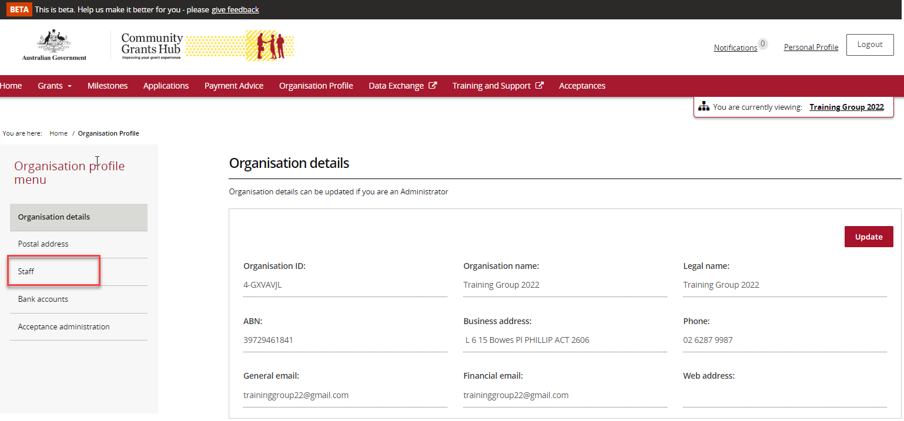
The Organisation’s Staff screen will display. This screen displays Active Staff for the organisation by default. The Staff list can be filtered using the drop down menu to choose one of the following:
- Active Staff
- Inactive Staff
- All Staff
Note: All staff records display a unique Contact ID. This ID can be very helpful for identification purposes in various areas and assisting with duplicate contacts.
You can view the Contact ID from the Staff screen.
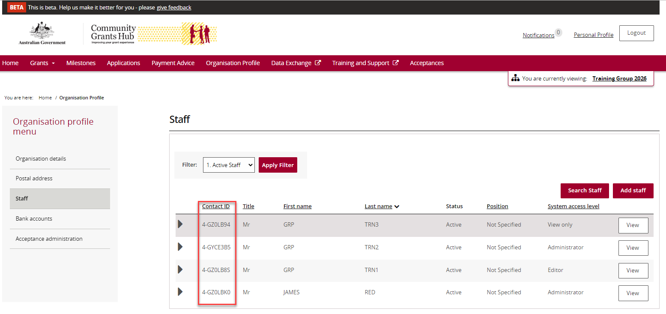
To add a new staff member select Add staff.
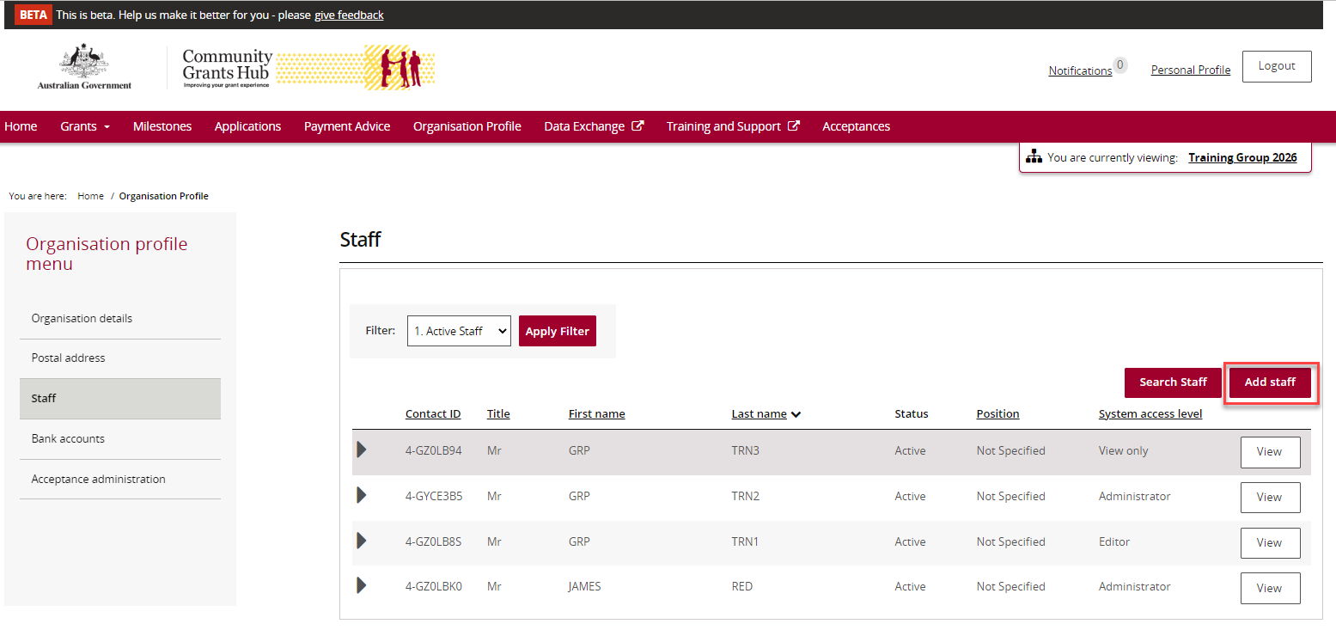
The Add staff details screen will display.
Enter the staff member’s details in the required fields including the Portal system access level required. Mandatory fields are marked with a red asterisk.
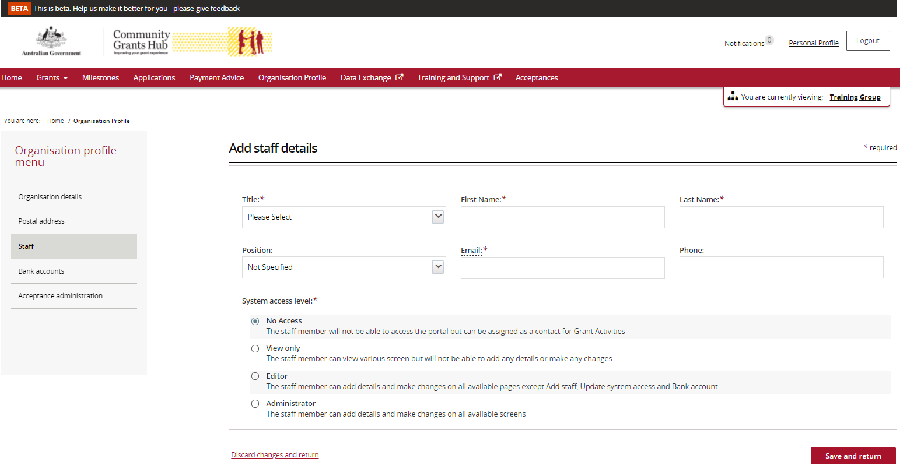
Select Save and return when complete.
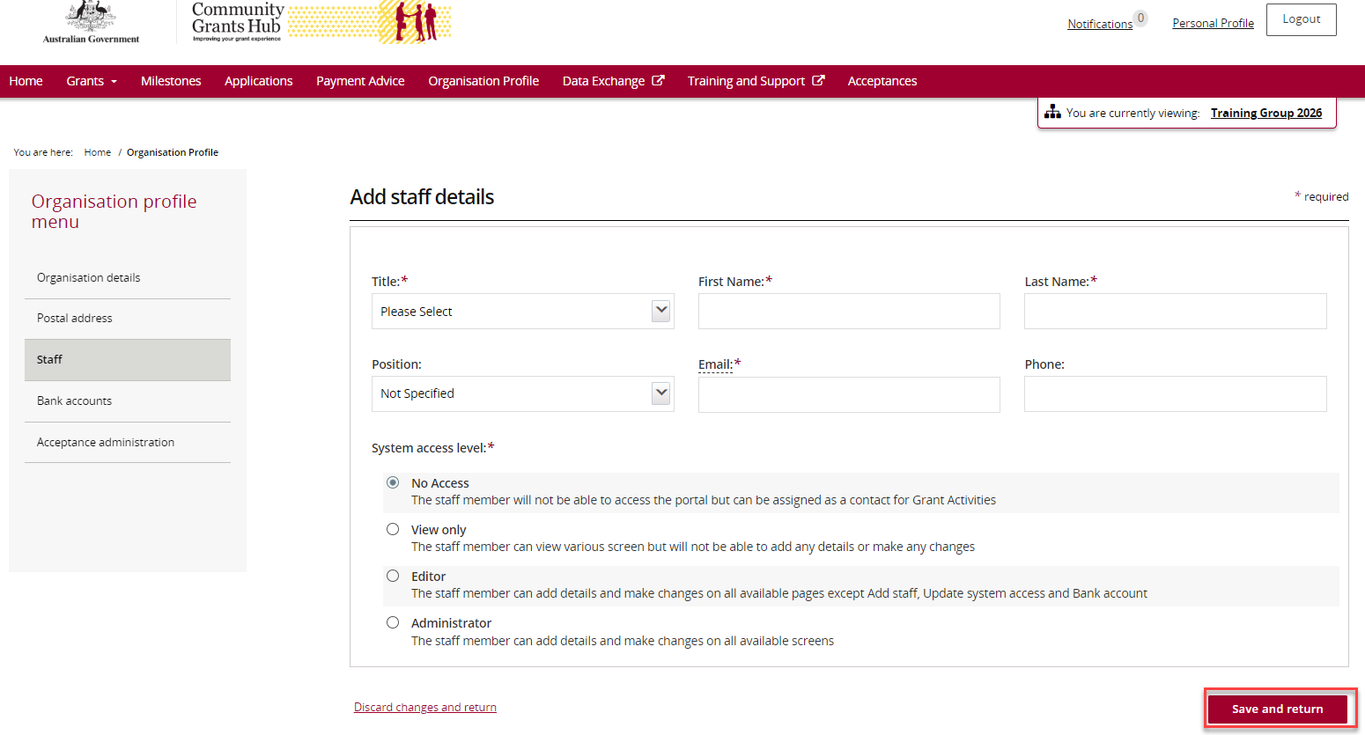
If the change is successful, a message will temporarily display on screen confirming the staff member was successfully added as a contact for your Organisation. The added contact will now be listed on the Staff screen under the Organisation Profile.
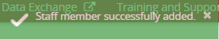
Your Staff member has now been added as a contact.
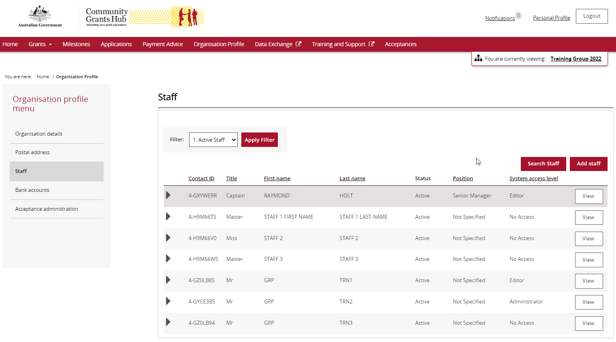
The following system validations are set up to prevent duplicate contacts being added:
- First Name, Last Name and Email Address matches an existing contact for the Organisation.
If the staff member already exists for your Organisation with the exact combination of First Name, Last Name and Email Address, the following error will occur. The system will not allow the staff member to be added.
- Email Address matches an existing contact for the Organisation.
If the email address entered matches an existing contact for your Organisation but the First Name/Last Name is different, a warning message will appear on screen. To proceed select Continue or to cancel the request select Discard changes and return.
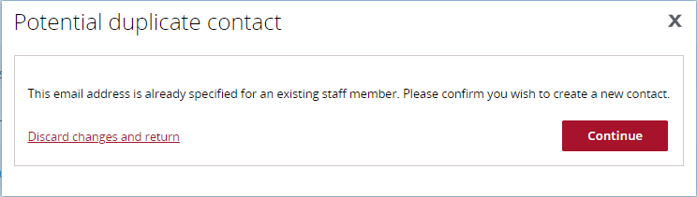
Need Help?
For further assistance, contact the Grant Recipient Portal Helpdesk:
Email: GRP.Helpdesk@communitygrants.gov.au
Phone: 1800 020 283 (Option 5)
Operating Hours: Monday to Friday 9:00am – 5:00pm (AEST/AEDT)

