Search for Organisation Staff
  - Grant Recipient Portal Task Card
Portal Access required: Administrator, Editor or View Only
The Grant Recipient Portal (Portal) enables grant recipients to view and search for Organisation Staff in the Portal.
This task card describes the key functions available for Portal users to view and search for staff within their Organisation.

Viewing a Staff record
Step | Action
From the Home screen, select the Organisation Profile tile. Alternatively, select the Organisation Profile link from the Navigation menu.
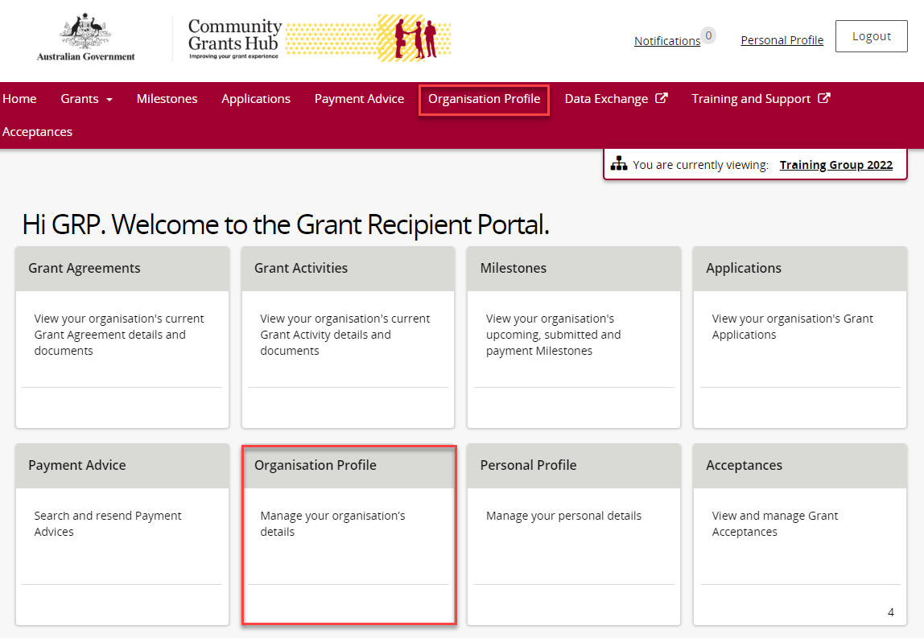

The Organisation Profile screen will display. Select Staff from the Organisation profile menu to display the Organisation’s Staff screen.
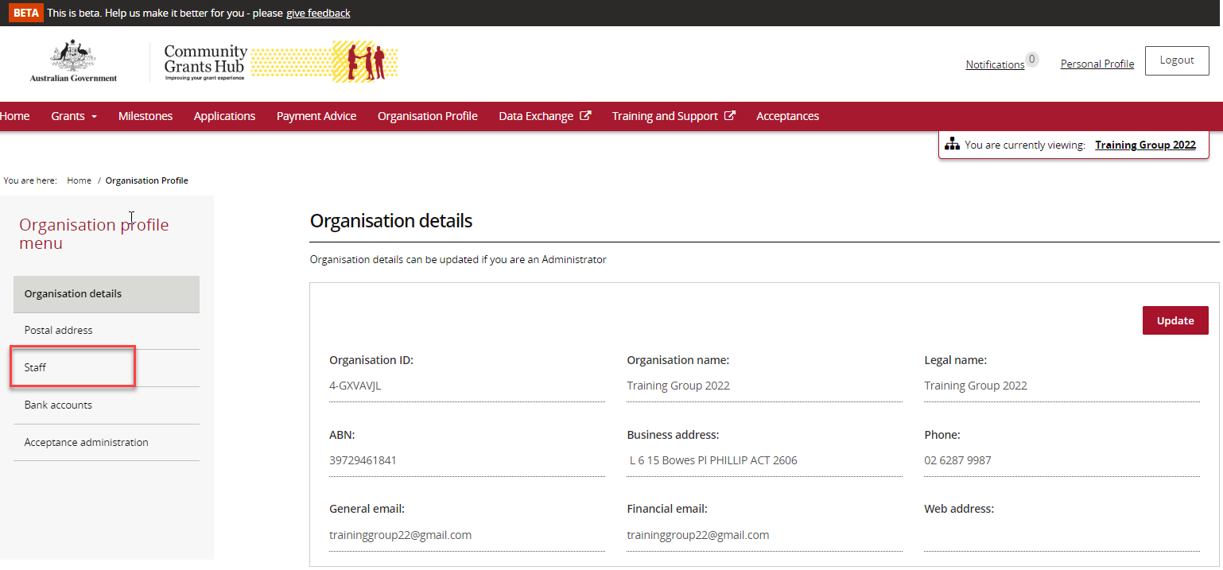
The Organisation’s Staff screen will display. This screen displays Active Staff for the organisation by default. The Staff list can be filtered using the drop down menu to choose one of the following:
- Active Staff
- Inactive Staff
- All Staff
Active staff are staff members who are listed as a contact for an Organisation in the Community Grant Hub’s (Hub’s) Grant Payment System (GPS) without an end date against the record.
Inactive staff are staff members who are listed as a contact for an Organisation in the Hub’s GPS with an end date against their record as they are no longer a contact for the Organisation.
Note:
- Grant recipients are unable to see the end date in the Portal
- Contacts without an end date = Active staff (in Portal)
- Contacts with an end date = Inactive staff (in Portal).
The Status column displayed in this screen will show the Status of each contact.
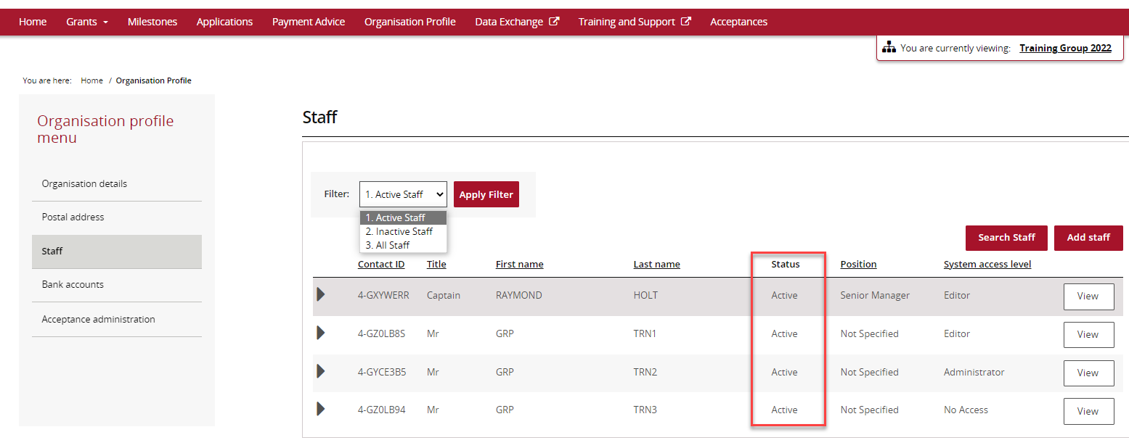

Note: All staff records display a unique Contact ID. This ID can be very helpful for identification purposes in various areas and assisting with duplicate contacts.

You can view the Contact ID from the Organisation’s Staff screen.
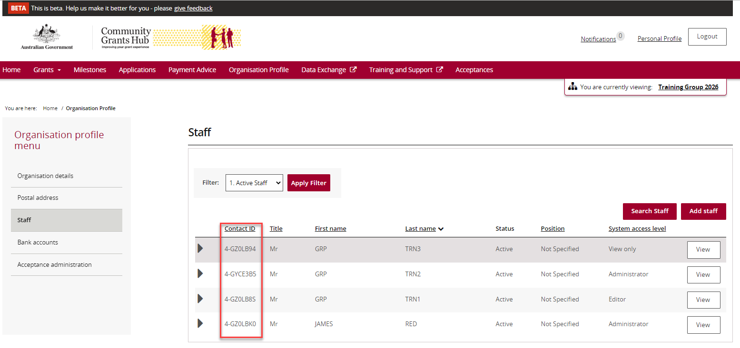
To view additional information about an Organisation staff member select the View button next to the staff member.
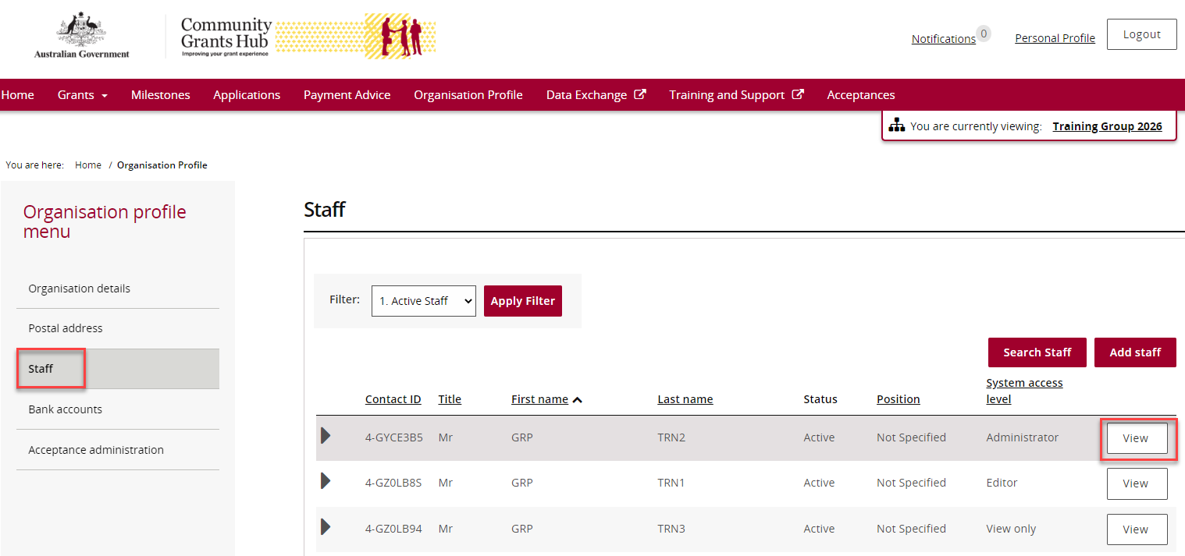
The Staff details screen will display.
This screen has four sections:
- Staff details
- System access
- Contact for Grant Agreements
- Contact for Grant Activities.
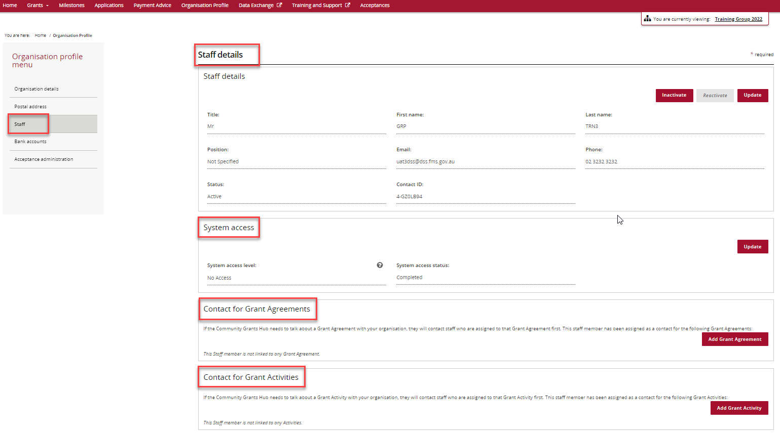

Searching for Organisation Staff
Step | Action
From the Organisation’s Staff Screen, select Search Staff.
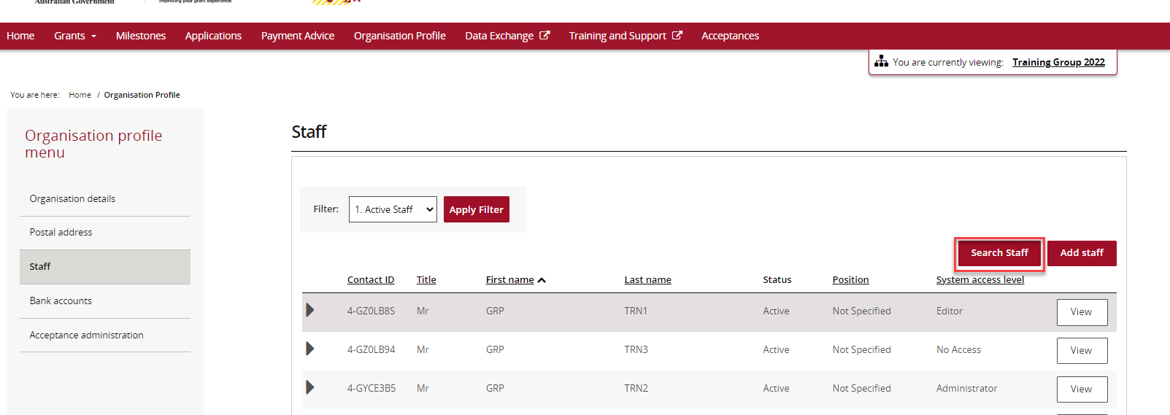
The Search staff screen will display. This screen allows you to search by First name, Last Name, Email, Position and/or Contact Id.
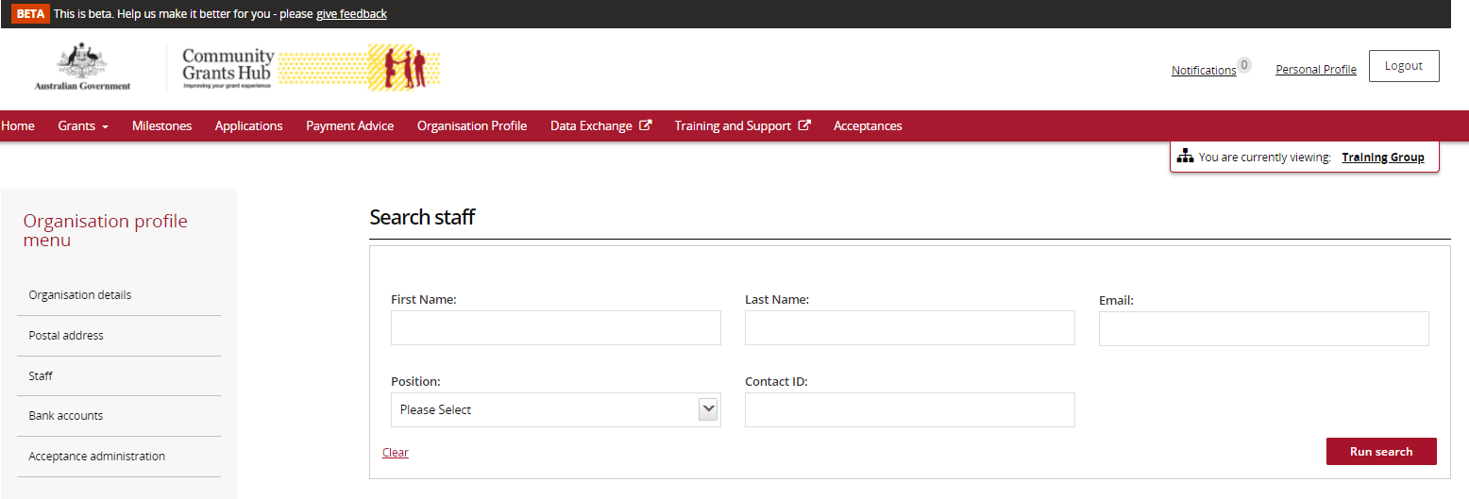
Once you have entered the information, select Run Search to continue with the search or Clear to exit the search.
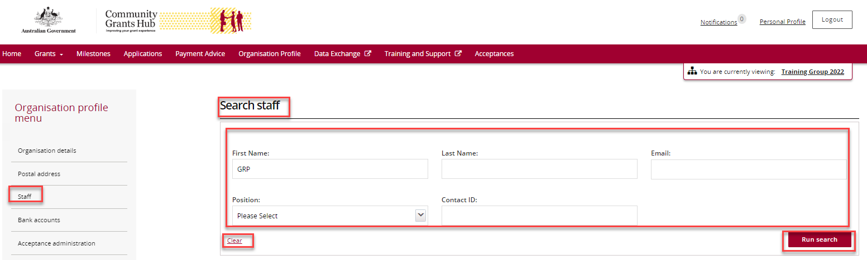

The search results will display when the search is complete.
To view additional information about an Organisation staff member select the View button next to the staff member.
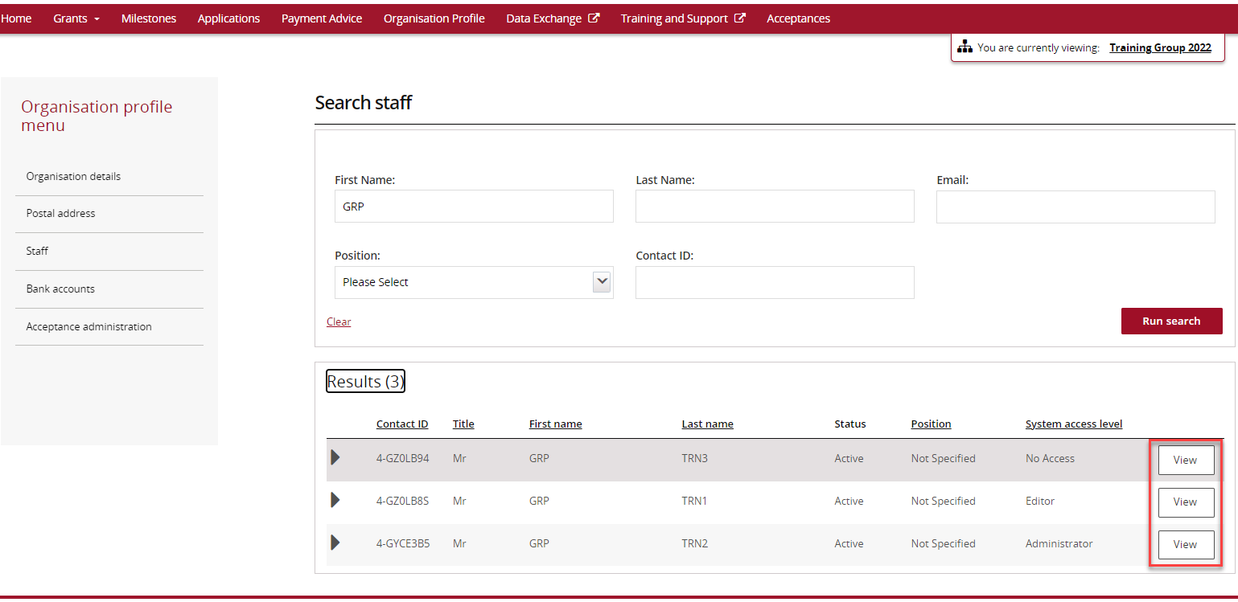
The Staff details screen will display.
This screen has four sections:
- Staff details
- System access
- Contact for Grant Agreements
- Contact for Grant Activities.
Need Help?
For further assistance, contact the Grant Recipient Portal Helpdesk:
Email: GRP.Helpdesk@communitygrants.gov.au
Phone: 1800 020 283 (Option 5)
Operating Hours: Monday to Friday 9:00am – 5:00pm (AEST/AEDT)

