Update Grant Activity Contacts
  - Grant Recipient Portal Task Card
Portal Access required: Administrator or Editor
The Grant Recipient Portal (Portal) enables grant recipients to update their Grant Activity Contacts.
This task card describes the process of viewing, adding and removing Grant Activity Contacts.
There are two pathways for a user to add and remove a contact for a Grant Activity in the Portal, either through the Organisation Profile of through the Grant Activities link/tile on the Home screen.

Navigating to Grant Activity Contacts through the Organisation Profile
Step | Action
From the Home screen, select the Organisation Profile tile. Alternatively, select the Organisation Profile link from the Navigation menu.
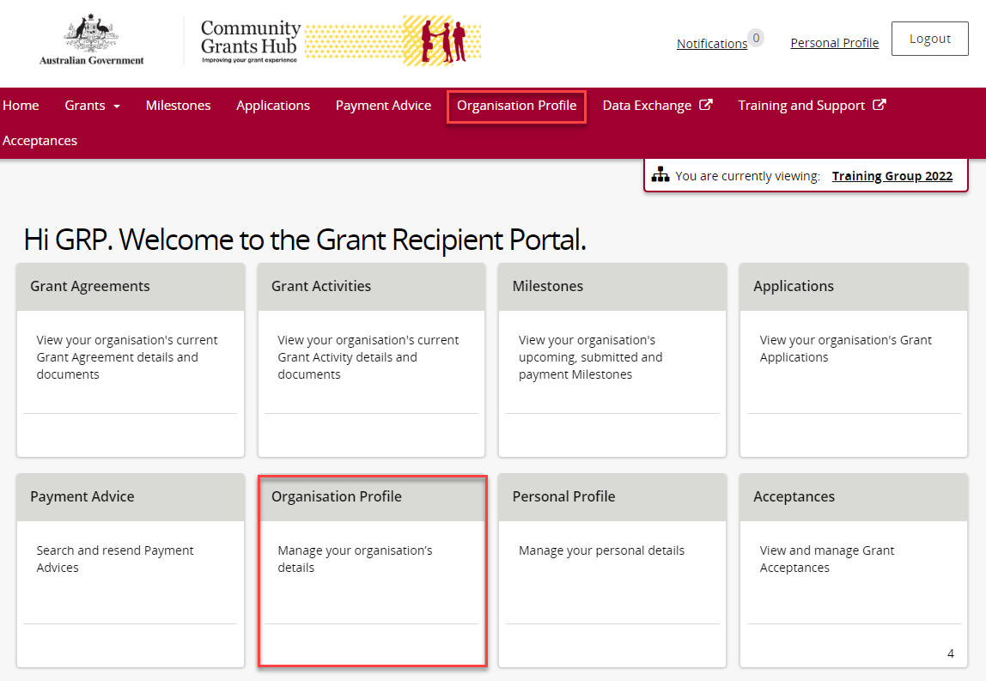
The Organisation Profile screen will display. Select Staff from the Organisation profile menu to display the Organisation’s Staff screen.
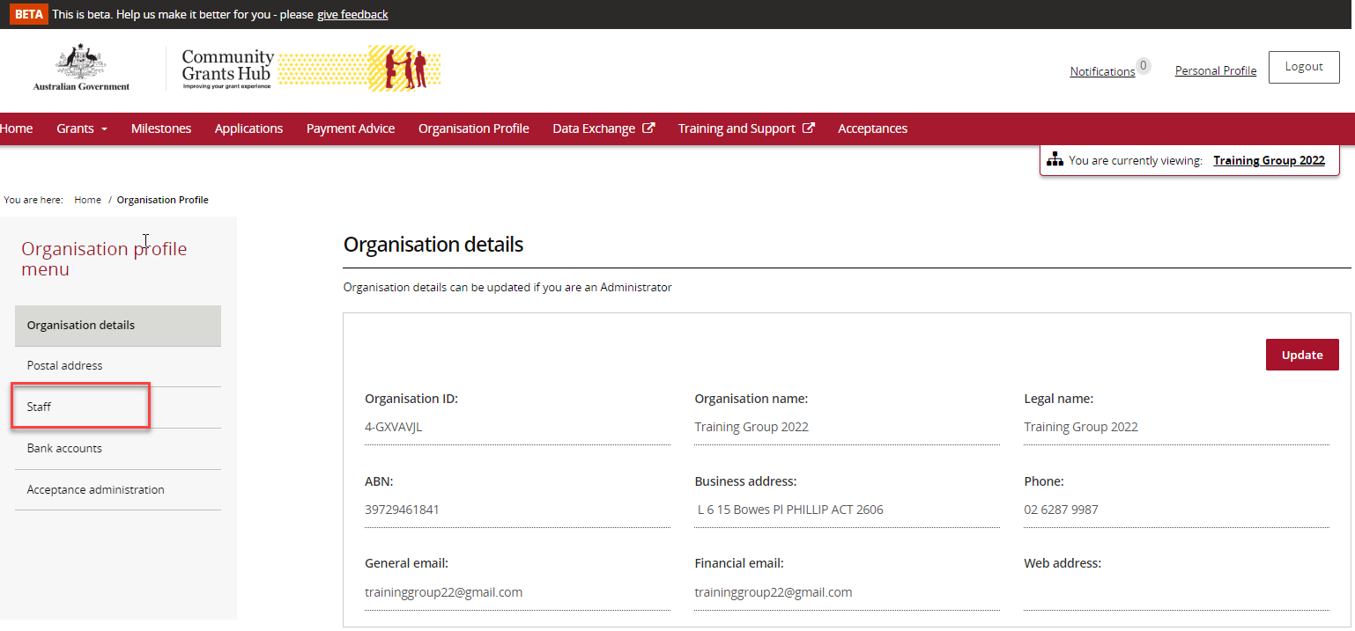
The Organisation’s Staff screen will display. This screen displays Active Staff for the organisation by default. The Staff list can be filtered using the drop down menu to choose one of the following:
- Active Staff
- Inactive Staff
- All Staff
Select View to display additional information about a particular contact.
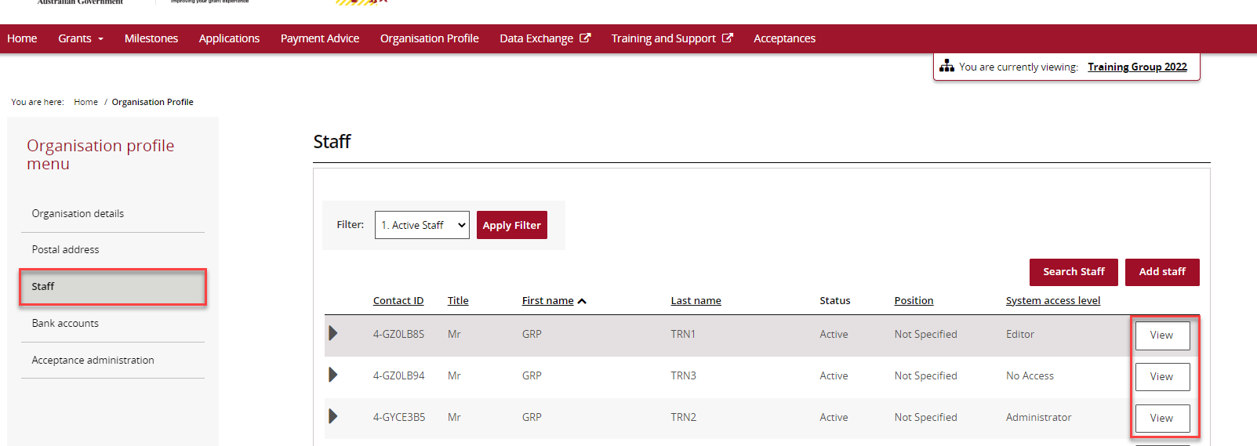
The Staff details screen will display. This screen has four sections:
- Staff details
- System access
- Contact for Grant Agreements
- Contact for Grant Activities
Grant Activity Contacts are listed under the Contact for Grant Activities section.
To add a contact through the Organisation Profile, proceed to step 5.
To remove a contact through the Organisation Profile, proceed to step 11.
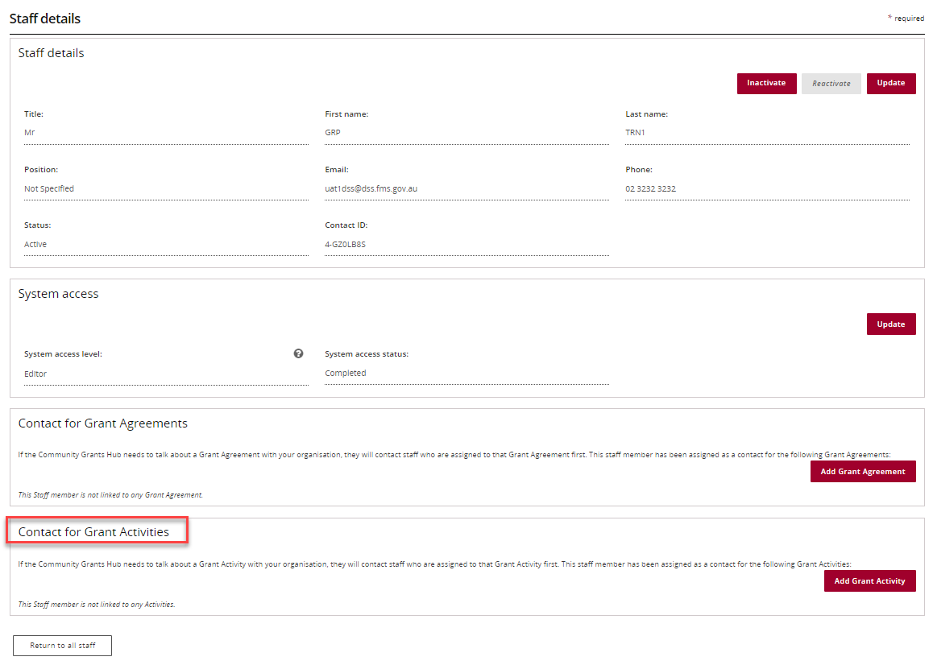

Adding a Grant Activity Contact through the Organisation Profile
Step | Action
 | To add a contact to a Grant Activity, select Staff from the Organisation profile menu. Click View next to the staff member you want to add as a Grant Activity Contact.
The Staff details page will display. Select Add Grant Activity.
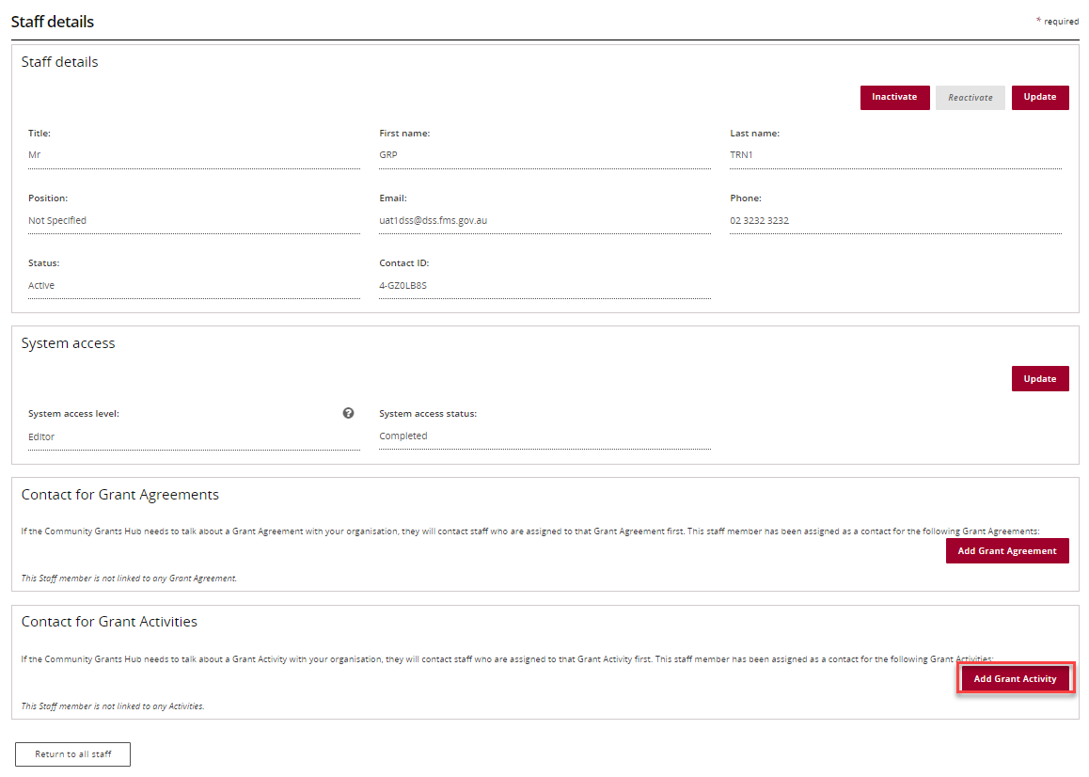
The list of Grant Activities will display which you can assign the contact to. Select the Actions button next to the Grant Activity you want to add the contact to. The Actions button provides you with three options:
1. Assign as a contact
2. Assign as the primary contact
3. View all contacts for this Activity.
Select Assign as a contact if you want to assign the contact to the Grant Activity (but not as the primary contact).
Select Assign as the primary contact if you want to assign the contact to the Grant Activity as the primary contact.
Note: If you want to see all contacts assigned to the Grant Activity, select View all contacts for this Activity.
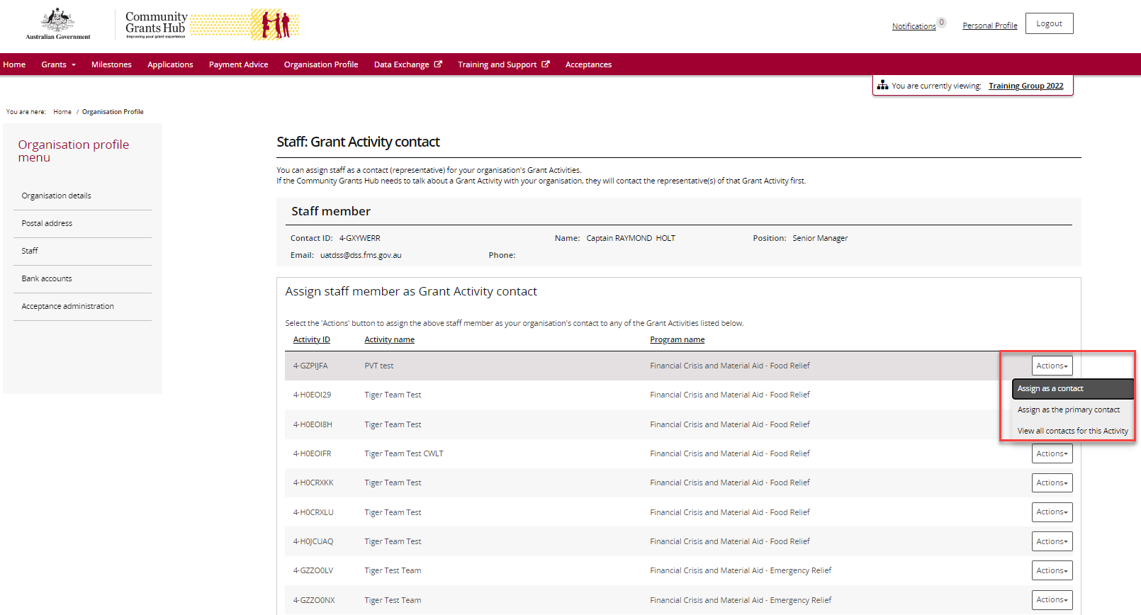
To assign as a contact, select Assign as a contact.
If the change is successful, a message will temporarily display on screen confirming the change was successful and the Grant Activity will be listed on the Staff details screen under Contact for Grant Activities with a No for Primary Activity contact.
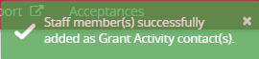
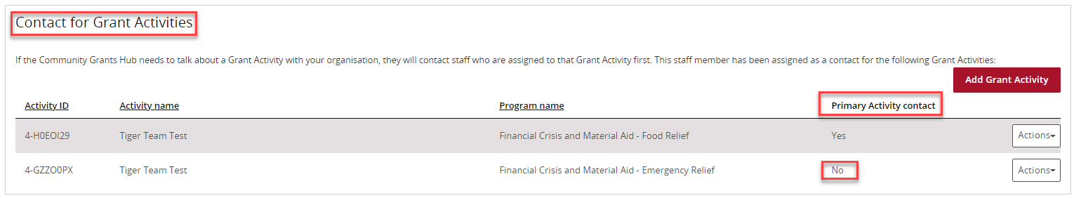
To assign as the primary contact, select Assign as the primary contact.
A confirmation message will display asking you to confirm the change by selecting Confirm.
Select Confirm to proceed with changing the primary contact.
Note: you can select Discard changes and return to cancel the change.
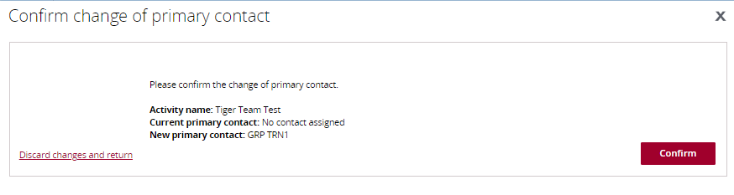
A message will temporarily display on screen confirming the change was successful and the Grant Activity will be listed on the Staff details screen under Contact for Grant Activities with a Yes for Primary Activity contact.
Successful message - changing primary contact
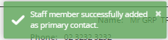
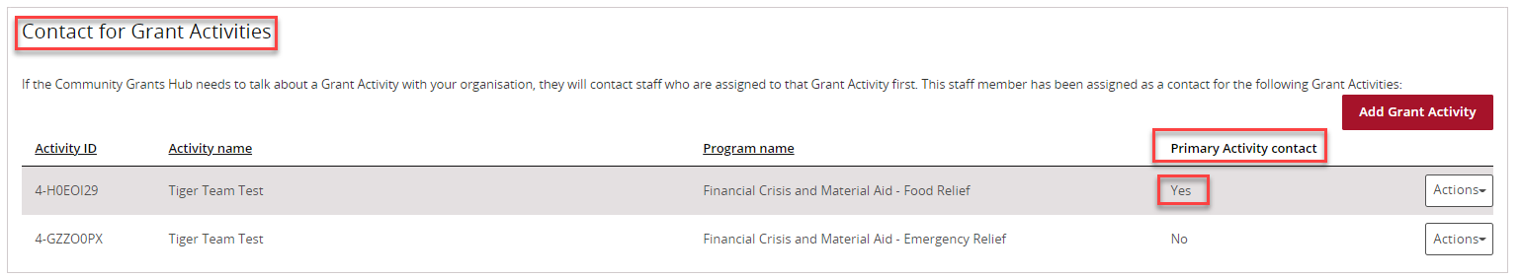

Removing a Grant Activity Contact through the Organisation Profile
Step | Action
 | To remove a contact from a Grant Activity, select Staff from the Organisation profile menu. Click View next to the staff member you want to remove as a Grant Activity Contact.
The Staff details page will display. To remove a staff member as a contact for a Grant Activity, go to the Contact for Grant Activities section. Click on the Actions button next to the Grant Activity you want to remove the contact from and select Remove contact from Activity.
Note: you are unable to remove a contact from the Grant Activity if they are listed as the primary contact. You will need to assign a new primary contact before removing the existing primary contact.
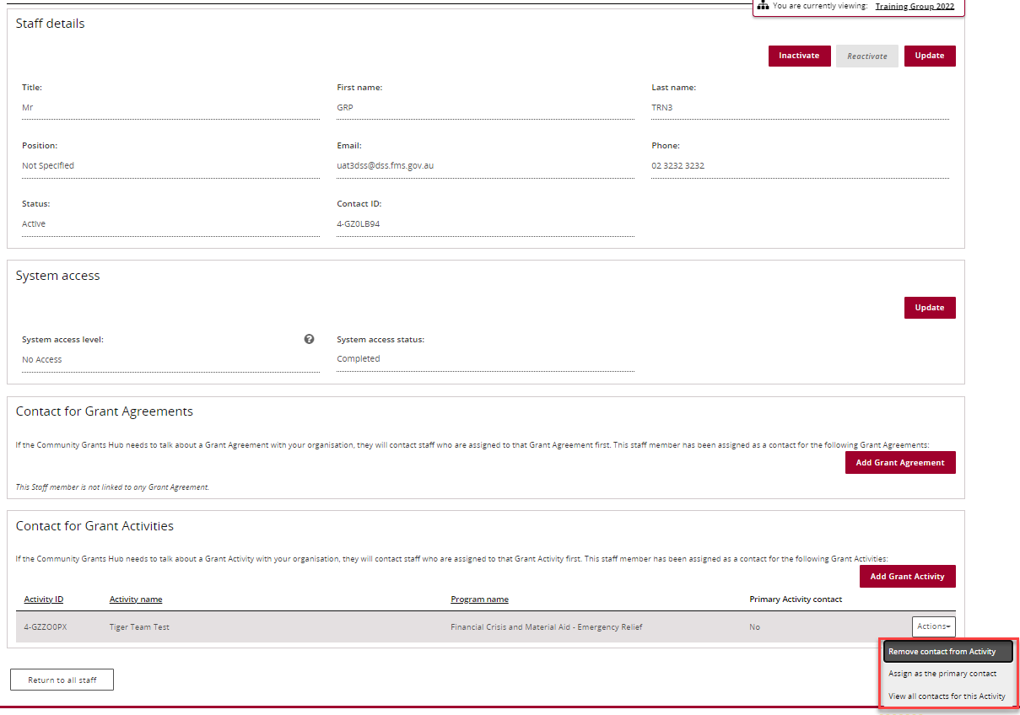
If the change is successful, a message will temporarily display on screen confirming the change was successful and the Grant Activity will be removed from the Staff details screen under Contact for Grant Activities.
Successful message - removing contact
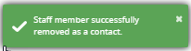
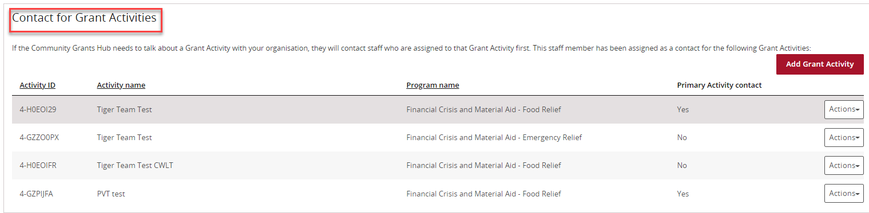
The following error message will appear on the top of the page if the contact is a primary contact for the Grant Activity. You will need to assign a new primary contact to the Grant Activity before removing the existing primary contact. The system will not allow the removal of the primary contact without a replacement.
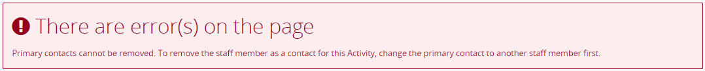

Navigating to Grant Activity Contacts through the Grant Activities link/tile
Step | Action
From the Home screen, select the Grant Activities tile. Alternatively, select Grants in the Navigation menu and select Grant Activities from the drop down menu.
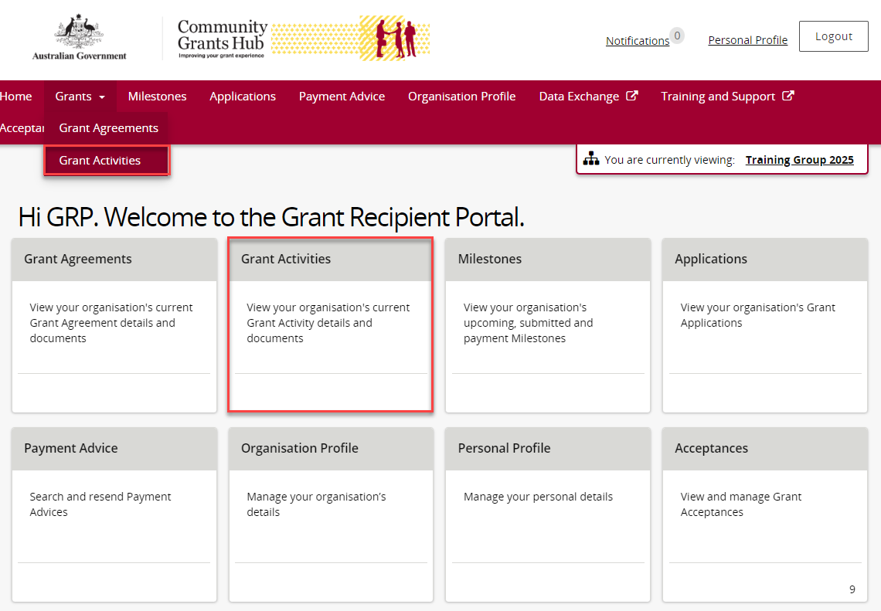
The Grant Activities screen will display a list of your organisation’s Grant Activities.
To view a particular Grant Activity, select the Grant Activity’s View button or use the Search Activities button to help navigate to your Grant Activity.
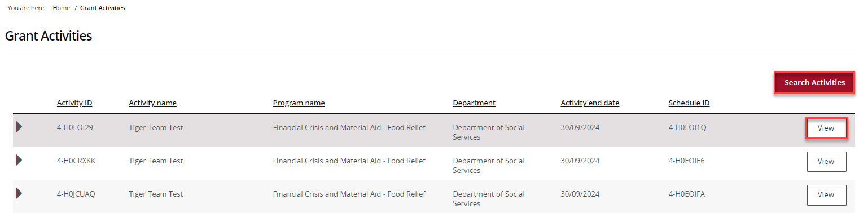
The Activity details screen will display an overview of the Grant Activity by default. The below information related to the Grant Activity can be viewed:
- Activity name | - Activity ID
- Program name | - Schedule ID
- Organisation name | - Organisation ID
- Activity start date  - Department | - Activity end date  - Funding Arrangement Manager
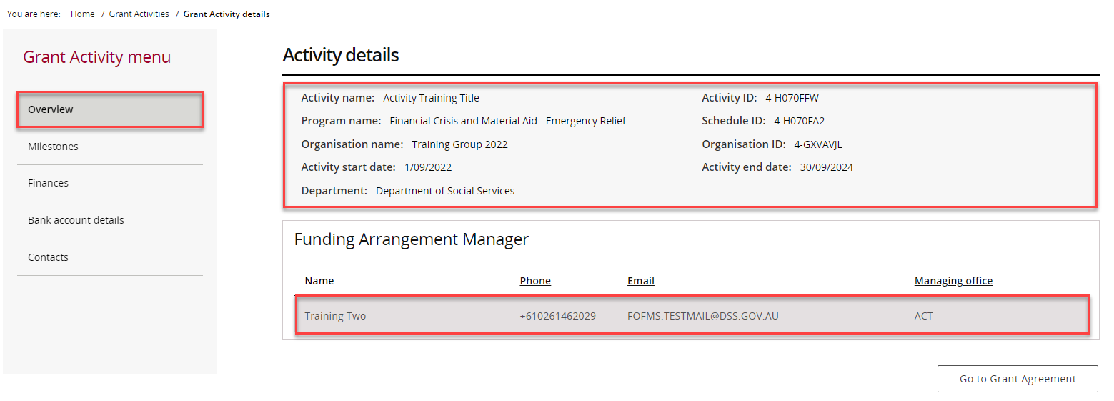
 | From the Grant Activity menu, select Contacts.
The Contacts screen will display. This screen displays all contacts linked to the Grant Activity.
To add a contact through the Grant Activities link/tile, proceed to step 19.
To remove a contact through the Grant Activities link/tile, proceed to step 25.
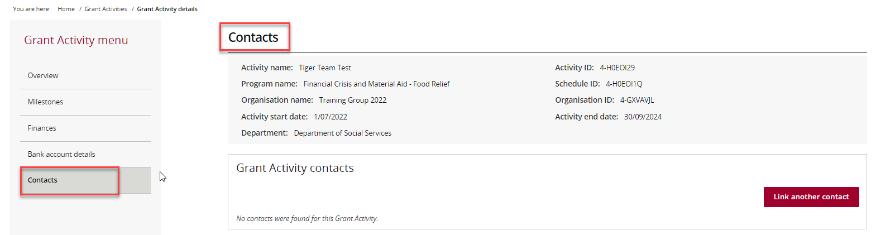

Adding a Grant Activity Contact through the Grant Activities link/tile
Step | Action
To add a contact to a Grant Activity, select Contacts from the Grant Activity menu, then click on Link another contact.
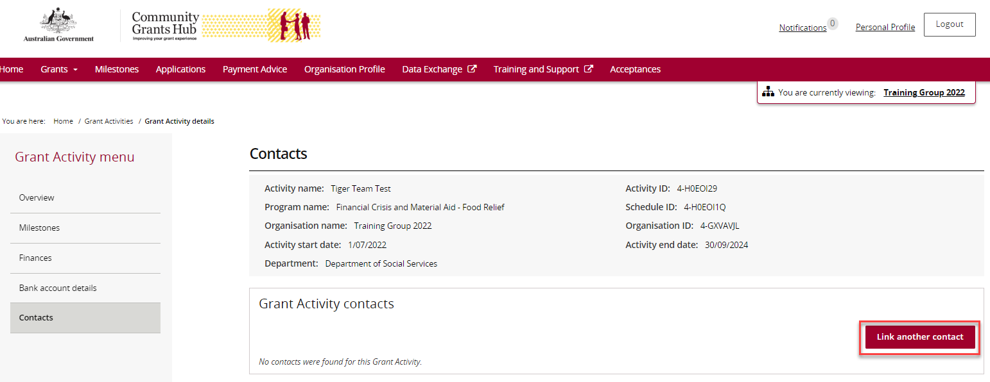
A list of contacts for the organisation will display. Click on the box next to the staff member(s) you want to add as a contact for the Grant Activity and then click on the Confirm selection button.
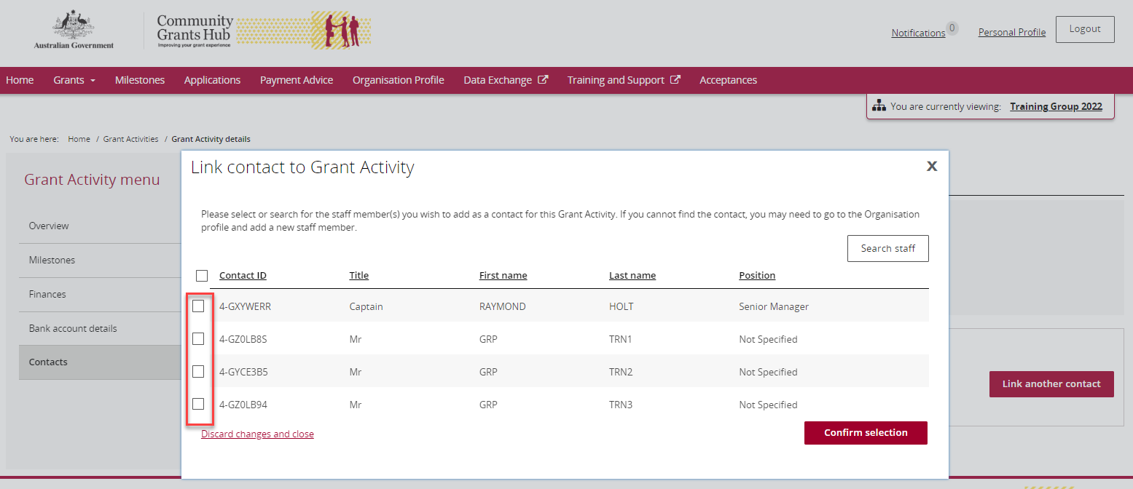
If the change is successful, a message will temporarily display on screen confirming the change was successful and the contact will be listed on the Contacts screen under Grant Activity contacts.
Successful message – adding contact to Grant Activity
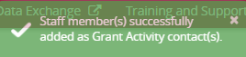
Your contact has now been added to the Grant Activity.
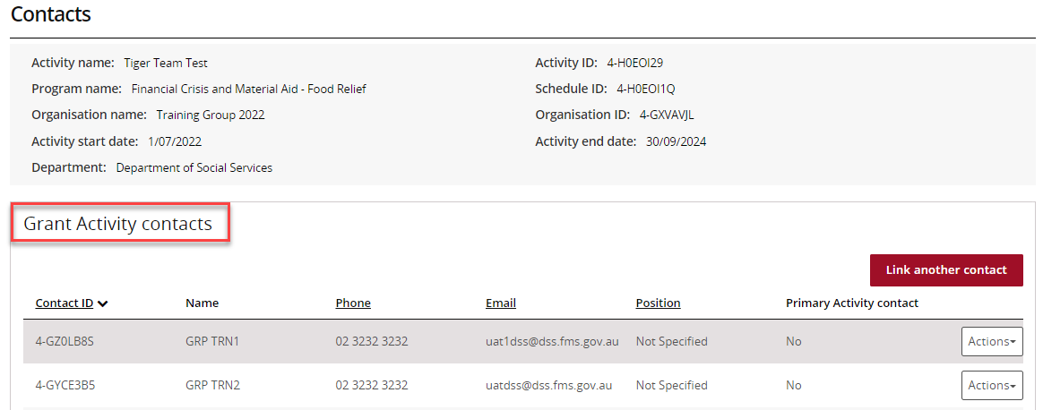

To update the contact as the primary contact, select Actions and then select Assign as the primary contact.
Note: There will be a Yes under the Primary Activity contact column for the contact who is listed as the primary contact.
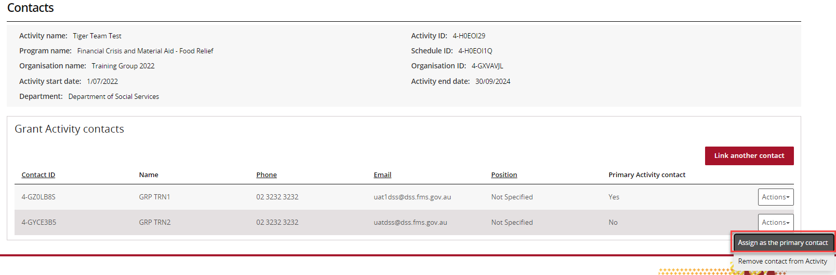
When you select Assign as the primary contact a confirmation message will display asking you to confirm the change of the primary contact by selecting Continue.
Select Continue to confirm the change of primary contact.
Note: you can select Discard changes and return to cancel the change.
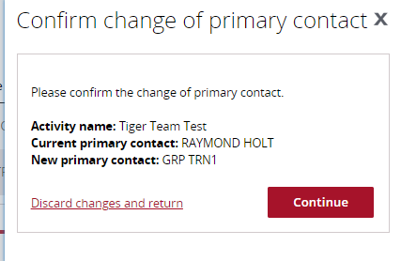
If the change is successful, a message will temporarily display on screen confirming the change was successful and the contact will be listed on the Contacts screen under Grant Activity contacts with a Yes for Primary Activity Contact.
A message will temporarily display on screen confirming the change was successful.
Successful message - changing primary contact
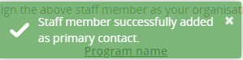
Your contact has now been updated as the primary contact.
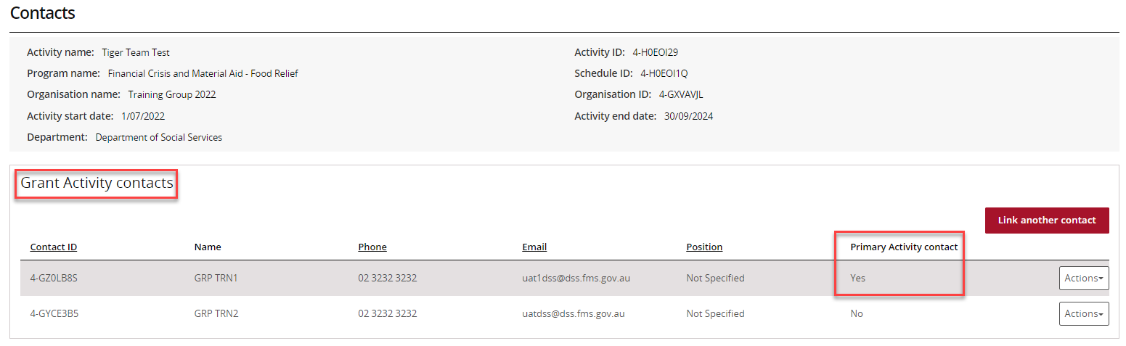

Removing a Grant Activity Contact through the Grant Activities link/tile
Step | Action
To remove a contact from a Grant Activity, select Contacts from the Grant Activity menu, then select the Actions button next to the contact and select Remove contact from Activity.
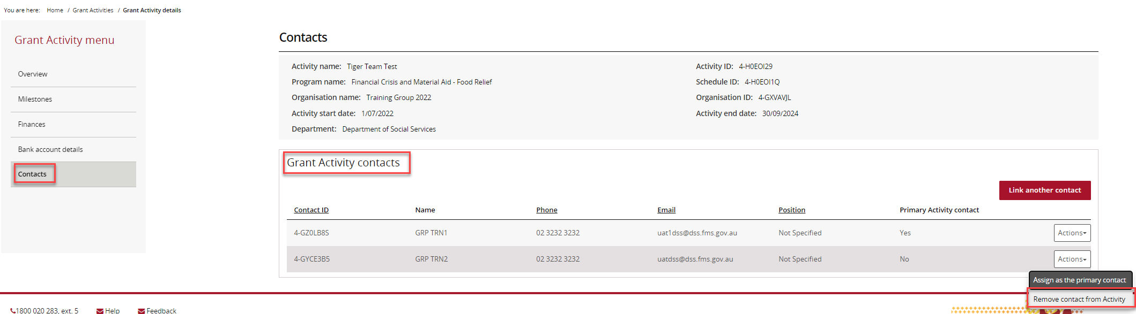
The message box below will display asking for confirmation to remove the contact from the Grant Activity. Click on Yes remove as contact to continue.
Note: you can select Cancel to not progress with the change.
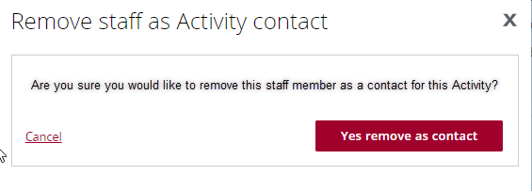
If the change is successful, a message will temporarily display on screen confirming the change was successful and the Grant Activity will be removed from the Contacts screen under Grant Activity contacts.
Successful message - removing contact
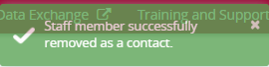
Your contact has now been removed from the Grant Activity.
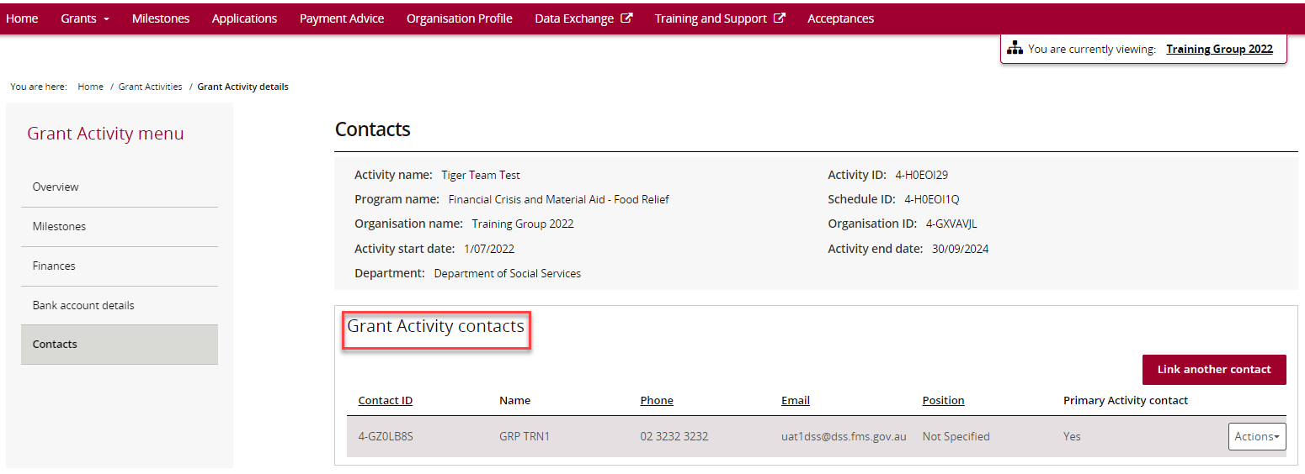
The following error message will appear on the top of the page if the contact is a primary contact for the Grant Activity. You will need to assign a new primary contact to the Grant Activity before removing the existing primary contact. The system will not allow the removal of the primary contact without a replacement.
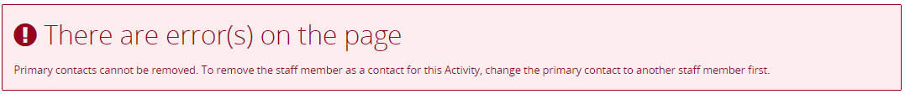

Need Help?
For further assistance, contact the Grant Recipient Portal Helpdesk:
Email: GRP.Helpdesk@communitygrants.gov.au
Phone: 1800 020 283 (Option 5)
Operating Hours: Monday to Friday 9:00am – 5:00pm (AEST/AEDT)

