Update Grant Agreement Contacts
  - Grant Recipient Portal Task Card
Portal Access required: Administrator or Editor
The Grant Recipient Portal (Portal) enables grant recipients to update their Grant Agreement Contacts.
This task card describes the process of viewing, adding and removing Grant Agreement Contacts.
There are two pathways for a user to add and remove a contact for a Grant Agreement in the Portal, either through the Organisation Profile or through the Grant Agreement link/tile on the Home screen.

Navigating to Grant Agreement Contacts through the Organisation Profile
Step | Action
From the Home screen, select the Organisation Profile tile. Alternatively, select the Organisation Profile link from the Navigation menu.
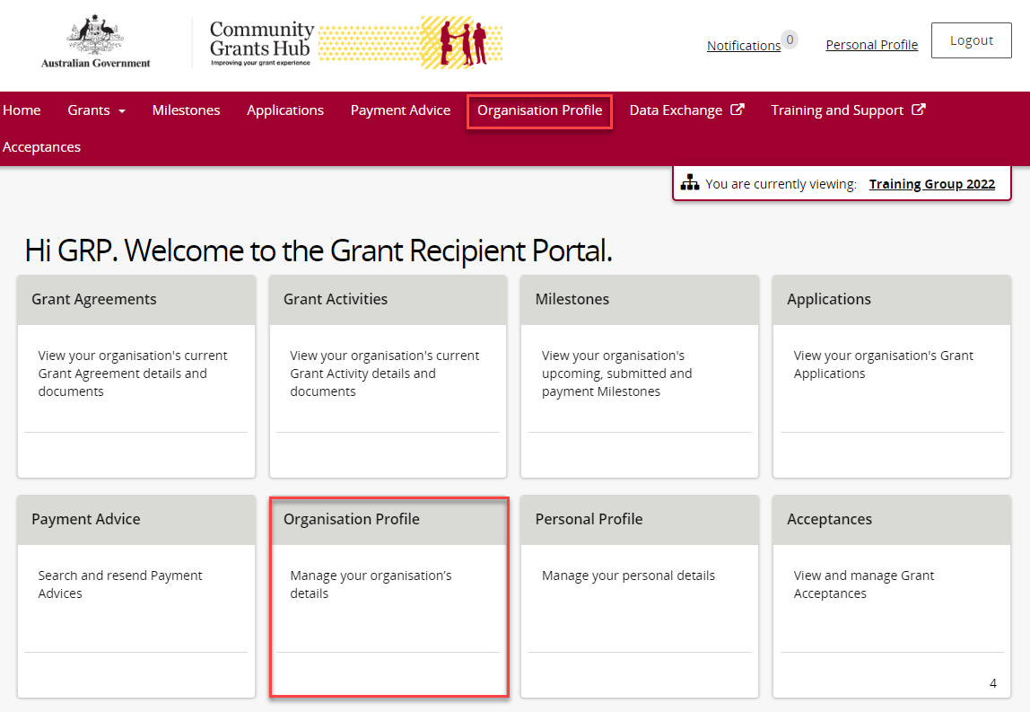
The Organisation Profile screen will display. Select Staff from the Organisation profile menu to display the Organisation’s Staff screen.
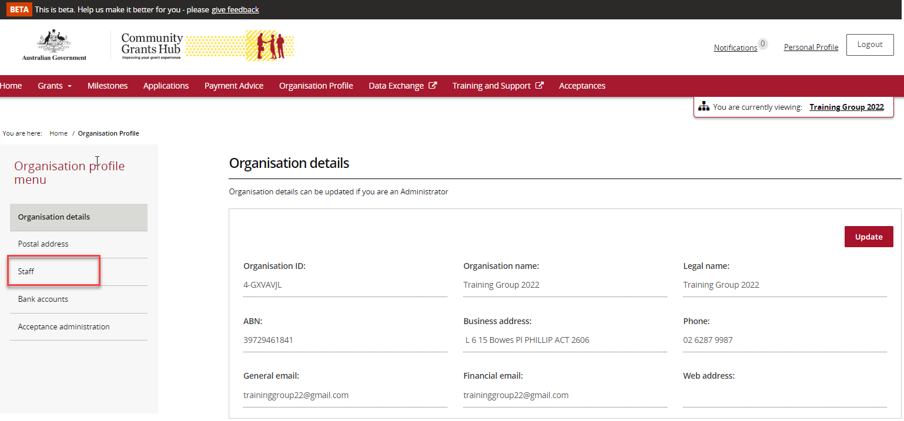
The Organisation’s Staff screen will display. This screen displays Active Staff for the organisation by default. The Staff list can be filtered using the drop down menu to choose one of the following:
- Active Staff
- Inactive Staff
- All Staff
Select View to display additional information about a particular contact.
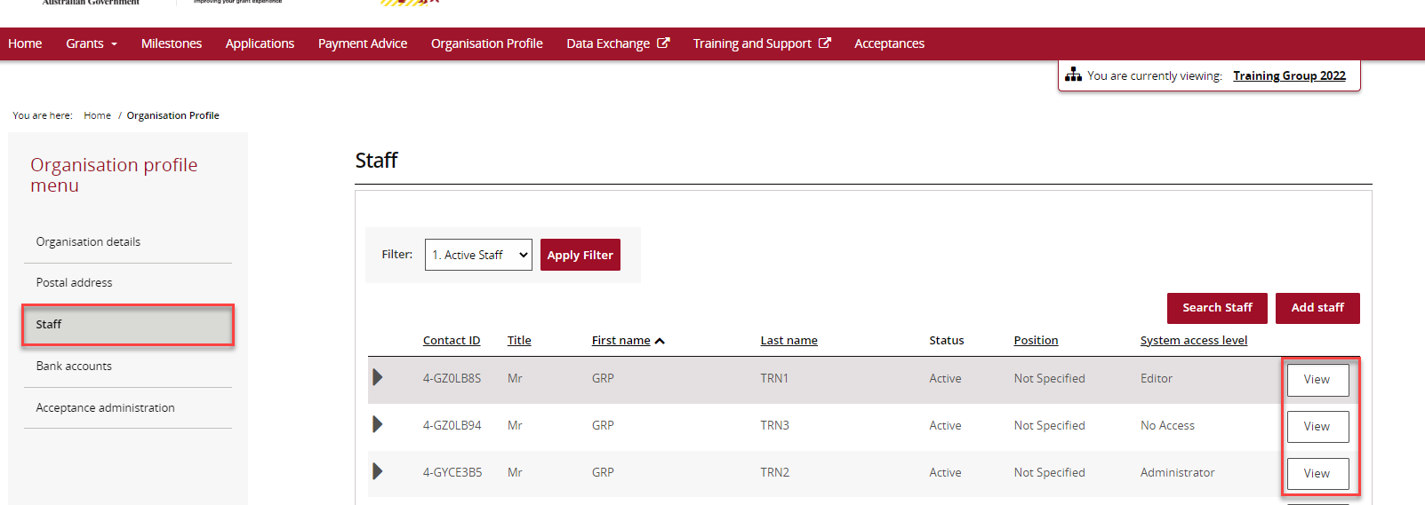
The Staff details screen will display. This screen has four sections:
- Staff details
- System access
- Contact for Grant Agreements
- Contact for Grant Activities
Grant Agreement Contacts are listed under the Contact for Grant Agreements section.
To add a contact through the Organisation Profile, proceed to step 5.
To remove a contact through the Organisation Profile, proceed to step 11.
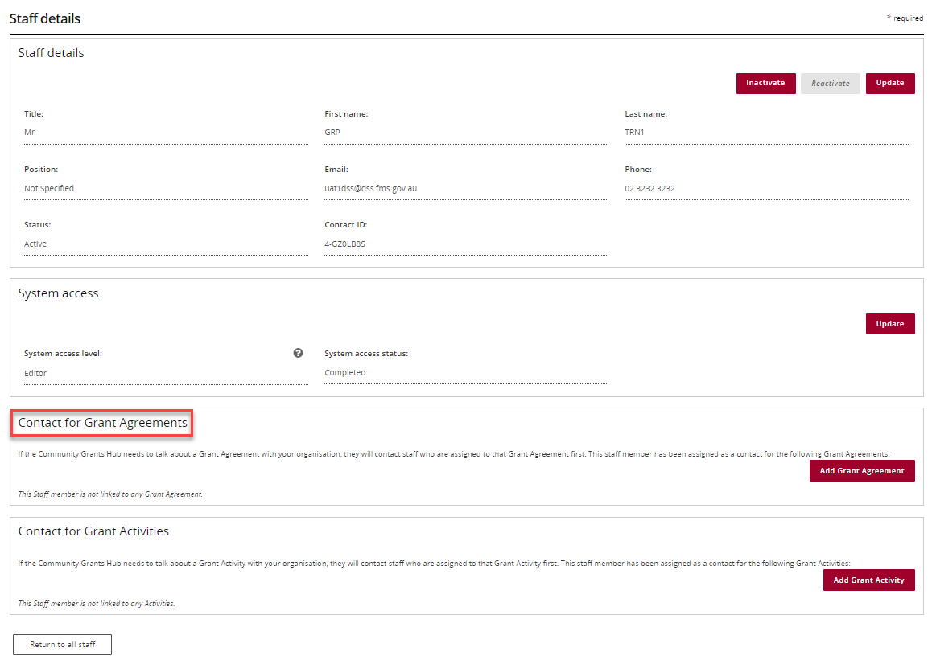

Adding a Grant Agreement Contact through the Organisation Profile
Step | Action
 | To add a contact to a Grant Agreement, select Staff from the Organisation profile menu. Click View next to the staff member you want to add as a Grant Agreement Contact.
The Staff details page will display. Select Add Grant Agreement.
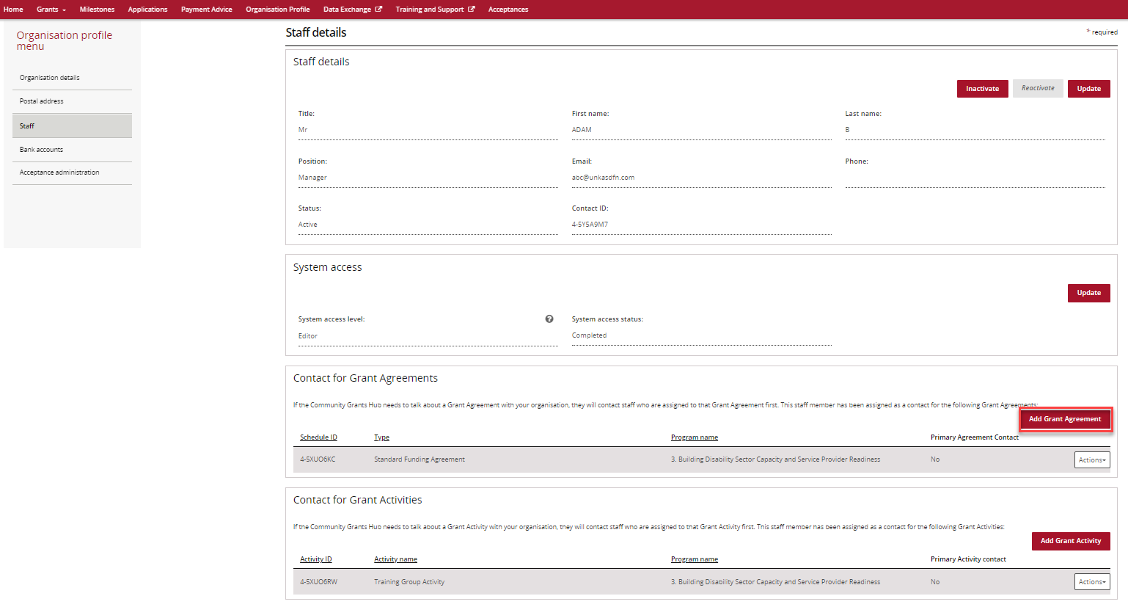
The list of Grant Agreements will display which you can assign the contact to. Select the Actions button next to the Grant Agreement you want to add the contact to. The Actions button provides you with three options:
1. Assign as a contact
2. Assign as the primary contact
3. View all contacts for this Agreement.
Select Assign as a contact if you want to assign the contact to the Grant Agreement (but not as the primary contact).
Select Assign as the primary contact if you want to assign the contact to the Grant Agreement as the primary contact.
Note: If you want to see all contacts assigned to the Grant Agreement, select View all contacts for this Agreement.
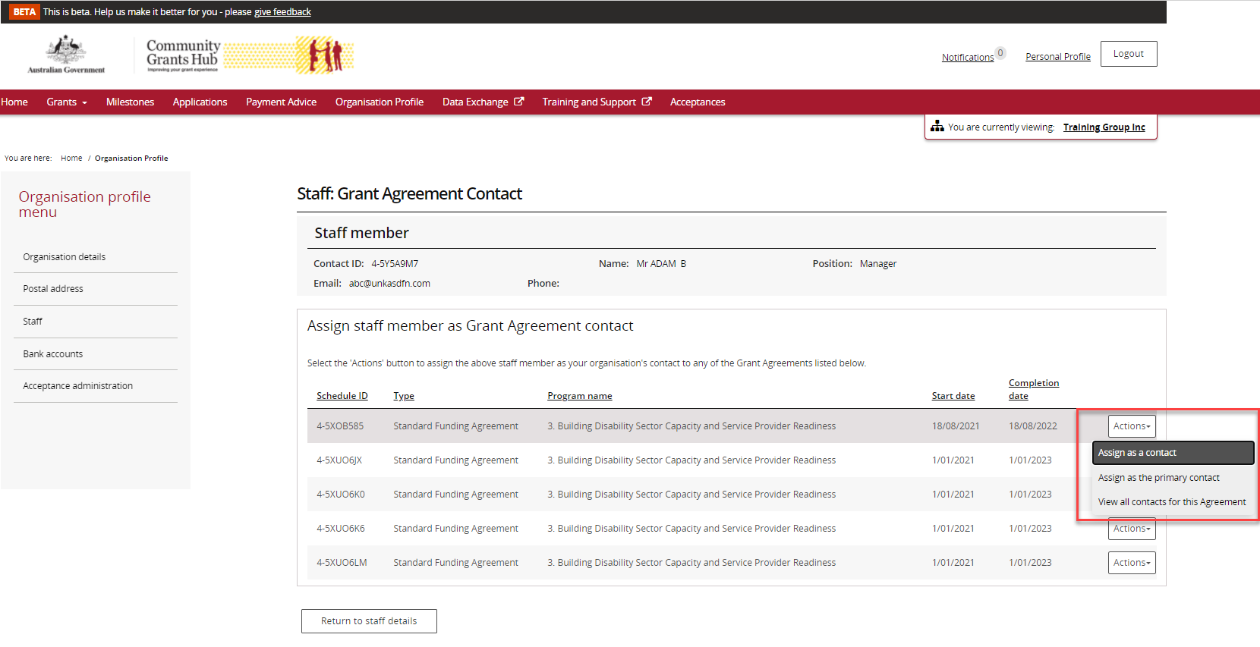
To assign as a contact, select Assign as a contact.
If the change is successful, a message will temporarily display on screen confirming the change was successful and the Grant Agreement will be listed on the Staff details screen under Contact for Grant Agreements with a No for Primary Agreement Contact.
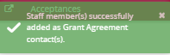
Your contact has now been added to the Grant Agreement.
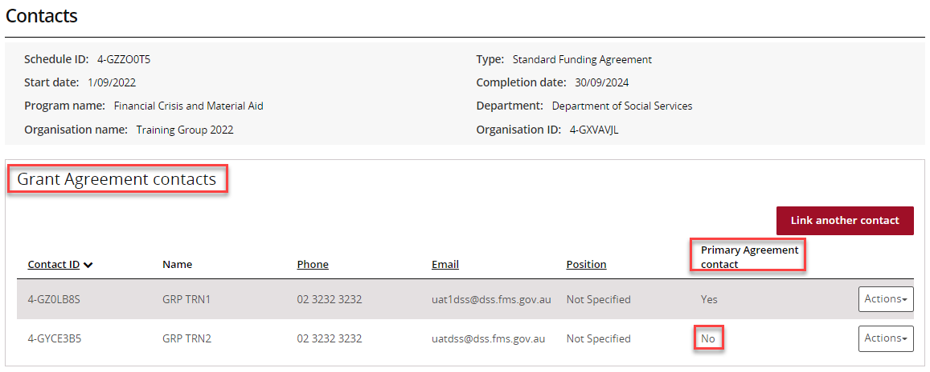
To assign as the primary contact, select Assign as the primary contact.
A confirmation message will display asking you to confirm the change by selecting Continue.
Select Continue to confirm the change of primary contact.
Note: you can select Discard changes and return to cancel the change.
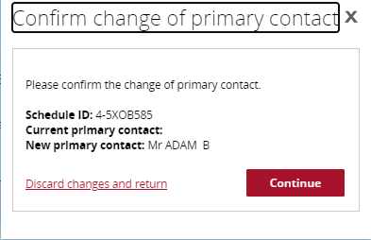
A message will temporarily display on screen confirming the change was successful and the Grant Agreement will be listed on the Staff details screen under Contact for Grant Agreements with a Yes for Primary Agreement Contact.
Successful message - changing primary contact
Your contact has now been added to the Grant Agreement as the primary contact.
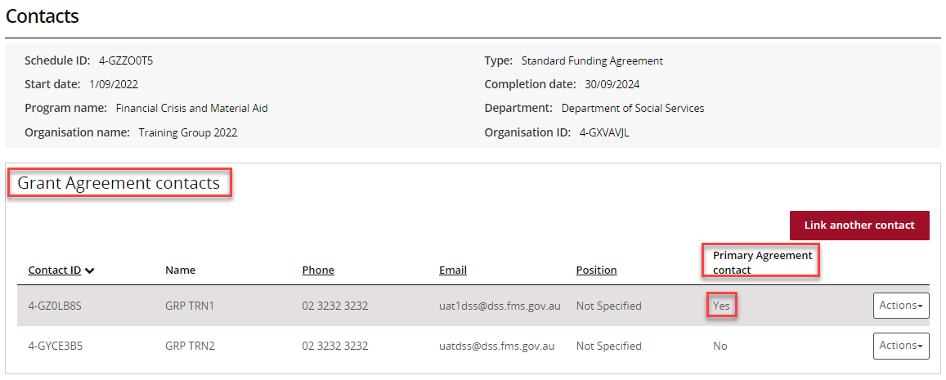

Removing a Grant Agreement Contact through the Organisation Profile
Step | Action
 | To remove a contact from a Grant Agreement, select Staff from the Organisation profile menu. Click View next to the staff member you want to remove as a Grant Agreement Contact.
The Staff details page will display. To remove a staff member as a contact for a Grant Agreement, go to the Contact for Grant Agreements section. Click on the Actions button next to the Grant Agreement you want to remove the contact from and select Remove contact from Agreement.
Note: you are unable to remove a contact from a Grant Agreement if they are listed as the primary contact. You will need to assign a new primary contact before removing the existing primary contact.
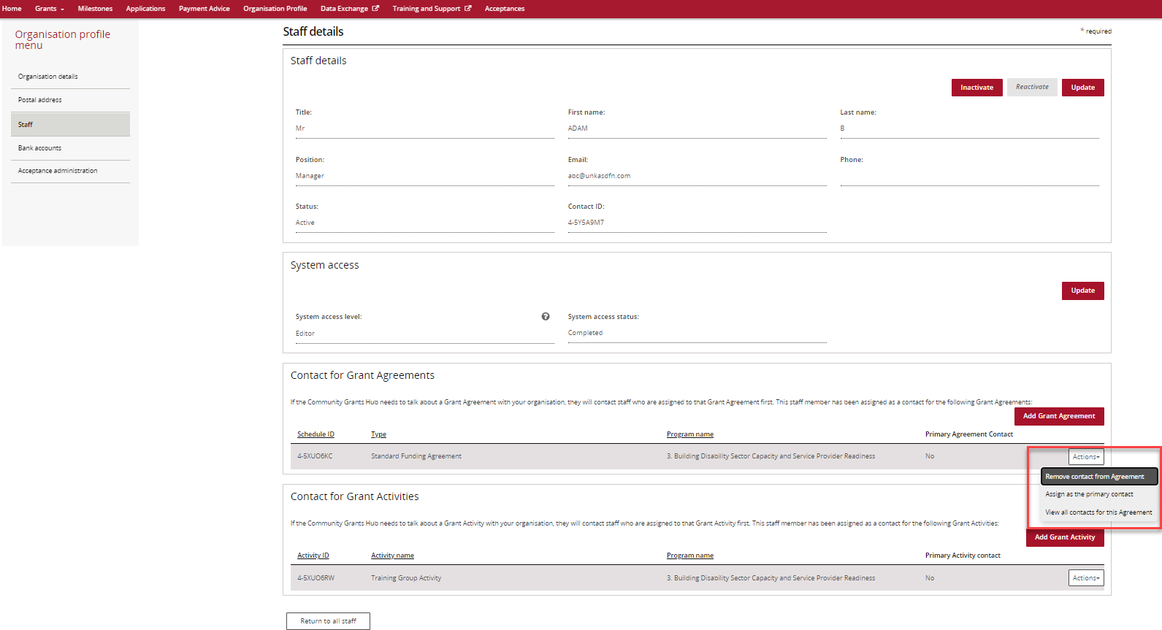
If the change is successful, a message will temporarily display on screen confirming the change was successful and the Grant Agreement will be removed from the Staff details screen under Contact for Grant Agreements.
Successful message - removing contact
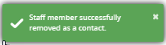
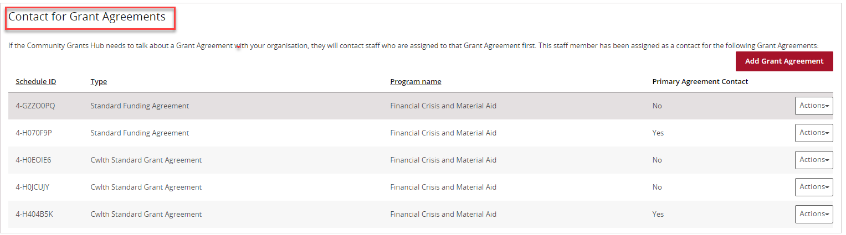
The following error message will appear on the top of the page if the contact is a primary contact for the Grant Agreement. You will need to assign a new primary contact to the Grant Agreement before removing the existing primary contact. The system will not allow the removal of the primary contact without a replacement.
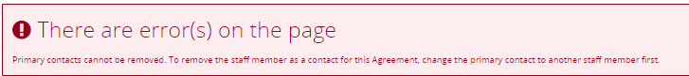

Navigating to Grant Agreement Contacts through the Grant Agreements link/tile
Step | Action
From the Home screen, select the Grant Agreements tile. Alternatively, select Grants in the Navigation menu and select Grant Agreements from the drop down menu.
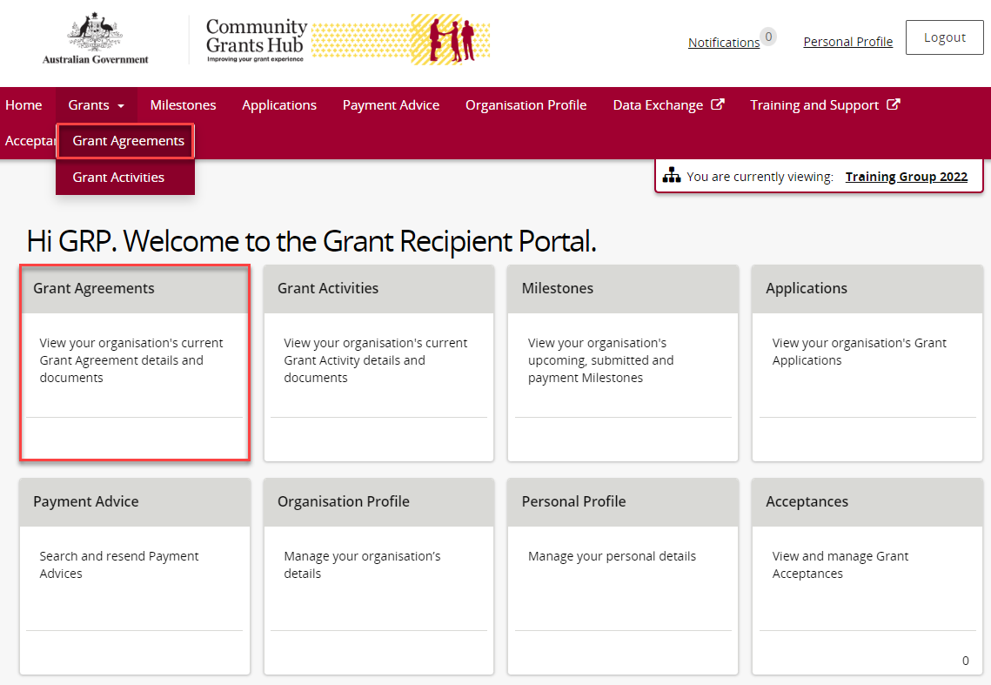
The Grant Agreements screen will display a list of your organisation’s Grant Agreements.
To view a particular Grant Agreement, select the Grant Agreement’s View button.
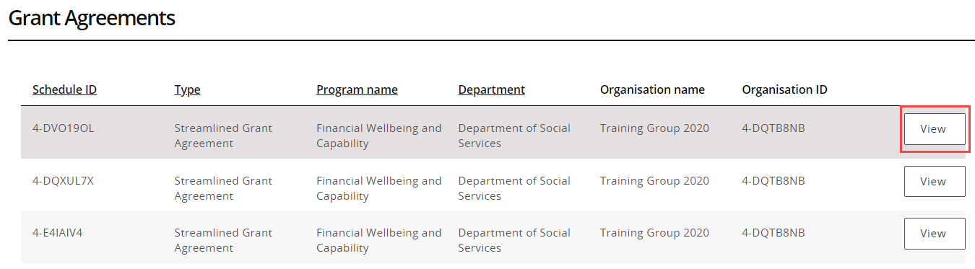
The Agreement details screen will display an overview of the Agreement by default. The below information related to the Grant Agreement can be viewed:
- Schedule ID | - Agreement Type
- Start date | - Completion date
- Program name | - Department
- Organisation name | - Organisation ID
A list of Grant Activities associated with the Grant Agreement are displayed below.
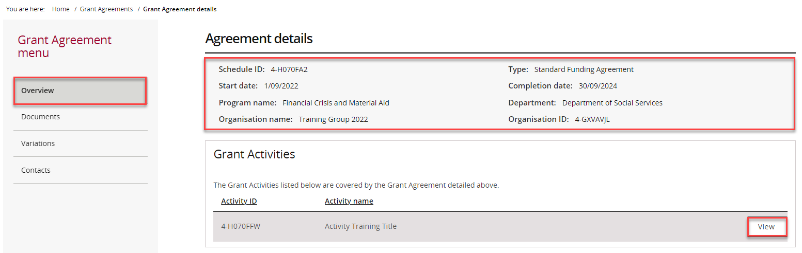
From the Grant Agreement menu, select Contacts.
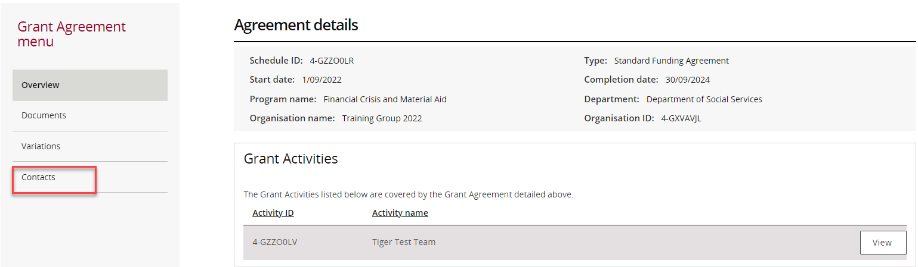
The Contacts screen will display. This screen displays all contacts linked to the Grant Agreement.
To add a contact through the Grant Agreements link/tile, proceed to step 19.
To remove a contact through the Grant Agreements link/tile, proceed to step 25.
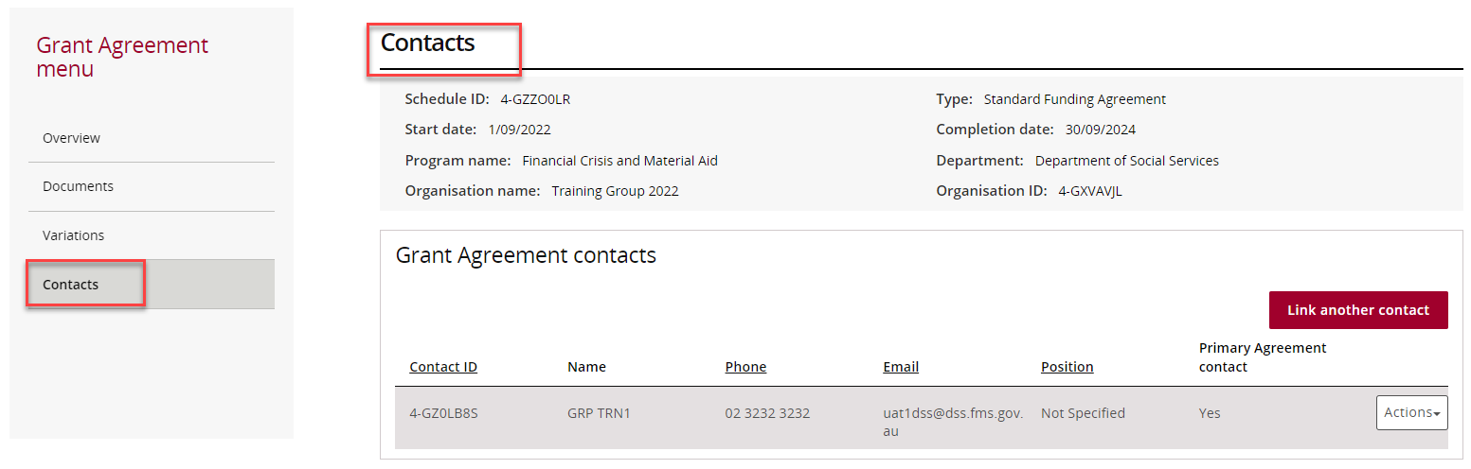

Adding a Grant Agreement Contact through the Grant Agreements link/tile
Step | Action
To add a contact to a Grant Agreement, select Contacts from the Grant Agreement menu, then click on Link another contact.
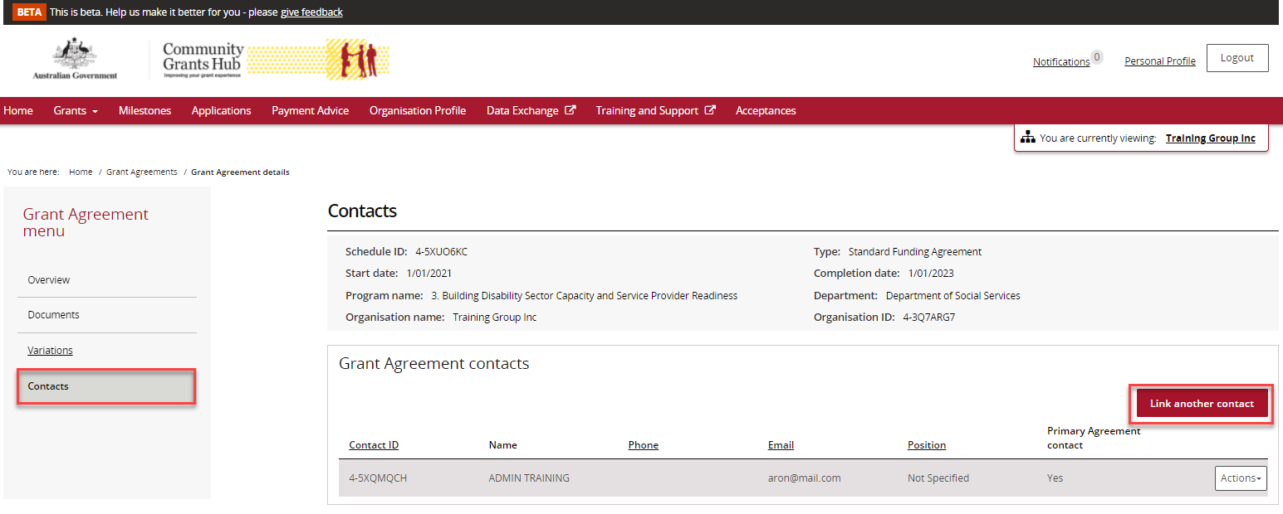
A list of contacts for the organisation will display. Click on the box next to the staff member(s) you want to add as a contact for the Grant Agreement and then click on the Confirm selection button.
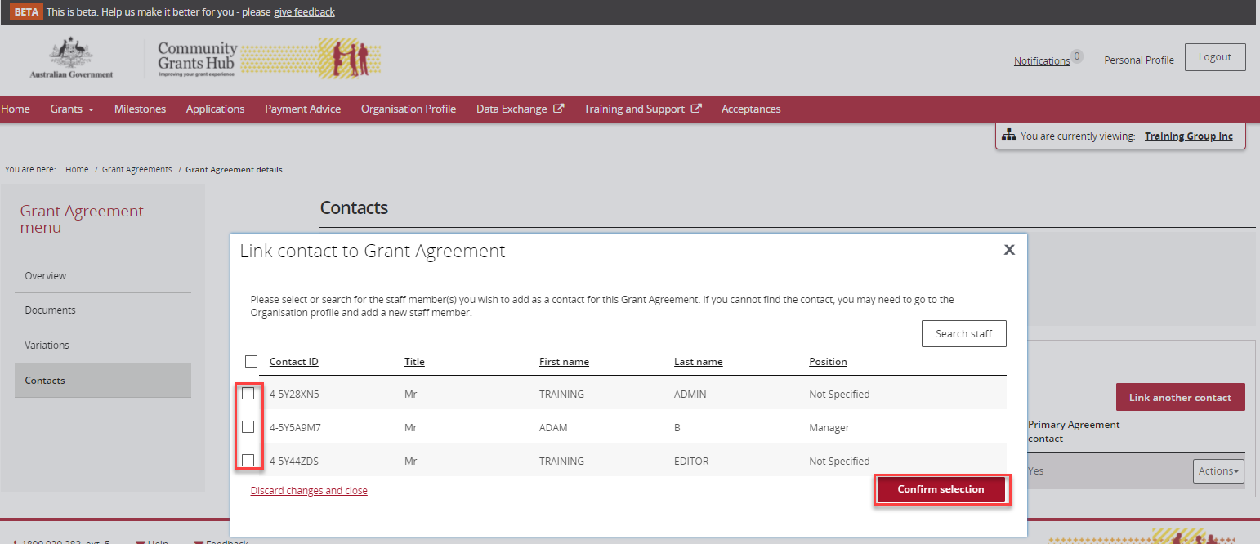
If the change is successful, a message will temporarily display on screen confirming the change was successful and the contact will be listed on the Contacts screen under Grant Agreement contacts.
Successful message – adding contact to Grant Agreement
Your contact has now been added to the Grant Agreement.
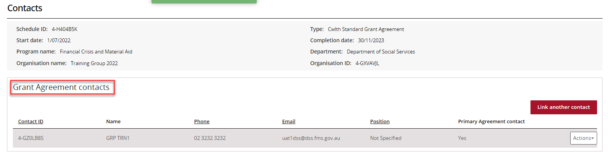
To update the contact as the primary contact, select Actions and then select Assign as the primary contact.
Note: There will be a Yes under the Primary Agreement contact column for the contact who is listed as the primary contact.
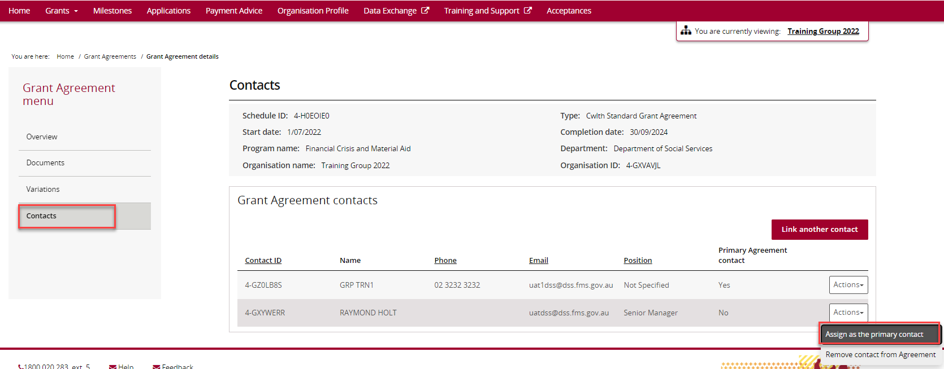

When you select Assign as the primary contact, a confirmation message will display asking you to confirm the change of the primary contact by selecting Continue.
Select Continue to confirm the change of primary contact.
Note: you can select Discard changes and return to cancel the change.
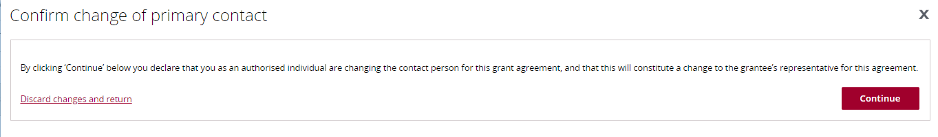
If the change is successful, a message will temporarily display on screen confirming the change was successful and the contact will be listed on the Contacts screen under Grant Agreement contacts with a Yes for Primary Agreement Contact.
A message will temporarily display on screen confirming the change was successful.
Successful message - changing primary contact
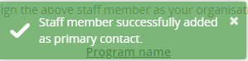
Your contact has now been updated as the primary contact.
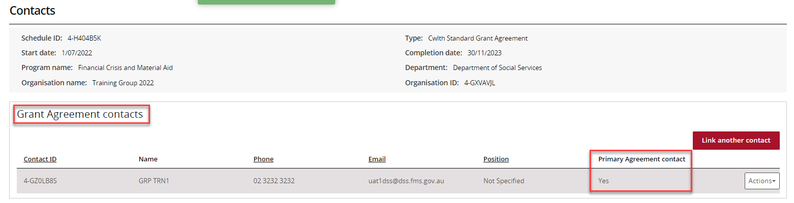

Removing a Grant Agreement Contact through the Grant Agreements link/tile
Step | Action
To remove a contact from a Grant Agreement, select Contacts from the Grant Agreement menu, then select the Actions button next to the contact and select Remove contact from Agreement.
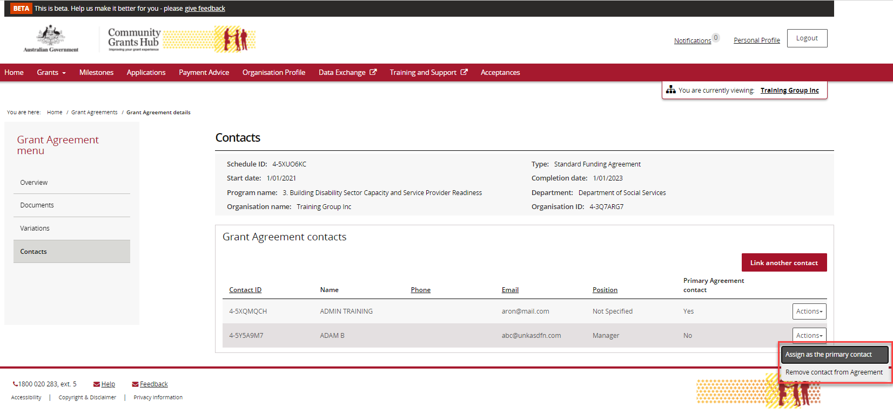
The message box below will display asking for confirmation to remove the contact from the Grant Agreement. Click on Yes remove as Agreement contact to remove the contact.
Note: you can select Cancel to not progress with the change.
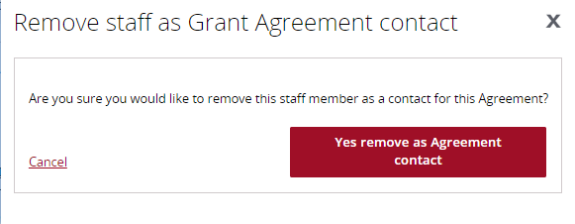
If the change is successful, a message will temporarily display on screen confirming the change was successful and the Grant Agreement will be removed from the Contacts screen under Grant Agreement contacts.
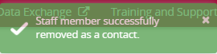
Your contact has now been removed from the Grant Agreement.
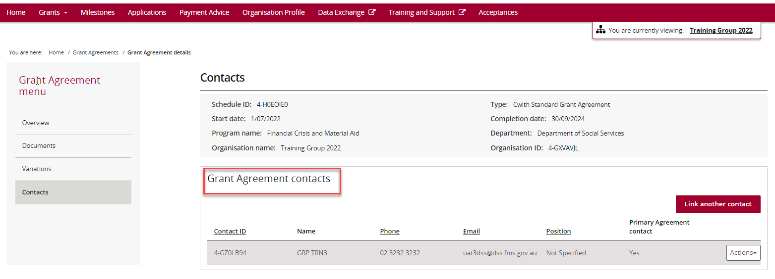
The following error message will appear on the top of the page if the contact is a primary contact for the Grant Agreement. You will need to assign a new primary contact to the Grant Agreement before removing the existing primary contact. The system will not allow the removal of the primary contact without a replacement.
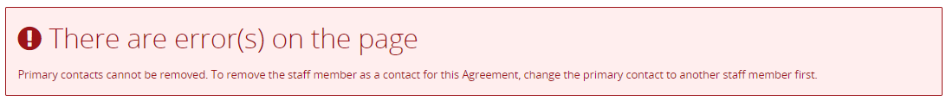

Need Help?
For further assistance, contact the Grant Recipient Portal Helpdesk:
Email: GRP.Helpdesk@communitygrants.gov.au
Phone: 1800 020 283 (Option 5)
Operating Hours: Monday to Friday 9:00am – 5:00pm (AEST/AEDT)

