Update Grant Activity Contacts

Grant Recipient Portal Task Card

______________________________________________________________________________

**Portal Access required**: Administrator or Editor

The Grant Recipient Portal (Portal) enables grant recipients to update their Grant Activity Contacts.

This task card describes the process of viewing, adding and removing Grant Activity Contacts.

There are two pathways for a user to add and remove a contact for a Grant Activity in the Portal, either through the **Organisation Profile** or through the **Grant Activities** link/tile on the Home screen.

## Navigating to Grant Activity Contacts through the Organisation Profile

### Step 1

From the Home screen, select the **Organisation Profile** tile. Alternatively, select the **Organisation Profile** link from the Navigation menu.

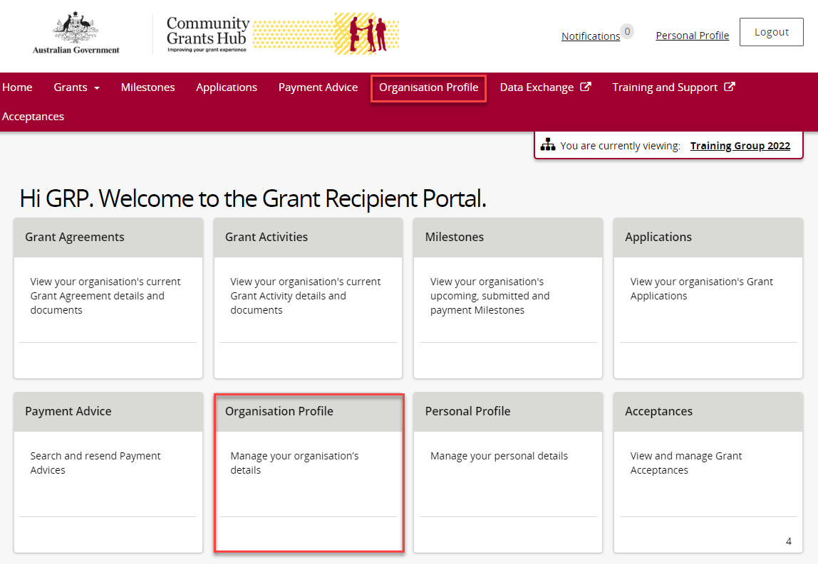

### Step 2

The Organisation Profile screen will display. Select **Staff** from the Organisation profile menu to display the Organisation’s Staff screen.

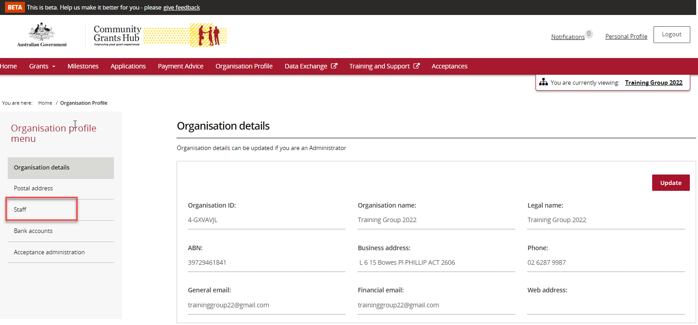

### Step 3

The Organisation’s Staff screen will display. This screen displays Active Staff for the organisation by default. The Staff list can be filtered using the **drop down** menutochoose one of the following:

1. Active Staff
2. Inactive Staff
3. All Staff

Select **View** to display additional information about a particular contact.

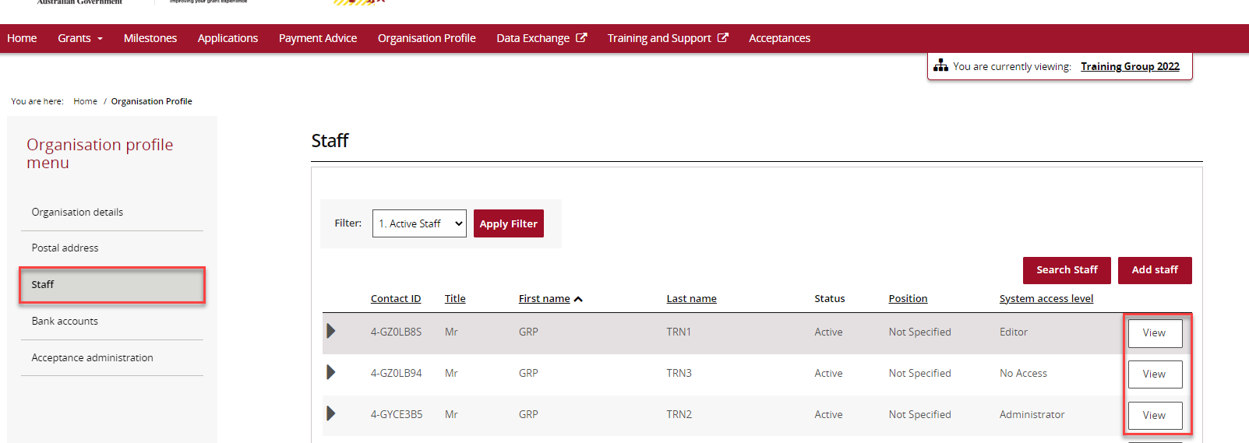

### Step 4

The Staff details screen will display. This screen has four sections:

* Staff details
* System access
* Contact for Grant Agreements
* Contact for Grant Activities

Grant Activity Contacts are listed under the **Contact for Grant Activities** section.

To add a contact through the Organisation Profile, proceed to step 5.

To remove a contact through the Organisation Profile, proceed to step 11.

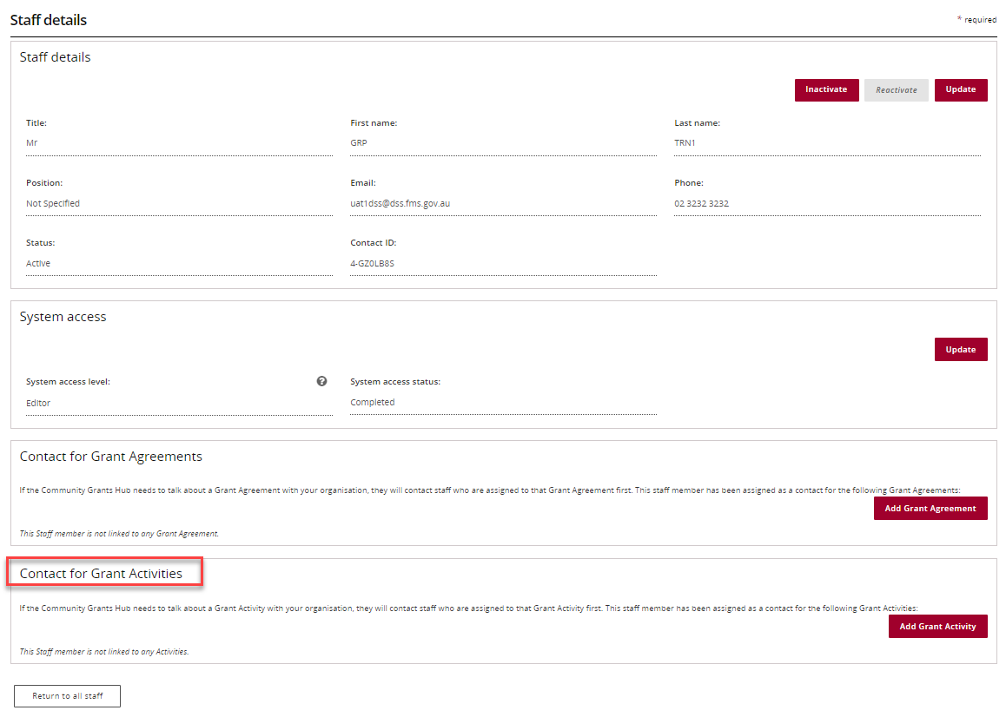

## Adding a Grant Activity Contact through the Organisation Profile

### Step 5

To add a contact to a Grant Activity, select **Staff** from the Organisation profile menu. Click **View** next to the staff member you want to add as a Grant Activity Contact.



### Step 6

The Staff details page will display. Select **Add** **Grant Activity**.

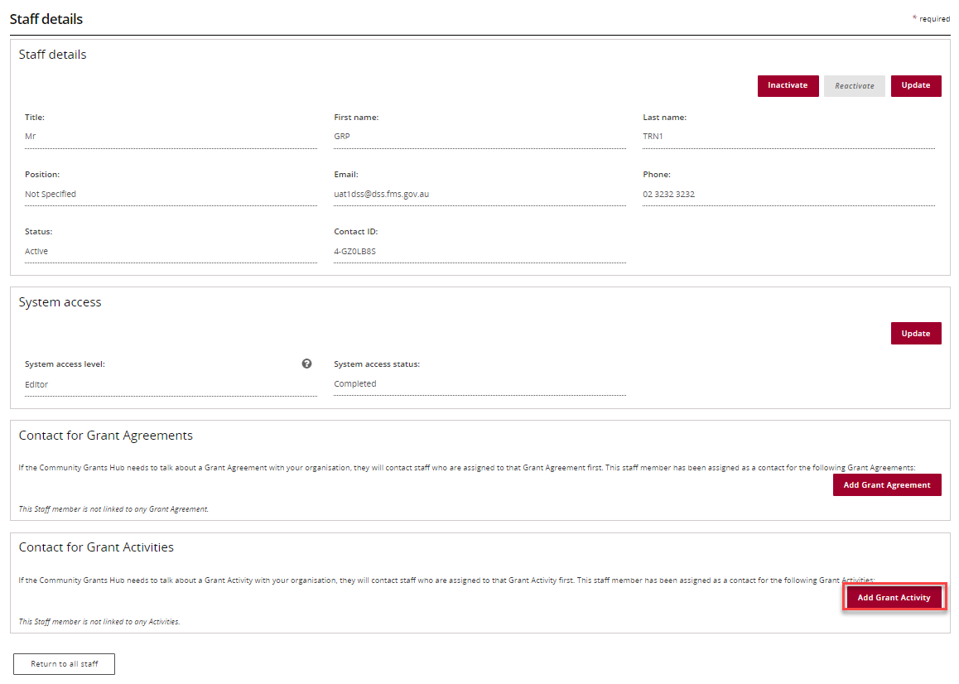

### Step 7

The list of Grant Activities will display which you can assign the contact to. Select the **Actions** button next to the Grant Activity you want to add the contact to. The Actions button provides you with three options:

1. Assign as a contact

2. Assign as the primary contact

3. View all contacts for this Activity.

Select **Assign as a contact** if you want to assign the contact to the Grant Activity (but not as the primary contact).

Select **Assign as the primary contact** if you want to assign the contact to the Grant Activity as the primary contact.

**Note:** If you want to see all contacts assigned to the Grant Activity, select **View all contacts for this Activity**.

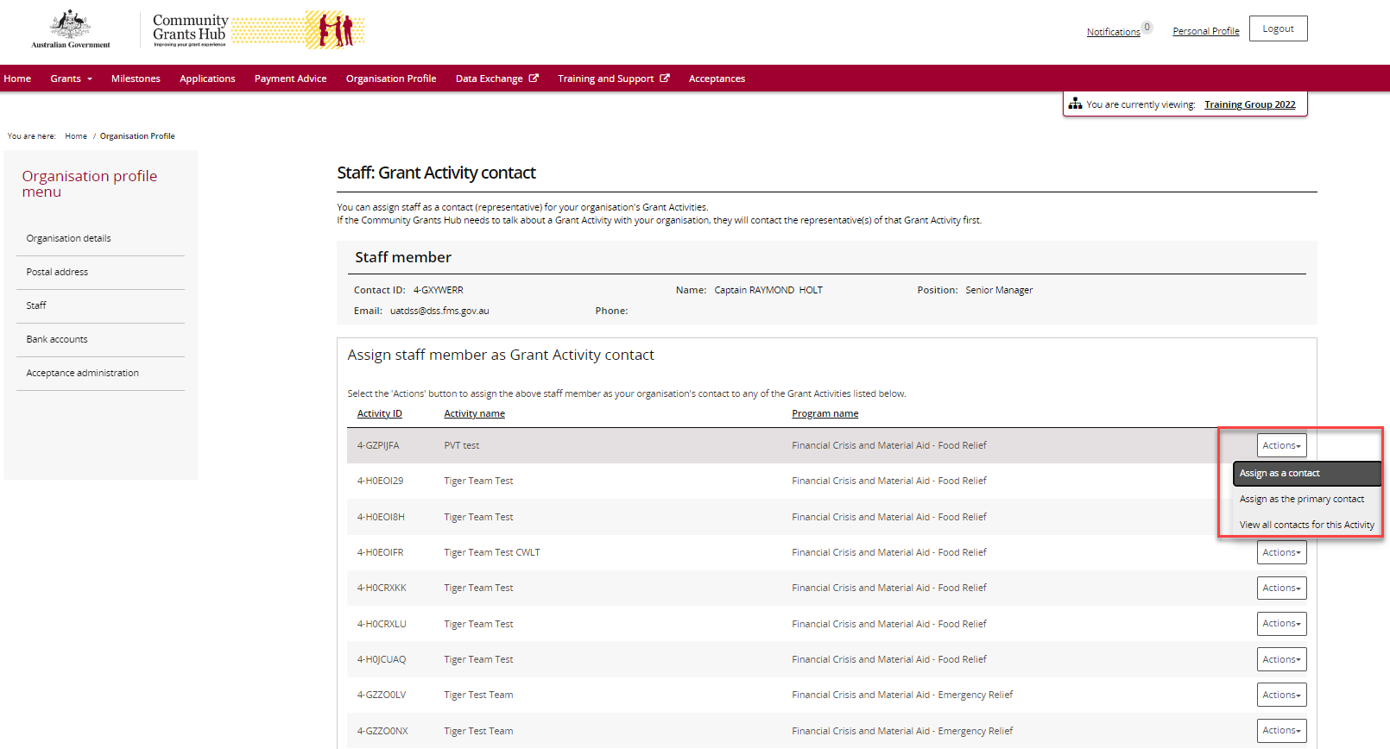

### Step 8

To assign as a contact, select **Assign as a contact.**

If the change is successful, a message will temporarily display on screen confirming the change was successful and the Grant Activity will be listed on the Staff details screen under **Contact for Grant Activities** with a **No** for **Primary Activity contact**.

Screenshot of the successful message displayed to grant recipient when the change is successful. The popup says Staff member(s) successfully added as Grant Activity contact(s).

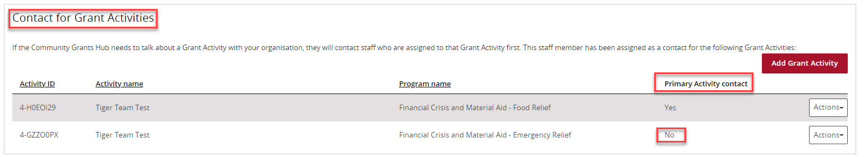

### Step 9

To assign as the primary contact, select **Assign as the primary contact.**

A confirmation message will display asking you to confirm the change by selecting **Confirm**.

Select **Confirm** to proceed with changing the primary contact.

**Note:** you can select **Discard changes and return** to cancel the change.

Screenshot of popup asking to confirm change of primary contact.

The popup says Please confirm the change of primary contact.

It includes the Activity name, current primary contact and new primary contact details. The user has two options available to them 1. discard changes and return or                2. Continue.  

### Step 10

A message will temporarily display on screen confirming the change was successful and the Grant Activity will be listed on the Staff details screen under **Contact for Grant Activities** with a **Yes** for **Primary Activity contact**.

*Successful message - changing primary contact*

Screenshot of the successful message displayed to grant recipient when the change is successful. The popup says Staff member successfully added as primary contact.

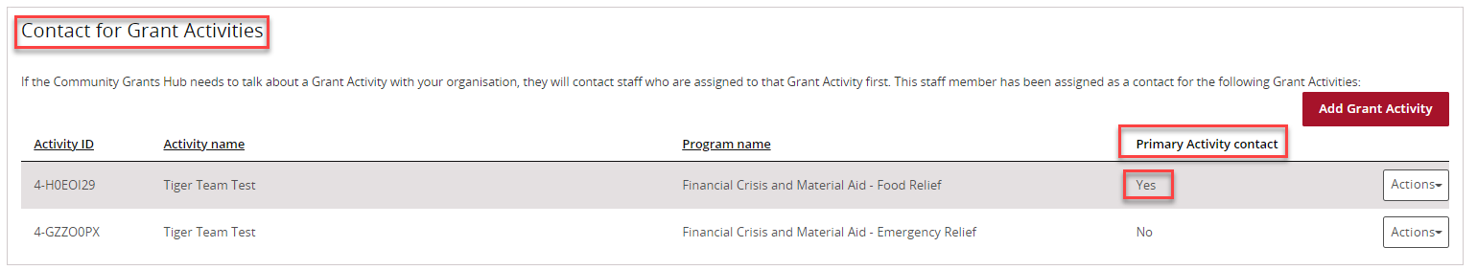

## Removing a Grant Activity Contact through the Organisation Profile

### Step 11

To remove a contact from a Grant Activity, select **Staff** from the Organisation profile menu. Click **View** next to the staff member you want to remove as a Grant Activity Contact.



### Step 12

The Staff details page will display. To remove a staff member as a contact for a Grant Activity, go to the **Contact for Grant Activities** section. Click on the **Actions** button next to the Grant Activity you want to remove the contact from and select **Remove contact from Activity**.

**Note:** you are unable to remove a contact from the Grant Activity if they are listed as the primary contact. You will need to assign a new primary contact before removing the existing primary contact.

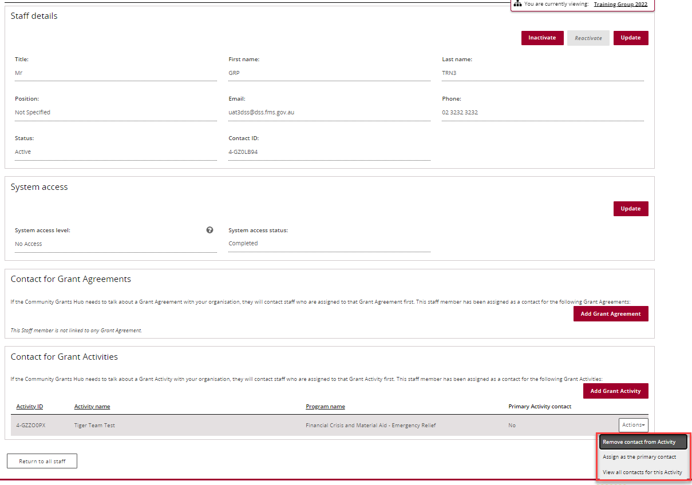

### Step 13

If the change is successful, a message will temporarily display on screen confirming the change was successful and the Grant Activity will be removed from the Staff details screen under **Contact for Grant Activities**.

*Successful message - removing contact*

Screenshot of the successful message displayed to grant recipient when the change is successful. The popup says Staff member successfully removed as  a contact.

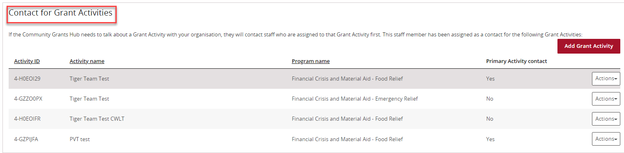

The following error message will appear on the top of the page if the contact is a primary contact for the Grant Activity. You will need to assign a new primary contact to the Grant Activity before removing the existing primary contact. The system will not allow the removal of the primary contact without a replacement.

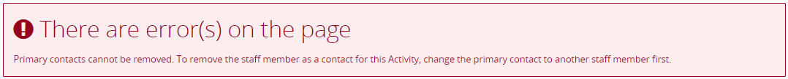

## Navigating to Grant Activity Contacts through the Grant Activities link/tile

### Step 14

From the Home screen, select the **Grant Activities** tile. Alternatively, select **Grants** in the Navigation menu and select **Grant Activities** from the drop down menu.

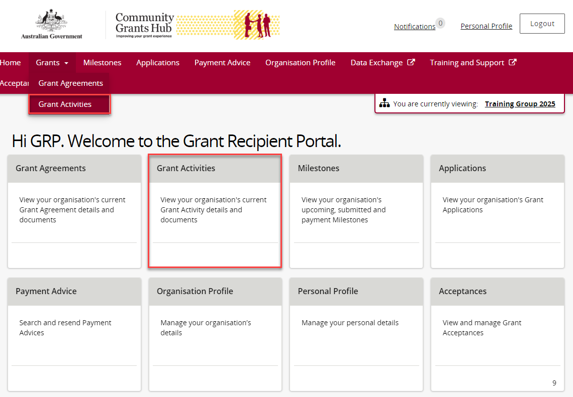

### Step 15

The Grant Activities screen will display a list of your organisation’s Grant Activities.

To view a particular Grant Activity, select the Grant Activity’s **View** button or use the **Search Activities** button to help navigate to your Grant Activity.

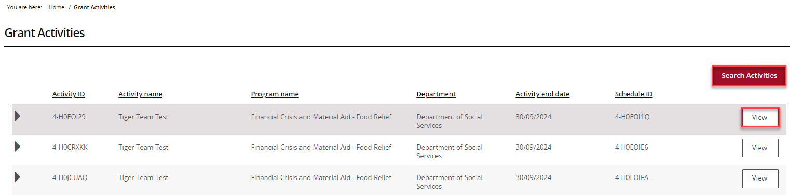

### Step 16

The Activity detailsscreenwilldisplay an overview of the Grant Activity by default. The below information related to the Grant Activity can be viewed:

* Activity name
* Activity ID
* Program name
* Schedule ID
* Organisation name
* Organisation ID
* Activity start date
* Activity end date
* Department
* Funding Arrangement Manager

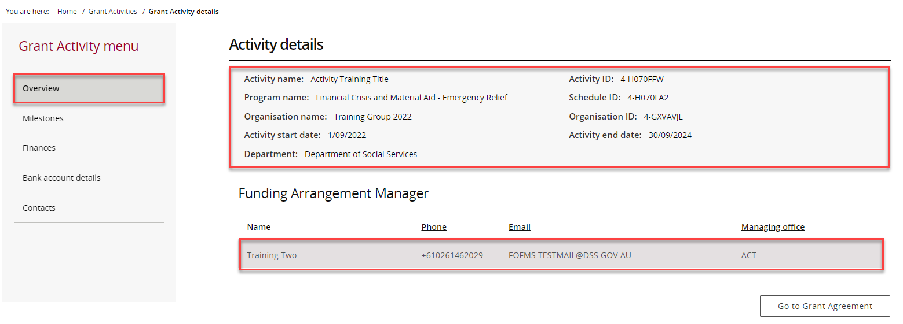

### Step 17

From the Grant Activity menu, select **Contacts**.

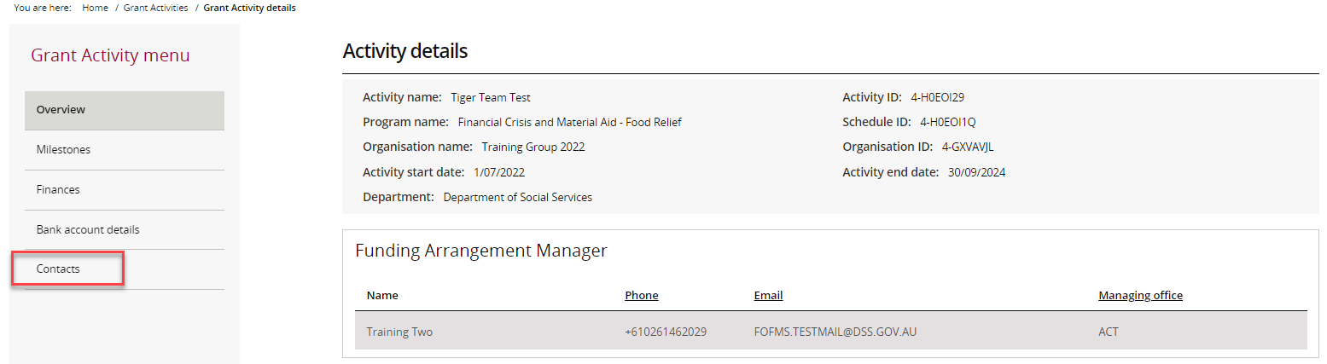

### Step 18

The Contacts screen will display. This screen displays all contacts linked to the Grant Activity.

To add a contact through the Grant Activities link/tile, proceed to step 19.

To remove a contact through the Grant Activities link/tile, proceed to step 25.

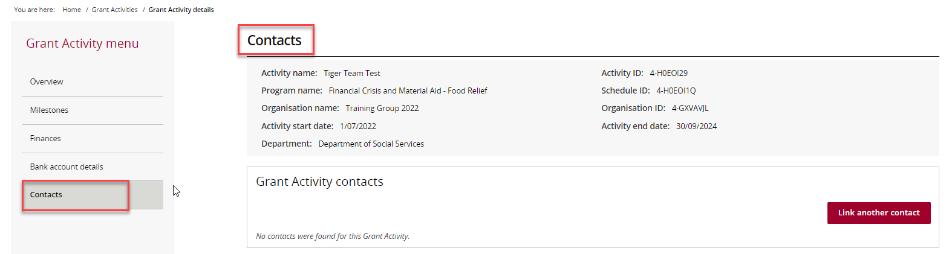

## Adding a Grant Activity Contact through the Grant Activities link/tile

### Step 19

To add a contact to a Grant Activity, select **Contacts** from the Grant Activity menu, then click on **Link another contact**.

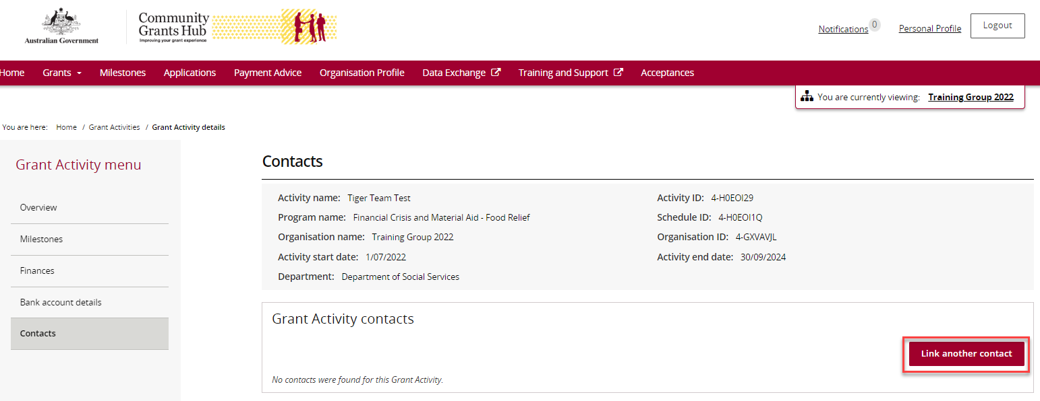

### Step 20

A list of contacts for the organisation will display. Click on the **box** next to the staff member(s) you want to add as a contact for the Grant Activity and then click on the **Confirm selection** button.

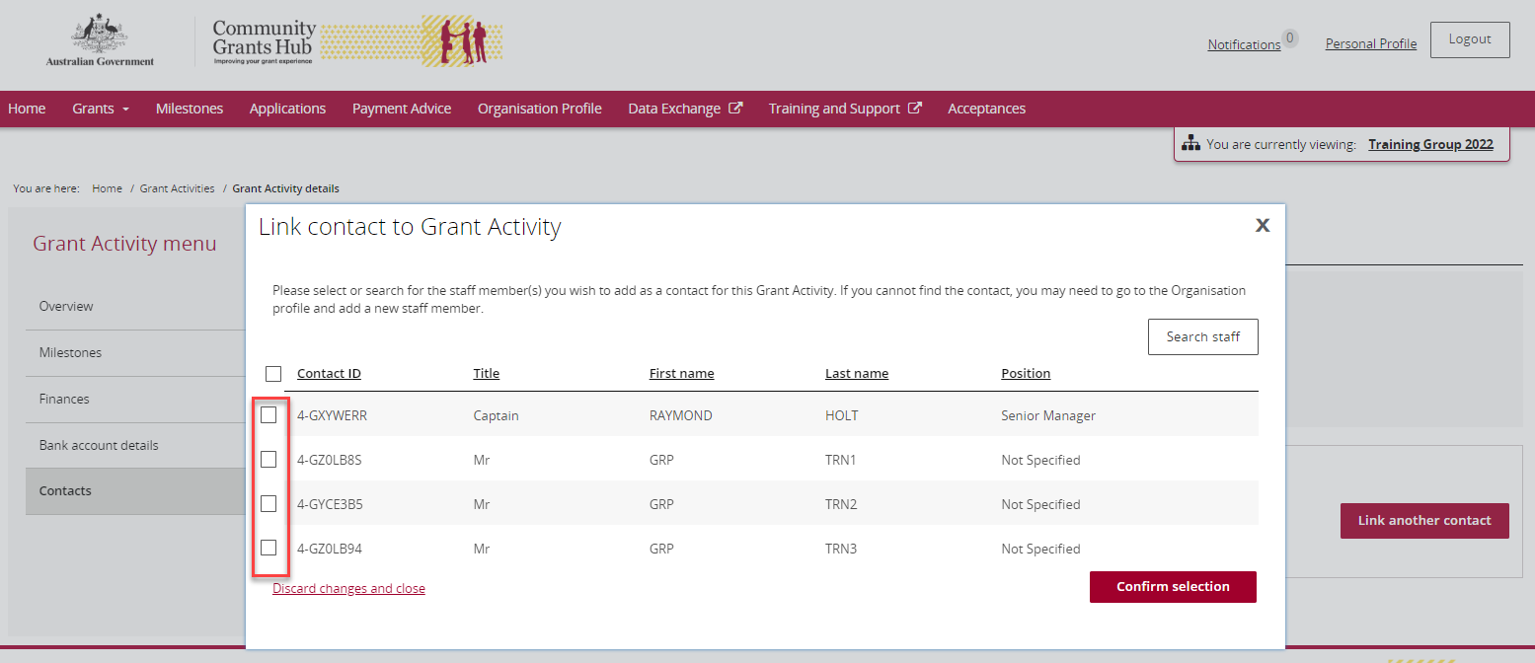

### Step 21

If the change is successful, a message will temporarily display on screen confirming the change was successful and the contact will be listed on the Contacts screen under **Grant Activity contacts.**

*Successful message – adding contact to Grant Activity*

Screenshot of the successful message displayed to grant recipient when the change is successful. The popup says Staff member(s) successfully added as Grant Activity contact(s).

Your contact has now been added to the Grant Activity.

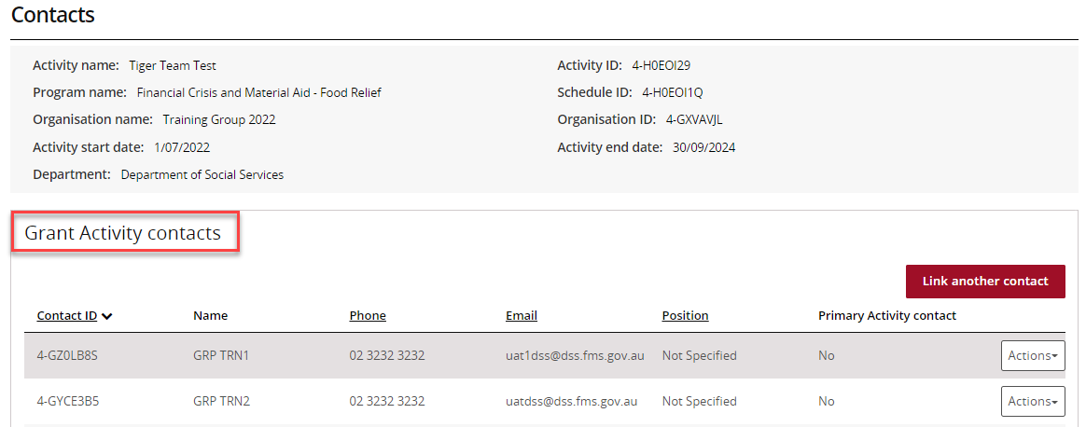

### Step 22

To update the contact as the primary contact, select **Actions** and thenselect **Assign as the primary contact**.

**Note:** There will be a **Yes** under the **Primary Activity contact** column for the contact who is listed as the primary contact.

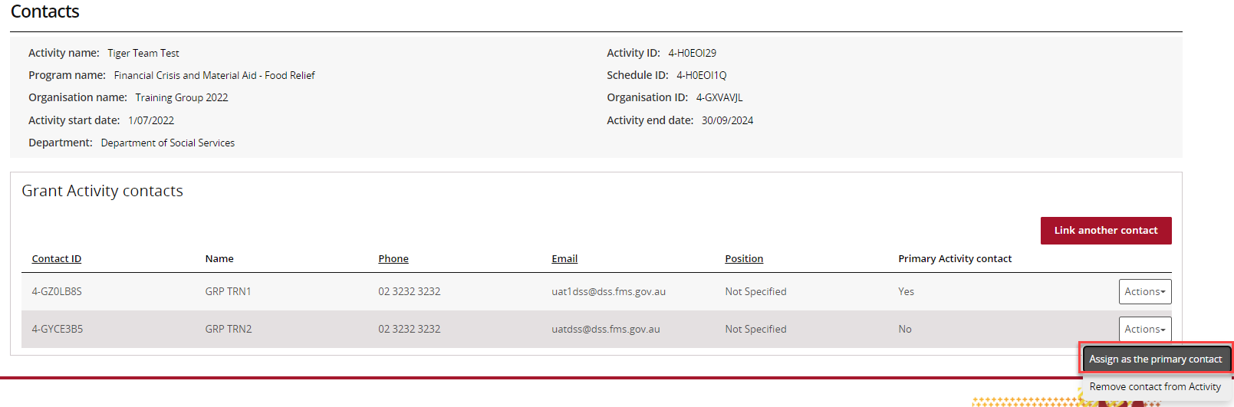

### Step 23

When you select **Assign as the primary contact** a confirmation message will display asking you to confirm the change of the primary contact by selecting **Continue**.

Select **Continue** to confirm the change of primary contact.

**Note:** you can select **Discard changes and return** to cancel the change.

Screenshot of the Confirm change of primary contact popup. This popup says Please confirm the change of primary contact.

It includes the Activity name, Current primary contact and the 
New primary contact details.

The user has the option to discard changes and return or Continue with the change. 

### Step 24

If the change is successful, a message will temporarily display on screen confirming the change was successful and the contact will be listed on the Contacts screen under **Grant Activity contacts** with a **Yes** for **Primary Activity Contact.**

A message will temporarily display on screen confirming the change was successful.

*Successful message - changing primary contact*

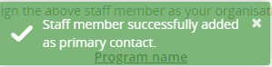

Your contact has now been updated as the primary contact.

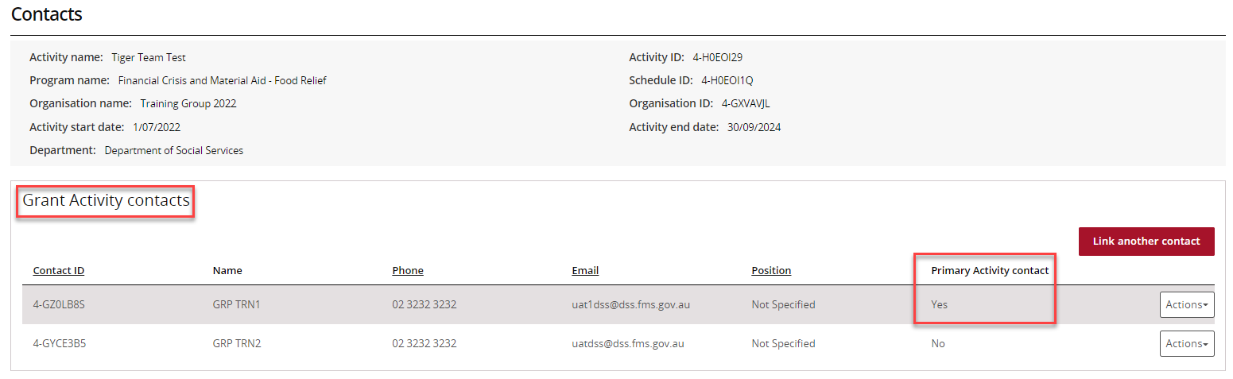

## Removing a Grant Activity Contact through the Grant Activities link/tile

### Step 25

To remove a contact from a Grant Activity, select **Contacts** from the Grant Activity menu, then select the **Actions** button next to the contact and select **Remove contact from Activity**.

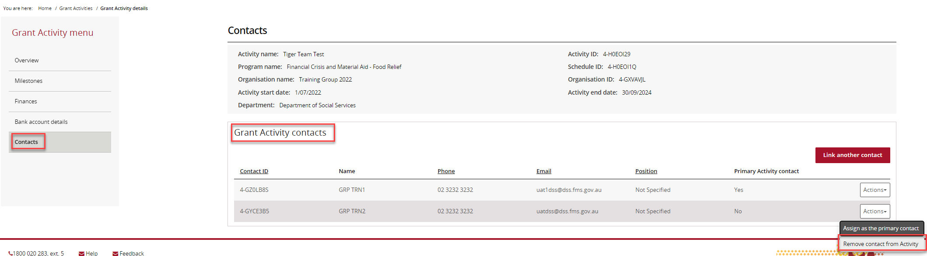

### Step 26

The message box below will display asking for confirmation to remove the contact from the Grant Activity. Click on **Yes remove as contact to continue**.

**Note:** you can select **Cancel** to not progress with the change.

Screenshot of the popup message displayed. This popup says Are you sure you would like to remove this staff member as a contact for this Activity?

The user has the option to Cancel or select Yes remove as Contact.

### Step 27

If the change is successful, a message will temporarily display on screen confirming the change was successful and the Grant Activity will be removed from the Contacts screen under **Grant Activity contacts**.

*Successful message - removing contact*

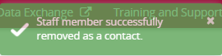

Your contact has now been removed from the Grant Activity.

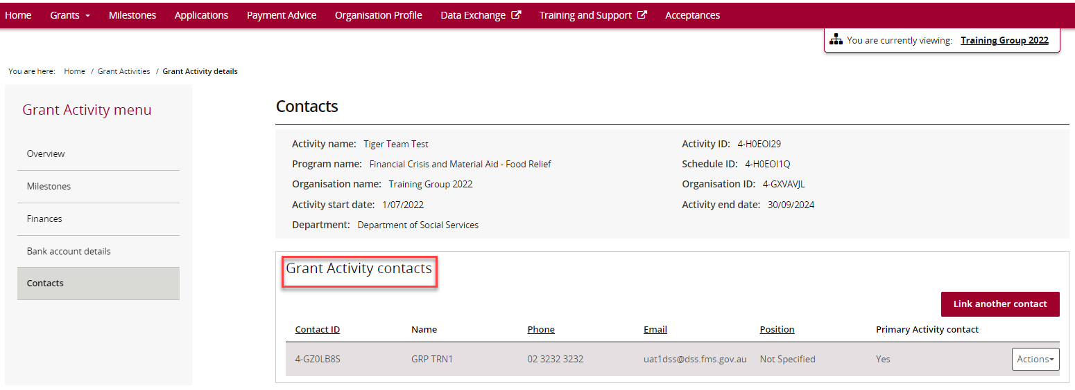

The following error message will appear on the top of the page if the contact is a primary contact for the Grant Activity. You will need to assign a new primary contact to the Grant Activity before removing the existing primary contact. The system will not allow the removal of the primary contact without a replacement.

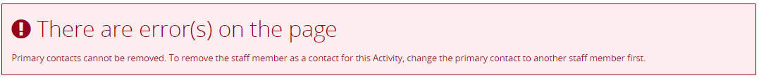

## Need Help?

For further assistance, contact the Grant Recipient Portal Helpdesk:

**Email**: [GRP.Helpdesk@communitygrants.gov.au](mailto:GRP.Helpdesk@communitygrants.gov.au)

**Phone**: 1800 020 283 (Option 5)

**Operating Hours:** Monday to Friday 9:00am – 5:00pm (AEST/AEDT)