

Grant Recipient Portal Quick Start Guide
  - User Guide
The Grant Recipient Portal (Portal) uses the Australian Government Digital ID System to verify users. Digital ID is a safe, secure, and convenient way to prove who you are online.
To discuss alternate methods to manage your grant offline, please email the GRP Helpdesk.
In this task card:
- Set up your Digital ID
- Link your Digital ID to an ABN using RAM
- Request access to the Portal
- Sign into the Portal using Digital ID
- Login to the Grant Recipient Portal
- Need help?
Access Required: All roles

Set up your Digital ID
Steps | Actions
Step 1 | myID is the Australian Government’s Digital ID app, which you can download to your smart device. myID allows you to prove who you are when accessing government online services.  A myID is set up with a user’s personal email address. It should not be a shared, or work email address.  Download the myID app on your smart device through Apple Store or Google Play and follow the steps within the app to set up your Digital ID.  More information about setting up myID is available on the myID website.

Link your Digital ID to an ABN using RAM
Steps | Actions
Step 2 | Relationship Authorisation Manager (RAM) is an authorisation service that allows you to act on behalf of a business online when linked with your Digital ID. How you link depends on your role.  If you are the Principal Authority (generally the CEO or Director), you must link your Digital ID to your organisation’s ABN in RAM. Once linked, you can access online services on behalf of the business and authorise others to do the same.  If you are another user, the Principal Authority or authorisation administrator needs to authorise you to act on behalf of the organisation. When you are authorised, you will receive an email from RAM to link your Digital ID to your organisation.  More information about accepting an authorisation request can be found on the RAM website.

Request access to the Portal
Steps | Actions
Step 3 | To alleviate the need to submit multiple access request forms, it is recommended that the first person to access the Portal within an organisation be the designated Administrator. The Administrator will be able to manage user access for the organisation.  Anyone requesting Administrator access will need to complete a Grant Recipient Portal Access Form and submit this to the Portal Helpdesk.  An organisation will need only one Administrator; however, multiple Administrators can be set up in the Portal if the organisation desires. Once the Administrator account has been created, the Administrator can create additional Portal users.  Note: Administrators can only create Portal access for users. All users will still need to set up their Digital ID and be linked to the business in RAM.  Information on how to add users to the Portal can be found in the Add Organisation Staff task card found on the Portal website.

Sign into the Portal using Digital ID
Steps | Actions
Step 4 | Once you have:  - set up your Digital ID,  - linked to the ABN in RAM; and  - your Portal user account is created:  Go to the Grant Recipient Portal and select Digital ID.  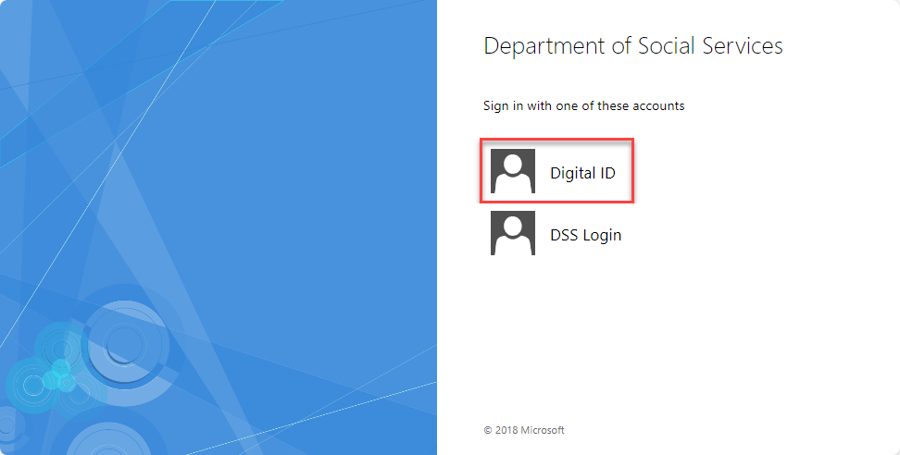
Step 5 | You will then be required to choose myID by clicking Select myID as your Digital ID.  You can also select Remember my choice to automatically progress to the Log in with myID screen next time.  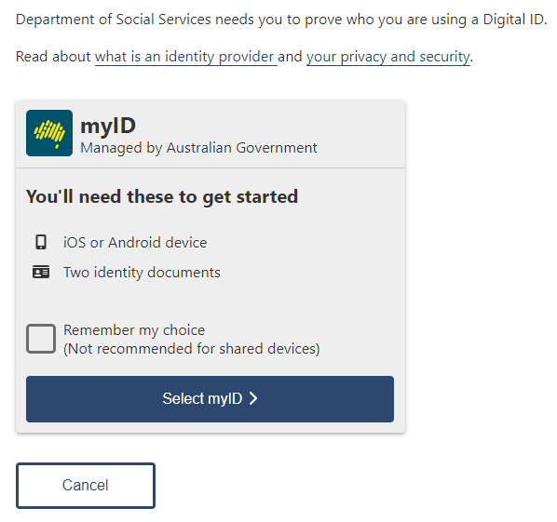
Step 6 | The Log in with myID screen will display. Enter your myID email address and select Get code.  You can select Remember me, and on subsequent log in’s, you will not need to enter your email address, and the four-digit code will be pre-filled in your app for you to accept.  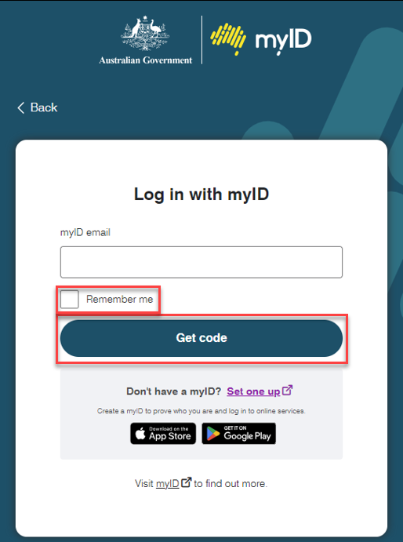
Step 7 | The following screen will display a four-digit code.  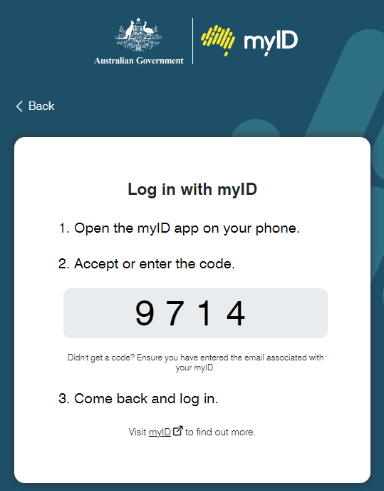
Step 8 | Open the myID app on your smart device. Enter the four-digit code and select Accept.  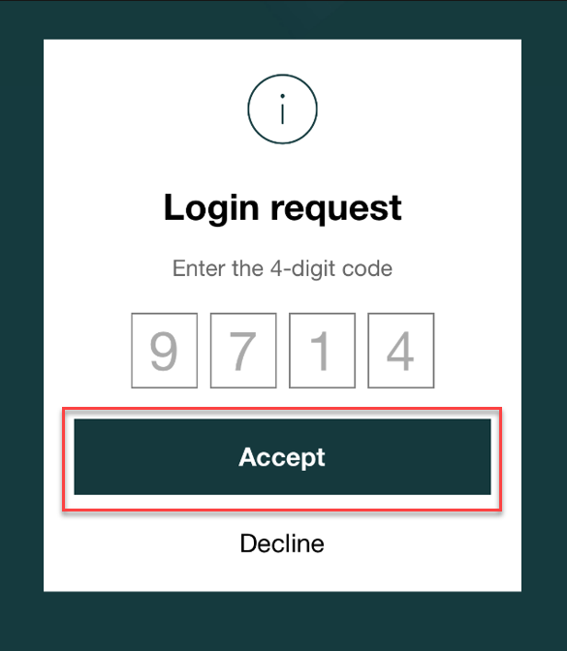
Step 9 | Return to the Grant Recipient Portal.  When logging into the Portal for the first time using myID, you will need to complete the account activation process. Enter in the email address that was provided in your Grant Recipient Portal Access Form or added for you by an Administrator.  Select Continue.  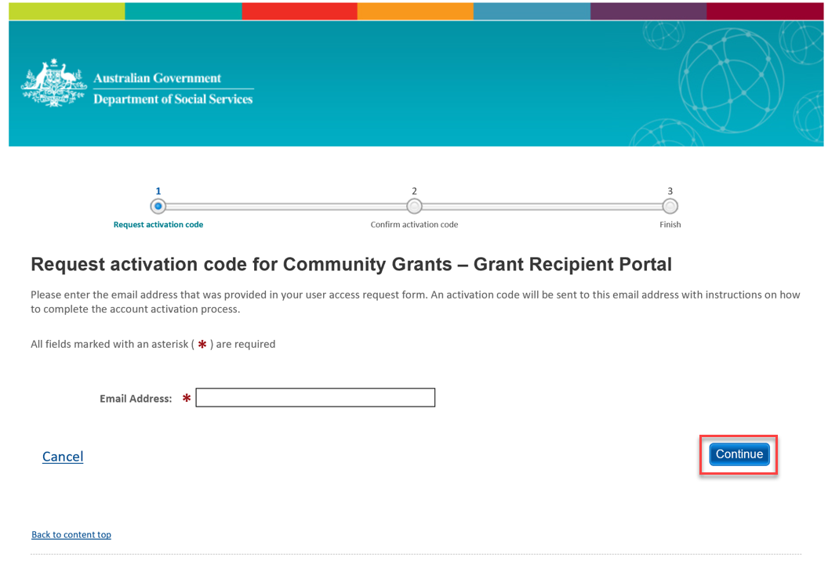
Step 10 | An eight-digit activation code will be sent to the email address provided. Enter the activation code and select Confirm.  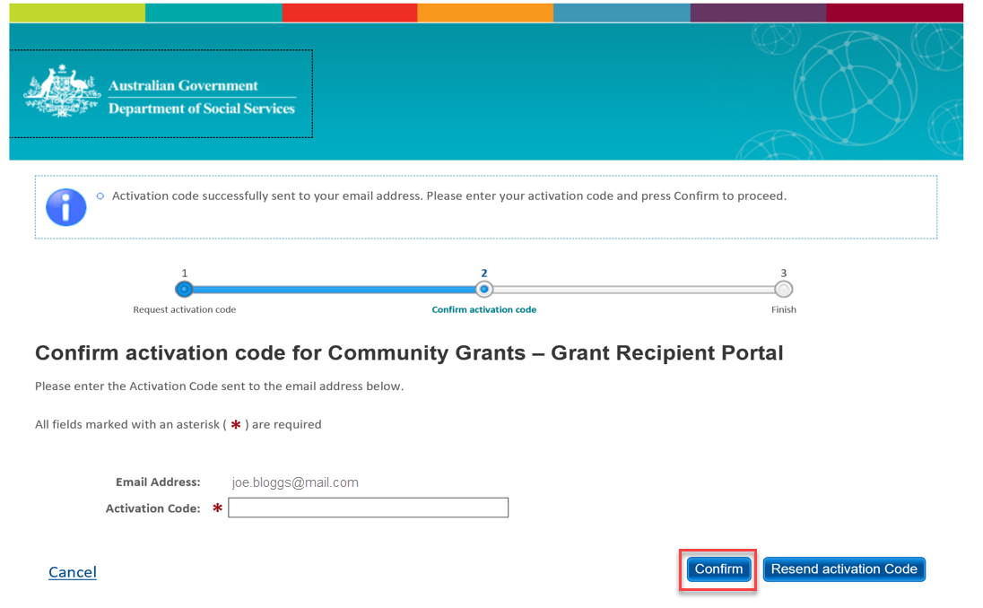

Login to the Grant Recipient Portal
Steps | Actions
Step 9 | Once an activation code has been successfully entered, you will be prompted to continue through to the Portal login page. Select Continue.  The Welcome screen will display. Select I Agree to accept the terms and conditions, and you will be logged into the Portal.  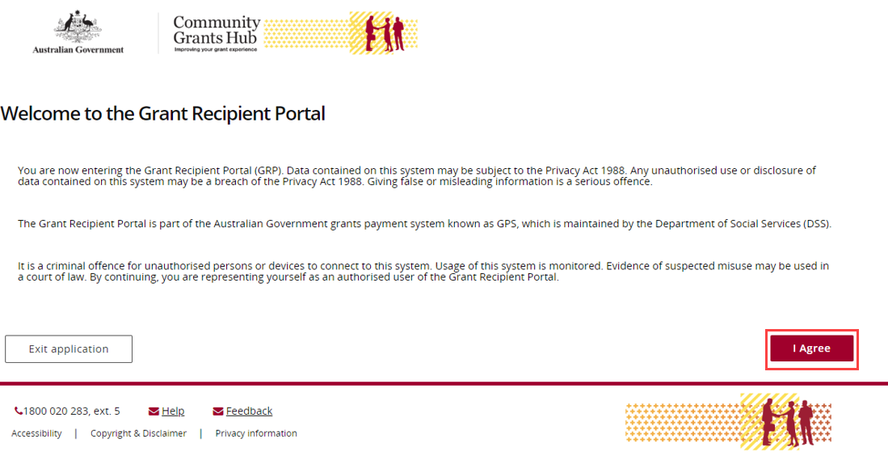

Need help?
For assistance with Digital ID, please see the resources available on the Digital ID and myID websites.
Digital ID | Digital ID System
Home | myID
Phone: 1300 287 539 (Select Option 2, then option 1 for myID)
Operating Hours: Monday to Friday 8.00am – 6.00pm (AEST/AEDT)
For assistance with Relationship Authorisation Manager, please visit the RAM website.
Help | Relationship Authorisation Manager
For further assistance with the Grant Recipient Portal, please contact the Community Grants Hub at GRP.helpdesk@communitygrants.gov.au.

