

View Milestones
  - Task Card
This guide explains how to view and search for milestones in the Grant Recipient Portal (Portal). Milestones are the actions, deliverables and payments linked to your organisation's Grant Agreement.
Portal access required: Administrator, Editor or View Only.

View Milestones
From the Portal home page, select the Milestones tile, or the link from the navigation menu.
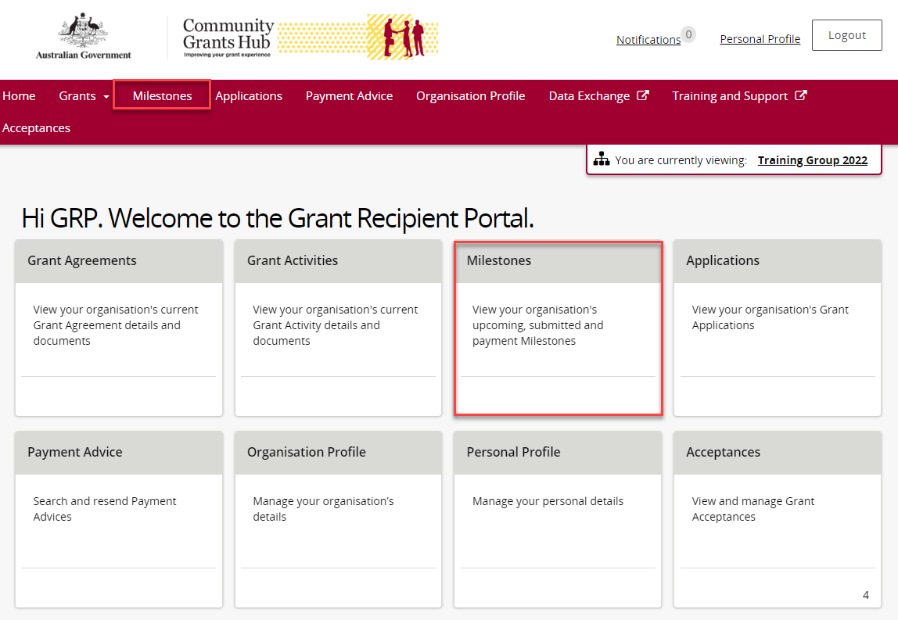

The Milestones page opens and displays your organisation's upcoming milestones by default.
You can use the filter to view:
- Upcoming Milestones
- Submitted Milestones
- Payment Milestones
- All Milestones
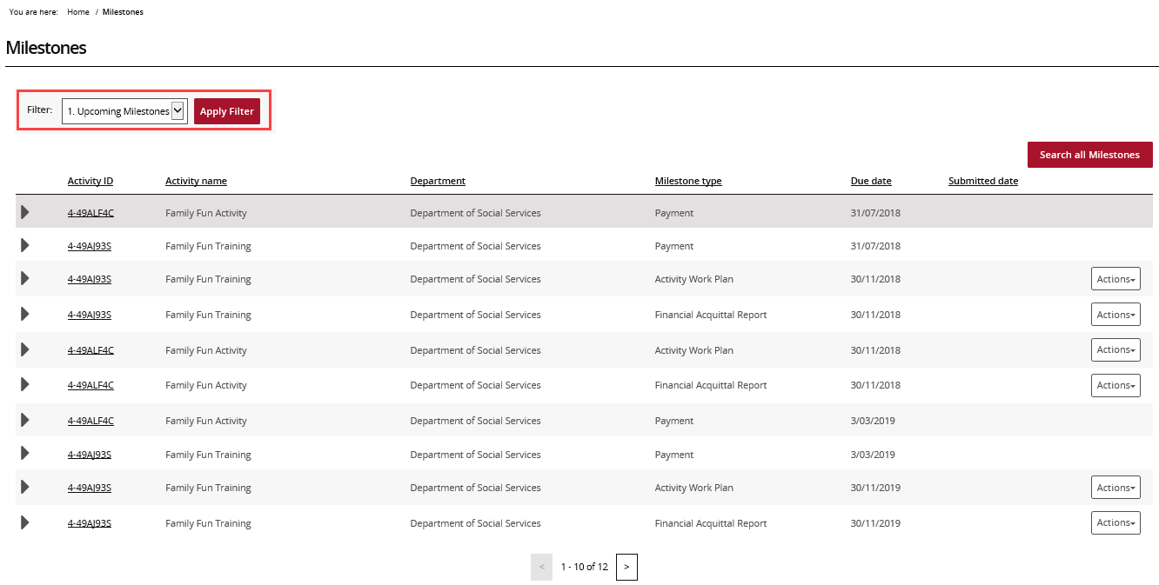
Select the filter drop-down list.
Choose the type of milestones you want to view.
Select Apply Filter.
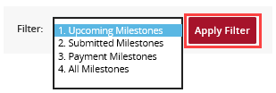
After applying the filter, the matching milestones will be displayed.
To see more information about a milestone, select the arrow next to the Activity ID.
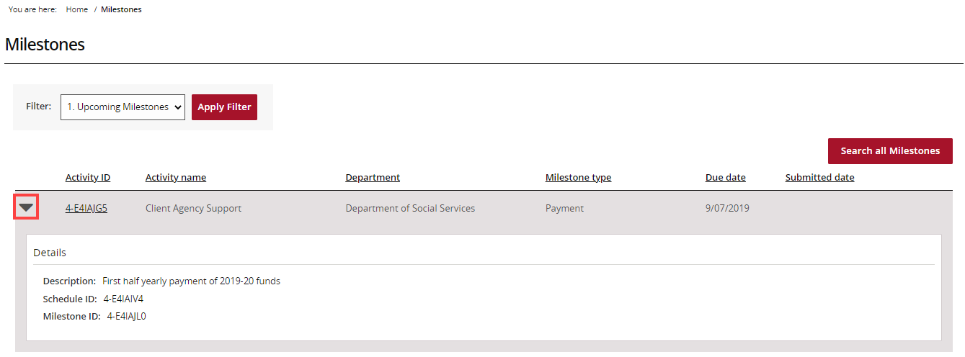
To view the related activity, select the Activity ID link.
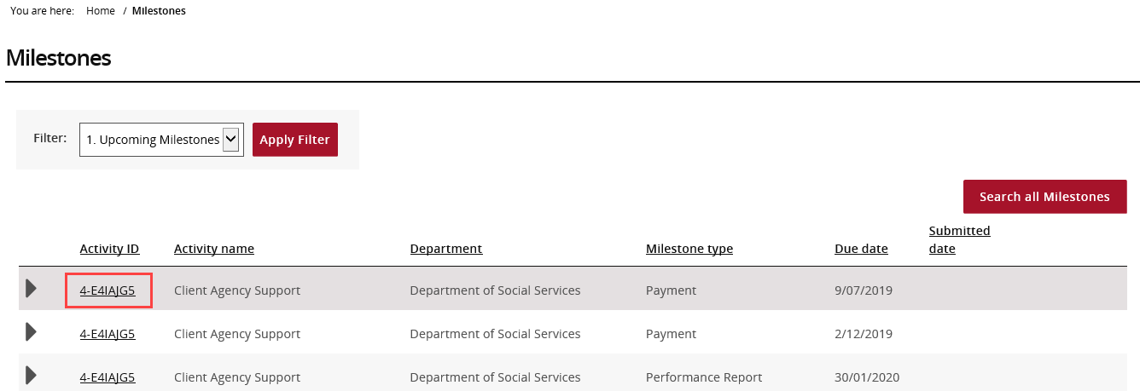
If you need to find a specific milestone, select Search all Milestones.
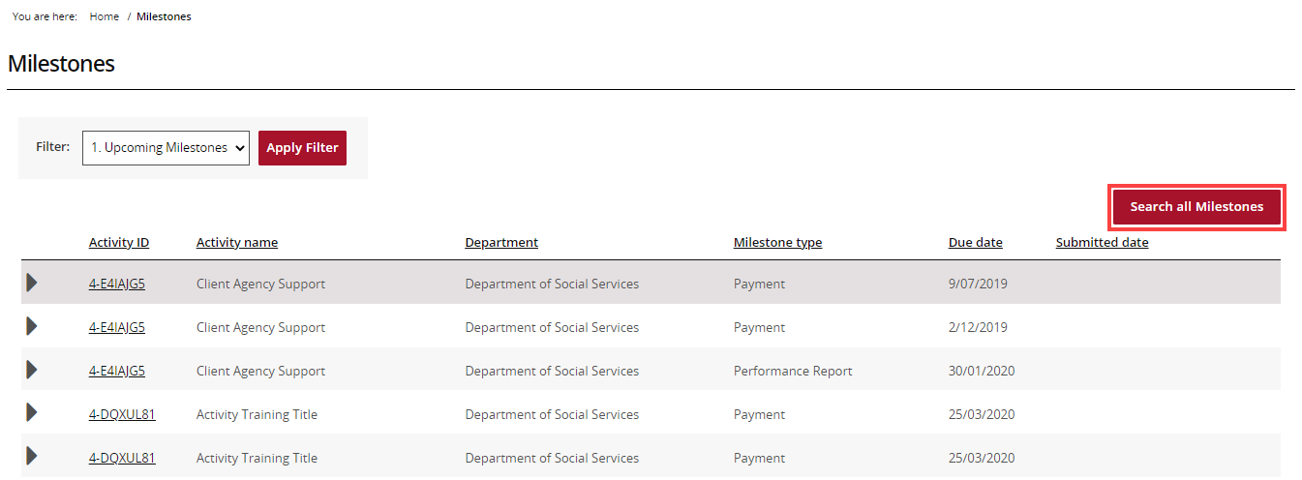
On the Search all Milestones page:
- Enter at least one search criterion.
- Select Run search.
You can search using information such as:
- Milestone type
- Department
- Activity ID
- Activity name
- Schedule ID
- Date range
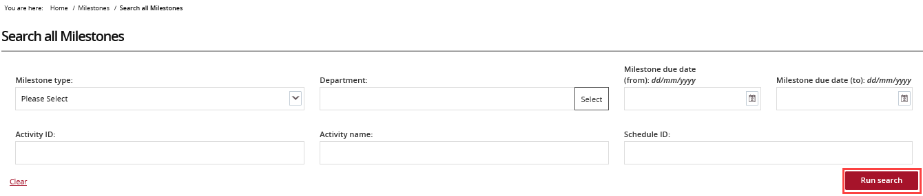
The search results will appear below the search fields.
To export the results:
- Select an export format from the Format drop-down list.
- Select Export.
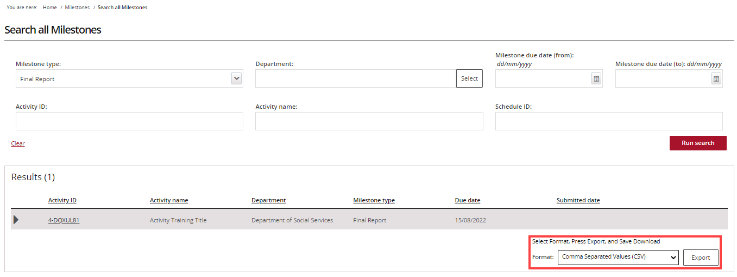

Need help?
For further assistance with the Grant Recipient Portal, please contact the Community Grants Hub at GRP.Helpdesk@communitygrants.gov.au.

