

Submit Reports
  - Task Card
The Grant Recipient Portal (Portal) allows organisations to submit reporting milestones online, including:
- Financial Acquittals
- Activity Work Plan (AWP) Reports
- Child Safety Statements of Compliance
Reporting milestones can be accessed from either the Milestones page or the Grant Activities page.
This task card explains how to submit each report type.
Portal access required: Administrator or Editor.

Quick Links
Navigate to Milestones
Navigate to Milestones from Grant Activities
Submit a Financial Acquittal
Submit an Activity Work Plan Report
Submit a Child Safety Statement of Compliance
Need help?

Navigate to Milestones
From the Portal home page, select the Milestones tile, or link from the navigation menu.
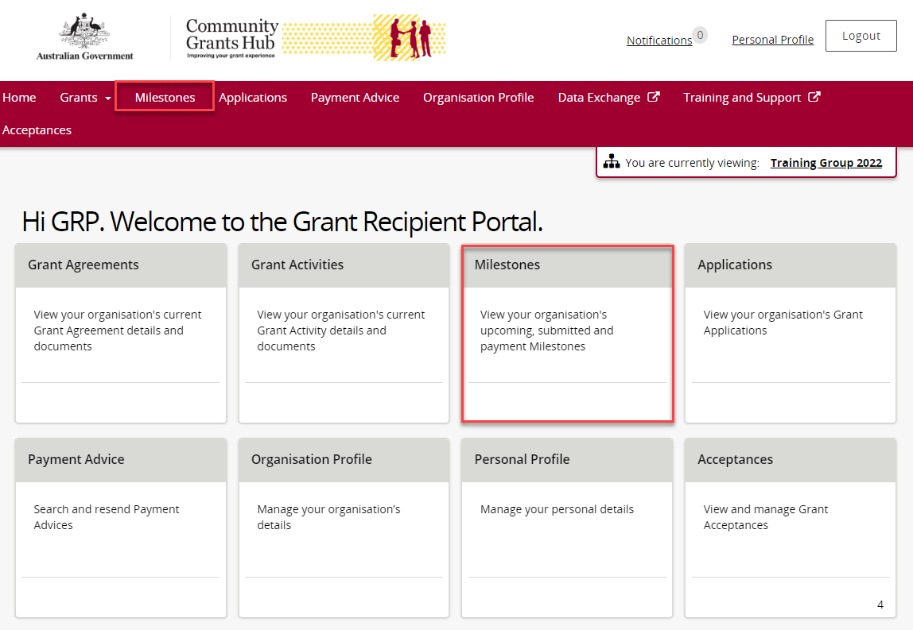
The Milestones page opens and displays upcoming milestones by default.
To view upcoming milestones, select Upcoming Milestones from the filter list and choose Apply Filter.
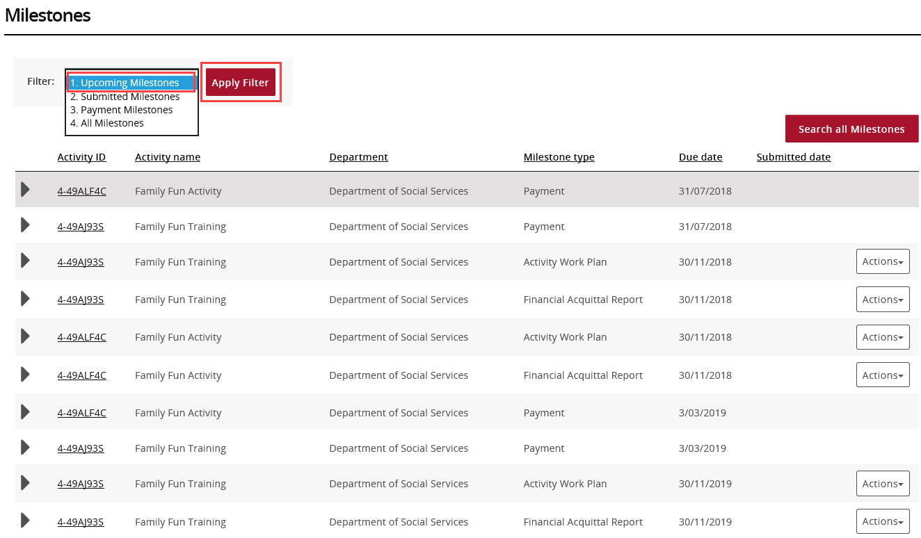
Locate the milestone you need and select Actions.
Choose Launch Report to open the report.
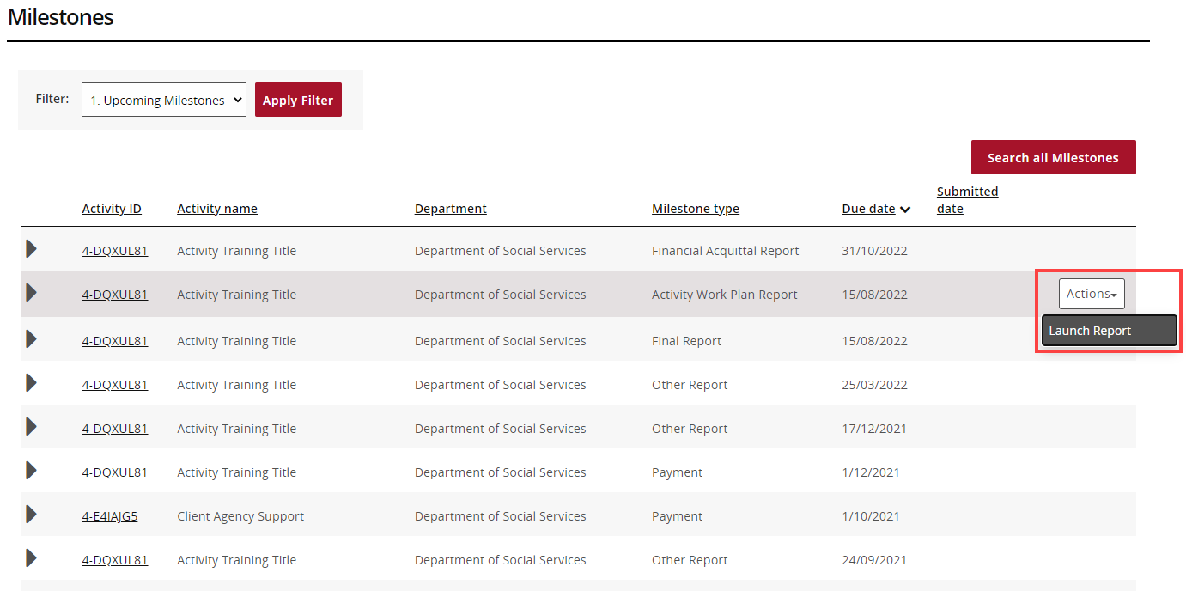
Proceed to the relevant task card section to submit:
- Financial Acquittal
- Activity Work Plan (AWP) Report
- Child Safety Statement of Compliance

Navigate to Milestones from Grant Activities
From the Portal home page:
- Select Grant Activities, or
- Select Grants from the menu and then select Grant Activities.
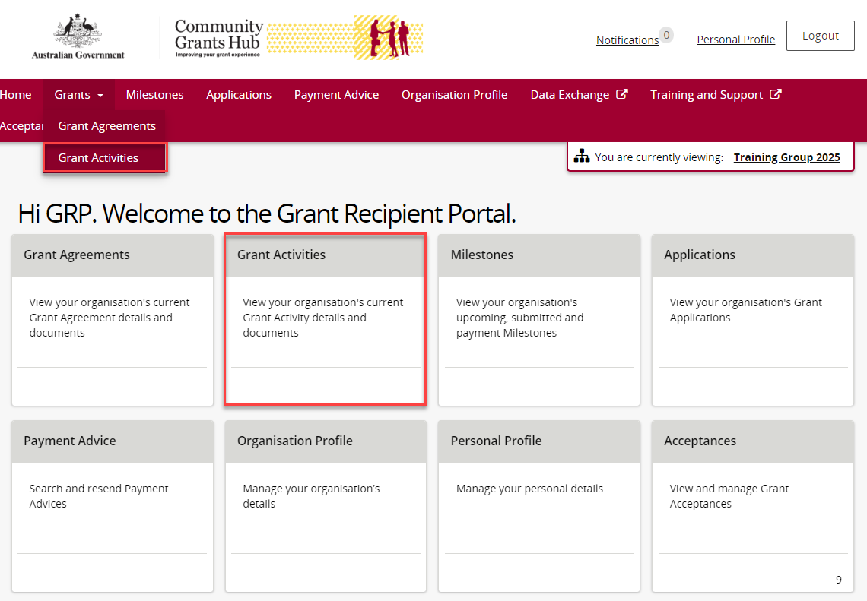
On the Grant Activities page, find the activity you need. Select the expansion arrow to view more information, then select View to open the activity details.
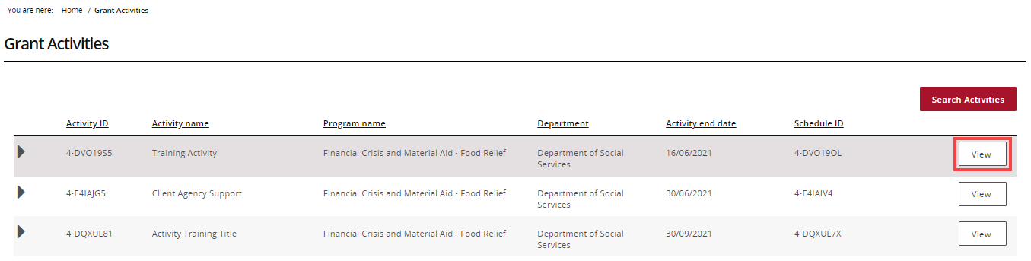
On the Activity Details page, select Milestones from the Grant Activity menu.
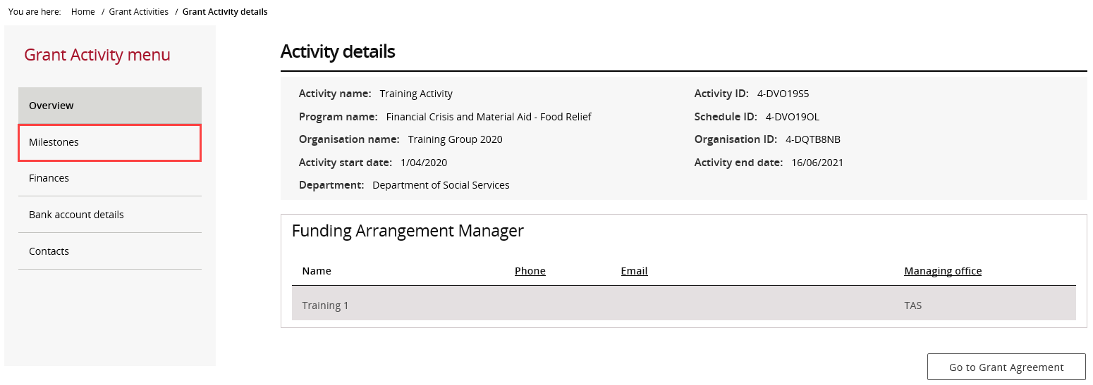
The Milestones page displays upcoming milestones by default. Use the filter or select Search all Milestones to find a specific milestone.
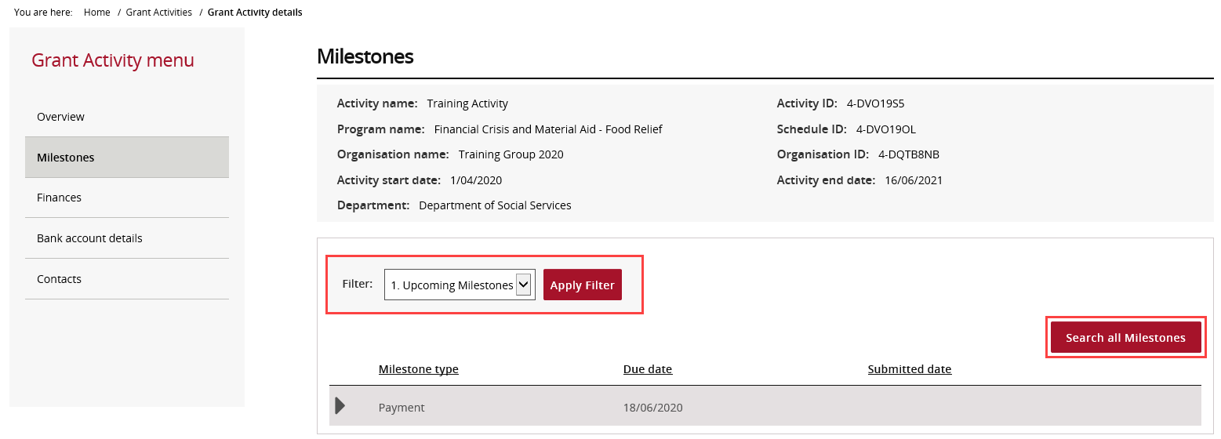
Find the required milestone and select Actions to open the report.
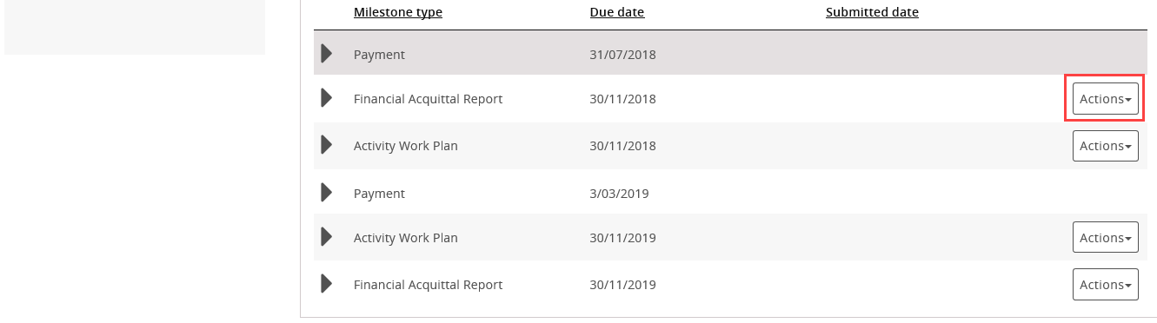
Proceed to the relevant task card section to submit:
- Financial Acquittal
- Activity Work Plan (AWP) Report
- Child Safety Statement of Compliance

Submit a Financial Acquittal
Select Actions and then Launch Report.
The Financial Acquittal Report page opens. Review the report details.
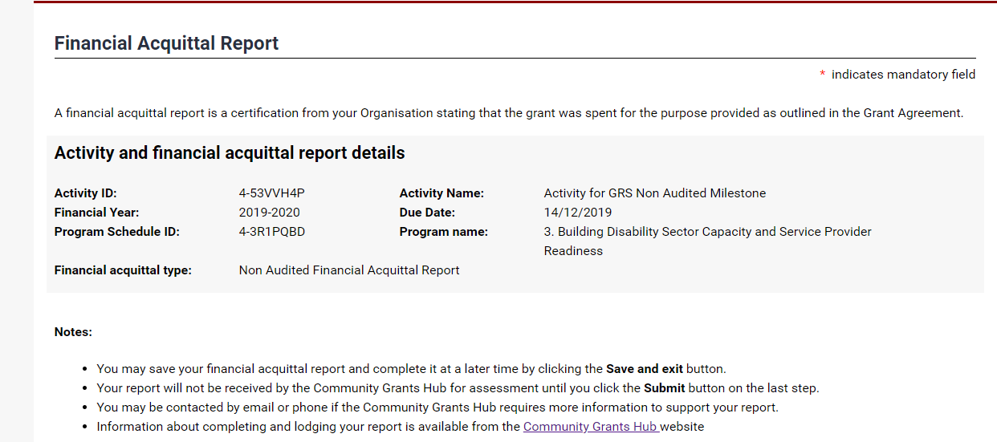
Complete the funding questions. All mandatory fields are marked with a red asterisk (*).
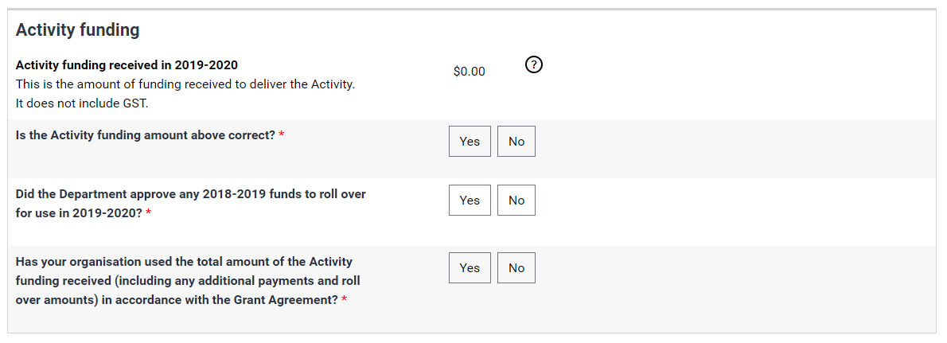
If required, upload supporting documents by selecting Add Attachment.
Note: Supporting documents must be provided if the Grant Agreement requires an Audited or Non-audited Financial Acquittal.
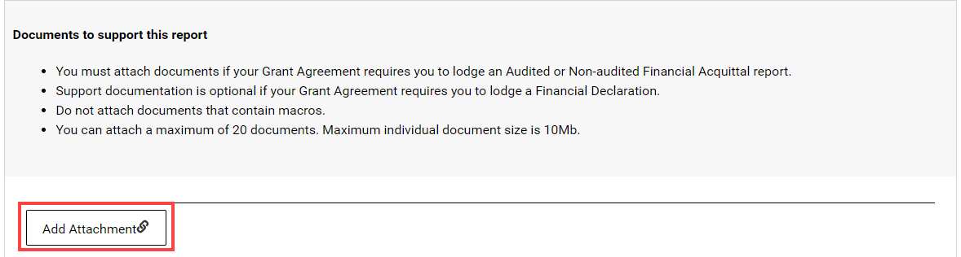
After uploading a document, use the Actions menu to view, remove, or edit comments for the attachment.
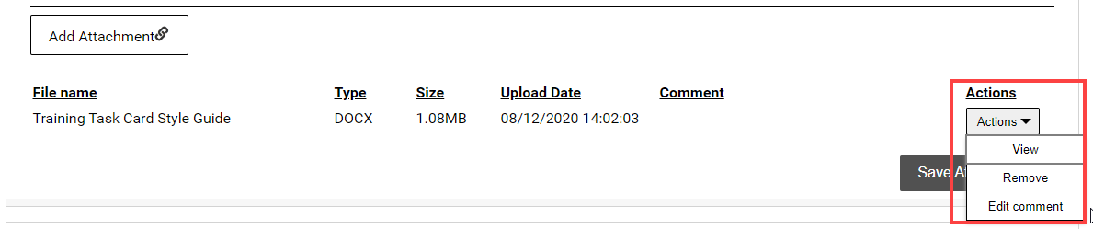
Select Save Attachments once all required documents have been uploaded.
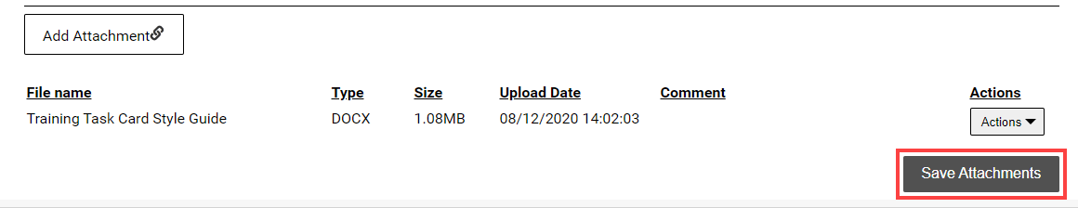
Wait while the files are uploaded. Do not leave the page until the upload is complete.
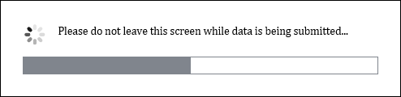
A confirmation message will appear when the documents have been saved. To upload more documents, select Return to list and repeat the above steps.
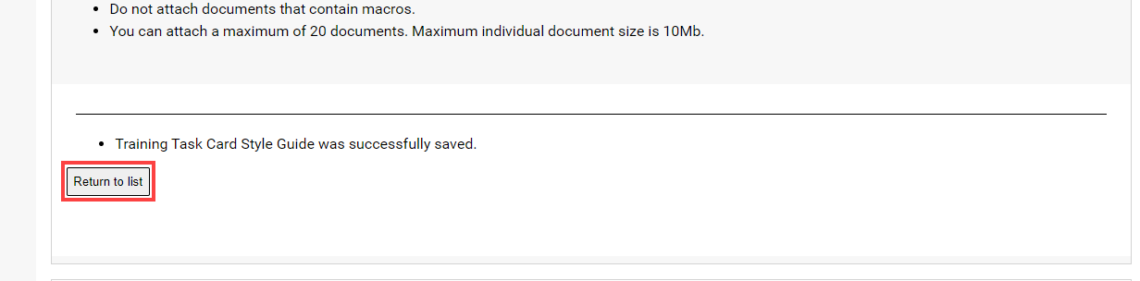
Read the disclaimer, select the checkbox to confirm your agreement, then Submit.
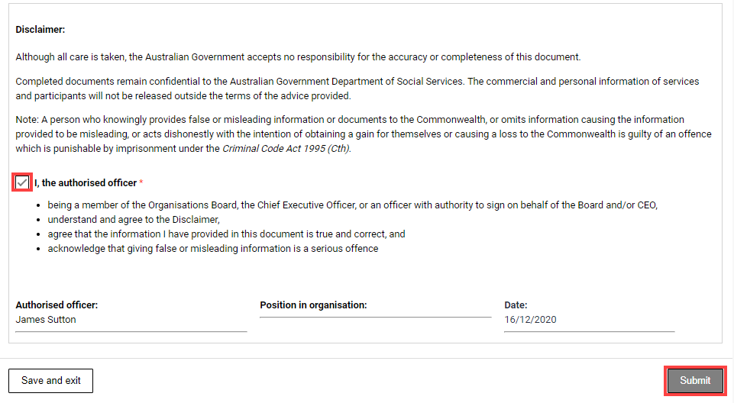
Wait while the report is being submitted. Do not leave the page.
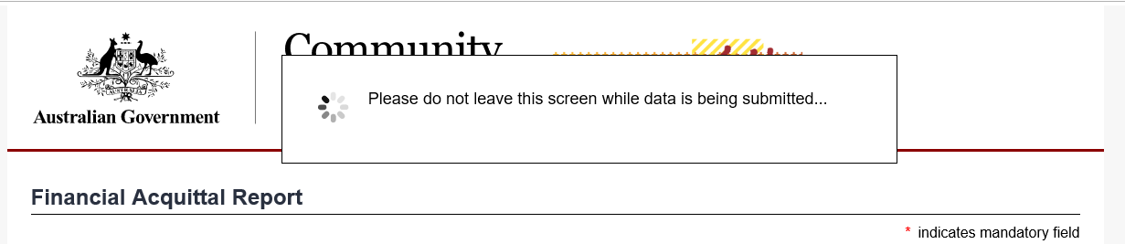
When the confirmation page appears, select Save and exit to close the report.
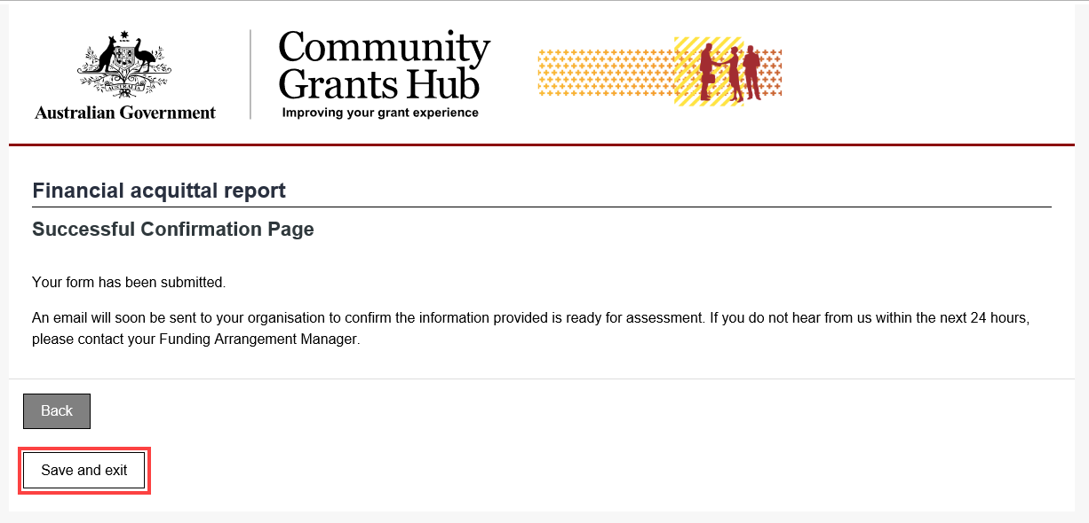

Submit an Activity Work Plan Report
Select Actions and then Launch Report.
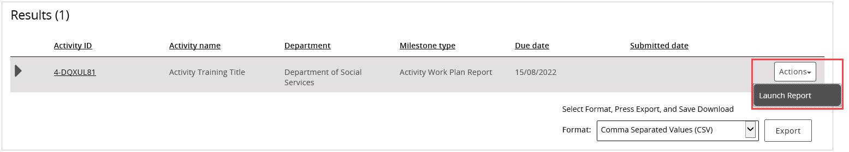
The Upload Report page opens. Review the milestone details and instructions.
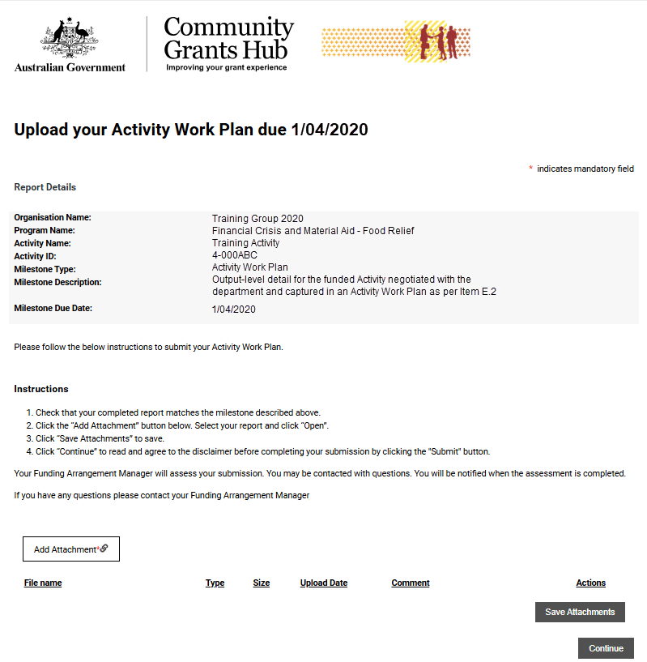
Complete the Activity Work Plan template and save it to your computer before uploading it to the Portal.
Use the Word version of the template available on the Department of Social Services website.
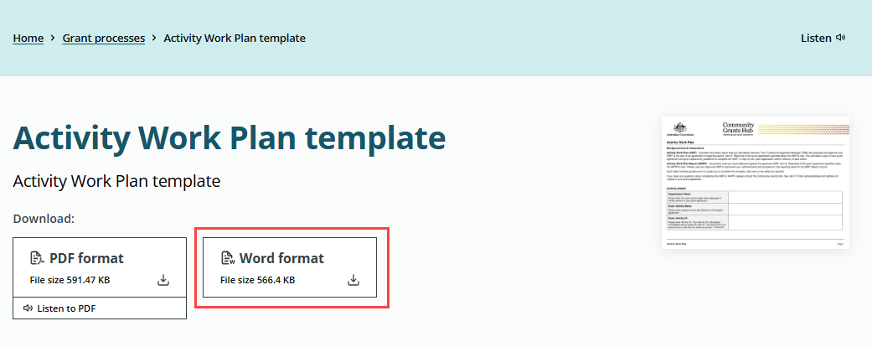
Select Add Attachment and upload the completed AWP report.
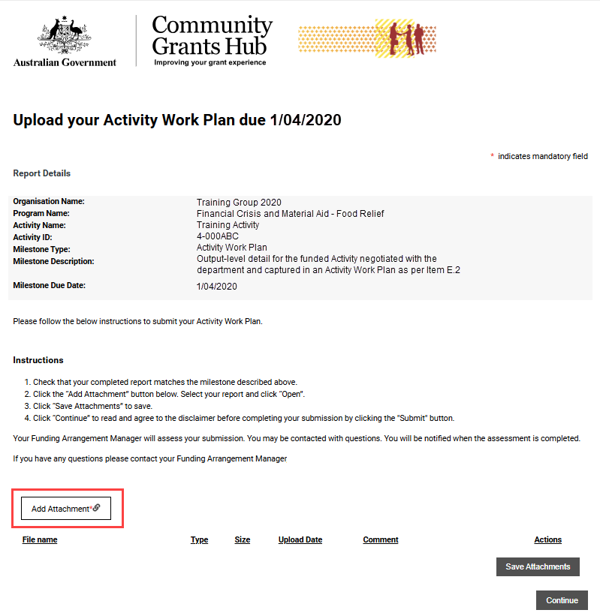
Use the Actions menu to manage attachments. You can view, remove, or edit comments for the attachment.
Select Save Attachments once all required documents have been uploaded.
Wait while the files are uploaded. Do not leave the page until the upload is complete.
A confirmation message will appear when the documents have been saved. To upload more documents, select Return to list and repeat the above steps.
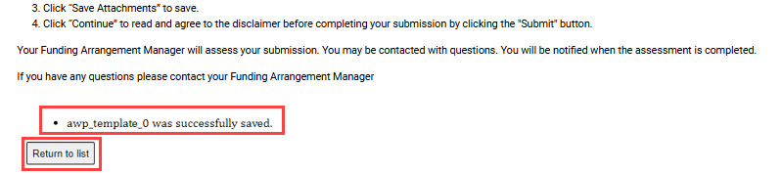
Read the disclaimer, select the checkbox to confirm your agreement, then Submit.
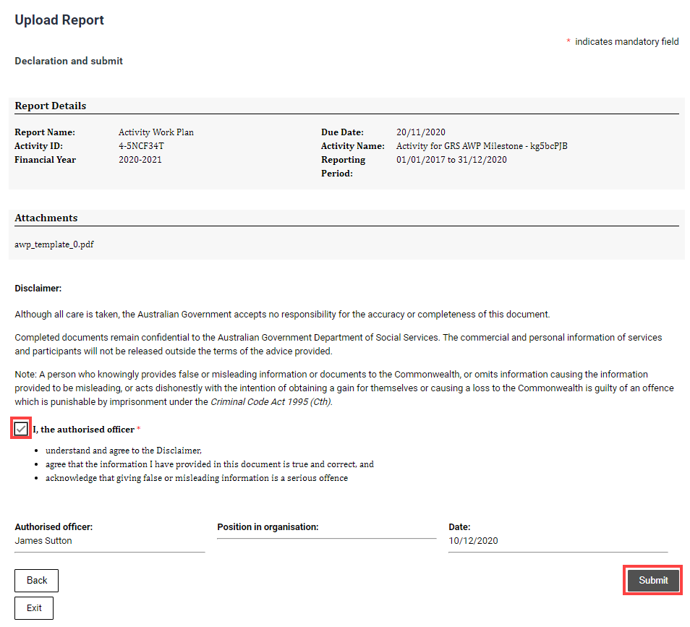
Wait while the report is submitted. Do not leave the page.
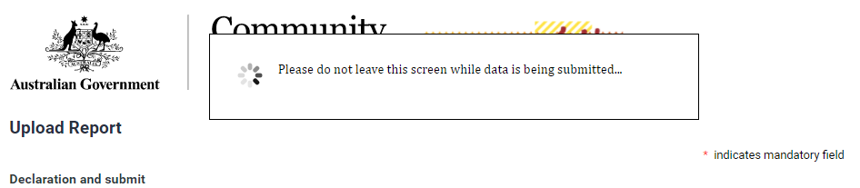
When the confirmation page appears, select Exit to close the report.
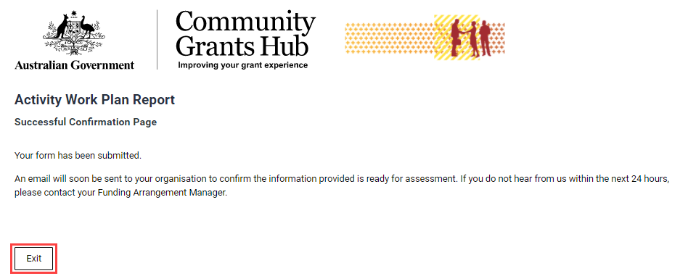

Submit a Child Safety Statement of Compliance
Select Actions and then Launch Report.
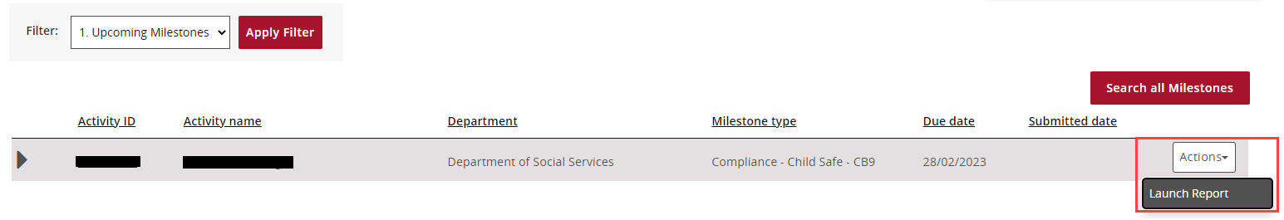
On the Instructions Cover Page, read the information and select Next.
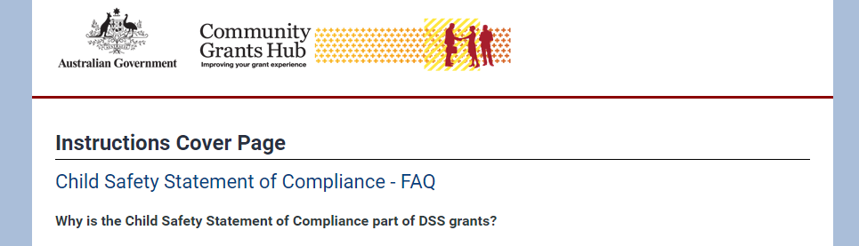
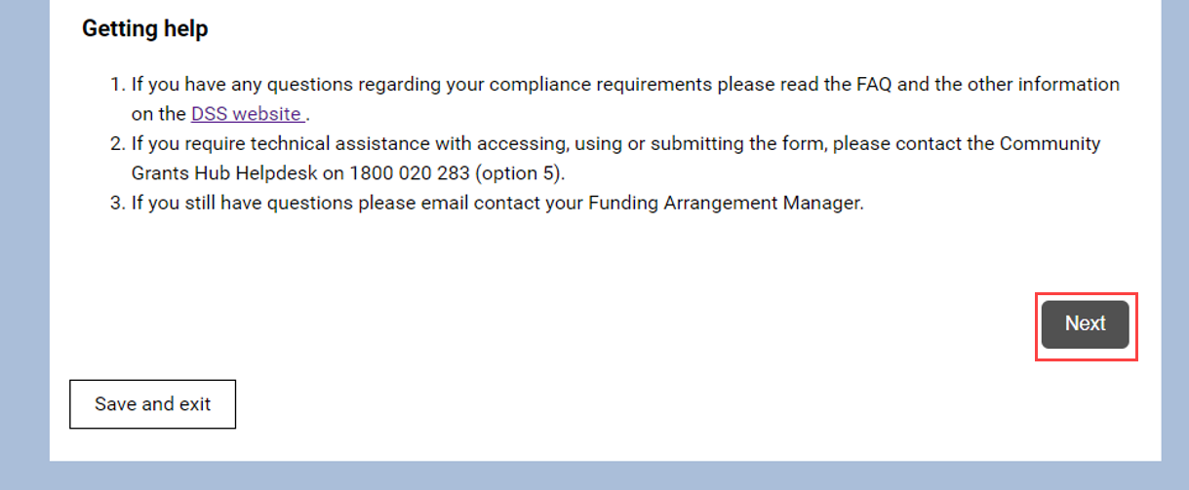
On the Child Safety Statement of Compliance page, review the grant details and declaration information.
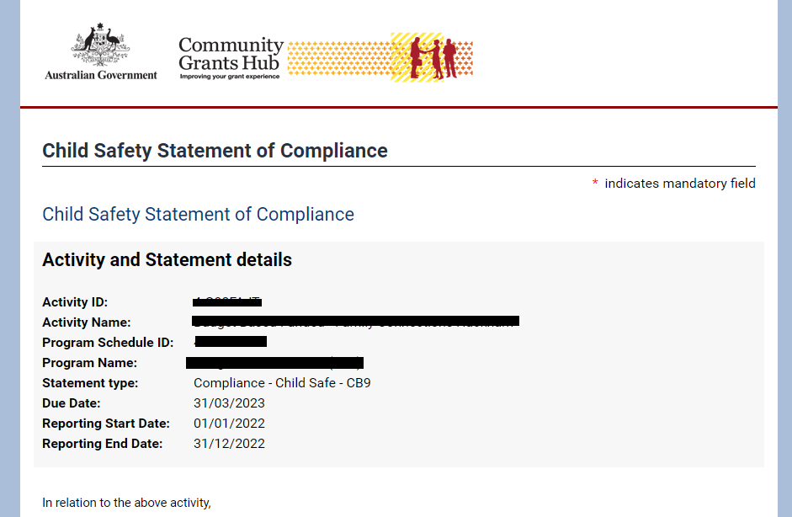
Complete all required fields and select Submit.
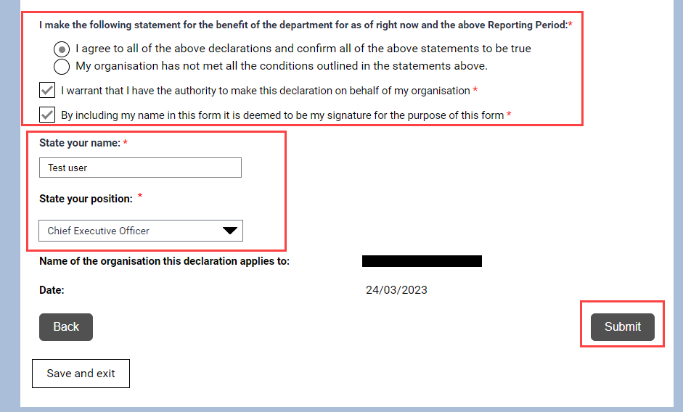
When the confirmation page appears, select Save and Exit
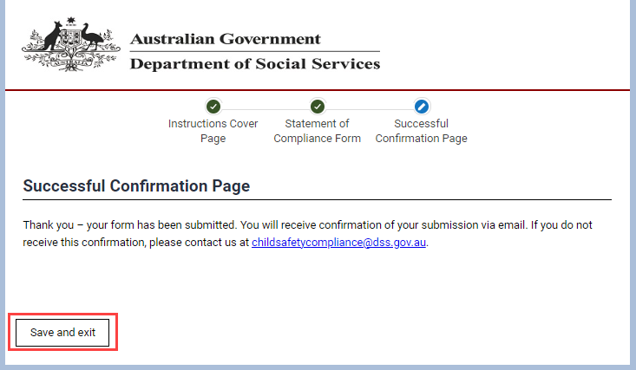
A confirmation email is sent to the primary contact listed for the Program Schedule.
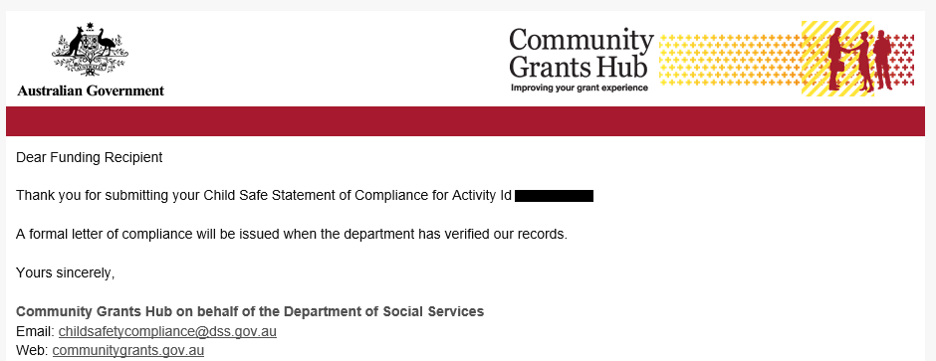

Need help?
For further assistance with the Grant Recipient Portal, please contact the Community Grants Hub at GRP.Helpdesk@communitygrants.gov.au.

