

Search and Resend Payment Advice
  - Task Card
The Grant Recipient Portal (Portal) allows users to search for payment advice records and resend them by email. Payment advice documents are also known as Recipient Created Tax Invoices (RCTIs) or Remittance Advices.
Portal access required: Administrator, Editor, or View Only.

Quick Links
Navigate to Payment Advice
Search for Payment Advice
Need help?

Navigate to Payment Advice
From the Portal home page, select the Payment Advice tile, or link from the navigation menu.
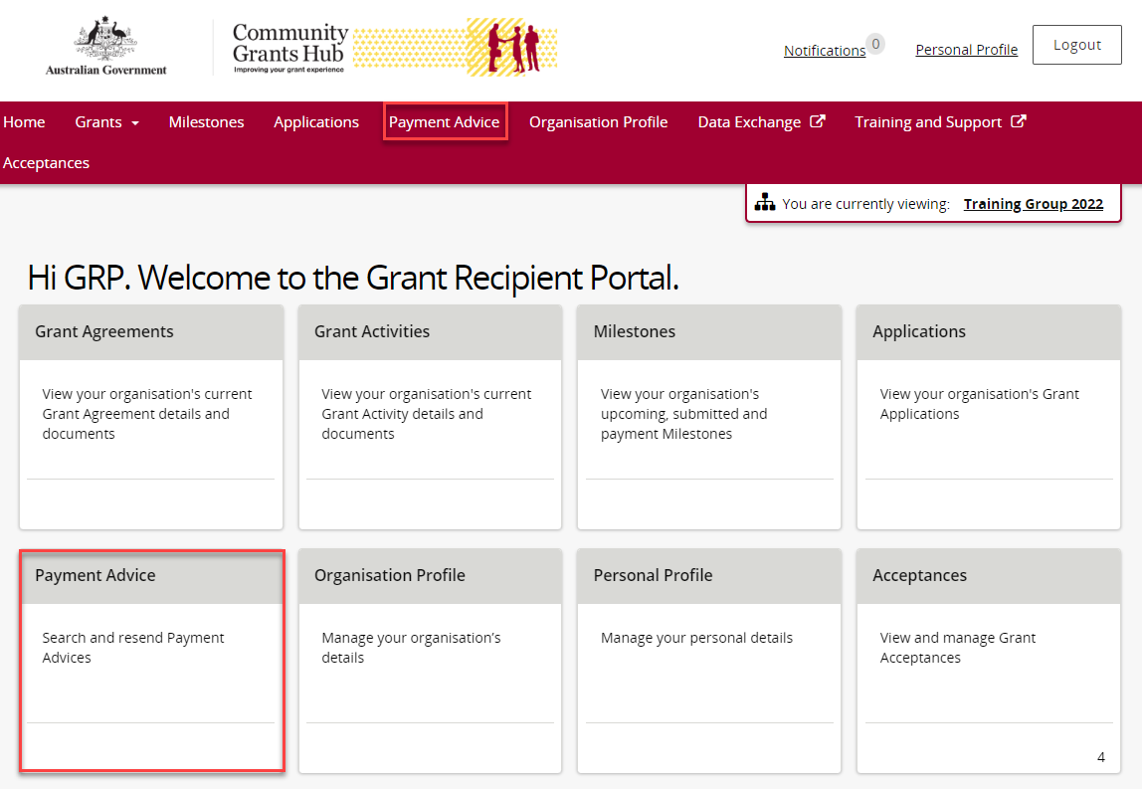
The Payment Advice search page opens. This is where you can search for payment advice records.
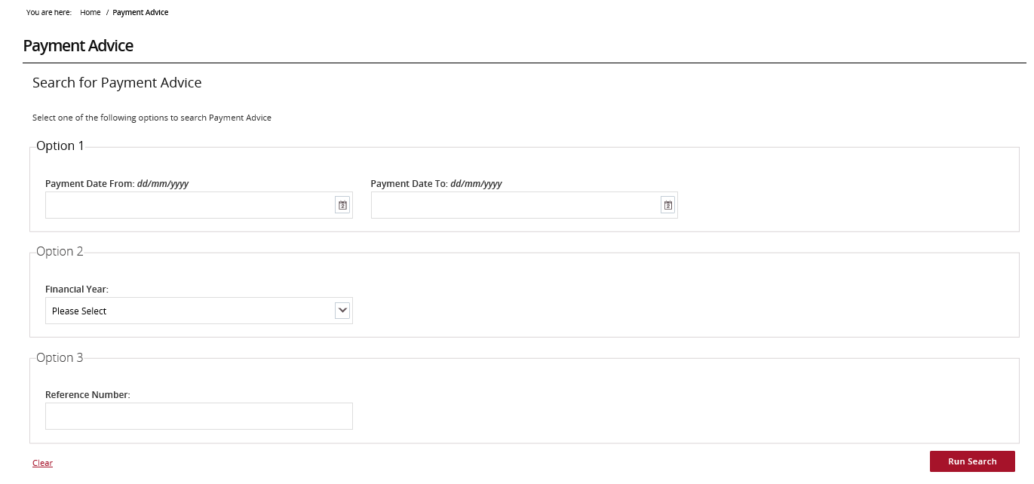

Search for Payment Advice
Search for a payment using one of the following options:
Payment Date Range
Search using a specific payment date or date range.
Financial Year
Search for all payments made in a financial year.
Note: Enter the second year of the financial year. For example, entering 2022 will return payments from the 2021-22 financial year.
Reference Number
Search using the payment reference number shown on your bank statement. Reference numbers usually begin with 150 or 015.
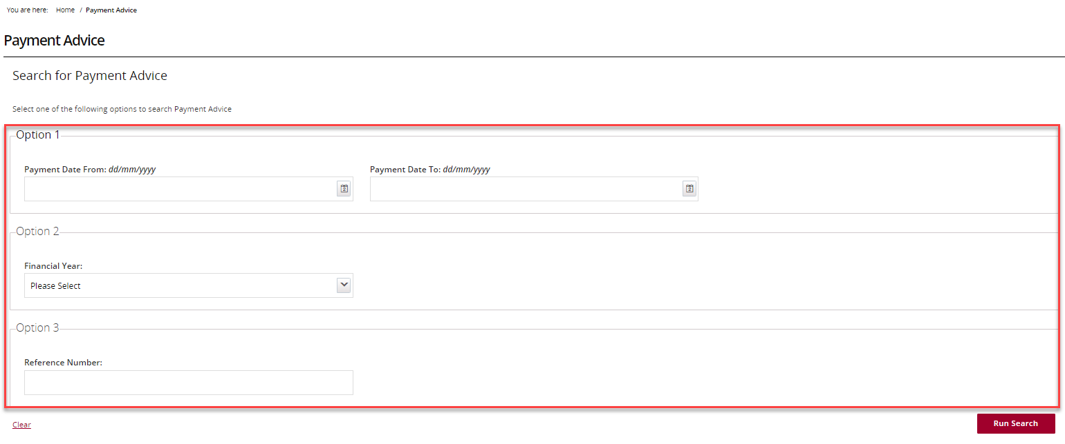

Enter the search information and select Run Search.
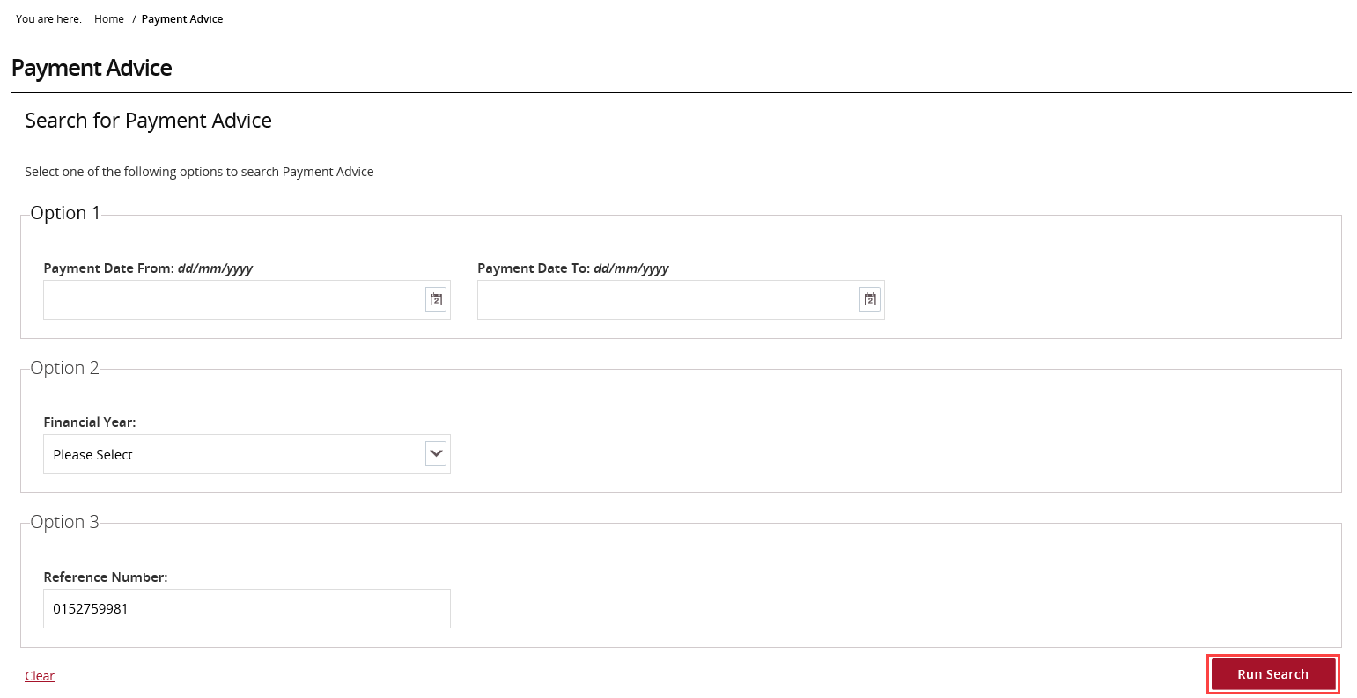
Review the search results.
Select the checkbox beside the payment advice you want to resend, then select Resend Selected.
To select all payment advice records displayed, select the checkbox in the column heading next to Payment Date.
Note: Payment advice documents cannot be viewed in the Portal before they are resent
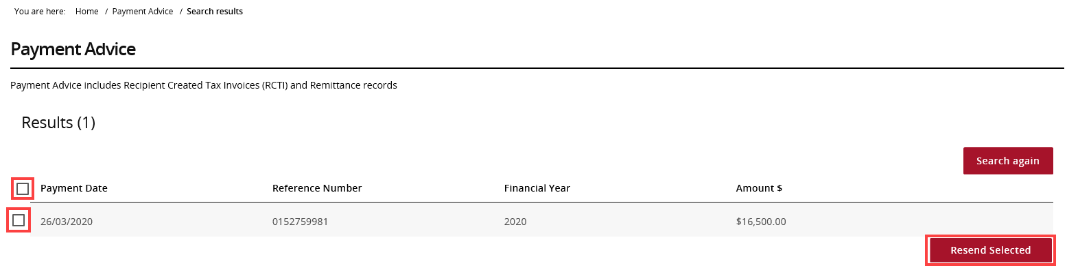
Enter up to three email addresses and select Resend.
The selected payment advice documents will be emailed to the addresses entered.
Note: If the payment advice is not received within 24 hours, contact the Portal Helpdesk
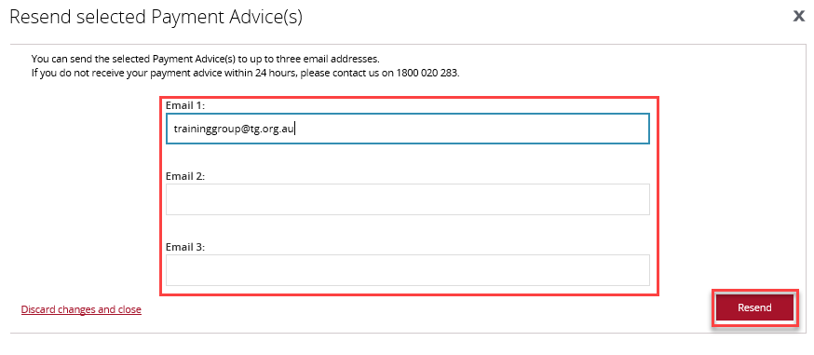

Need help?
For further assistance with the Grant Recipient Portal, please contact the Community Grants Hub at GRP.Helpdesk@communitygrants.gov.au.

