

Navigate the Grant Recipient Portal
  - User Guide
This guide explains the main areas of the Grant Recipient Portal (Portal) and the tasks you can complete in each section. The Portal home page contains navigation tiles that give you access to different grant management functions.

Quick Links
Grant Recipient Portal Home Screen
Grant Activities
Milestones
Applications
Payment Advice
Organisation Profile
Personal Profile
Need help?

Grant Recipient Portal Home Screen
When you sign in to the Portal, the Home screen displays a series of tiles that provide quick access to key information and functions.
The main areas are:
- Grant Agreements
- Grant Activities
- Milestones
- Applications
- Payment Advice
- Organisation Profile
- Personal Profile
- Acceptances
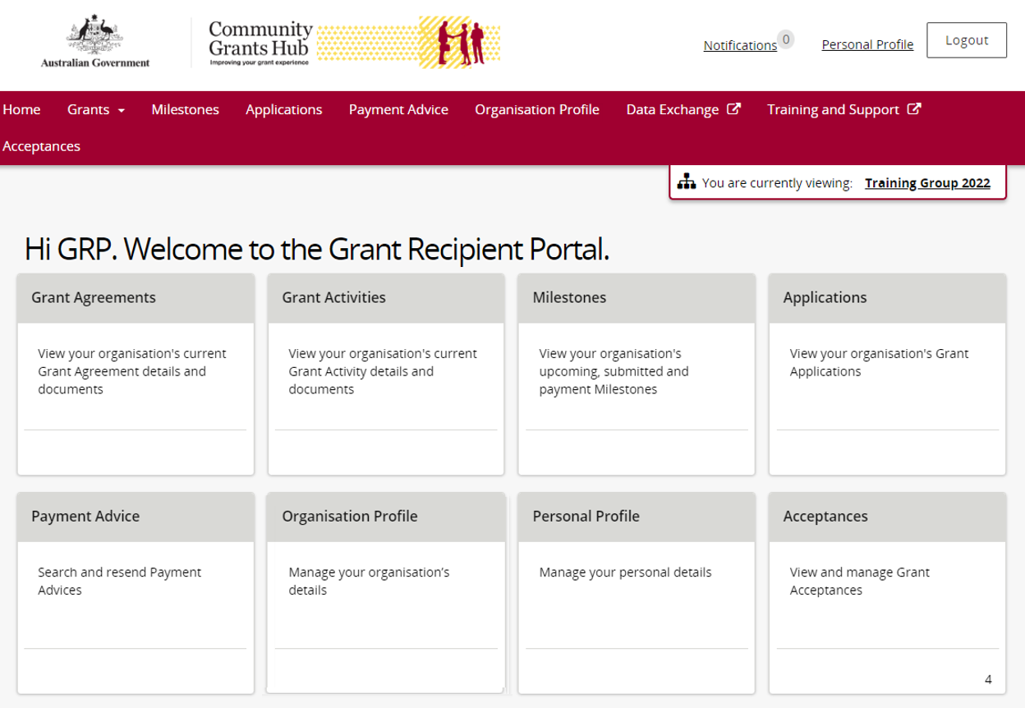

Grant Agreements
Use the Grant Agreements area to:
- View your grant agreements
- View and download executed agreements
- View and download executed variations
- View and manage grant agreement contacts

Grant Activities
Use the Grant Activities area to:
- View your grant activities
- Search for grant activities
- Export a list of grant activities
- Find your Funding Arrangement Manager
- View milestones
- View financial information
- View bank account details
- View and manage grant activity contacts

Milestones
Use the Milestones area to:
- View current and upcoming milestones
- View payment milestones
- Search for milestones
- Export milestone information
- Check reporting requirements
- Submit Financial Acquittals
- Submit Activity Work Plan (AWP) reports
- Submit Child Safety Statements of Compliance

Applications
Use the Applications area to view applications that have been submitted by your organisation.
You can see information including:
- Application ID
- Funding round name
- Department
- Funding round category

Payment Advice
Use the Payment Advice area to:
- Search for payments
- View payment details
- Check payment dates
- View reference numbers
- View financial information and payment amounts
- Resend a payment advice to another person if required

Organisation Profile
Use the Organisation Profile area to manage organisation information.
You can:
- View organisation details
- Add, update or remove staff and contacts
- Activate or deactivate staff records
- Update grant agreement and grant activity contacts
- Update organisation email addresses
- Update phone numbers and website details
- Update postal addresses
- View bank account details
- Request changes to bank account information

Personal Profile
Use the Personal Profile area to manage your own details.
You can:
- View your personal information
- Update your job title
- Update phone numbers
- Change your preferred communication method
- View the organisations linked to your account
- Check your Portal access level
- Switch between organisations if you have access to more than one organisation

Need help?
For further assistance with the Grant Recipient Portal, please contact the Community Grants Hub at GRP.Helpdesk@communitygrants.gov.au.

