

Financial Acquittal
  - Task Card
This guide explains how to access, complete and submit a Financial Acquittal report. Funding recipients can complete the report through the Grant Recipient Portal (Portal) or by using the unique link provided by email.
Portal access required: Administrator or Editor.

Quick Links
Before You Start
Access the Financial Acquittal Report Through the Portal
Access the Financial Acquittal Report Without the Portal
Complete the Financial Acquittal Report
Attach Supporting Documents (Audited or Non-Audited Reports)
Financial Declaration
Need help?
Acquittal Contacts
Appendix A – Financial Declaration
Appendix B – Notes on Non-Audited and Audited Financial Acquittals

Before You Start
You will receive a reminder email 30 days before your acquittal is due. The email includes instructions on how to access your Financial Acquittal report.
There are two ways to access the report:
- Portal users access the report through the Grant Recipient Portal.
- Non-portal users access the report using a unique link and access code provided in the email.

Access the Financial Acquittal Report Through the Portal
From the Portal home page:
- Select Grant Activities, or
- Select Grants from the menu and then select Grant Activities.
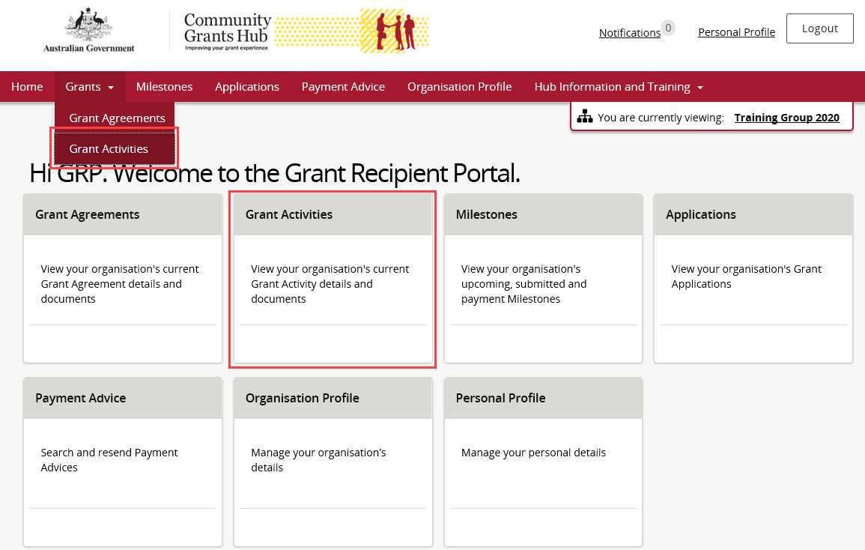
Find the relevant grant activity and select View.
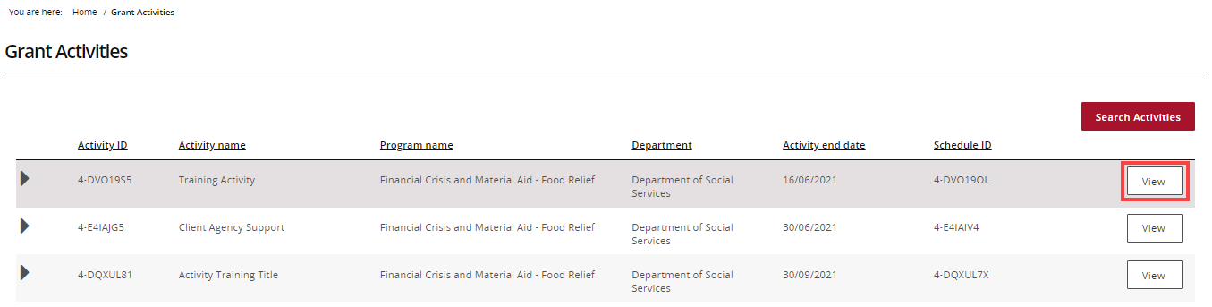
From the Activity Details page, select Milestones from the Grant Activity menu.
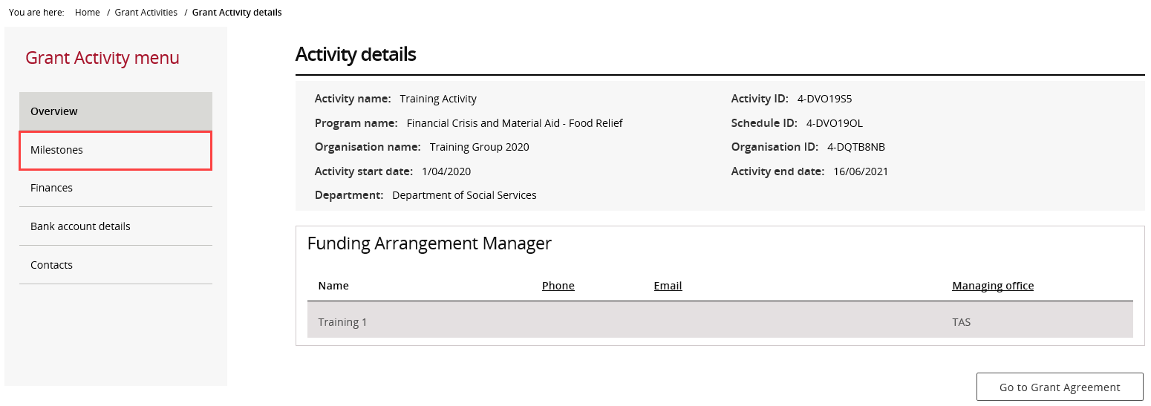
The Milestones page opens with Upcoming Milestones selected.
You can:
- Change the filter and select Apply Filter, or
- Select Search all Milestones to find a specific milestone.
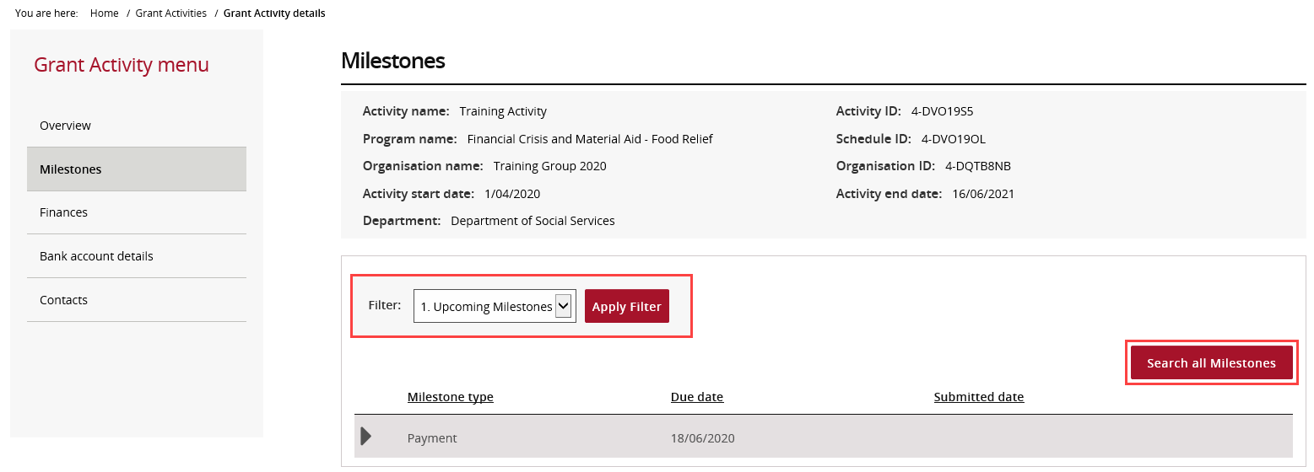
Locate the Financial Acquittal milestone.
Select Actions.
Select Launch Report.
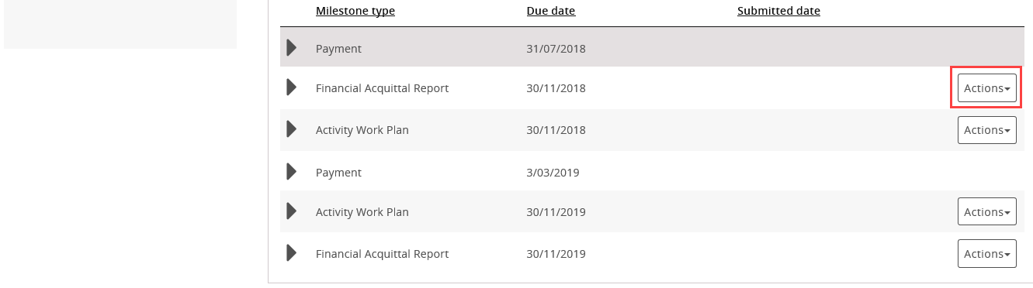

Continue to Complete the Financial Acquittal Report.

Access the Financial Acquittal Report Without the Portal
Thirty days before the due date, you will receive an email containing:
- A unique report link
- A unique access code
Each acquittal report has its own link and code.
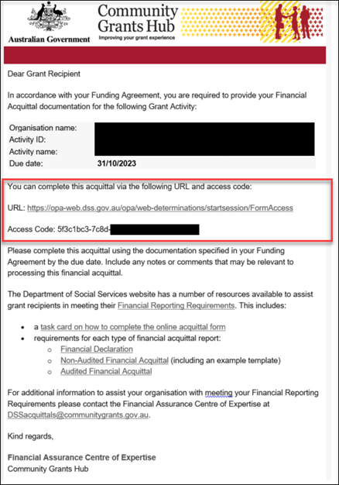
Open the link from the email.
Copy the access code.
Paste it into the Access Code field.
Select Next.
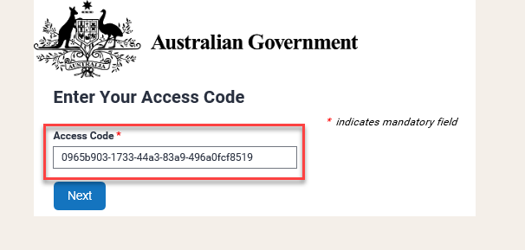
Enter your password and select Next.
Your default password is your Organisation ID, which can be found in your Grant Agreement.
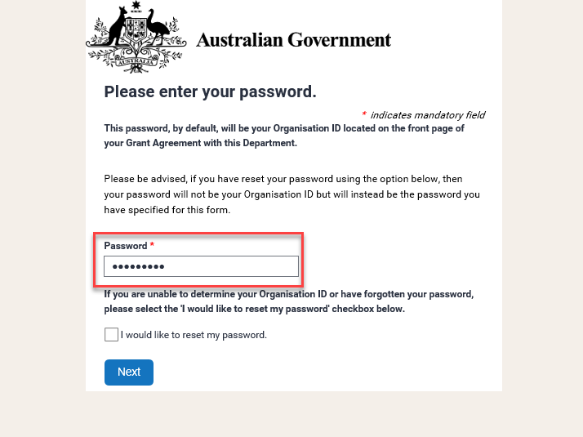

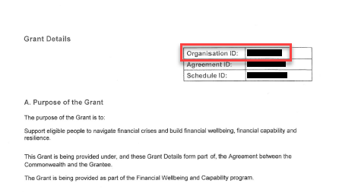
If you do not know your password, select I would like to reset my password and continue to the next step.
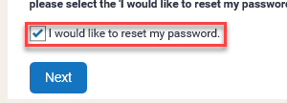
Enter the email address that received the original acquittal email and select Next.
Only this email address can be used to reset the password.
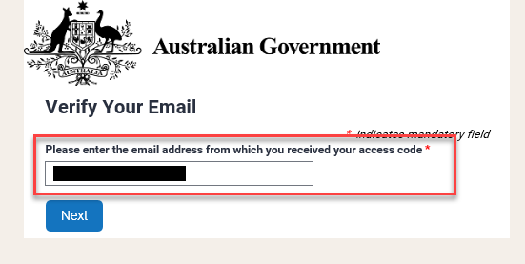
You will receive an email containing a reset token.
Copy the token, paste it into the Reset Token field, and select Next.
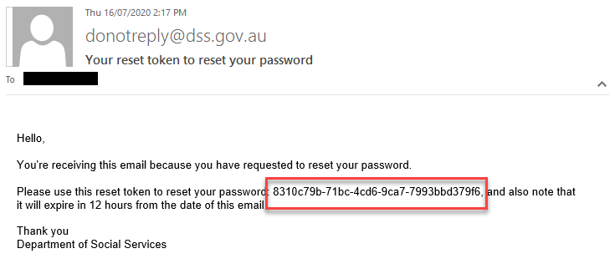
Enter and confirm your new password, then select Next.
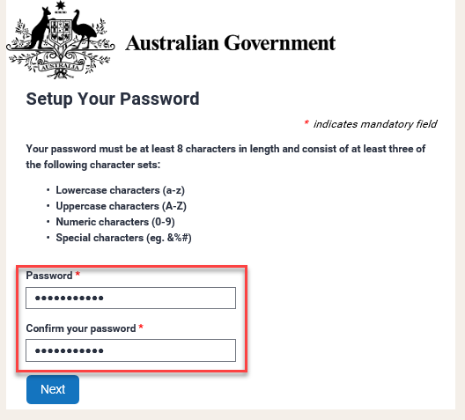
After entering or resetting your password, the Financial Acquittal Report page will open.

Complete the Financial Acquittal Report
The report displays information about your grant, activity, and reporting period.
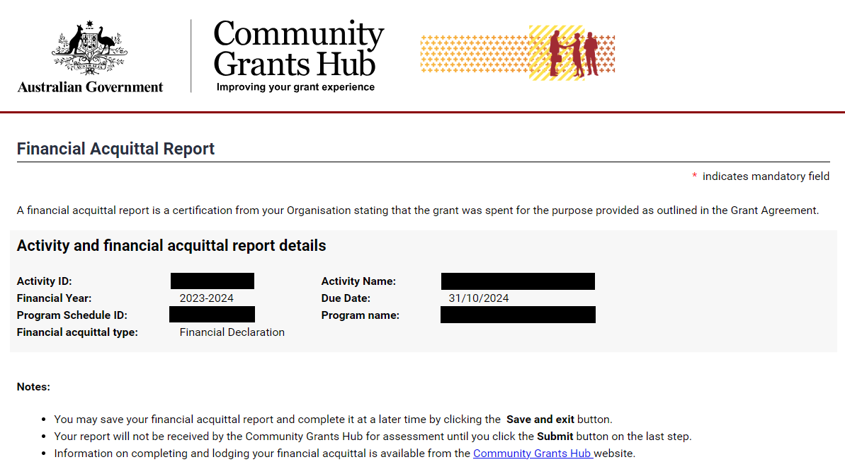
The report automatically displays:
- Activity funding received for the year
- Approved rollover funding from the previous year
All amounts are GST exclusive.
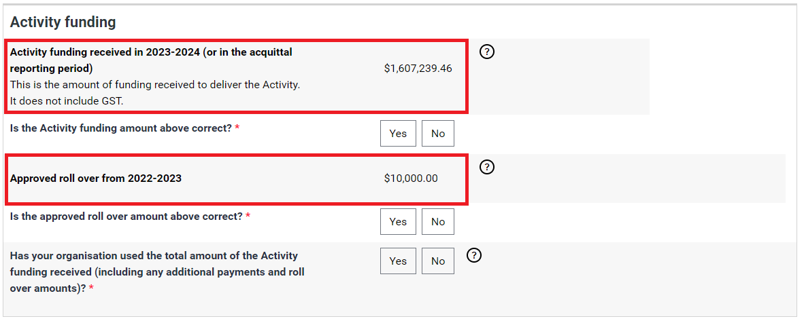
Confirm whether the funding amount shown is correct.
- Select Yes if the amount is correct.
- Select No if the amount is incorrect.
If you select No, provide:
- The correct amount
- The reason for the adjustment
- Supporting comments
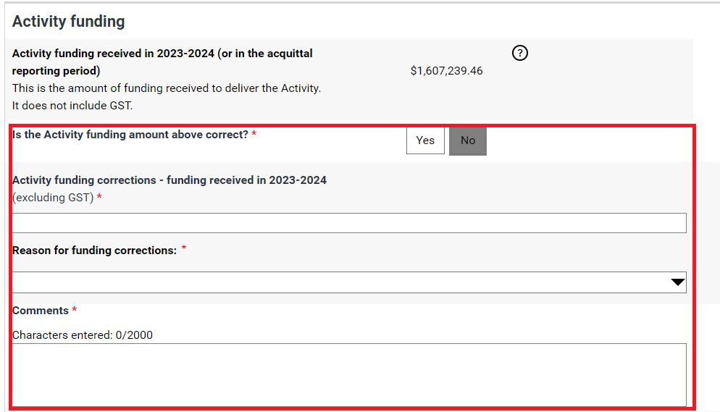
Confirm whether the approved rollover amount is correct.
- Select Yes if correct.
- Select No if incorrect and provide revised information and comments.
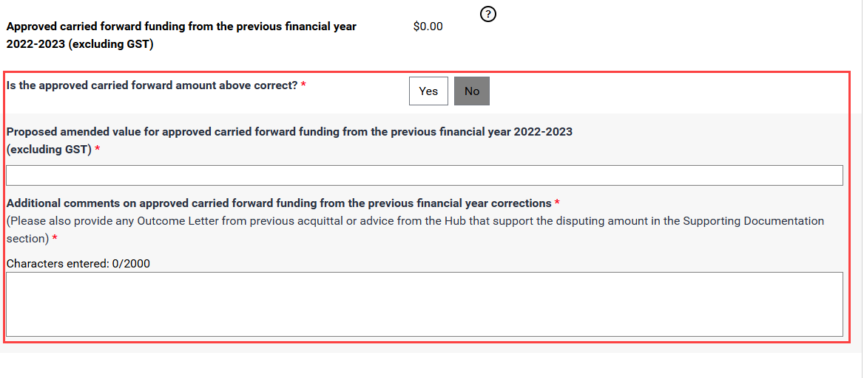
Confirm whether all funding was used for the approved purpose.
- Select Yes if all funds were spent.
- Select No if any funds remain unspent.
If funds remain unspent, provide:
- The unspent amount
- The reason the funds were not spent
- Additional comments
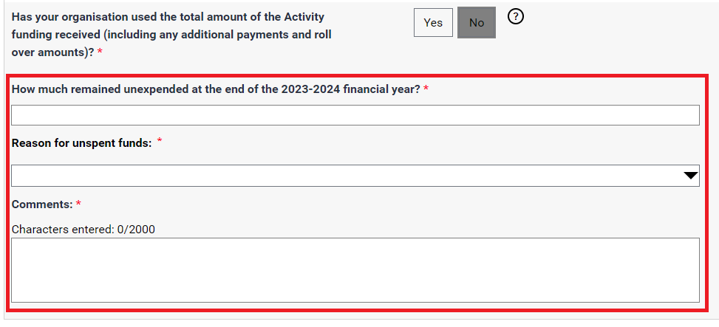
If you need to submit a Non-Audited Financial Acquittal or Audited Financial Acquittal, continue to the attachment steps.
If you only need to submit a Financial Declaration, skip to the declaration section.

Attach Supporting Documents (Audited or Non-Audited Reports)
Attach the required financial acquittal documents before submitting.
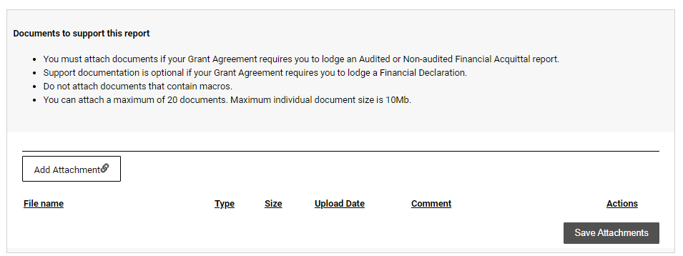
Select Add Attachment.
Choose the required file.
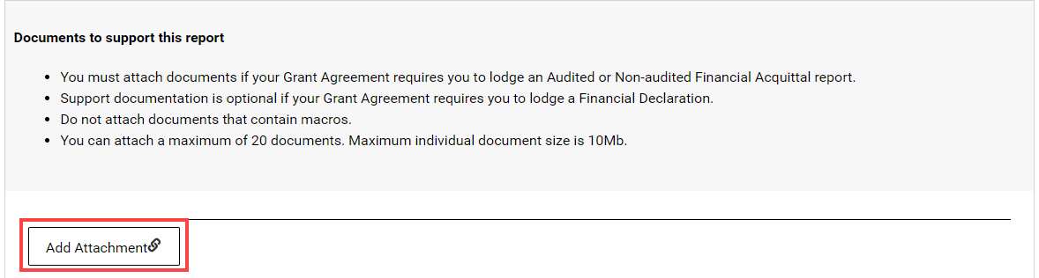
You can also use the Actions menu to:
- View a file
- Remove a file
- Edit comments
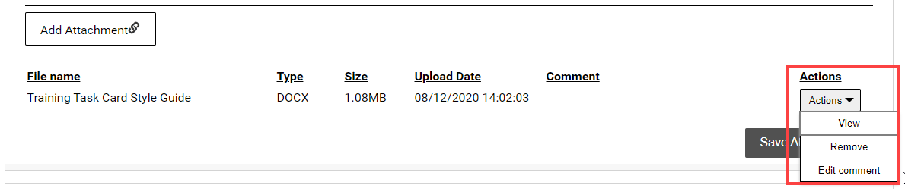
Save the attachment.
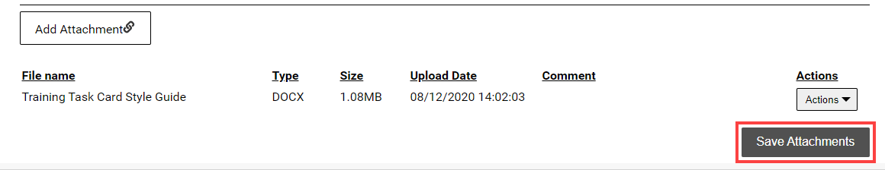
Wait until the upload process is complete.
Remain on the page until the submission process is complete.
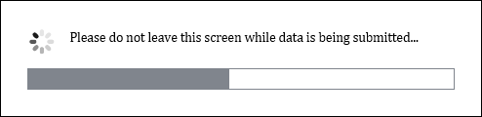
A confirmation message will appear when your documents have been successfully saved.
To attach more documents, select Return to list and repeat the attachment process.
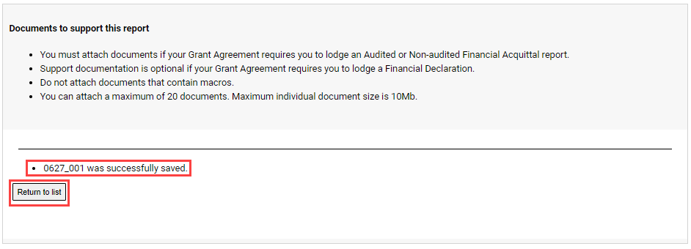

Financial Declaration
Read the Disclaimer.
Select the checkbox to confirm agreement.
By submitting the declaration, you confirm that:
- The information provided is correct.
- You are authorised to make the declaration on behalf of the organisation.
Enter your details.
Select Submit.
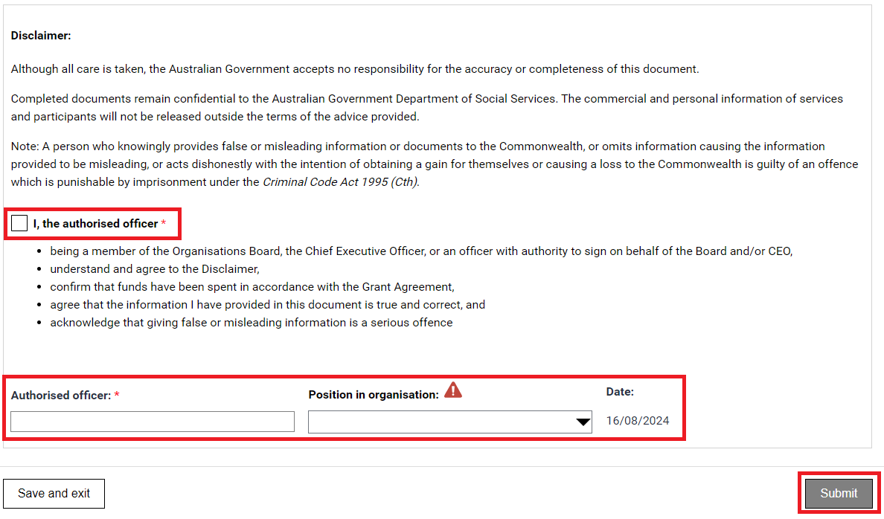
A message will appear advising to stay on this screen until the data has been submitted.
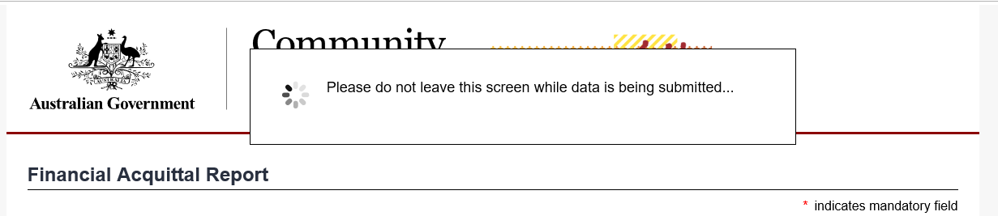
A confirmation page will display. Select Save and exit to close the form.
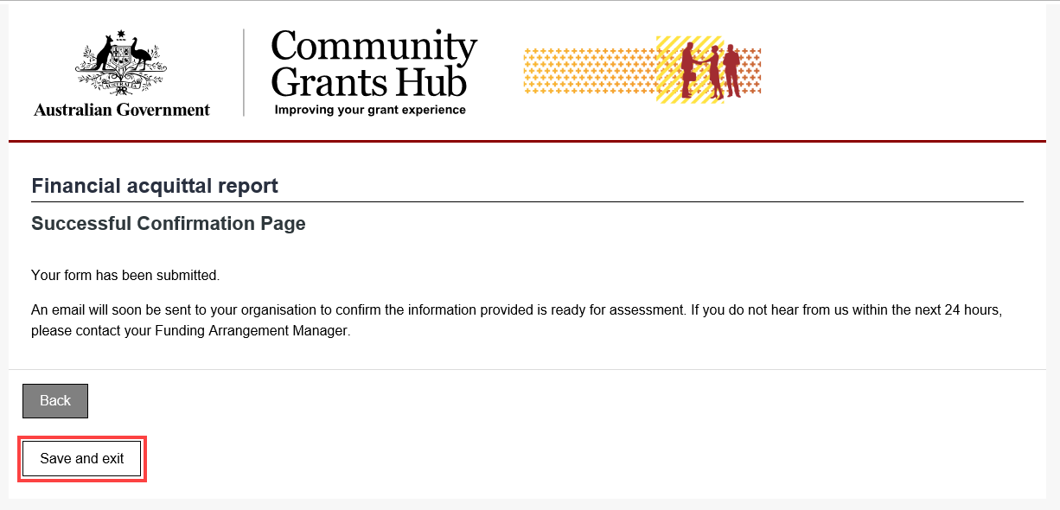
You will also receive an email to confirming the submission of the online Financial Acquittal report.
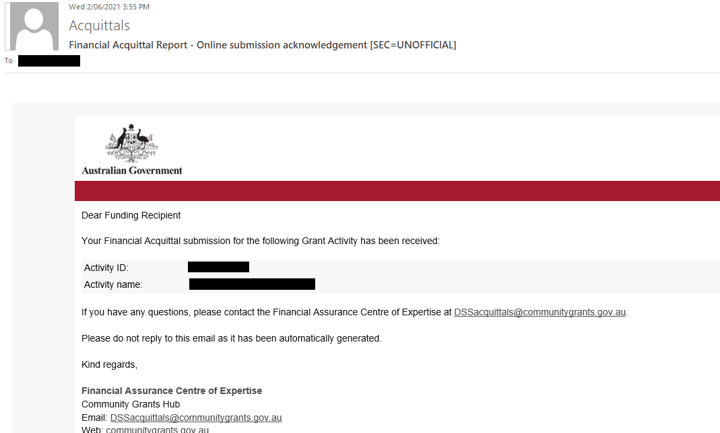

Need help?
For further assistance with the Grant Recipient Portal, please contact the Community Grants Hub at GRP.Helpdesk@communitygrants.gov.au.

Acquittal Contacts
If you have any questions regarding the Financial Acquittal report, please contact the Financial Assurance Centre of Expertise through the relevant inbox:
Agency Name | Financial Acquittal Inbox
Department of Social Services | DSSacquittals@communitygrants.gov.au
Department of Social Services – Volunteer Grants | VGacquittals@communitygrants.gov.au
Attorney-General’s Department | AGD.acquittals@communitygrants.gov.au
Department of Agriculture, Fisheries and Forestry | DAWE.Acquittals@communitygrants.gov.au
Department of Climate Change, Energy, the Environment and Water | DCCEEW.Acquittals@communitygrants.gov.au
Department of Education | DE.Acquittals@communitygrants.gov.au
Department of Employment and Workplace Relations | DEWR.Acquittals@communitygrants.gov.au
Department of Home Affairs | DHA.Acquittals@communitygrants.gov.au
Department of Health, Disability and Ageing  Note: Some Department of Health Disability and Ageing programs have program-specific financial acquittal templates - please check with your Funding Arrangement Manager | DOH.acquittals@communitygrants.gov.au
Prime Minister and Cabinet | PMC.Acquittals@communitygrants.gov.au
Department of Veterans’ Affairs | DVAacquittals@communitygrants.gov.au
Department of Infrastructure, Transport, Regional Development, Communications, Sport and the Arts | DITRDCA.Acquittals@communitygrants.gov.au
If you experience technical difficulties with the online form, you can submit your report manually by completing the template at Appendix A – Financial Declaration and emailing to the relevant mailbox above.
Note: if you have a Non-Audited or Audited Financial Acquittal requirement and you cannot submit online, this can be emailed directly to the relevant mailbox above.

Appendix A – Financial Declaration

Financial Declaration
Organisation Name
Name of Activity
Activity ID

Grant Funding
Financial year grant funding was received
YYYY-YY (e.g. 2022-23)
Grant funding received (excluding GST)
$ enter amount received
Grant funding approved for roll-over from the previous financial year (excluding GST)
$ enter amount approved for rollover from previous financial year
Has your organisation used the total amount of the Activity funding received (including any additional payments, indexation and roll over amounts)? | ☐ Yes  ☐ No – please provide amount below and details on page 2
If no, how much remained unexpended at the end of the financial year? (excluding GST)
$ enter amount unspent

Unspent Funds
Complete this section only if you have unspent funds.
Reasons for Underspend  Select reasons why the underspend occurred.  ☐ Funds received late in the financial year  ☐ Reduced demand for services  ☐ Issues with recruiting staff  ☐ Delay in project implementation  ☐ Expenses less than anticipated  ☐ Failure to manage expenses  ☐ Other – provide in detailed explanation | Reason for underspend:  - Enter an explanation of the underspend

Declaration
By making this declaration, I declare:
- I am a member of the Organisation’s Board, the Chief Executive Officer, or an officer with authority to sign on behalf of the Board and/or CEO,
- I confirm that funds have been spent in accordance with the Grant Agreement,
- I agree that the information I have provided in this document is true and correct, and
- I acknowledge that giving false or misleading information is a serious offence under the Criminal Code Act 1995 (Cth).
Name of person making the declaration
enter name
Signature of the person making the declaration
insert signature
Position in organisation
position
Date of declaration
date
Witnessed by
witness name
If you have any questions regarding the Financial Acquittal report, please contact the Financial Assurance Centre of Expertise through the relevant inbox:

Appendix B – Notes on Non-Audited and Audited Financial Acquittals

Non-Audited Financial Acquittal Reports
A Non-Audited Financial Acquittal Report shows how your organisation spent the grant money provided for a funded activity. It also needs to clearly show whether any grant funds remain unspent.
The report must be approved by someone in your organisation who has the authority to certify financial information.
There is no required template, but the report must:
- Be based on accurate financial records and comply with Australian Accounting Standards.
- Confirm that the grant funding was used for the approved activity and in line with the grant agreement.
- Only include income and expenses related to the Department's grant funding (not your organisation's overall finances).
- Clearly separate the income and expenses for each grant if you receive more than one grant.
- Include any additional information required by the grant agreement.
- Be certified by the organisation's Board, Chief Executive Officer (CEO), or another authorised officer.
To submit a Non-Audited Financial Acquittal Report, complete the online form and attach your income and expenditure statement (for example, a Word, PDF or Excel file).
You can refer to the Example Non-Audited Financial Acquittal Report for a sample that meets the requirements.
For more information visit the Non-Audited Financial Acquittals page on the Community Grants Hub website.

Audited Financial Acquittal Reports
An Audited Financial Acquittal Report shows how your organisation spent the grant funding and must be independently reviewed by a qualified auditor.
The audit must be completed by one of the following:
- A Registered Company Auditor under the Corporations Act 2001.
- A member of CPA Australia.
- A member of the Institute of Public Accountants.
- A member of Chartered Accountants Australia and New Zealand.
There is no required template for the report, but it must:
- Include an auditor's report or audit opinion.
- Be based on accurate financial records and comply with Australian Accounting Standards.
- Confirm that the grant funding was used for the approved activity and in line with the grant agreement.
- Only include income and expenses related to the Department's grant funding (not your organisation's overall finances).
- Clearly separate the income and expenses for each grant if you receive more than one grant.
- Include any additional information required under the grant agreement.
To submit an Audited Financial Acquittal Report, complete the online form and attach both:
- The audited financial statement, and
- The auditor's report (audit opinion).
For more information visit the Audited Financial Acquittal page on the Community Grants Hub website.
Note: An audited financial acquittal is an independently verified report that confirms grant funding was spent correctly and in accordance with the grant agreement.

